0983-AGV小车货架连接件的生产日志
AGV trolley shelf connector
🖨️ SLS尼龙烧结
🖥️ 打印机: Mimaki
📦 材料: SLS阻燃尼龙
“在生活的每一个转角，我们总能找到新的机会。就像这一单AGV小车货架连接件，正是因人而生。”
"At every corner of life, we can always find new opportunities. Just like this AGV cart shelf connector, which is born out of necessity."
________________________________________________________________________________
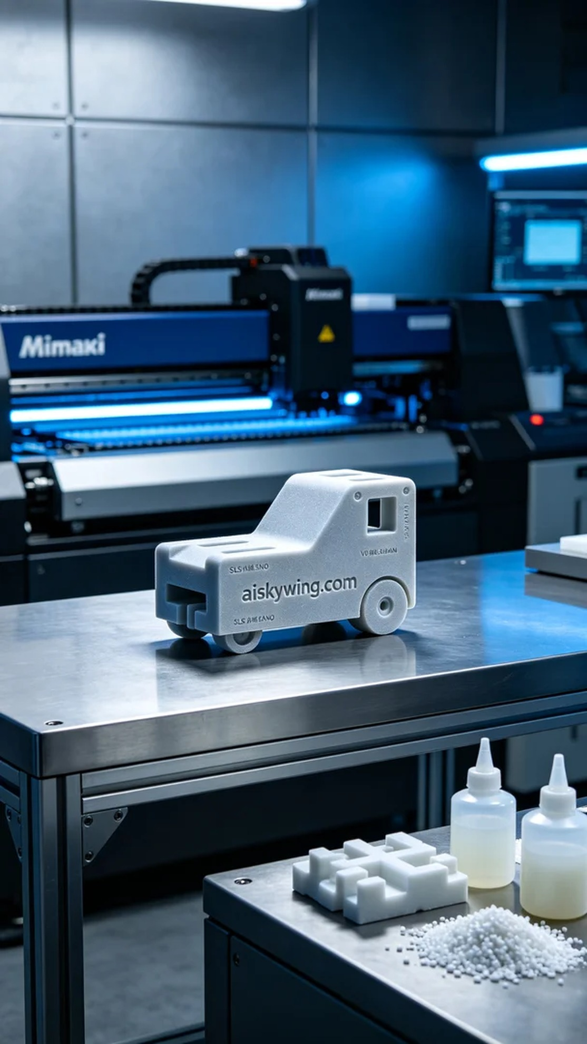
Today’s task is to print a batch of AGV cart shelf connectors, a request born from someone’s desire to enhance their automation handling efficiency. They discovered our technology via TikTok and reached out for help to address this need.
We chose SLS flame-retardant nylon as the raw material because of its excellent strength and heat resistance, making it ideal for industrial applications. The printer used is a Mimaki 3D printer, with parameters set to a layer thickness of 0.1mm, a printing temperature of 180°C, power set to 70%, and a speed of 30mm per second, with an estimated printing time of about 6 hours.
During the printing process, the Mimaki printer ran smoothly, with even heating of the material and quality monitoring indicating that each layer was printed perfectly. Throughout the process, I kept a close eye on the equipment, ensuring no abnormalities occurred. It was gratifying to watch the contours of the printed parts gradually take shape.
Once printing was complete, I first removed the AGV cart shelf connectors from the print platform, followed by cleaning to remove any excess powder from the surface. Next, I proceeded to the sanding process, meticulously smoothing the edges to ensure each connection point was free of burrs. Finally, a curing process was conducted to ensure the material's strength reached its optimum state, and a thorough inspection confirmed that each piece met the standards.
Through this production, we successfully completed the printing task for AGV cart shelf connectors, witnessing how technology can empower industrial development, and I look forward to the next challenge and achievement.
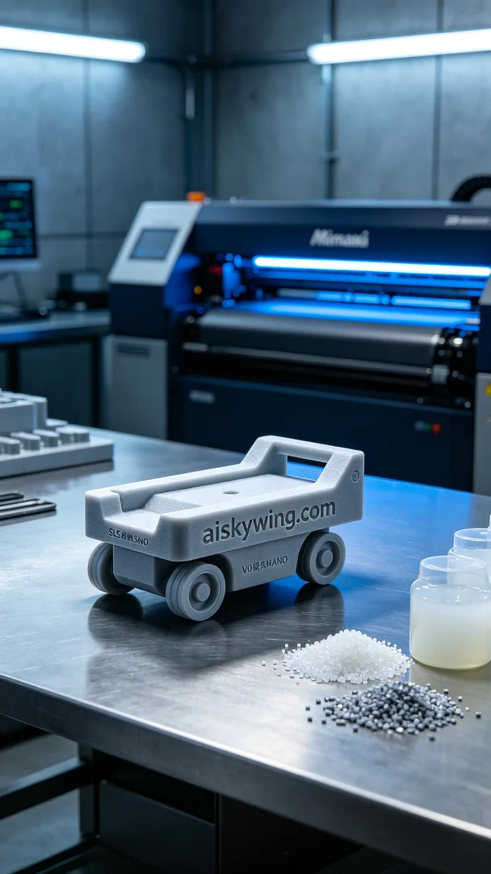
今天的任务是打印一批AGV小车货架连接件，这个需求是因为有人希望提升他们的自动化搬运效率。通过TikTok了解到我们的技术，便找上了我们，希望我们能帮助解决这一问题。
我们选择了SLS阻燃尼龙作为原材料，因其具备优异的强度和耐热性，特别适合工业应用。打印设备是Mimaki的3D打印机，调整后的参数是层厚0.1毫米，打印温度为180°C，功率设定在70%，打印速度为30毫米每秒，预计打印时间大约为6小时。
在打印过程中，Mimaki打印机运行平稳，材料加热均匀，质量监控显示每一层都打印得相当完美。整个过程中，我时刻关注着设备的状态，确保没有任何异常情况发生。每当看到打印件的轮廓逐渐显现，心里也倍感欣慰。
打印完成后，首先将AGV小车货架连接件从打印平台上取下，然后进行清洗，去除表面的多余粉末。之后进入打磨工序，精细地处理边缘，确保每个连接部分光滑无毛刺。最后进行固化处理，让材料的强度达到最佳状态，合格后进行仔细检验，确保每一件都符合标准。
通过这次生产，我们顺利完成了AGV小车货架连接件的打印任务，见证了技术如何为工业发展助力，期待下一次的挑战与收获。
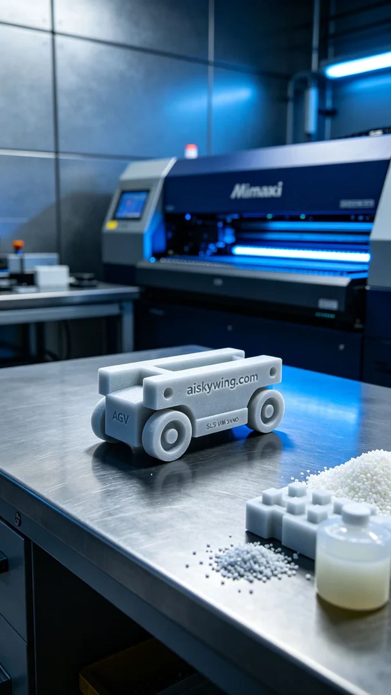
Aiskywing Industrial 3D Printing
AGV trolley shelf connector


