0985-AGV小车车体外壳3D打印生产记录
AGV trolley body shell
🖨️ SLS尼龙烧结
🖥️ 打印机: Voxeljet
📦 材料: SLS尼龙PA12
在这个充满挑战的时代，别怕艰难险阻。正如我们这次制作的AGV小车车体外壳，专注与创新，终将迎来光明未来。
In this challenging era, do not fear difficulties and obstacles. Just like the AGV cart body shell we created this time, with focus and innovation, we will ultimately usher in a bright future.
________________________________________________________________________________
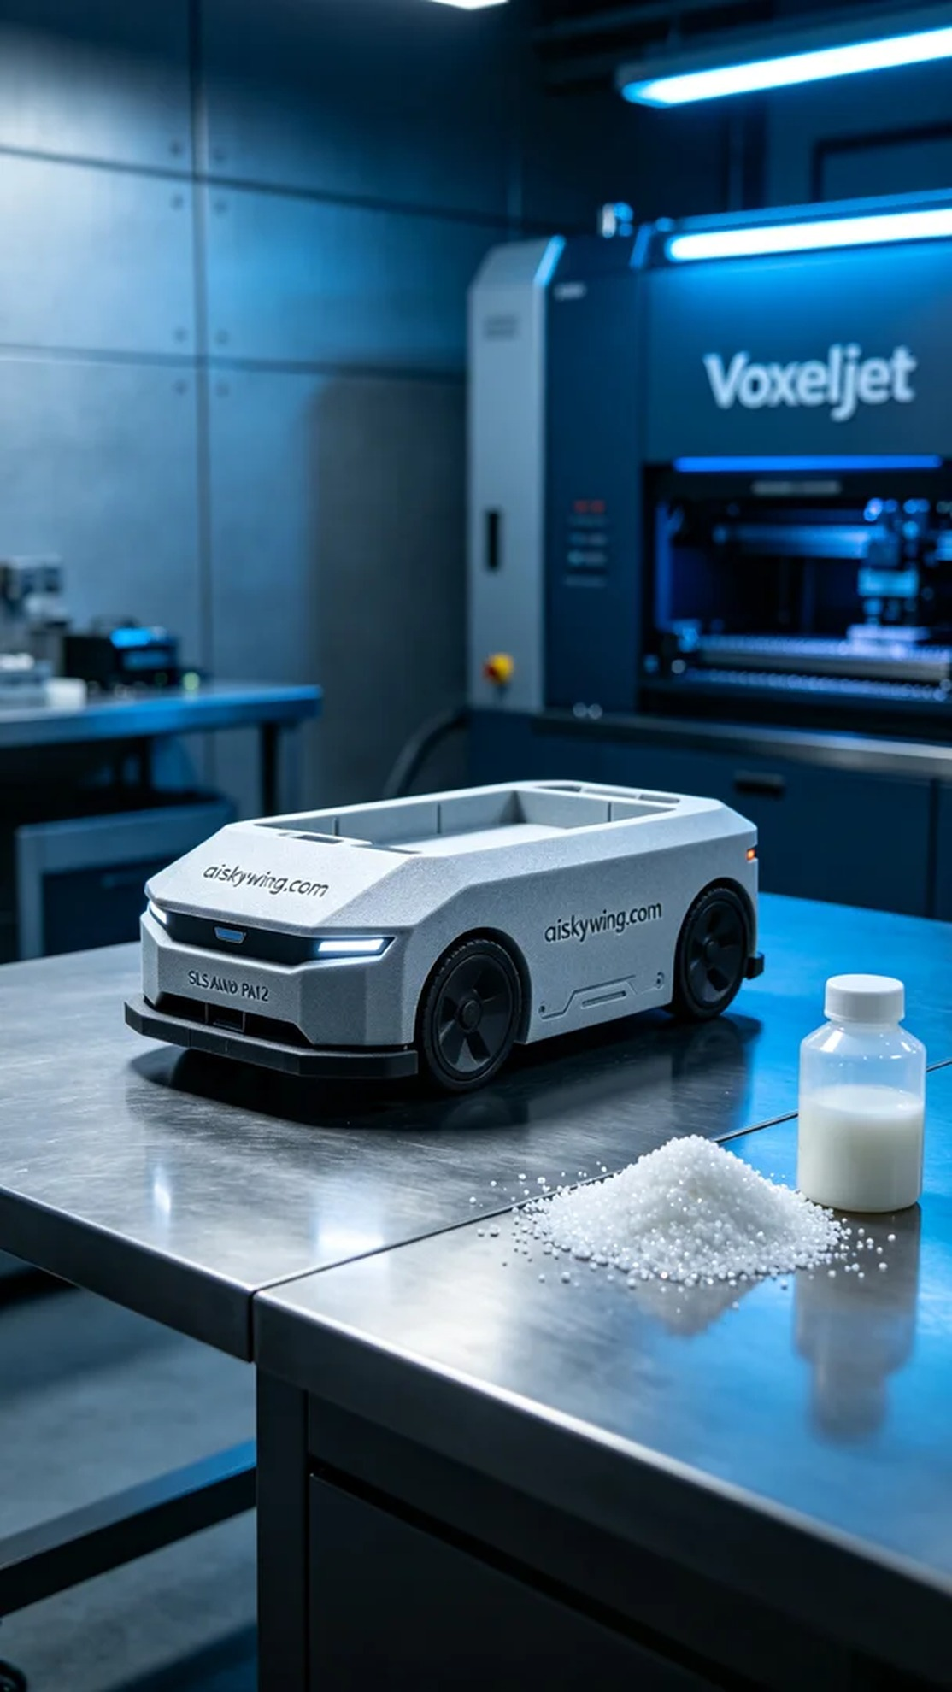
Recently, someone reached out to us via Twitter, expressing an urgent need for an AGV car shell with high strength and precision. After understanding their challenges, we decided to provide them with the best solution.
We opted for SLS Nylon PA12 as the raw material, which is perfect for creating complex structures due to its high-strength engineering properties. To ensure optimal printing results, we configured the Voxeljet printer with a layer thickness of 0.1mm, maintaining the temperature at 180°C, a power output of 30W, and a printing speed of about 100mm/s, with the entire process estimated to take around 8 hours.
During the printing process, the machine operated smoothly, and the material was evenly distributed, ensuring product quality. We monitored the process closely to ensure every detail met the standards and made timely adjustments to the SLS Nylon PA12 in the feed chamber to maintain optimal printing conditions.
After printing, we carried out detailed post-processing steps. First, we washed the finished product with a cleaning solution to remove any uncured material. Then we meticulously sanded the surface to ensure it was smooth and flawless. Next, we cured the product to enhance its strength, followed by a rigorous quality inspection to ensure every detail met the expected standards.
After a series of meticulous procedures, the AGV car shell was successfully completed, showcasing excellent quality and a perfect appearance, bringing satisfaction to both us and the requester.
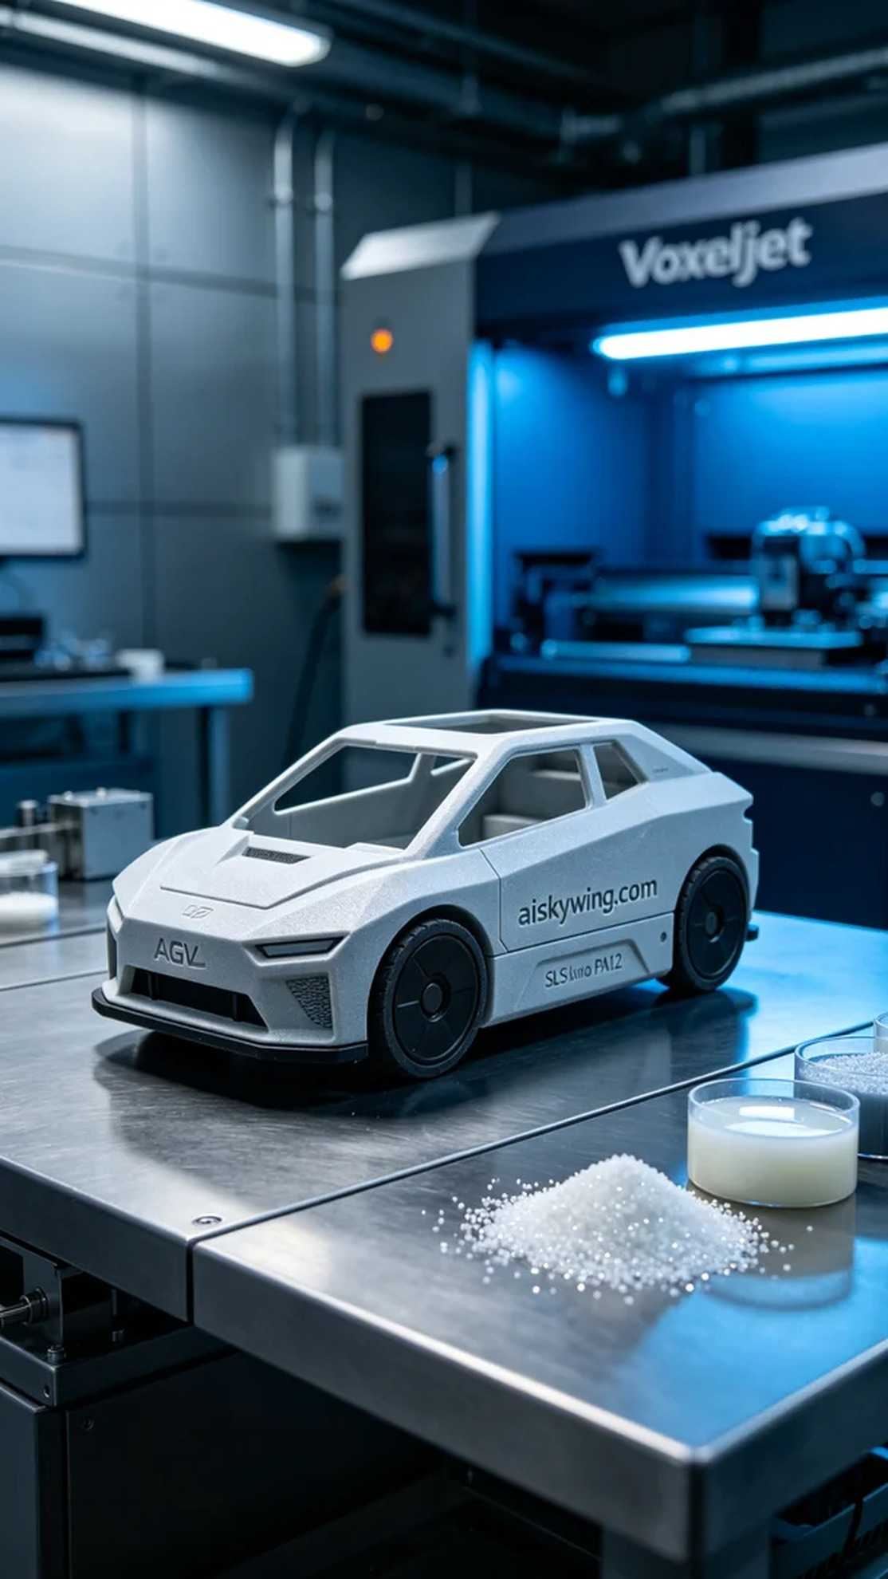
这次，有人通过Twitter联系到我们，提到急需一款AGV小车车体外壳，要求高强度和精确度。我们了解他们面临的难题后，决定为他们提供最好的解决方案。
我们选择使用SLS尼龙PA12作为原材料，这种高强度工程塑料非常适合制作复杂结构。为了确保打印效果，我们调试了Voxeljet打印机，设置的层厚为0.1mm，温度保持在180°C，打印功率为30W，打印速度约为100mm/s，整个打印过程预计耗时8小时。
在打印过程中，机器运转平稳，材料均匀分布，保障了产品的质量。我们进行了全程监控，确保每个细节都符合标准，及时调整了料仓中的SLS尼龙PA12，保持最佳打印状态。
打印完成后，我们进行了详细的后处理工序。首先，用清洗液对成品进行清洗，以去除未固化的材料。然后，进行细致的打磨，确保表面光滑无瑕。接着，我们对产品进行固化，增强其强度，最后进行了严格的质量检验，确保每一个细节都符合预期标准。
经过一系列精细的工序，这个AGV小车车体外壳终于顺利完成，呈现出优异的质量和完美的外观，给我们和对方都带来了满意的结果。
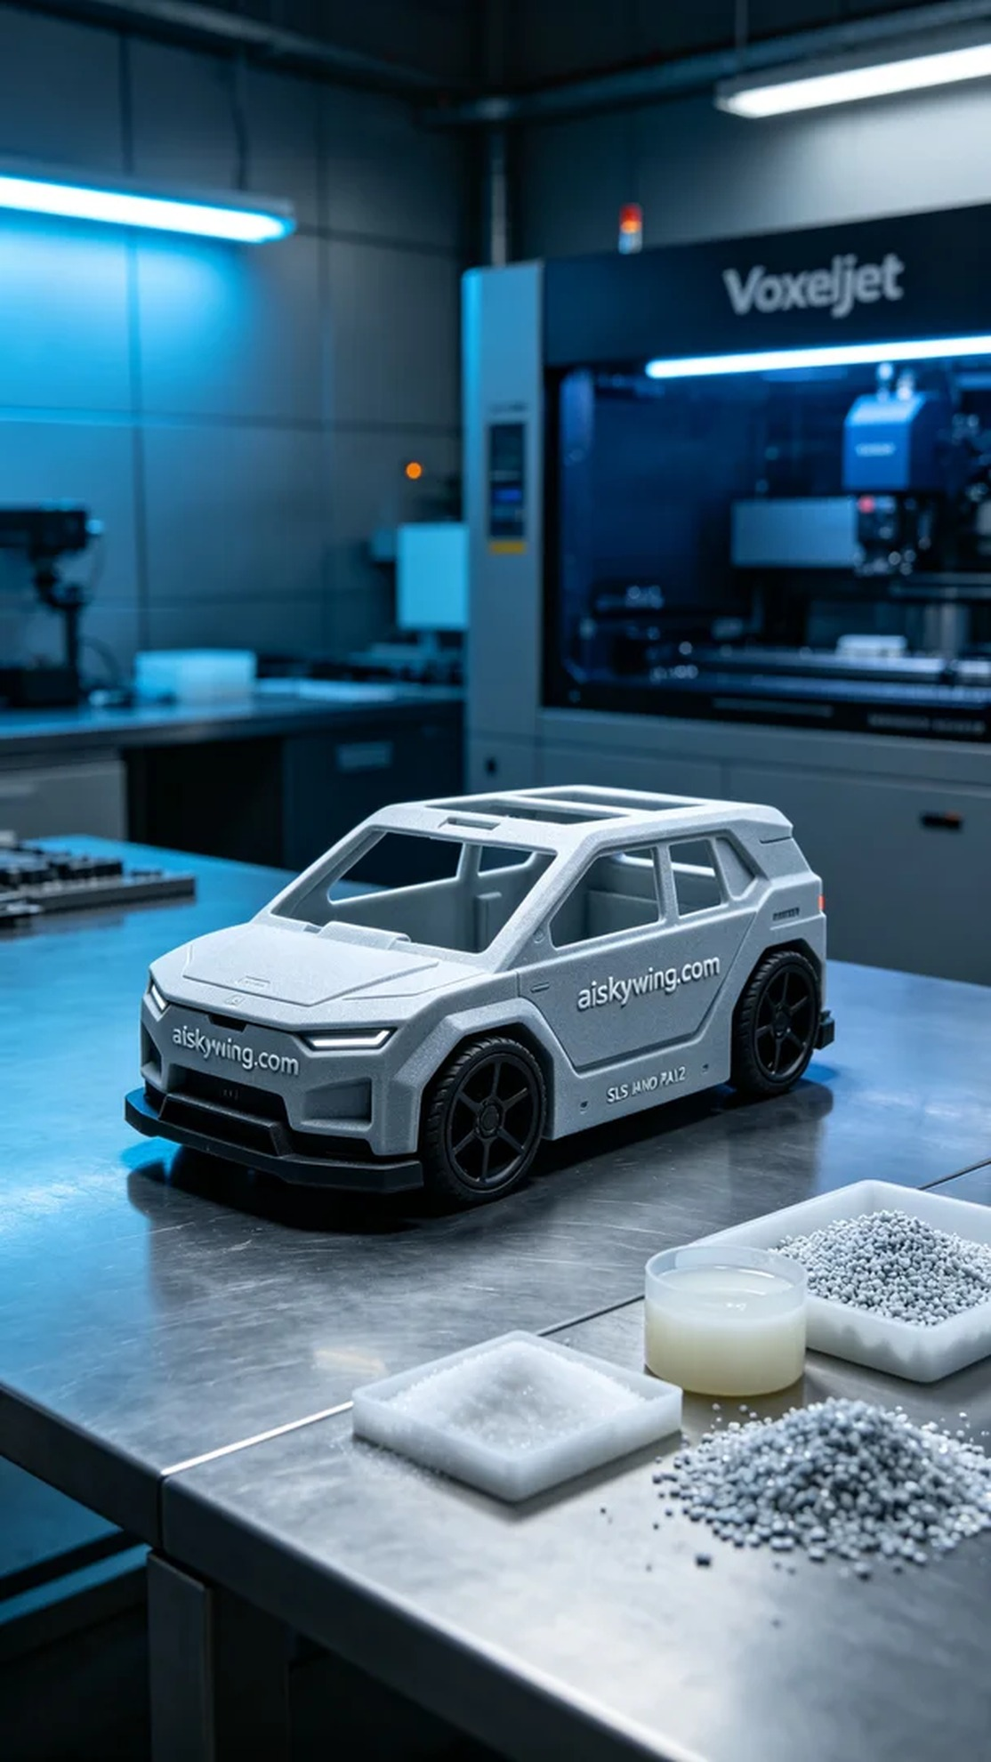
Aiskywing Industrial 3D Printing
AGV trolley body shell


