0986-AGV小车车轮护盖的3D打印记录
AGV trolley wheel cover
🖨️ SLS尼龙烧结
🖥️ 打印机: Voxeljet
📦 材料: SLS尼龙
生活就像3D打印，有时候需要你用心去雕琢。最近，有人找我们制作AGV小车车轮护盖，想要解决他们在运输上的问题。
Life is like 3D printing; sometimes it requires you to carve it with care. Recently, someone approached us to create wheel covers for their AGV (Automated Guided Vehicle) carts, aiming to solve their transportation issues.
________________________________________________________________________________
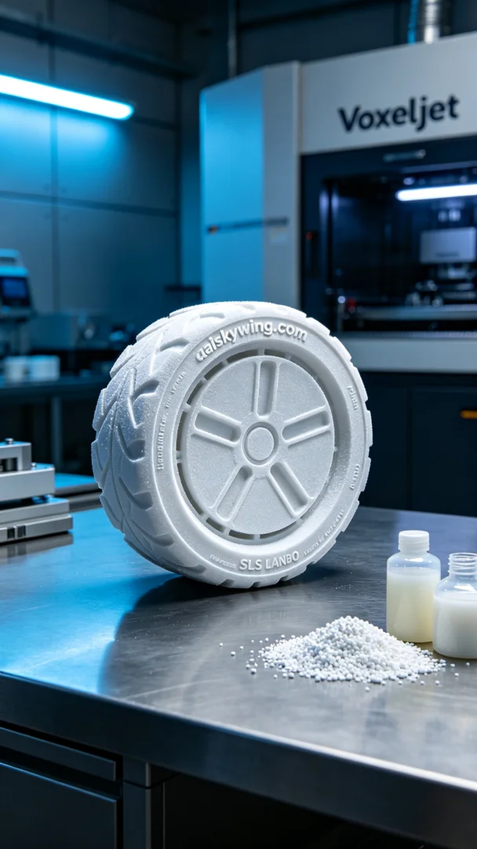
Life is like 3D printing, sometimes you need to carve it with your heart. Recently, someone approached us to create a cover for the wheels of an AGV cart, looking to solve their transportation issues.
The request came from a video recommendation on YouTube, where someone saw the design of the AGV small car wheel cover and realized that this accessory could effectively enhance their cart's performance. Their goal was to obtain a lightweight and durable protective device for frequent use in industrial settings.
We selected SLS nylon as the raw material, known for its excellent durability and lightweight characteristics, along with a fine sintered texture on the surface that provides good wear resistance. For the equipment, we prepared the Voxeljet 3D printer, setting parameters at a layer thickness of 0.1 mm, temperature at 200 degrees Celsius, power at 1000 watts, and a print speed of about 30 mm per second, with an estimated total print time of 6 hours.
During the printing process, the Voxeljet printer operated very steadily. We monitored the print quality in real-time to ensure each layer adhered properly. As the printing progressed, the shape of the AGV small car wheel cover gradually emerged, with details clear and the engraving of "aiskywing.com" on the surface standing out prominently, with everything going smoothly.
After the printing was completed, we conducted detailed post-processing. First, we cleaned the molded parts to remove any excess powder. Then, we polished the surface to make it smoother and ensure there were no defects. Next, we placed it into a UV curing device to further enhance the material's strength. The final step was a thorough inspection to ensure every product met our standards.
Through this production, we successfully delivered the AGV small car wheel cover, which is lightweight and durable, enhancing their transportation efficiency. Such results remind me that every effort put in is indeed rewarding.
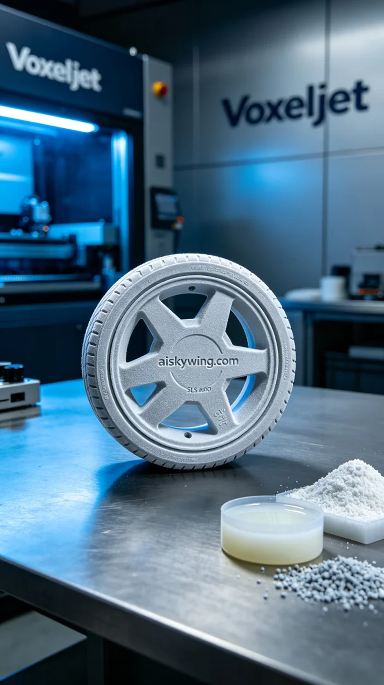
这次的任务来自YouTube上的一个视频推荐，有人看到了AGV小车车轮护盖的设计，认为这款配件能有效提升其小车的性能。他们的目标是获取轻量化且耐用的保护装置，以应对频繁的工业使用。
我们选用了SLS尼龙作为原材料，这种材料具有优良的耐用性和轻量化特性，表面还有细微的烧结纹理，提供了不错的抗磨损能力。在设备方面，我们准备了Voxeljet 3D打印机，设定参数为0.1毫米的层厚、温度200摄氏度、功率为1000瓦、打印速度约为30毫米每秒，并预计整个打印过程持续6小时。
在打印过程中，Voxeljet打印机的工作状态非常稳定。我们实时监控打印质量，确保每一层都贴合得当。随着打印的进行，AGV小车车轮护盖的外形逐渐显现，细节清晰可见，"aiskywing.com"的字样在表面雕刻中显得尤为突出，整个过程一切顺利。
打印完成后，我们进行了细致的后处理。首先，将成型的部件进行清洗，以去除多余的粉末。随后，通过打磨处理表面，使其更加光滑，并确保没有瑕疵。接着，我们将其置于光敏树脂固化设备中，使材料的强度进一步增强。最后一步是仔细检验，确保每个产品都能达到我们的标准。
经过这次的制作，我们成功交付了AGV小车车轮护盖，轻量化且耐用，助力了他们的运输效率。这样的结果，让我感受到每一次的努力都是有回报的。
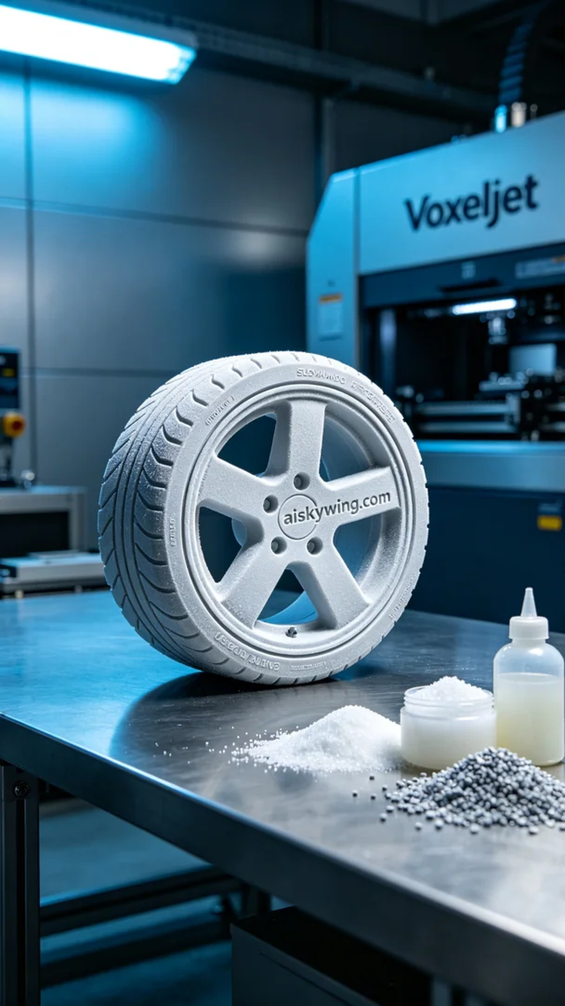
Aiskywing Industrial 3D Printing
AGV trolley wheel cover


