0987-AGV小车通信模块外壳生产记录
AGV cart communication module casing
🖨️ SLS尼龙烧结
🖥️ 打印机: Systems
📦 材料: SLS耐高温尼龙
生活再难，也别停下脚步。就像接下这个AGV小车通信模块外壳的单子，有人因为高温环境的需求找到我们。
No matter how difficult life gets, don't stop moving forward. Just like when we took on the order for the communication module shell for the AGV cart; someone reached out to us due to the requirements of a high-temperature environment.
________________________________________________________________________________
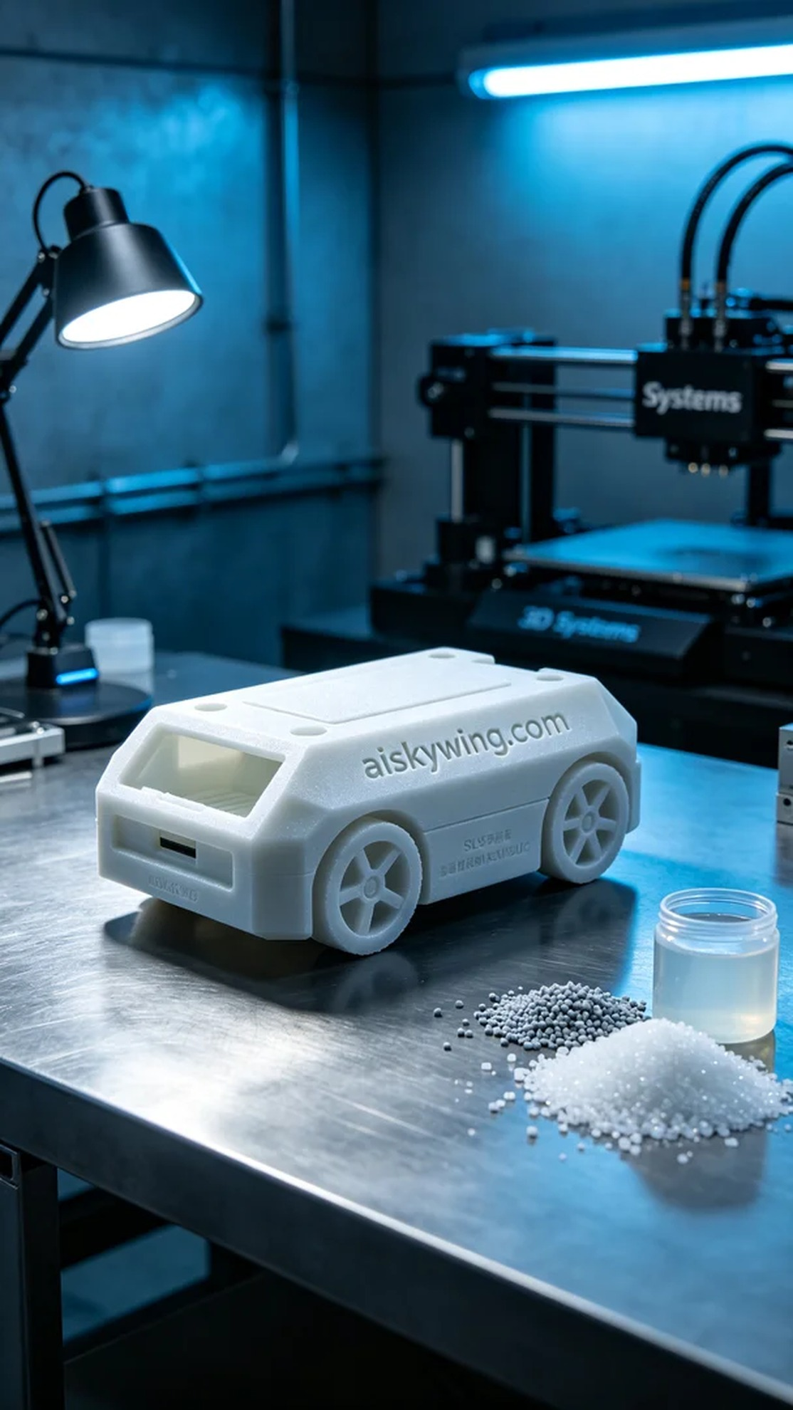
In TikTok, someone reached out to us for the AGV small car communication module shell due to its demand in high-temperature environments, which made them trust our materials and process.
In the preparation phase, we chose SLS high-temperature nylon as the raw material due to its capability to withstand temperatures above 150℃ and its elegant matte finish. We used a Systems printer, setting the layer thickness to 0.1mm, maintaining the printing temperature at 180℃, with power at 90%, and controlling the speed at 50mm/s to ensure print quality.
The printing process was in full swing, with stable machine operation, low noise, and energy efficiency. After completing each layer, I regularly checked the print quality to ensure there were no warps or other defects. After a few hours of printing, the outline of the AGV small car communication module shell gradually emerged from the powder, with the "aiskywing.com" engraving clearly visible.
After printing was completed, the shell underwent a series of post-processing steps. First, we placed it in a cleaning tank to remove excess powder before gently sanding the surface with sandpaper to ensure a smooth touch. The next step was curing, where we used UV light to cure the shell, increasing its hardness and durability, followed by strict quality inspection to ensure every detail was flawless.
Through this series of efforts, the AGV small car communication module shell not only exhibited excellent temperature resistance but also achieved high standards in both visual and tactile aspects, perfectly fitting the demands of high-temperature environments.
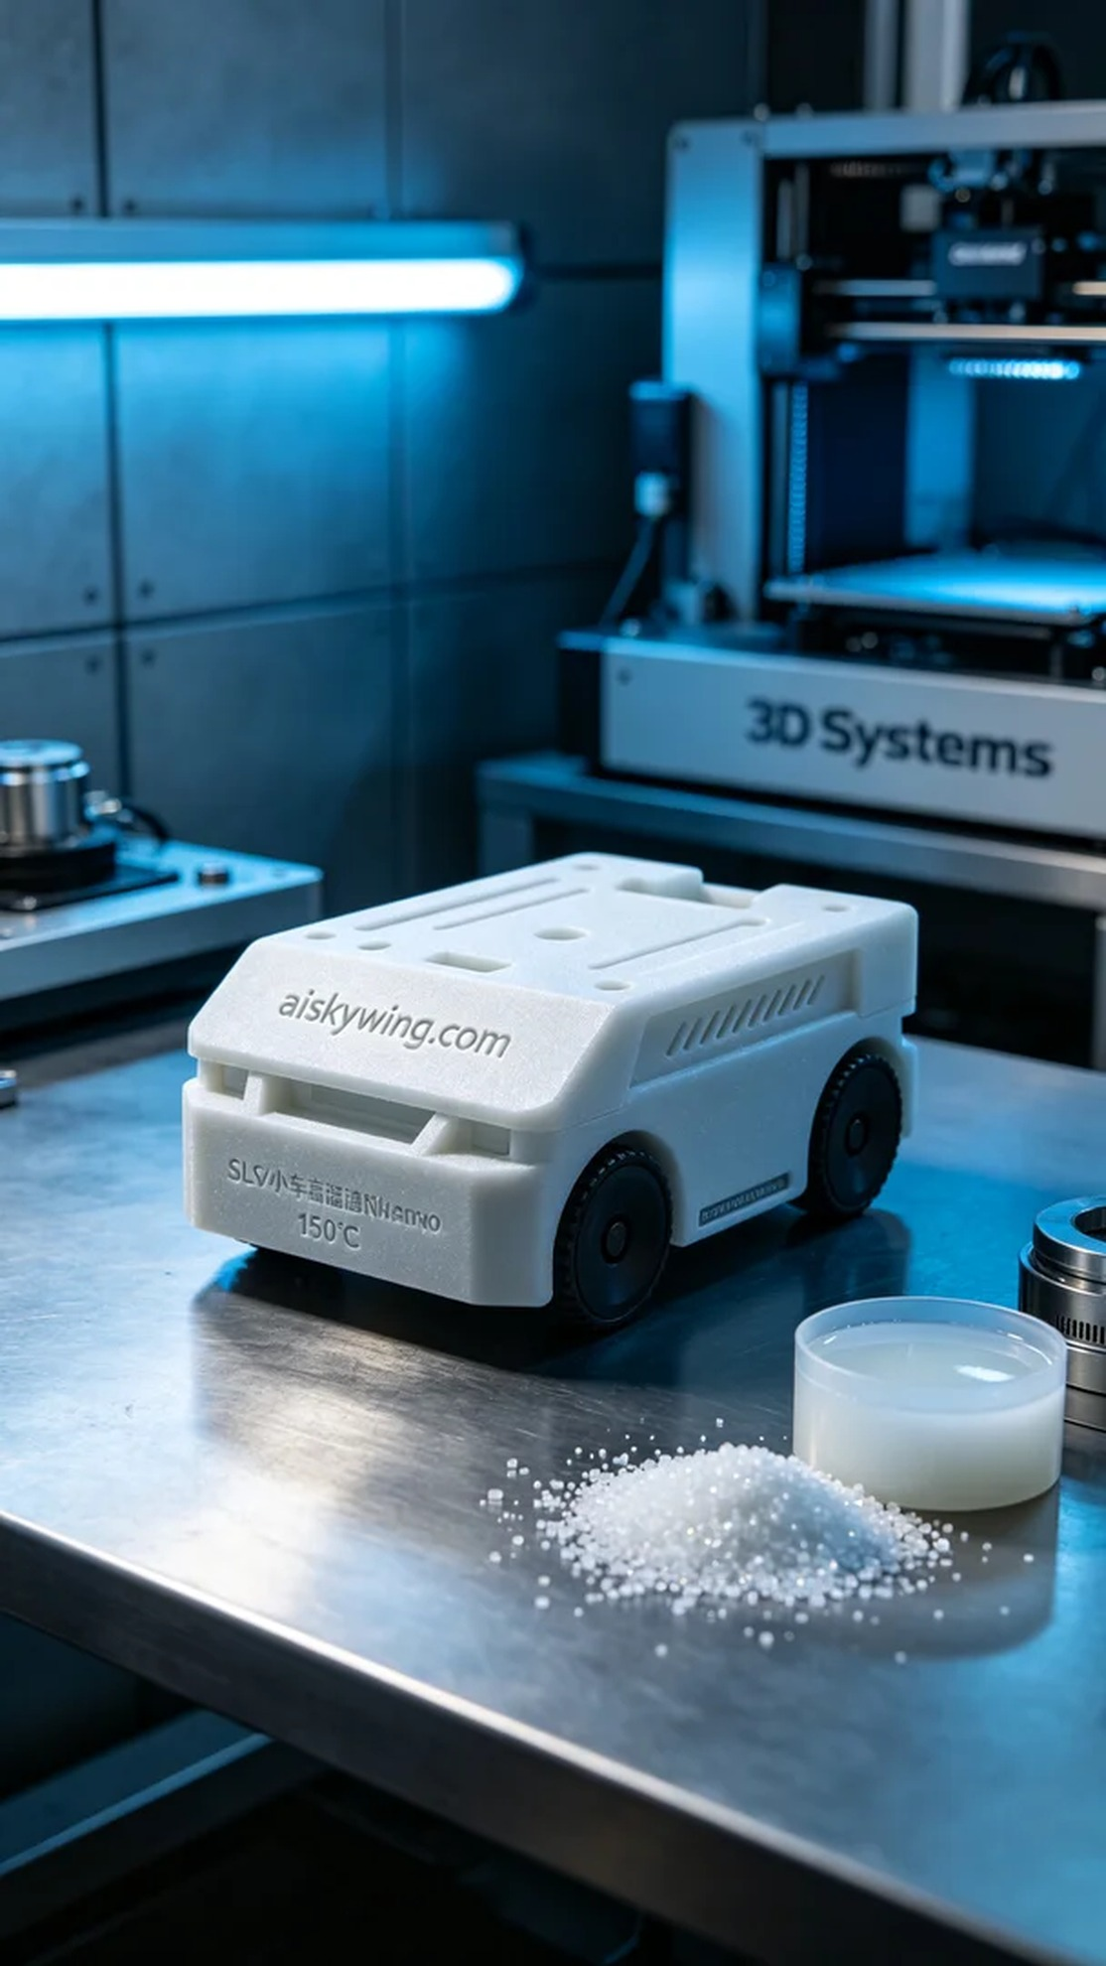
在TikTok上，有人因为对AGV小车通信模块外壳的需求而找到了我们，特别是在高温环境下的使用要求，让他们对材料和工艺产生了信任。我们需要用SLS耐高温尼龙来满足这一挑战。
在准备阶段，我们首先选择了SLS耐高温尼龙作为原材料，因其具备150℃以上的耐温性能以及磨砂表面的优雅质感。我们使用的打印机是Systems，设置层厚为0.1mm，打印温度维持在180℃，功率为90%，打印速度控制在50mm/s，以确保打印质量。
打印过程如火如荼，设备运行稳定，机器的噪音低且节能。每完成一层，我都会定期检查打印质量，确保没有翘边或其他缺陷。经过几小时的打印，AGV小车通信模块外壳的轮廓在粉末中逐渐显现，面部的“aiskywing.com”字样也清晰可见。
打印完成后，外壳需要经过一系列后处理工序。首先，我们将其放入清洗槽中，去除多余的粉末，然后用砂纸轻轻打磨表面，确保触感顺滑。下一步是固化，我们采用紫外线灯对外壳进行固化，增加其硬度和耐用性，最后进行严格的品质检验，确保每一个细节都完美无瑕。
通过这一系列的努力，AGV小车通信模块外壳不仅具备了优异的耐温性能，更在视觉和触感上达到了高标准，完美契合了高温环境下的使用需求。
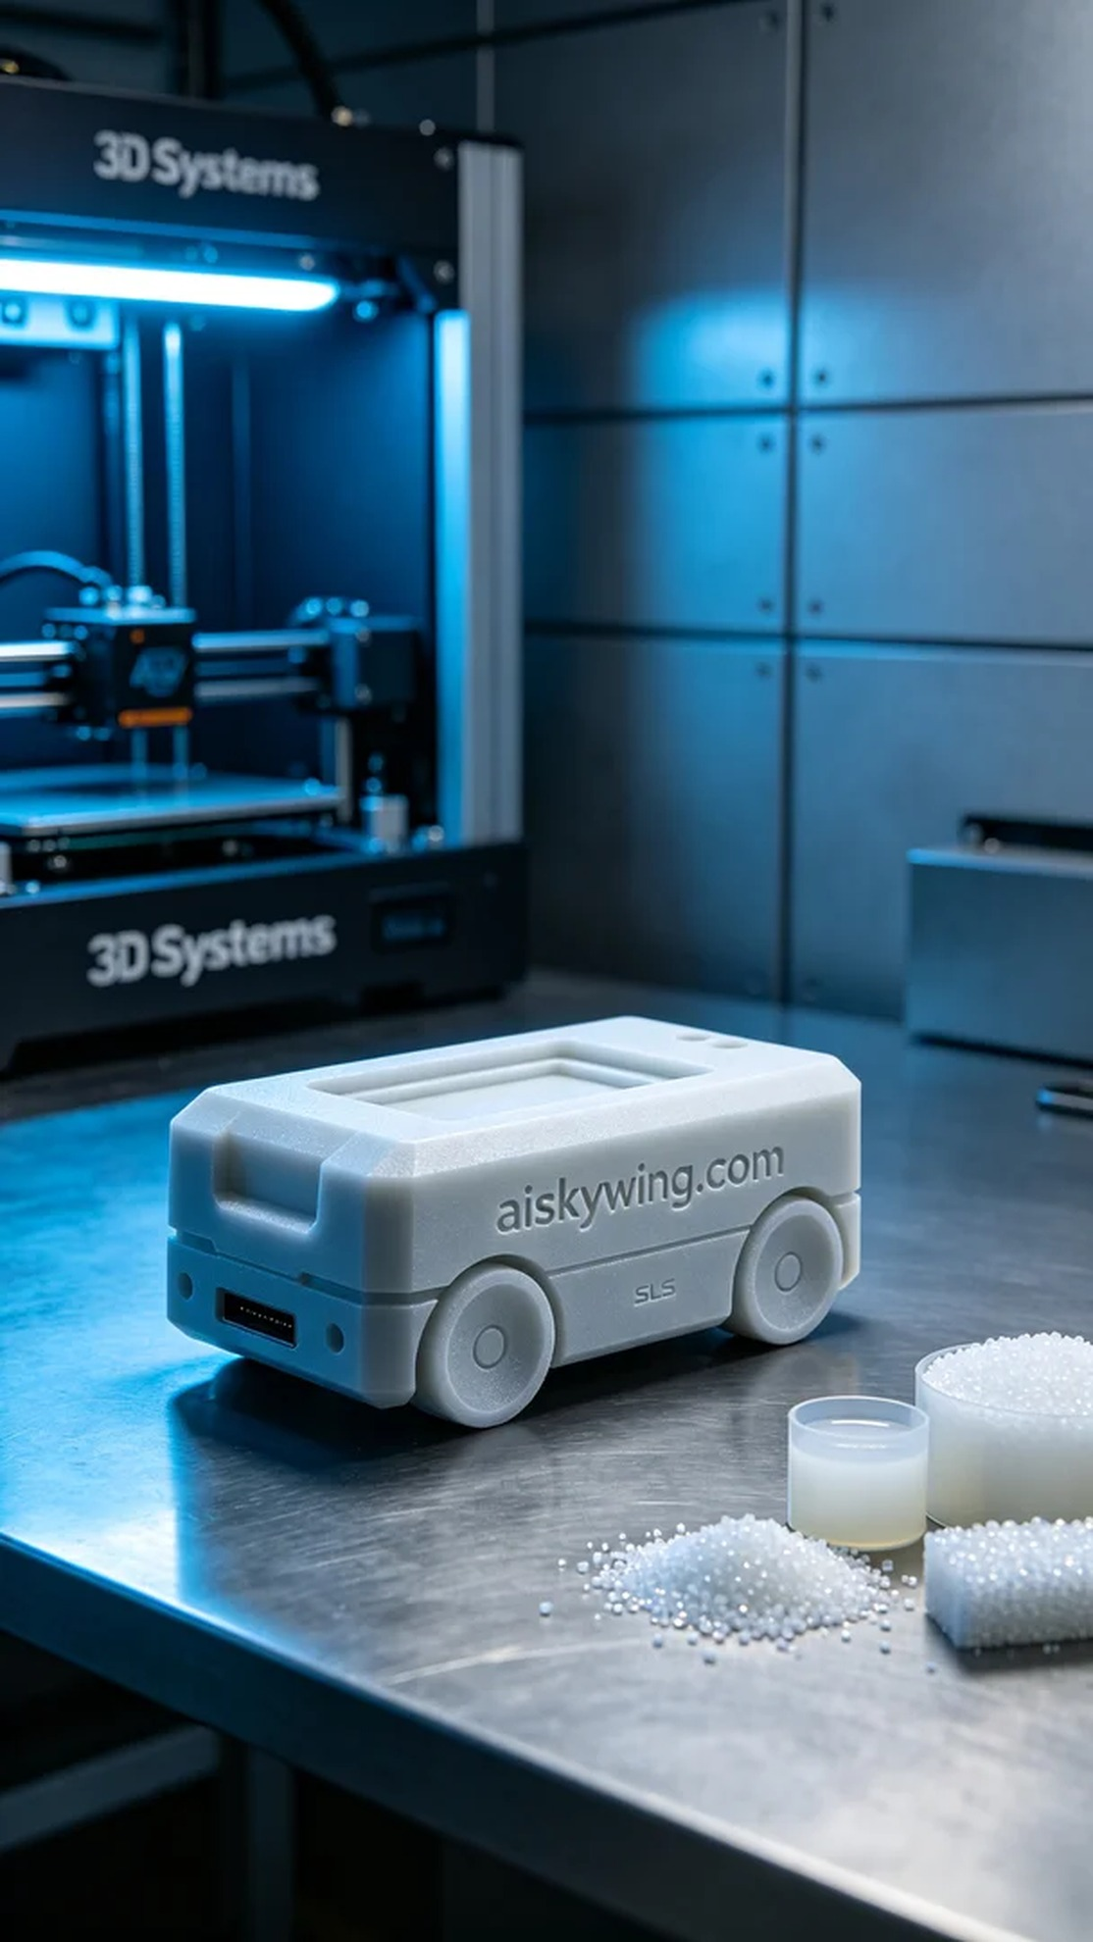
Aiskywing Industrial 3D Printing
AGV cart communication module casing


