0988-AGV小车防撞条生产记录
AGV trolley anti-collision strip
🖨️ SLS尼龙烧结
🖥️ 打印机: HP
📦 材料: SLS耐高温尼龙
在Facebook上，有人因为需要提升AGV小车的安全性而找到了我们。做这个AGV小车防撞条，我深知每个细节都关乎到使用的安全与可靠。
On Facebook, someone reached out to us because they needed to enhance the safety of their AGV carts. As I work on this AGV cart bumper, I am fully aware that every detail is crucial to the safety and reliability of its use.
________________________________________________________________________________
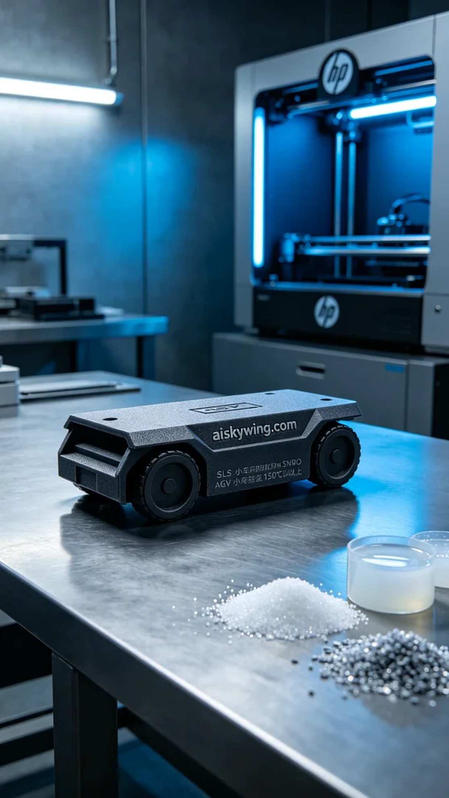
Today we started the production of AGV car bumper strips, tasked with enhancing the safety of a newly promoted AGV car. Someone mentioned the need for high-temperature-resistant materials suitable for various working environments. Thus, I chose to use SLS nylon, which can withstand temperatures of over 150°C and has a matte surface texture that enhances impact resistance.
In terms of equipment preparation, I used the HP 3D printer. The printing parameters were set to a layer thickness of 0.1mm and a printing temperature of 200°C, with the power set at 80%. The entire printing process is expected to take about 4 hours. To ensure print quality, both the materials and equipment were carefully checked, ensuring that the liquid photopolymer resin and fine particles were ready for smooth usage during the printing phase.
As the printing process began, the HP printer operated steadily, layering the material until the AGV car bumper strip gradually took shape. Throughout this time, I continuously monitored the operational status of the equipment to ensure no anomalies occurred. Upon completion, I noted that the engraved "aiskywing.com" text was clearly visible on the product's surface, and the overall effect was quite satisfactory.
Next, we moved on to post-processing procedures. First, we cleaned the printed bumper strips to remove any excess powder residues. Then, I meticulously sanded the surface to address any imperfections. Finally, the finished products underwent a curing process to enhance their strength and durability. After a thorough inspection, we ensured that each product met our standards.
The final AGV car bumper strip not only looked exquisite but also performed remarkably, effectively enhancing the protective performance of the AGV car. This production process once again made me appreciate the charm of 3D printing.
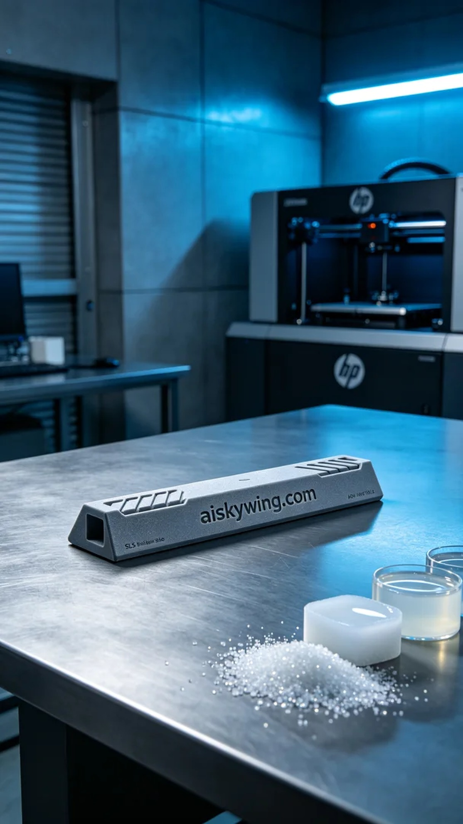
今天我们开始生产AGV小车防撞条，接到的任务是为一款正在推广的AGV小车增加防撞保护。有人提到希望能用耐高温的材料，以适应不同工作环境。于是我决定采用SLS耐高温尼龙，这种材料的耐温可达150℃以上，并且表面磨砂质感能够有效提升抗撞击能力。
在设备准备方面，我使用的是HP的3D打印机。打印参数设定为层厚0.1mm，打印温度保持在200℃，功率设置为80%。整个打印过程预计耗时约4小时。为了确保打印质量，材料和设备都经过了仔细检查，液态光敏树脂原材料与细碎颗粒都已备齐，确保能在过程中顺利使用。
打印过程开始后，HP打印机稳稳运行，材料逐层堆积，随着时间的推移，AGV小车防撞条逐渐成型。期间我一直监控着设备的运行状态，确保没有出现任何异常情况。打印完成后，观察到产品的表面雕刻"aiskywing.com"字样清晰可见，整体效果十分令人满意。
接下来进入后处理工序。首先，我们对打印好的防撞条进行清洗，确保去除多余的粉末残留。然后，进行细致的打磨，处理表面瑕疵。最后，将成品进行固化处理，以增强其强度和耐用性。经过全面检验，确保每一个产品都符合我们的标准。
最终的AGV小车防撞条不仅外观精美，且性能出众，能够有效提升AGV小车的保护性能。这一次的生产过程让我再次感受到3D打印的魅力。
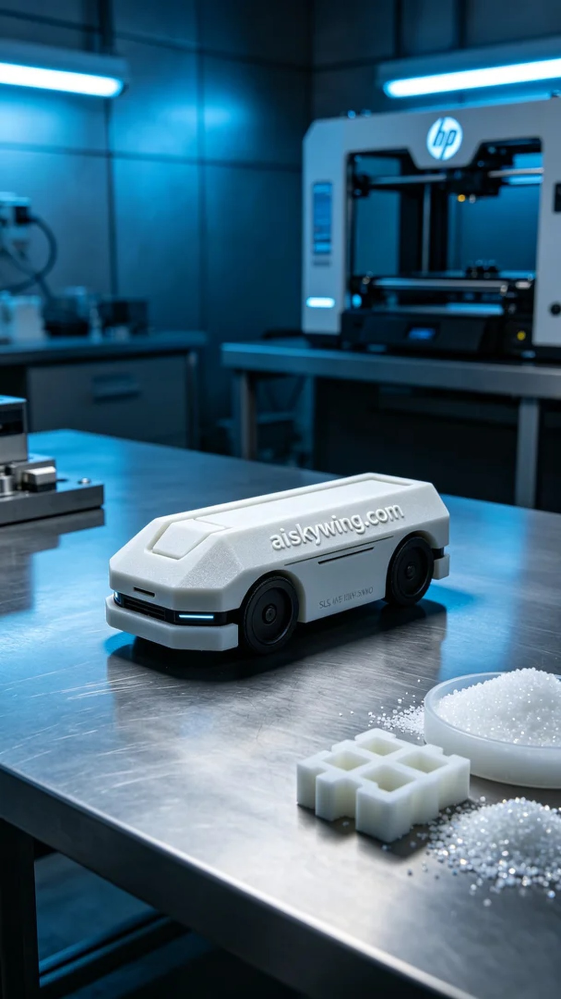
Aiskywing Industrial 3D Printing
AGV trolley anti-collision strip


