0989-AGV小车驱动器外壳生产记录
AGV cart driver housing
🖨️ SLS尼龙烧结
🖥️ 打印机: EOS
📦 材料: SLS尼龙PA12
生活在不断变化，唯有坚持才能迎来新的成果。就像我接到这份AGV小车驱动器外壳的任务，心里充满期待。
Life is constantly changing, and only by persevering can we achieve new results. Just like when I received the task of designing the shell for the AGV cart driver, I felt a surge of anticipation.
________________________________________________________________________________
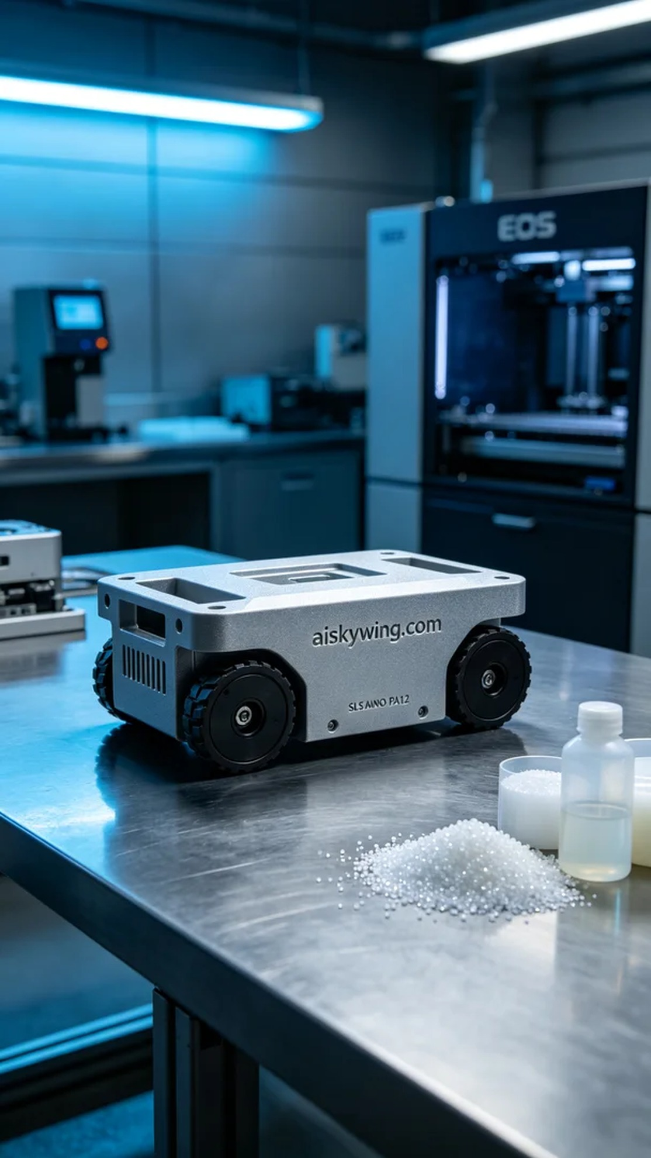
Someone contacted us via WhatsApp and asked if we could help them produce an AGV cart drive shell. Their request was urgent, and they needed a durable and high-quality shell, which made us feel a significant sense of responsibility.
For this production, we chose SLS Nylon PA12 as the material, known for its high strength and wear resistance, making it ideal for industrial applications. We set the EOS printer's parameters carefully, with a layer thickness of 0.1 mm, a printing temperature of 180℃, a power setting of 80%, and a printing speed of 20 mm per hour. This ensured that each layer was printed with the best possible quality.
During the printing process, the EOS printer operated smoothly. We continuously monitored the device status, ensuring that material supply was normal and the print head temperature remained stable. Throughout the printing period, we kept a close eye on the quality, ensuring no bubbles or defects appeared. As time went on, we began to see the shell take shape, which filled us with joy.
After printing, we moved on to the post-processing phase. First, we cleaned the printed part to remove excess powder from the surface. Then, we used fine sandpaper to polish the shell for a smooth finish. Next, we placed it in a curing device for a set amount of time, followed by a quality inspection to ensure all specifications were met.
In the end, the AGV cart drive shell was successfully completed, going through rigorous procedures to ensure its reliability. Every detail reflected our professionalism and dedication, making us truly proud of the outcome.
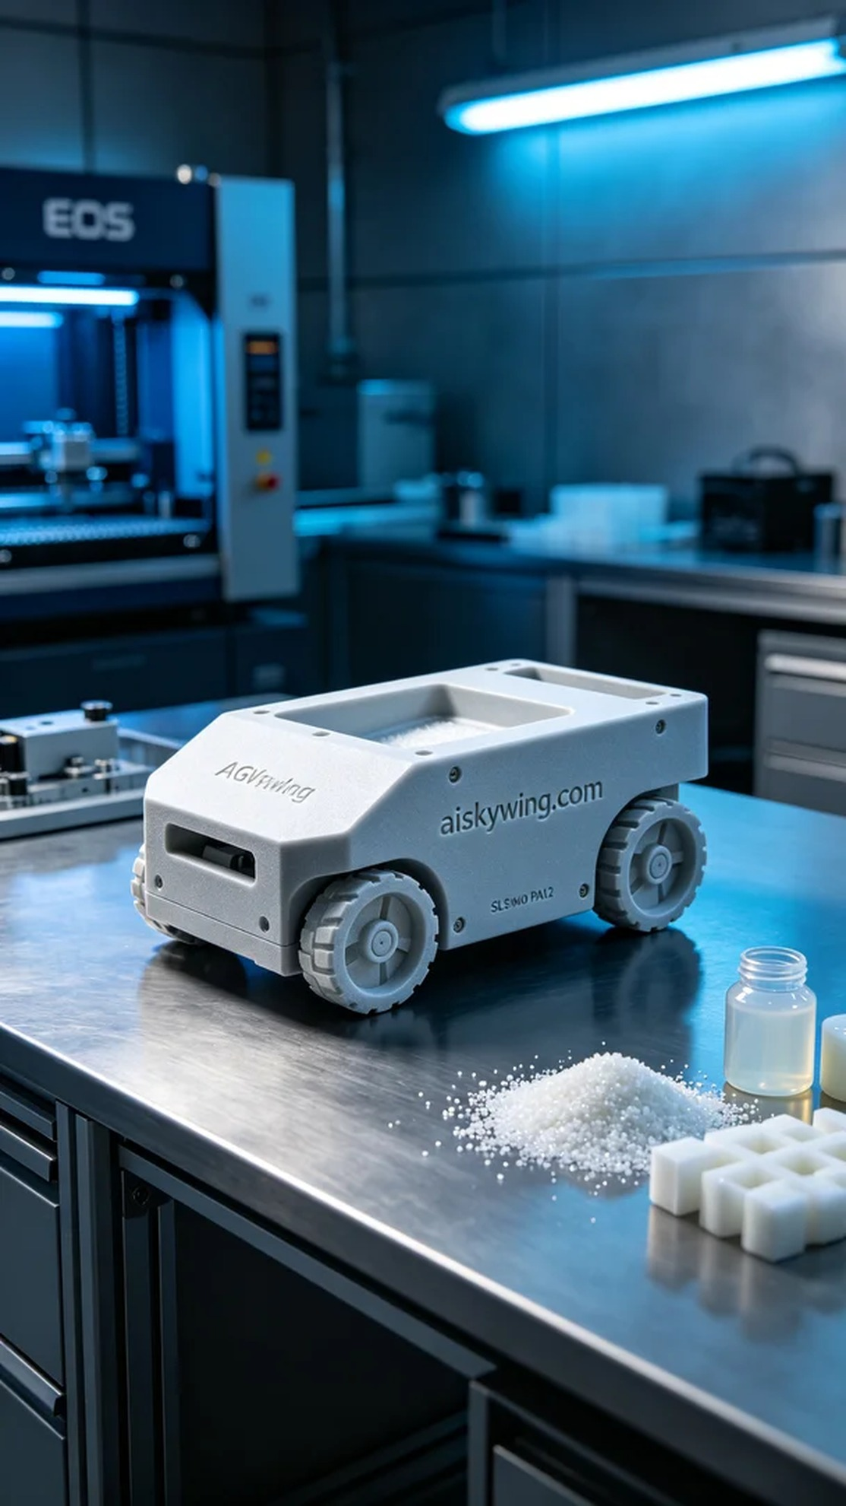
有人通过WhatsApp找到了我们，询问能否帮助他们制作AGV小车驱动器外壳。由于需要在短时间内完成，并且对外壳的耐用性和质量有高要求，这让我们感到责任重大。
这次生产我们选择了SLS尼龙PA12作为材料，这种材料强度高且耐磨，非常适合工业应用。我们使用的EOS打印机参数设定比较精细，层厚0.1毫米，打印温度设定在180℃，功率调整为80%，打印速度为每小时20毫米。这样能够确保每一层的打印都能达到最佳效果。
在打印过程中，EOS打印机运转顺利。我们全程监控设备状态，确保材料供给正常，打印头温度稳定。在整个打印时间中，持续观察质量，确保没有产生气泡或其他缺陷。随着时间的推移，逐渐看到外壳成型，心中备感欣喜。
打印完成后，我们进入了后处理环节。首先将打印件进行清洗，去除表面多余的粉末，然后使用细砂纸对外壳进行打磨，确保表面光滑。接下来，将其放入固化设备中，按照设定时间进行固化，最后进行质量检验，确保所有规格符合要求。
最终，AGV小车驱动器外壳如愿以偿地完成，经过严谨的工序，质量可靠。每一个细节都展现出我们的专业和用心，让人倍感欣慰。
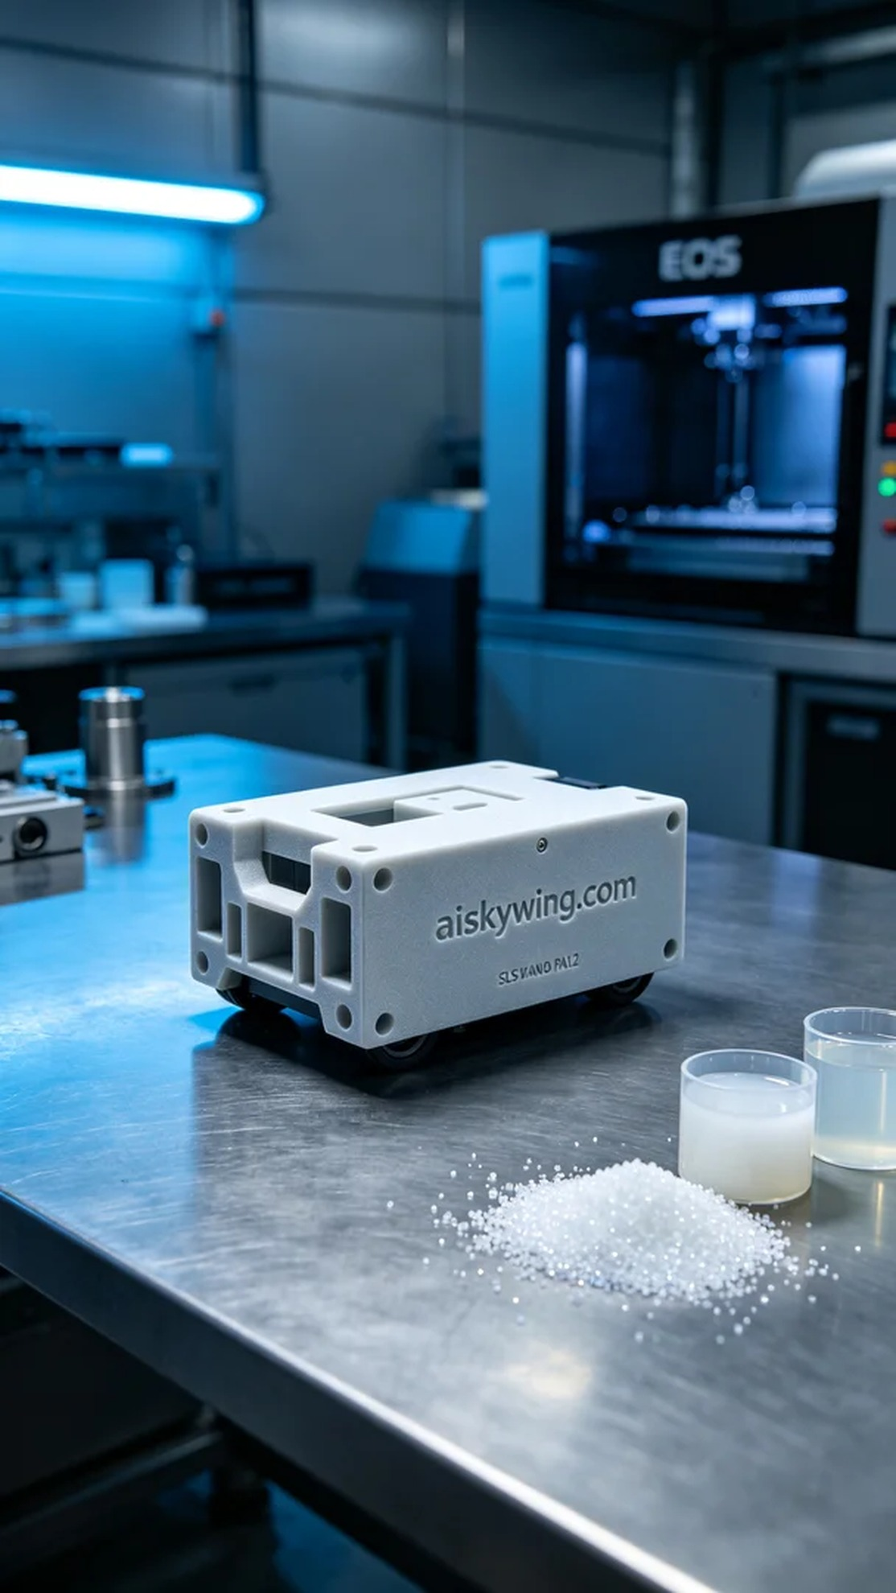
Aiskywing Industrial 3D Printing
AGV cart driver housing


