0990-AGV底座3D打印生产记录
AGV base
🖨️ SLS尼龙烧结
🖥️ 打印机: Stratasys
📦 材料: SLS尼龙PA12
生活就像3D打印，有时需要耐心和细致，就如我们这次制作的AGV底座，源于Facebook上的一个请求。
Life is like 3D printing; it sometimes requires patience and attention to detail, just like the AGV base we created this time, which originated from a request on Facebook.
________________________________________________________________________________
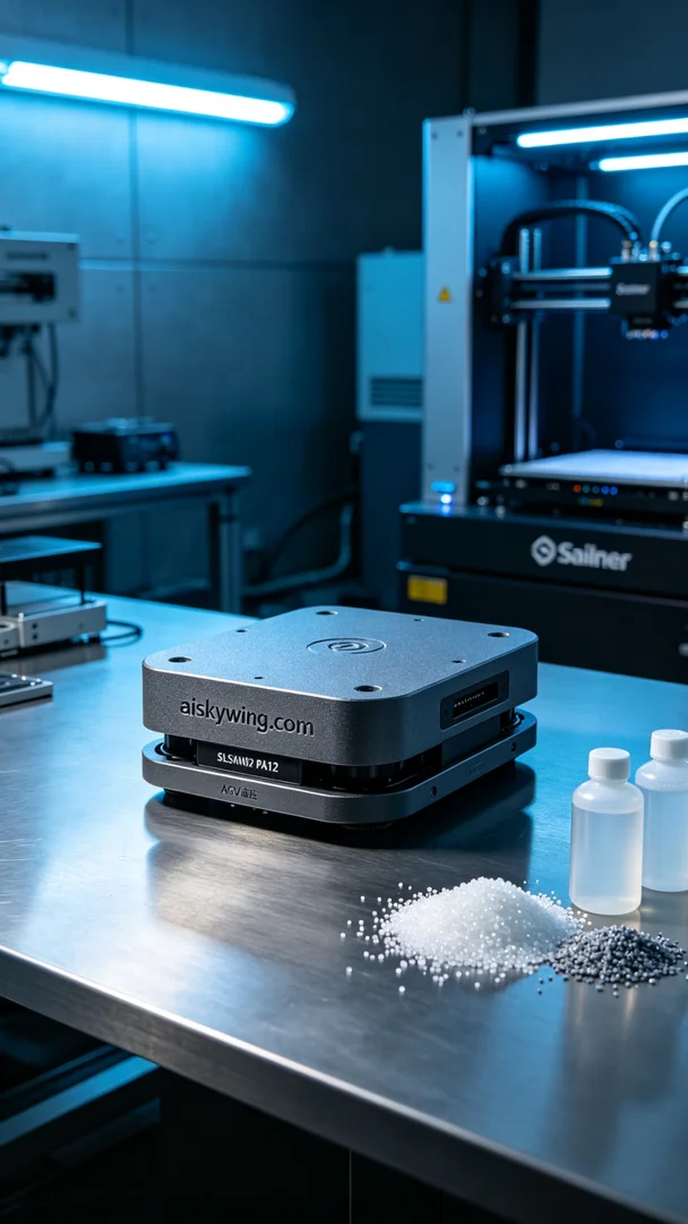
Recently, someone reached out to us via Facebook looking for a high-strength AGV base. They wanted to utilize SLS Nylon PA12 material for this project, and we were excited to take on the challenge using our Stratasys printer to ensure the best possible outcome.
For the preparation phase, we chose SLS Nylon PA12 as the raw material. This material offers high strength, excellent wear resistance, and chemical stability, making it ideal for industrial applications. When setting the print parameters, we configured a layer thickness of 0.1 mm, a printing temperature of 180°C, power set to 70%, speed adjusted to 25 mm/s, and estimated a total print time of 8 hours to ensure that every detail would be perfectly captured.
During the printing process, the Stratasys printer operated smoothly. We closely monitored the equipment to maintain stable temperature and pressure levels. At various stages of printing, we conducted regular quality checks to ensure that the adhesion and smoothness of each layer met our standards. Ultimately, the overall structure of the AGV base presented the expected results, with a clearly defined matte surface.
After printing, we moved on to the post-processing phase. First, we removed the printed part and performed cleaning to eliminate excess powder. Next, we used fine sandpaper to polish the surface, enhancing its feel and appearance. Finally, we conducted a curing process to ensure the material strength was at its best and carried out a thorough inspection of the final product to verify that there were no defects.
After a series of processes, the AGV base was successfully completed. Seeing it sit quietly on the industrial table, exuding a cool technological aesthetic, filled us with pride.
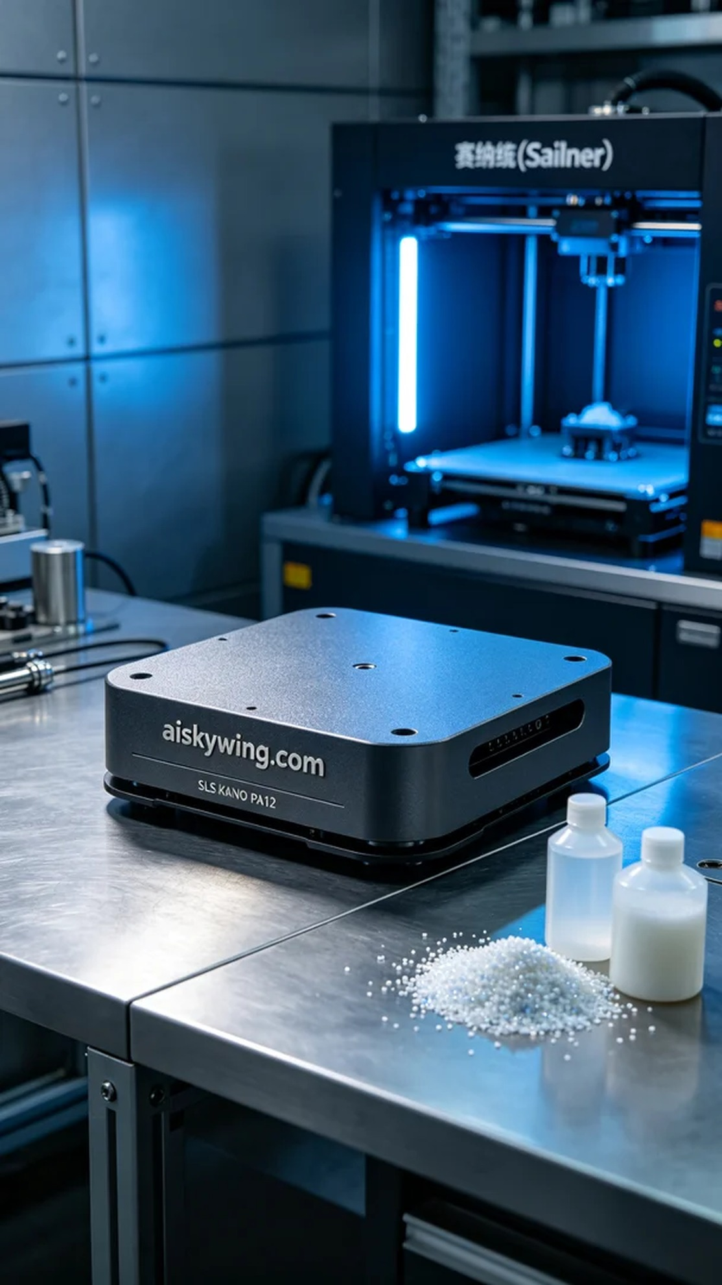
最近，有人因为需要一款高强度的AGV底座而找到我们，他们希望能用SLS尼龙PA12材料来实现这个需求。面对这个挑战，我们决定充分发挥Stratasys打印机的优势，确保生产出理想的产品。
在准备阶段，我们选择了SLS尼龙PA12作为原材料。这种材料不仅强度高，还具有优良的耐磨性和化学稳定性，非常适合工业用途。在设置打印参数时，我们设置了层厚0.1毫米，打印温度为180°C，功率设定为70%，速度调整为25毫米/秒，并预估打印时间为8小时，以确保每个细节都可以完美呈现。
打印过程中，Stratasys打印机运行得相当顺利。我们密切监视设备的状态，确保温度和压力保持在稳定范围内。在打印的各个阶段，我们定期检查打印质量，确保每一层的附着力和光滑度都达到标准。最终，AGV底座的整体结构呈现出了预期的效果，表面磨砂感清晰可辨。
完成打印后，我们进入了后处理阶段。首先将打印件取出并进行清洗，以去除多余的粉末。接着使用细砂纸对表面进行打磨，以提升其触感和外观。最后，进行固化处理，确保材料的强度达到最佳状态，并对最终产品进行全面检验，确保没有瑕疵。
经过一系列的流程，这个AGV底座成功完成了生产。看着它静静躺在工业桌面上，散发出冷峻的科技美感，令人倍感自豪。
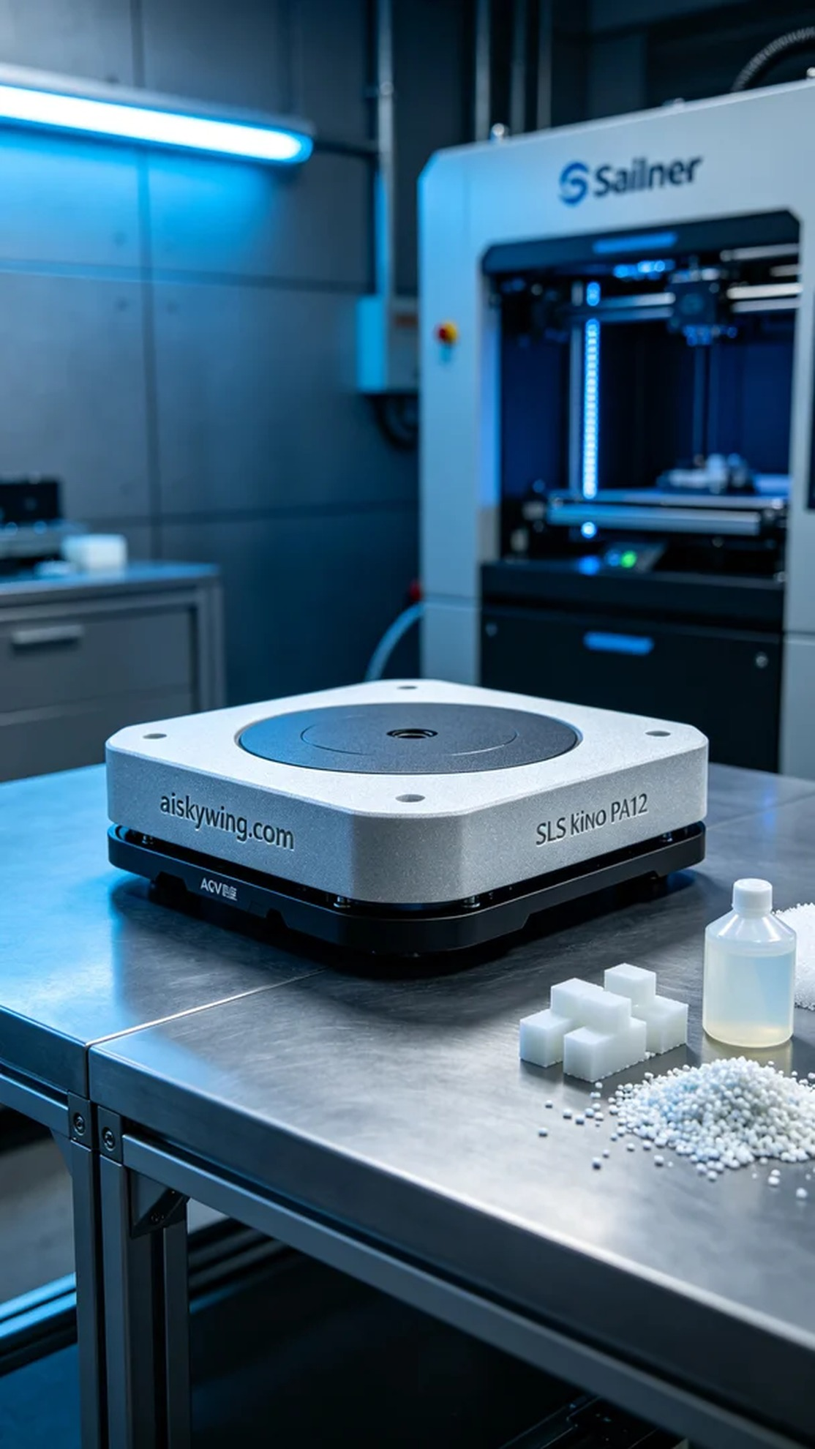
Aiskywing Industrial 3D Printing
AGV base


