0991-AGV手柄的3D打印生产日志
AGV Handle
🖨️ SLS尼龙烧结
🖥️ 打印机: Voxeljet
📦 材料: SLS阻燃尼龙
有时候咬牙坚持，不是为了证明什么。就像接下这个AGV手柄的单子，照样要让它在每个细节中绽放光芒。
Sometimes, gritting your teeth and persevering is not about proving anything. Just like taking on this AGV handle order, it is still necessary to make it shine in every detail.
________________________________________________________________________________
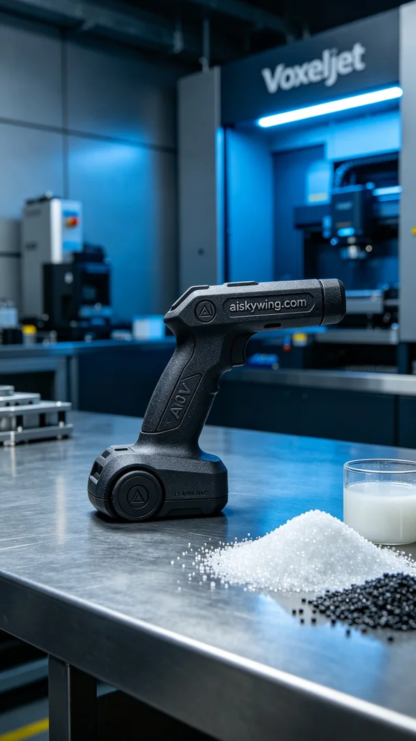
Recently, someone reached out to us via Instagram, expressing their need for a high-performance AGV handle that is flame-retardant and can withstand long-term use in industrial environments. Upon understanding their requirements, we decided to utilize SLS technology for printing to meet their standards.
To achieve this goal, we selected SLS flame-retardant nylon, which has excellent mechanical strength and thermal resistance, conforming to V0 flame-retardant standards. We then prepared the Voxeljet printer, setting the printing parameters: a layer thickness of 0.1mm, printing temperature around 180℃, power adjusted to 70%, and a printing speed of 15 mm per hour to ensure a detailed print.
The printing process unfolded like a well-rehearsed dance, as the equipment began running, the material melted layer by layer to form the desired AGV handle. Throughout this process, we constantly monitored the quality to ensure that each layer perfectly adhered without bubbles or delamination, guaranteeing the final product's quality.
After printing, we entered the post-processing stage. Initially, the handle underwent a cleaning process to remove any uncured powder from the surface. Next, we proceeded with sanding to eliminate surface irregularities and enhance smoothness. After that, the handle was cured to ensure its physical properties remained stable, followed by a rigorous inspection to ensure it met the standards before delivery.
The production process of this AGV handle was smoothly completed, presenting once again a product with strong industrial aesthetics and durability, truly the best reward for our team's effort.
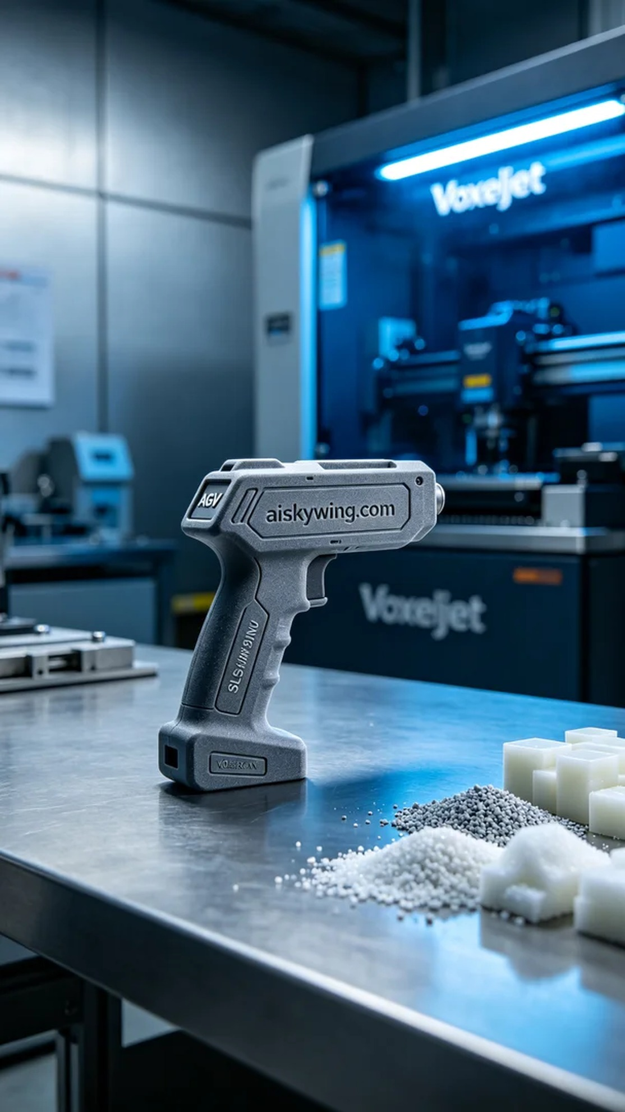
最近，有人通过Instagram与我们联系，说他们需要一款高性能的AGV手柄，要求阻燃且能在工业环境中长时间使用。我们在了解到他们的需求后，立刻决定采用SLS技术进行打印，确保能满足他们的使用标准。
为了实现这个目标，我们选用了SLS阻燃尼龙材料，其具有优良的机械强度和耐温性，且符合V0级阻燃标准。接下来，我们准备了Voxeljet打印机，设定打印参数：层厚0.1mm，打印温度在180℃左右，功率调至70%，并将打印速度设置为每小时15毫米，以确保打印效果的精细。
打印过程如同一场默契的舞蹈，设备开始运行后，材料逐层融化并固化，形成所需的AGV手柄。在此过程中，我们不断进行质量监控，确保每一层都能完美叠加，避免出现气泡或脱落的现象，确保最终成品的质量达到标准。
打印完成后，我们进入了后处理阶段。首先，手柄需要通过清洗工序去除表面的未固化粉末。接着，进行打磨，以消除表面不平整，并提高光滑度。之后，手柄将被固化，以确保其物理性能稳定，最后经过严格的检验，确保达标后才能交付。
此次AGV手柄生产过程顺利完成，一个极具工业感且耐用的产品再一次展现在我们眼前，实在是对我们团队努力的最好回报。
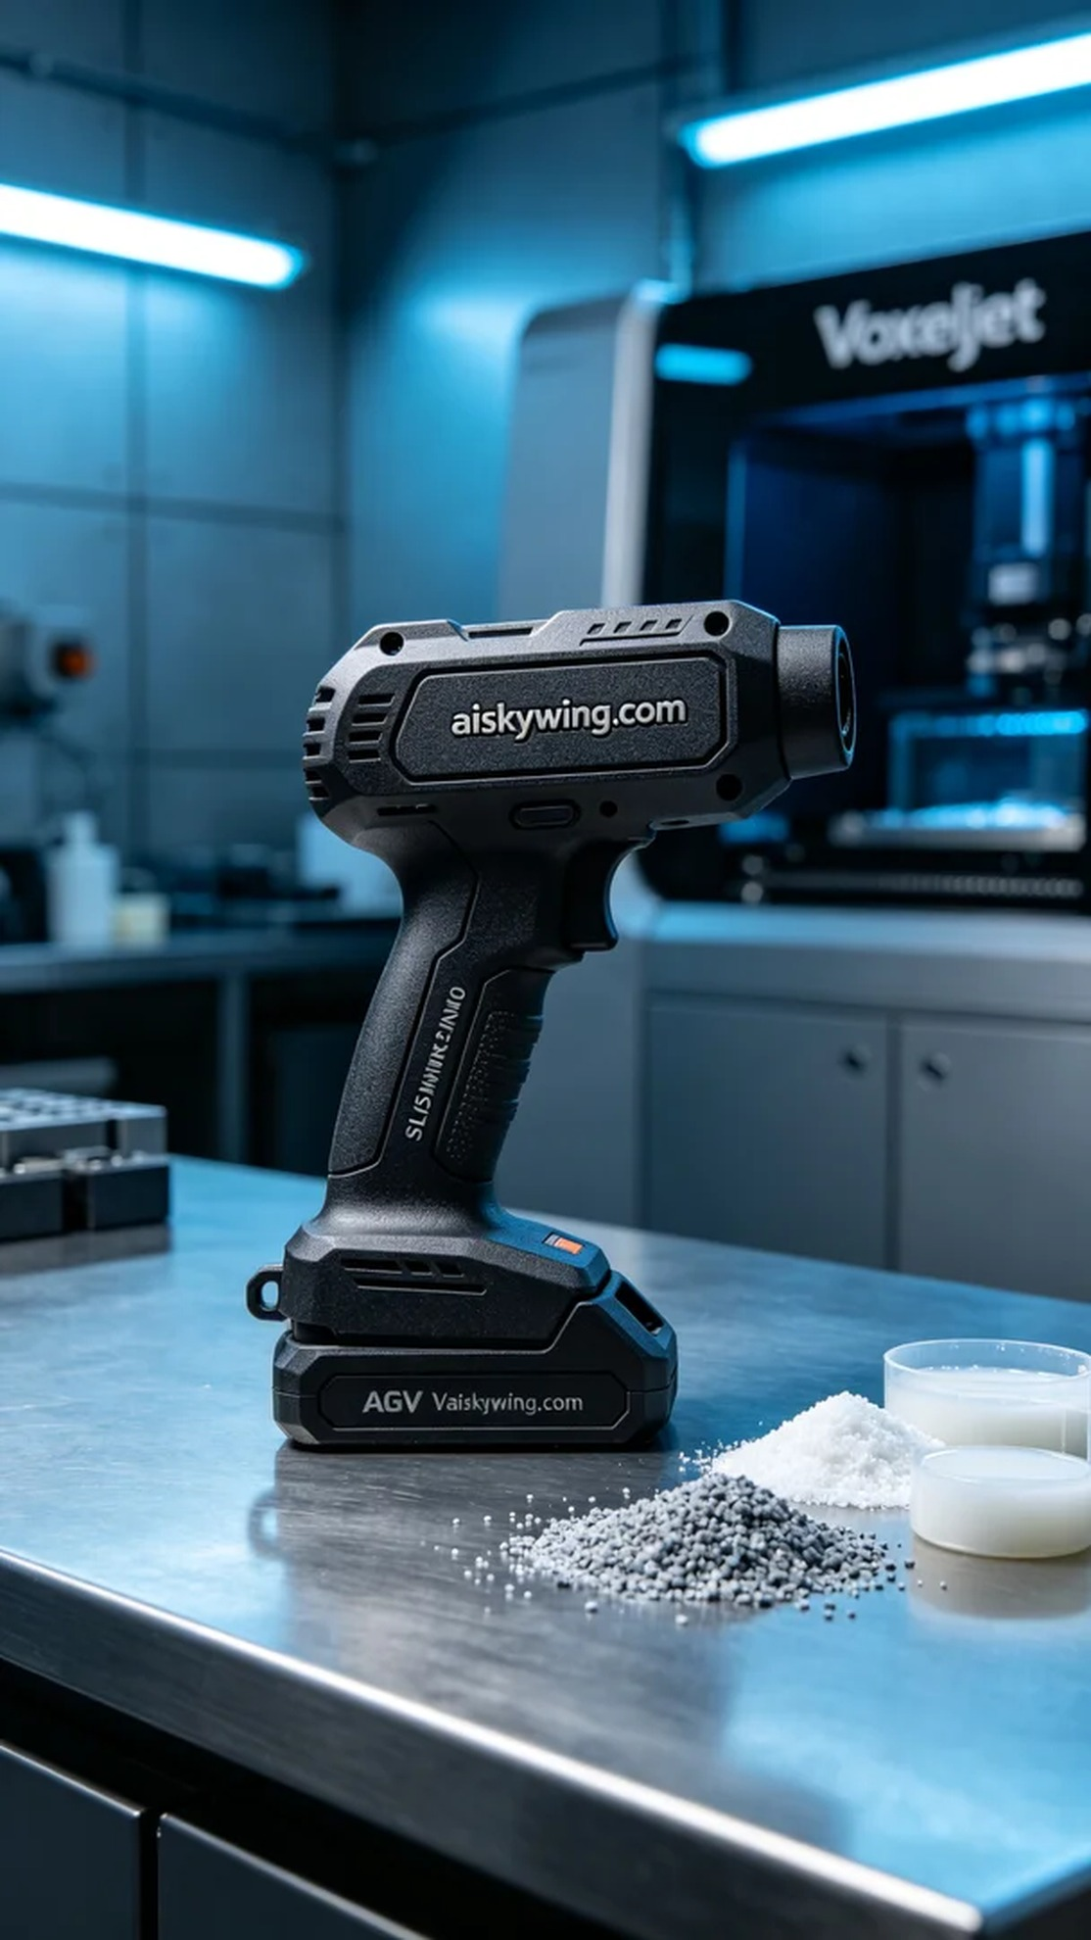
Aiskywing Industrial 3D Printing
AGV Handle


