0992-3D打印医用外壳生产记录
Medical casing
🖨️ SLA光固化
🖥️ 打印机: HP
📦 材料: SLA光固化树脂
生活再难，也别停下脚步。就像接下这个医用外壳的单子，有人需要我们解决医疗设备外壳的难题，真是责任重大。
No matter how difficult life gets, don't stop moving forward. Just like taking on this order for medical enclosures, someone needs us to solve the challenges of medical device casings, which is indeed a significant responsibility.
________________________________________________________________________________
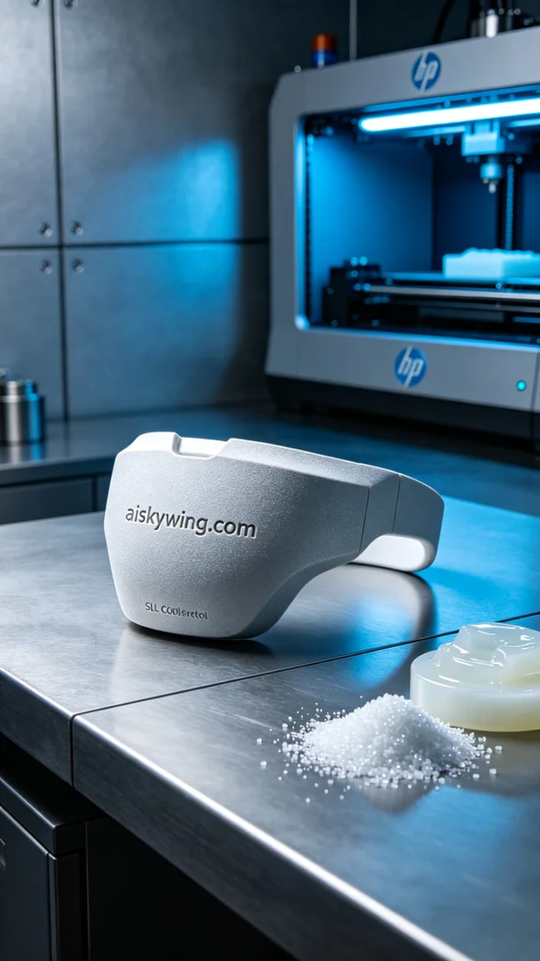
This project originated from a video on YouTube, where someone discussed the design and production of medical device housings, emphasizing the strict requirements for precision and materials. Thus, we received the task of creating a medical housing, aiming to perfectly combine functionality and aesthetics.
Our production material is SLA photopolymer resin, which features excellent detail representation and good mechanical properties. Using the HP printer, we set the layer thickness to 0.1 mm, maintained a temperature of 25°C, operated at 50% power, and a print speed of 40 mm per second. These parameters effectively balance printing time and precision.
During the printing process, the HP printer operated smoothly, ensuring even resin flow for perfect layer overlap. We closely monitored the device's operational status throughout, confirming that every detail met the expected criteria. The printing process lasted about eight hours, and the accuracy and finesse of the final product were satisfying.
After printing, we entered the post-processing stage. First, we cleaned the housing to remove uncured resin, then used fine sandpaper to polish the surface for a delicate touch. Next, we placed the housing in a UV curing device for 60 minutes. Once cured, we re-examined the housing quality to ensure it met medical standards without any defects.
In the end, the production of this medical housing not only met technical requirements but also enhanced our team's cooperation and confidence throughout the process. We were all delighted to see the finished product.
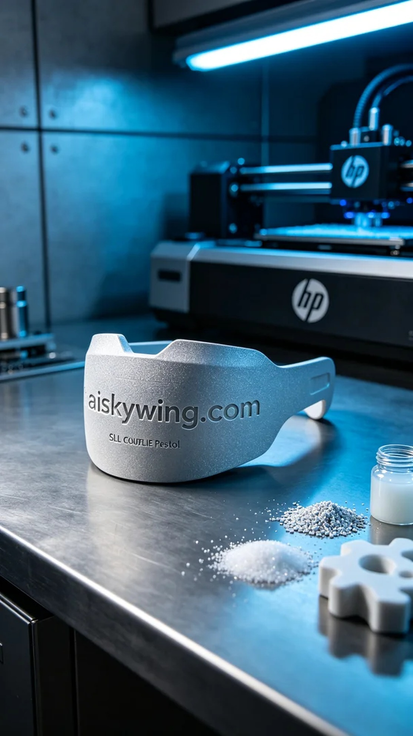
这次的项目源于YouTube上的一个视频，有人在讨论医疗器械外壳的设计与生产，提到对精度和材料的严格要求。因此，我们接到了制作医用外壳的任务，目标是确保其在功能和美观上的完美结合。
我们的生产材料是SLA光固化树脂，具备出色的细节呈现能力和良好的机械性能。为了确保打印质量，我们使用的HP打印机，设置了层厚为0.1毫米，温度控制在25°C，功率为50%和打印速度为40毫米每秒，这样的参数能够有效平衡打印时间与精度。
在打印过程中，HP打印机运行平稳，树脂均匀流动，确保了每一层的完美叠加。我们全程监控设备的工作状态，确认每个细节都能达到预期效果。打印过程持续了约八小时，最终成品的精度与细腻度都让人满意。
完成打印后，我们进入了后处理阶段。首先进行清洗，将未固化的树脂清除，然后用细砂纸对表面进行打磨，确保触感细腻。接着将外壳放入UV固化设备中进行固化，具体时间为60分钟。固化完成后，我们再次检验外壳的质量，确保没有瑕疵，所有参数符合医疗标准。
最后，这个医用外壳的制作不仅满足了技术要求，也让我们在过程中增强了团队合作的默契与信心。看到成品，我们都很欣慰。
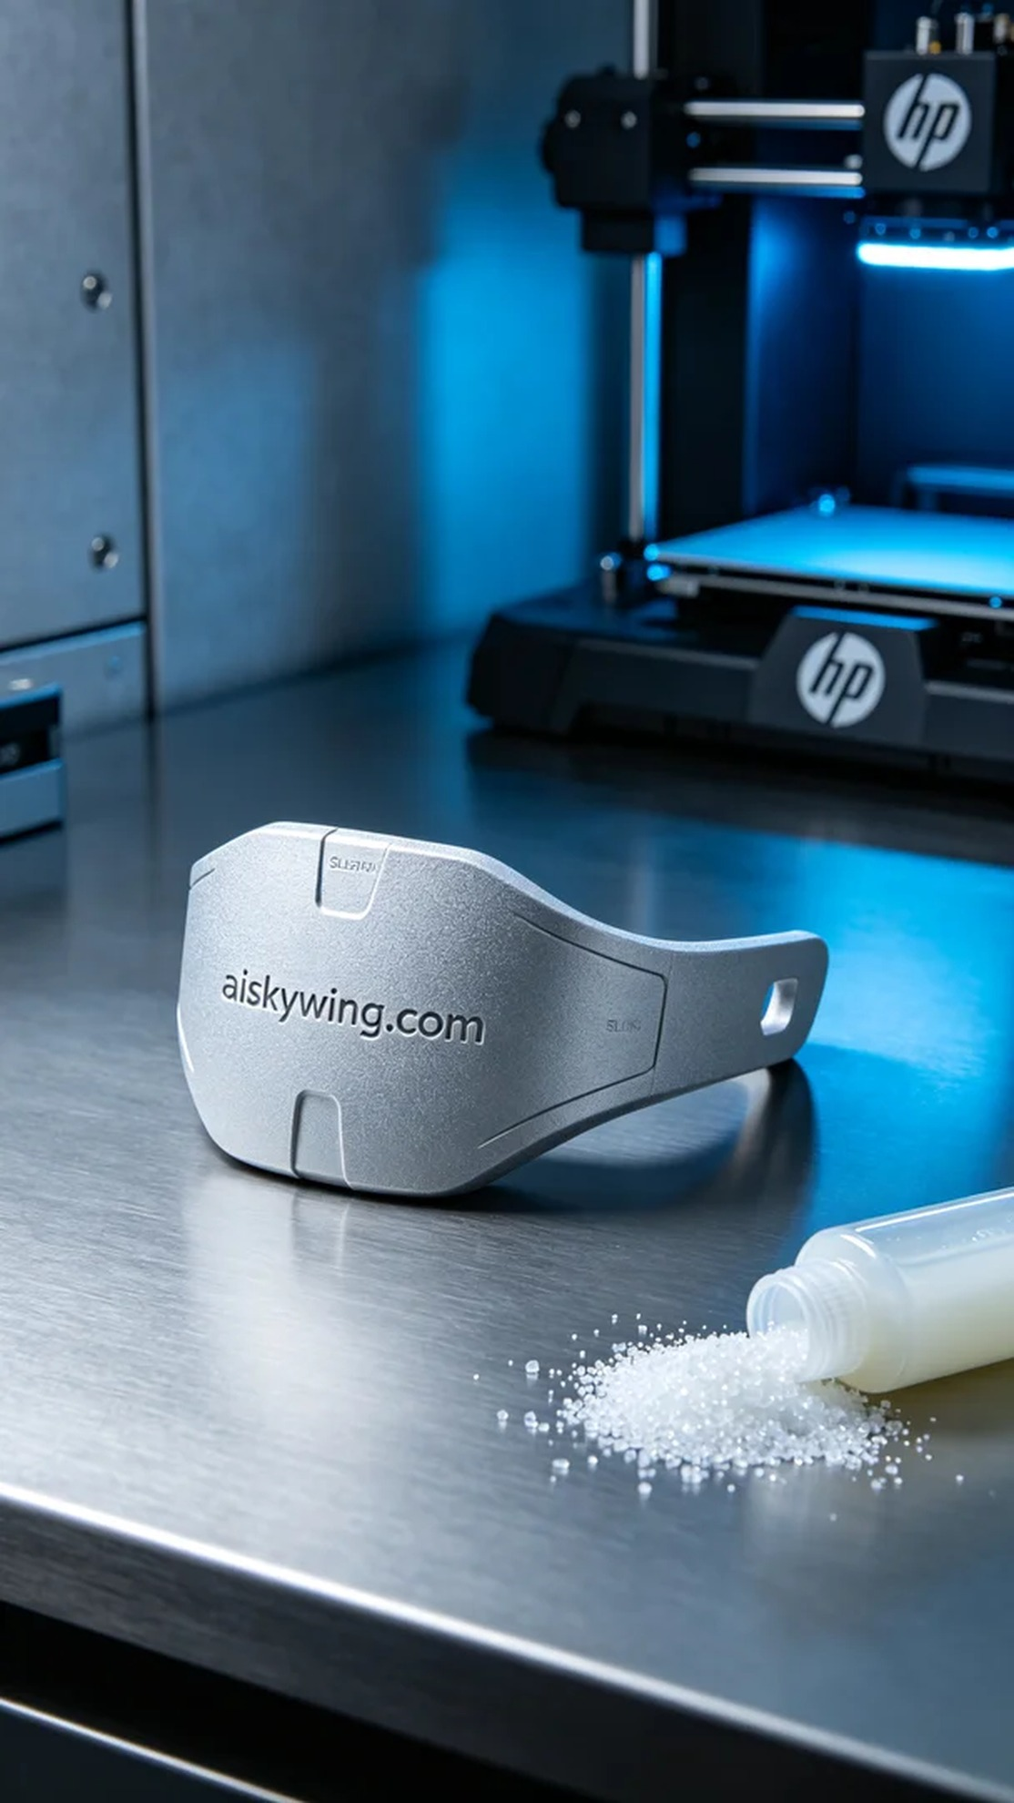
Aiskywing Industrial 3D Printing
Medical casing


