0993-医用孵育盒3D打印生产记录
Medical Incubator Box
🖨️ SLA光固化
🖥️ 打印机: Stratasys
📦 材料: SLA光固化树脂
人生就像3D打印一样，每一步都需要精准和坚持。最近，有人通过LinkedIn联系到我们，询问医用孵育盒的制作。
Life is like 3D printing; every step requires precision and perseverance. Recently, someone reached out to us through LinkedIn to inquire about the production of medical incubators.
________________________________________________________________________________
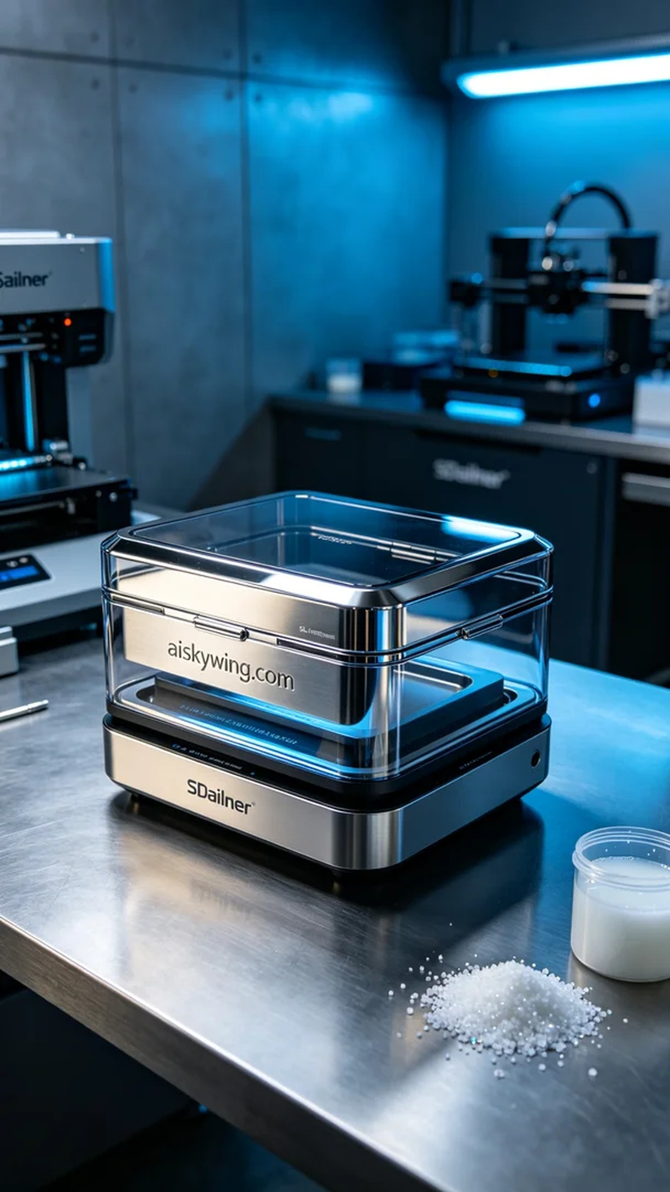
Life is much like 3D printing, requiring precision and perseverance at every step. Recently, someone contacted us through LinkedIn to inquire about the production of a medical incubation box.
This project was commissioned by a hospital, which needed a medical incubation box primarily for cell culture, with requirements for safety, durability, and excellent surface finish. After thorough communication, we understood their needs well.
We chose SLA photopolymer resin as the printing material, known for its excellent biocompatibility and mechanical properties. We used a Stratasys 3D printer for this project, with settings including a layer thickness of 50 microns, a printing temperature of 25°C, a laser power of 300mW, a printing speed of 40mm/s, and an estimated printing time of 8 hours.
The printing process went smoothly with stable equipment operation. During the print, we conducted regular quality monitoring to ensure the curing effect and detail presentation of each layer. Advanced sensor technology was employed to monitor temperature and light for uniform curing of materials, achieving the expected surface gloss level for the final product.
Post-processing was equally important. After printing, we first cleaned the printed parts in an isopropyl alcohol cleaning bath to remove uncured resin. Then, we performed sanding to smooth out small burrs and ensure every detail was polished. Following this, the incubation boxes were placed in a UV curing chamber for final solidification, ensuring structural integrity. Each product then underwent stringent inspection to meet medical standards.
After a series of rigorous processes, we successfully delivered the medical incubation boxes, and the team’s efforts paid off as the product quality exceeded expectations.
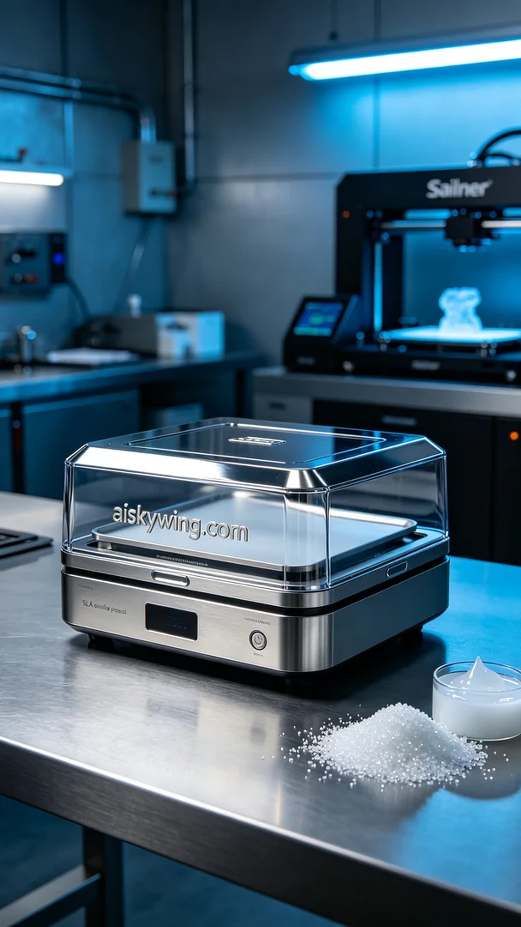
这次的项目是为了一家医院定制的医用孵育盒，具体问题是需要在有限的时间内生产出高质量的产品。通过LinkedIn，我们与客户进行了充分沟通，了解到他们需要的孵育盒主要用于细胞培养，要求材质安全、耐用且具有良好的表面光洁度。
我们选择了SLA光固化树脂作为打印材料，这种材料在生物相容性和力学性能上都有着卓越表现。设备方面，使用了Stratasys的3D打印机，设置方面：层厚为50微米，打印温度设定为25°C，激光功率为300mW，打印速度为40mm/s，预计打印时间为8小时。
打印过程相对顺利，设备稳定运行。在打印过程中，我们定期进行质量监控，确保每层的固化效果和细节呈现。过程中使用了先进的传感器技术，监测温度和光线，以确保材料的均匀固化，最终的成品表面光泽度达到了预期的标准。
后处理工序同样重要。打印完成后，首先在清洗槽中使用异丙醇对打印件进行清洗，去除未固化的树脂。之后，我们进行打磨处理，以去除表面的小毛刺，确保每个细节光滑。接下来，将孵育盒放入紫外线固化箱中进行固化，确保其结构的稳固性。最后，对每个产品进行严格检验，确保符合医疗标准。
经过一系列的严格流程，我们成功地交付了医用孵育盒，大家的努力得到了回报，产品质量令人满意。
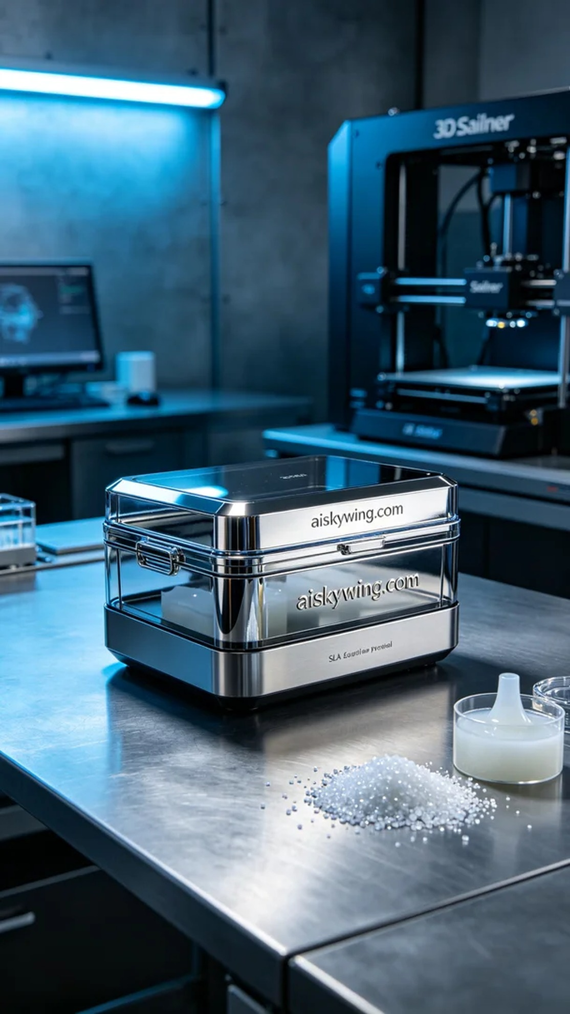
Aiskywing Industrial 3D Printing
Medical Incubator Box


