0994-医用导管架生产记录
Medical catheter rack
🖨️ SLA光固化
🖥️ 打印机: Mimaki
📦 材料: SLA光固化树脂
生活就像3D打印，总是需要时间和耐心。今天，我们接到了一单医用导管架的需求，这可是生命中的重要一环。
Life is like 3D printing; it always requires time and patience. Today, we received an order for a medical catheter holder, which is an important part of life.
________________________________________________________________________________
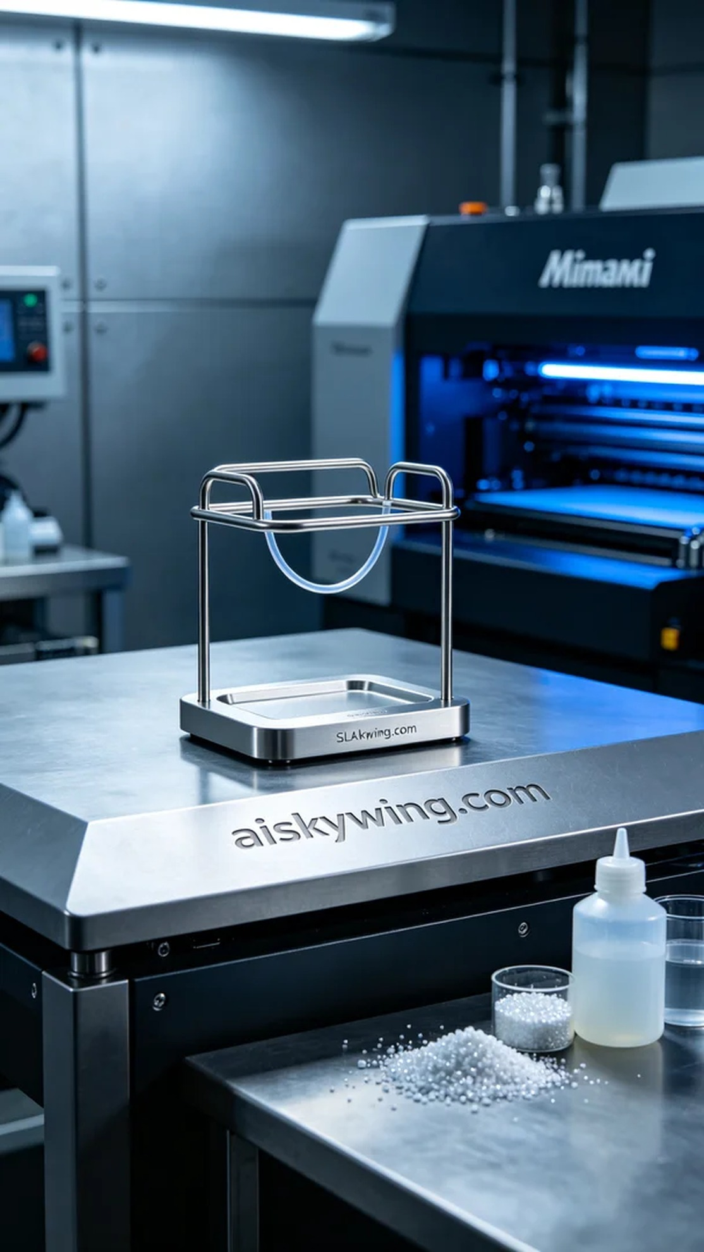
Life is like 3D printing, requiring time and patience. Today, we've received a request for a medical catheter holder, which is a vital component in healthcare.
On the social media platform TikTok, someone was looking for a highly precise medical catheter holder, emphasizing the need for safety and stability in medical use. Such technical requirements present a challenge not just to the product but also to our capabilities.
Today, I prepared to print using SLA photopolymer resin. This material features high strength, low shrinkage, and excellent surface smoothness. We will use a Mimaki 3D printer, setting the layer thickness at 0.05 mm, temperature at 25°C, power at 50%, and printing speed at 30 mm per second, expecting a print time of around 8 hours.
Throughout the printing process, I carefully monitored the device's operation to ensure every detail was under control. The precision of the Mimaki printer allowed the catheter holder to be perfectly presented at every part. As the print progressed, the liquid resin gradually solidified, forming a robust structure. Every now and then, I paused to check the progress of the model to ensure no issues arose.
After completing the print, we moved into the post-processing phase. First, the printed catheter holder was placed in a cleaning tank to wash away excess resin using isopropyl alcohol. Next, we meticulously sanded the surface to enhance smoothness and feel. Finally, we placed it in a UV curing machine to ensure it had optimal strength and stability. After inspection, the quality of the catheter holder fully met the standards.
Every production is a new challenge, and the successful print of the medical catheter holder proves our effort and technology. We hope our product will play a significant role in the healthcare industry.
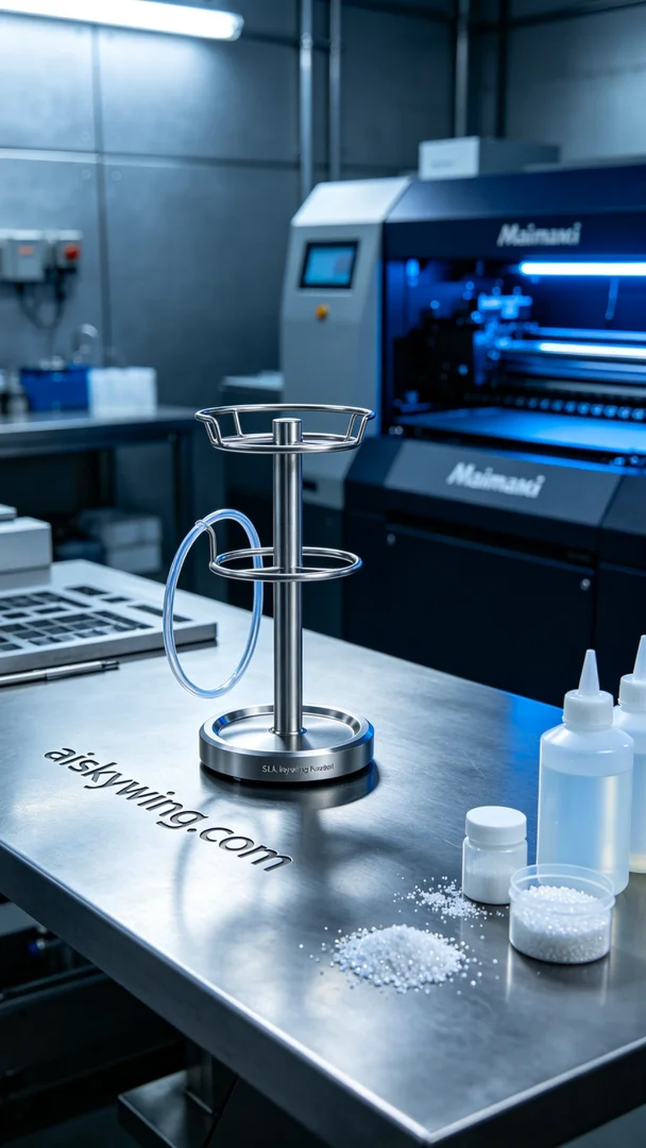
在社交平台TikTok上，有人在寻找一款高精度的医用导管架，强调其在医疗中对安全与稳定性的需求。这样的技术要求不仅是对产品的挑战，也是对我们能力的考验。
今天我准备使用SLA光固化树脂进行打印。这种材料具有高强度、低收缩性和优良的表面光滑度。我们将使用Mimaki的3D打印机，设置层厚为0.05毫米，温度调至25°C，功率保持在50%和打印速度选定为30毫米每秒，预计打印时间在8小时左右。
打印过程中，我仔细观察设备的运行状态，确保每一个细节都在控制之中。Mimaki打印机的精度使得导管架的各个部位都能得到完美呈现。随着打印的推进，液态树脂逐渐固化，形成了坚固的结构。每隔一段时间，我都会暂停检查模型的进展，确保没有任何问题出现。
完成打印后，我们进入了后处理环节。首先将打印好的导管架放入清洗槽，使用异丙醇清洗掉多余的树脂。接着进行细致的打磨，以提升表面的光滑度和触感。最后，我们将其放置在UV固化机中固化，确保其拥有最佳的强度与稳定性。经过检验，导管架的质量完全达标。
每一次生产都是一次新的挑战，而医用导管架的成功打印则证明了我们的努力和技术。希望我们的产品能在医疗行业中发挥重要作用。
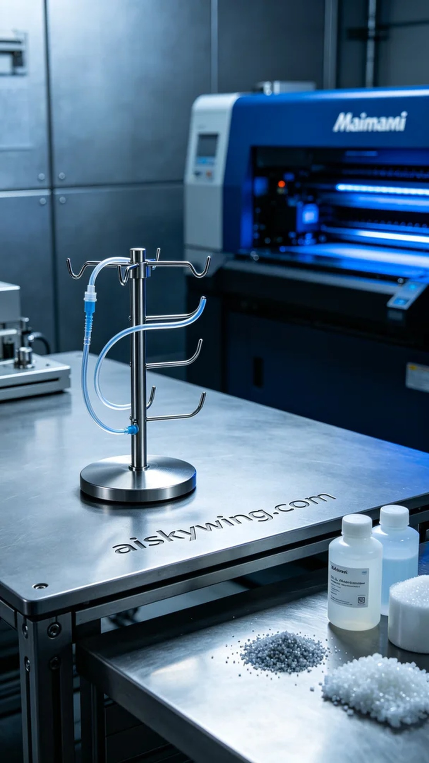
Aiskywing Industrial 3D Printing
Medical catheter rack


