0995-医用帽檐支架3D打印生产记录
Medical cap brim support
🖨️ SLA光固化
🖥️ 打印机: Mimaki
📦 材料: SLA光固化树脂
在YouTube上，有人因为想要防护更全面而找到了我们，就像接下这个医用帽檐支架的单子一样，我们始终在前行。
On YouTube, someone found us because they wanted more comprehensive protection, just like how we took on the order for the medical cap brim support. We are always moving forward.
________________________________________________________________________________
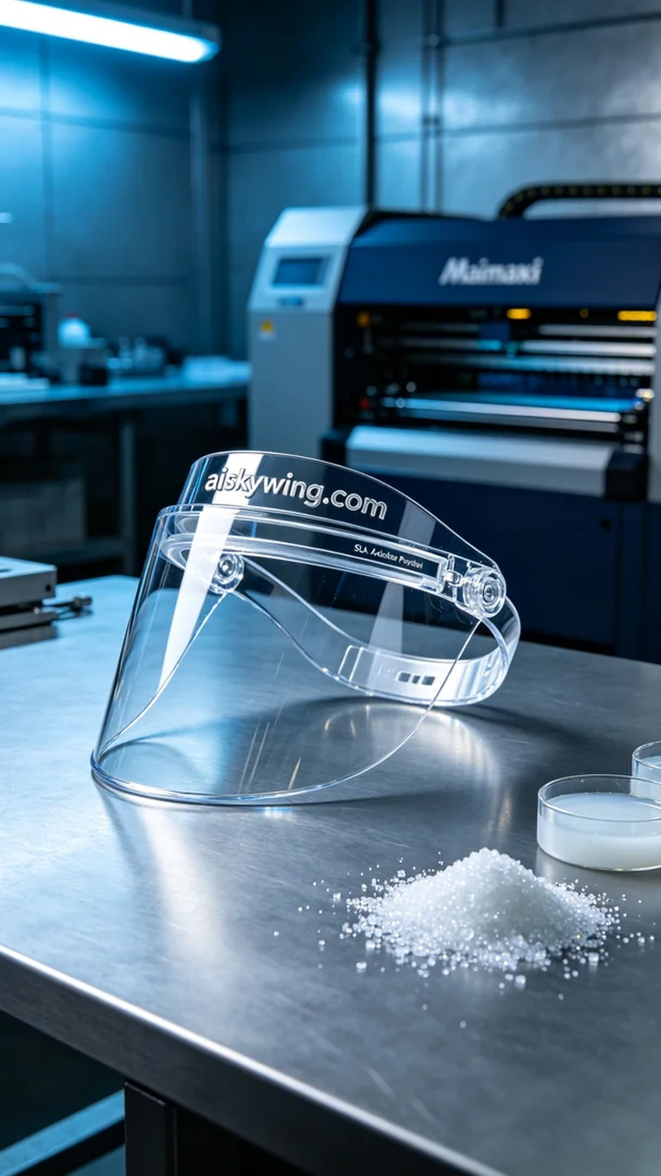
Today, we received an order for a medical cap visor bracket. Someone wanted to produce this bracket through 3D printing to enhance protection in medical environments. We quickly got to work, ensuring timely delivery.
We used SLA photopolymer resin for this project. This material has excellent transparency and high gloss, making it perfect for detailed products. During our preparations, we employed the Mimaki 3D printer, setting the layer thickness to 0.05mm, the print temperature to 25°C, the laser power to 50mW, and the printing speed to 30mm/s, with an estimated print time of about 5 hours.
During the printing process, the Mimaki equipment performed reliably, with the photopolymer resin solidifying layer by layer under the laser. We continuously monitored the printing status to ensure there were no bubbles or quality issues. Each layer formed clearly, showcasing the product's intricate details very well.
After the printing was completed, post-processing was a crucial step. We first submerged the bracket in isopropyl alcohol for cleaning to remove any uncured resin from the surface. Then, we used an ultrasonic cleaner for further cleaning to ensure the product was smooth without blemishes. After that, we carefully sanded the edges, and finally placed the bracket in a UV curing machine to ensure the material achieved peak strength. After passing inspection, the product looked brand new and was ready for shipping.
Overall, this medical cap visor bracket printing process went smoothly, and the final result was satisfying. Each print is a new experience, and we will continue to strive for better products.
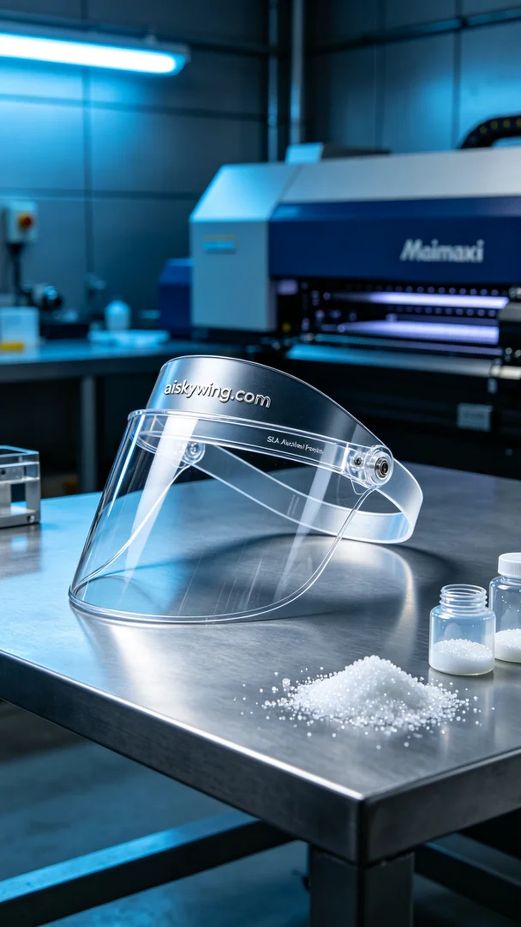
今天，我们接到了一个关于医用帽檐支架的订单。有人希望通过3D打印来生产这种支架，以提升在医疗环境中的防护效果。我们迅速着手准备，确保能够如期交付。
我们使用的是SLA光固化树脂，这种材料具备优良的透明度和高光泽度，特别适合需要清晰细致的产品。准备工作中，我们使用Mimaki 3D打印机进行打印，设置了层厚为0.05毫米，打印温度为25℃，激光功率设定为50毫瓦，打印速度为30毫米/秒，预计打印时间约为5个小时。
打印过程中，Mimaki的设备表现稳定，光固化树脂在激光照射下逐层硬化。我们随时监控打印状态，确保没有出现气泡或其他质量问题。每一层的成型都相当清晰，产品的细节表现非常出色。
打印完成后，后处理是至关重要的一步。我们首先将支架放入异丙醇中进行清洗，以去除表面的未固化树脂。接着，使用超声波清洗机进一步清理，确保产品光滑无瑕。然后我们进行了适度的打磨，细致处理边角，最后将支架放入UV固化机中进行固化，确保材料达到最佳强度。检验合格后，产品焕然一新，准备发货。
总的来说，这次的医用帽檐支架打印过程顺利，最终成果令人满意。每一次打印都是一次新体验，我们会继续努力，带来更好的产品。
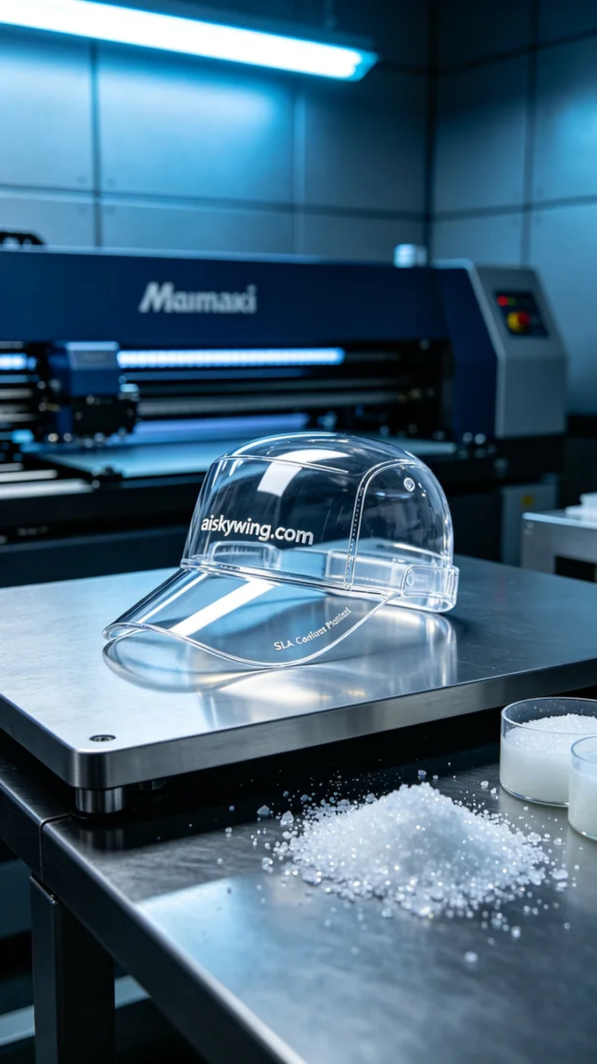
Aiskywing Industrial 3D Printing
Medical cap brim support


