0996-医用干燥架3D打印生产记录
Medical drying rack
🖨️ SLA光固化
🖥️ 打印机: Mimaki
📦 材料: SLA光固化树脂
在Facebook上，有人因为需要一款高效的医用干燥架而找到我们。这就是我今天要分享的故事。
On Facebook, someone reached out to us because they needed an efficient medical drying rack. This is the story I want to share today.
________________________________________________________________________________
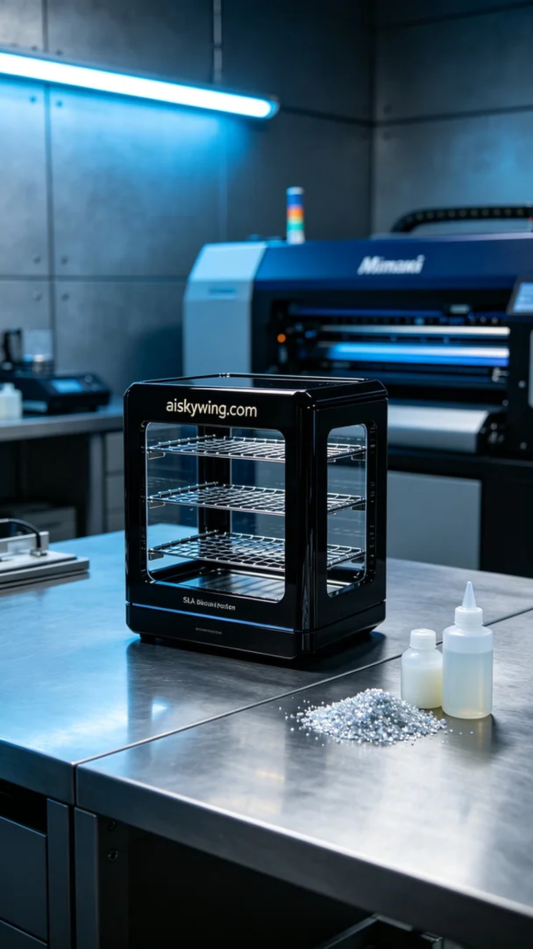
We received an order for a medical drying rack, as someone was facing issues with their existing equipment that resulted in uneven drying. They specifically reached out to us for a solution to this problem.
For the preparation, we selected SLA photopolymer resin as our printing material. This material has excellent fluidity and high strength, allowing for intricate surface finishes. We set the Mimaki printer to a layer thickness of 0.05mm, maintained a temperature of 25°C, set the power to 80%, and the printing speed to 30mm/s. The entire print process was expected to take 8 hours to ensure every detail was accurately represented.
During the printing process, the Mimaki printer operated very smoothly. We closely monitored the print quality to ensure even resin distribution and prevent bubbles or defects, while also periodically checking the printer's status to maintain normal operation. Watching the printed piece gradually take shape, our anticipation grew steadily.
After printing, we moved on to the post-processing stage. First, the printed piece was placed in a cleaning tank and washed with isopropanol to remove excess photopolymer resin. Then, we sanded the surface to ensure smoothness. After that, we placed the drying rack in the curing machine for UV curing to enhance its strength and durability. Finally, we conducted strict inspections to ensure it met quality standards.
After a series of processes, the medical drying rack was finally completed. Knowing that it could help someone solve their problem brings me great satisfaction.
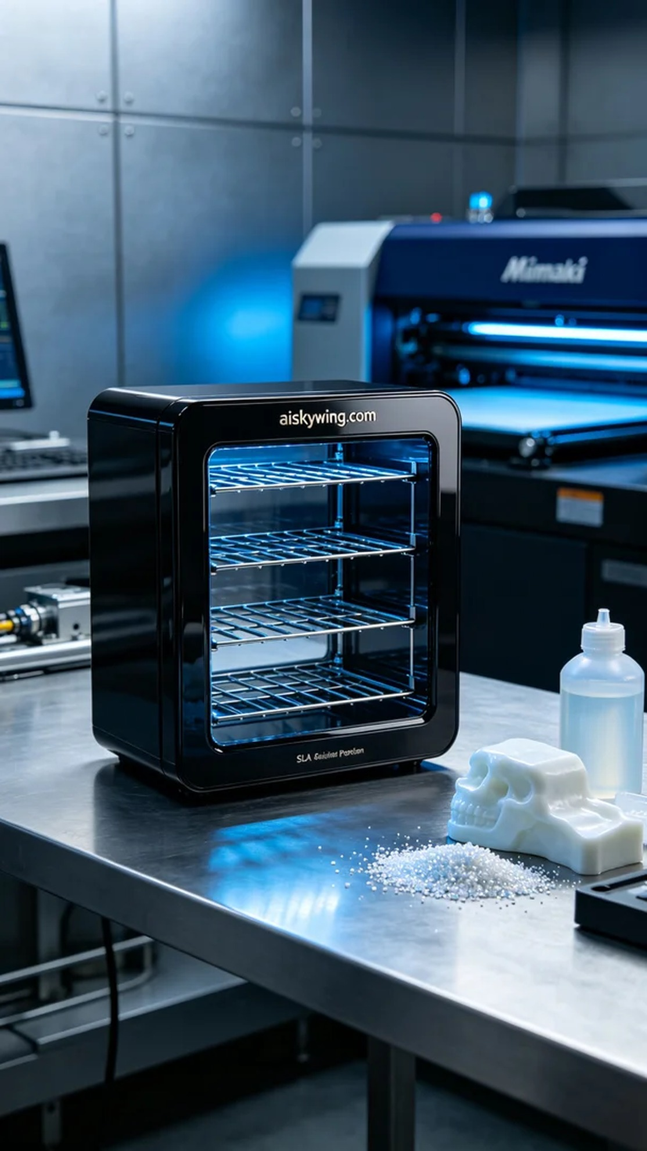
我们接到一个关于医用干燥架的订单，客户希望我们能提供一款高效、可靠的产品。经过沟通，了解到他们在现有设备上遇到了一些干燥不均的问题，因此特意找到我们来解决这个难题。
在准备工作方面，我们选择了SLA光固化树脂作为打印材料。此材料具有优良的流动性和高强度，同时能够实现细致的表面效果。使用的Mimaki打印机设置为0.05mm的层厚，温度保持在25°C，功率设置为80%，打印速度为30mm/s。整个打印过程预计需要8小时，确保每一个细节都得以精确展现。
打印过程中，Mimaki打印机的运行非常稳定。我们全程监控打印质量，保证树脂的均匀分布，避免气泡和缺陷的产生，也定期检查打印机的状态，确保设备的正常运转。看到打印件逐渐成型，心里的期待感不断增强。
完成打印后，我们进入后处理阶段。首先将打印件放入清洗槽中，使用异丙醇进行清洗，去除多余的光敏树脂。然后，我们对表面进行打磨，确保光滑度。接着，将干燥架放入固化设备中，进行UV固化，以增强其强度和耐用性。最后，我们对成品进行严格检验，确保符合质量标准。
经过一系列的工序，这款医用干燥架终于完成。能够帮助有人解决问题，让我感到十分欣慰。
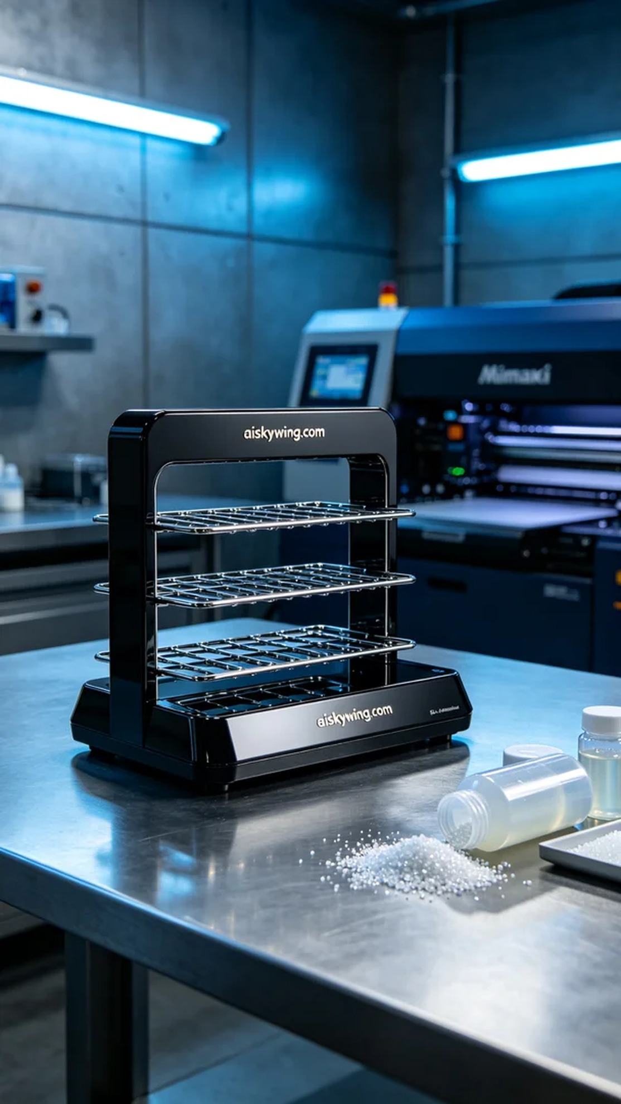
Aiskywing Industrial 3D Printing
Medical drying rack


