0997-医用底座3D打印生产记录
Medical base
🖨️ SLA光固化
🖥️ 打印机: Xjet
📦 材料: SLA光固化树脂
生活再难，也别停下脚步。就像接下这个医用底座的单子，有人对我们提了需求，希望能借助3D打印技术解决他们的医疗设备问题。
No matter how difficult life gets, don't stop moving forward. Just like when we took on the order for this medical base, someone reached out to us with a request, hoping to solve their medical equipment issues using 3D printing technology.
________________________________________________________________________________
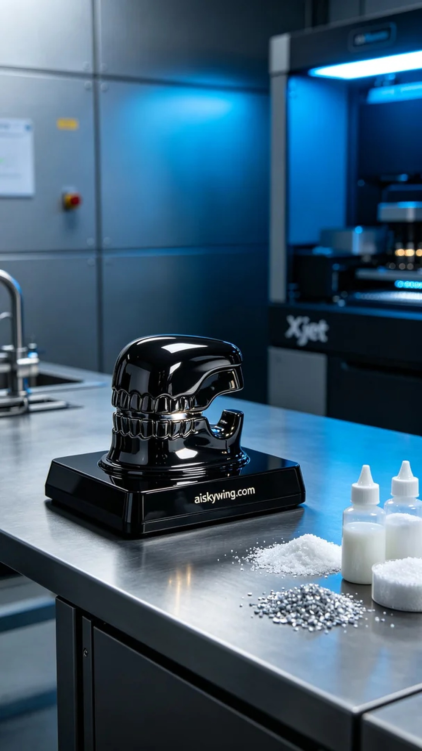
Life can be tough, but we must keep moving forward. Someone reached out on Twitter with a request for a medical base, hoping we could utilize 3D printing technology to solve their medical equipment needs.
We chose SLA photopolymer resin as the main material. This material not only has excellent flow properties but also allows for intricate details, making it suitable for medical devices. During the preparation, we utilized the Xjet printer, setting the parameters to a layer thickness of 0.05 mm, a temperature of 25 degrees Celsius, a laser power of 50 mW, a print speed of 30 mm per second, and an estimated print time of about 6 hours.
Throughout the printing process, the Xjet printer operated smoothly, with resin evenly sprayed to form a perfect base structure. We monitored the quality closely to ensure that each layer formed accurately, without any breaks or defects, achieving the high standards we expected.
The post-processing steps are crucial for ensuring product quality. First, we cleaned the printed base to remove excess resin. Next, we sanded the surface with fine sandpaper to ensure it was smooth and flawless. The curing stage was also vital; we placed the base in a UV curing box for prolonged exposure to enhance durability and glossiness. Finally, we conducted a thorough inspection to ensure the product met medical standards.
After a series of processes, the medical base was successfully printed, showcasing an elegant appearance and robust functionality, perfectly aligning with our goals. We hope to continue pushing the boundaries of 3D printing technology, providing high-quality solutions for various industries.
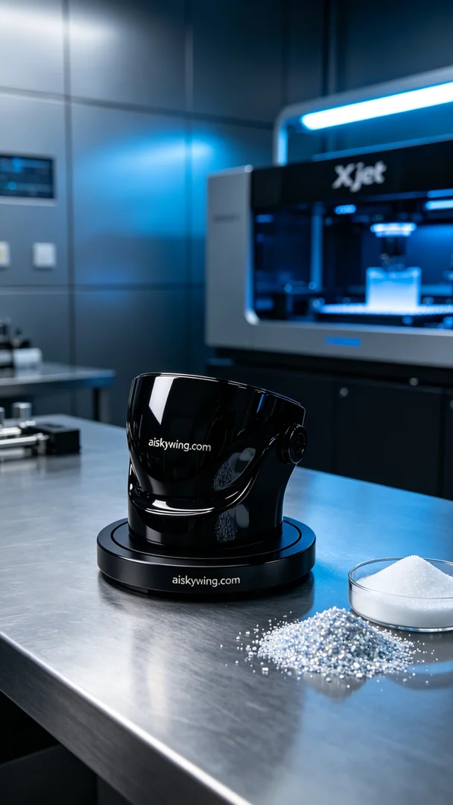
有人通过Twitter找到了我们，询问能否用3D打印技术制作一款医用底座。他们希望底座不仅具备实用功能，还能在外观上达到精致的效果，以便更好地融入医疗环境。
我们选择了SLA光固化树脂作为主要材料。这种材料不仅具有良好的流动性，还可以打印出细腻的细节，适合医疗器械的需求。准备工作中，我们使用Xjet打印机进行打印，设置参数为层厚0.05毫米，温度设定在25摄氏度，激光功率为50毫瓦，打印速度为30毫米每秒，预计打印时间约为6个小时。
打印过程中，Xjet打印机运转平稳，树脂均匀喷射，形成了完美的底座结构。我们在整个过程中进行了质量监控，确保每一层都能准确成型，没有出现断层或瑕疵，打印效果达到预期的高标准。
后处理工序是保证产品质量的重要环节。首先，我们将打印完成的底座进行清洗，以去除多余的树脂。接着，使用细砂纸进行打磨，确保表面光滑无瑕。固化环节也至关重要，我们将底座放置在紫外线固化箱中，进行持续固化，以增强耐用性和光泽感。最后进行详细检验，确保产品符合医用标准。
经过一系列的流程，这个医用底座成功打印完成，展现出优雅的外观与强大的功能，正是我们追求的目标。希望未来能继续推动3D打印技术，为更多的行业提供优质解决方案。
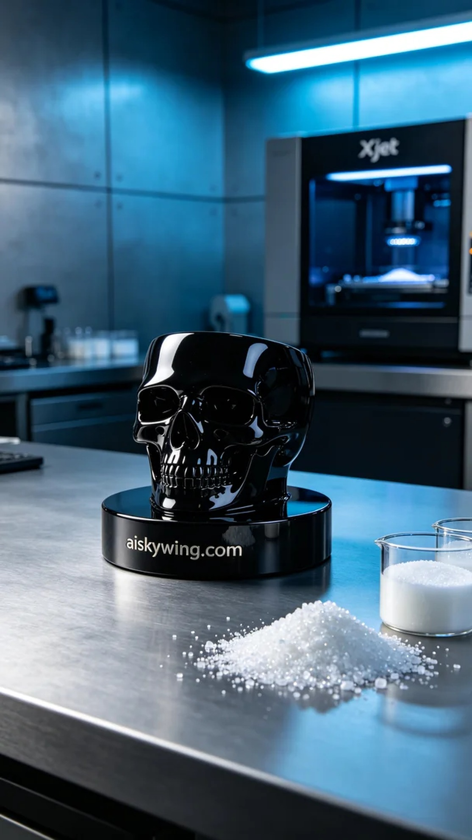
Aiskywing Industrial 3D Printing
Medical base


