1008-AGV支架的SLS打印之旅
AGV Bracket
🖨️ SLS尼龙烧结
🖥️ 打印机: Stratasys
📦 材料: SLS尼龙
有时候咬牙坚持，不是为了证明什么。就像做这个AGV支架，我在Facebook上接到的单子，遇到的挑战让我更加坚定自己的信念。
Sometimes, gritting your teeth and persevering is not about proving anything. Just like when I was making this AGV stand, the challenges I encountered from the orders I received on Facebook made me more resolute in my beliefs.
________________________________________________________________________________
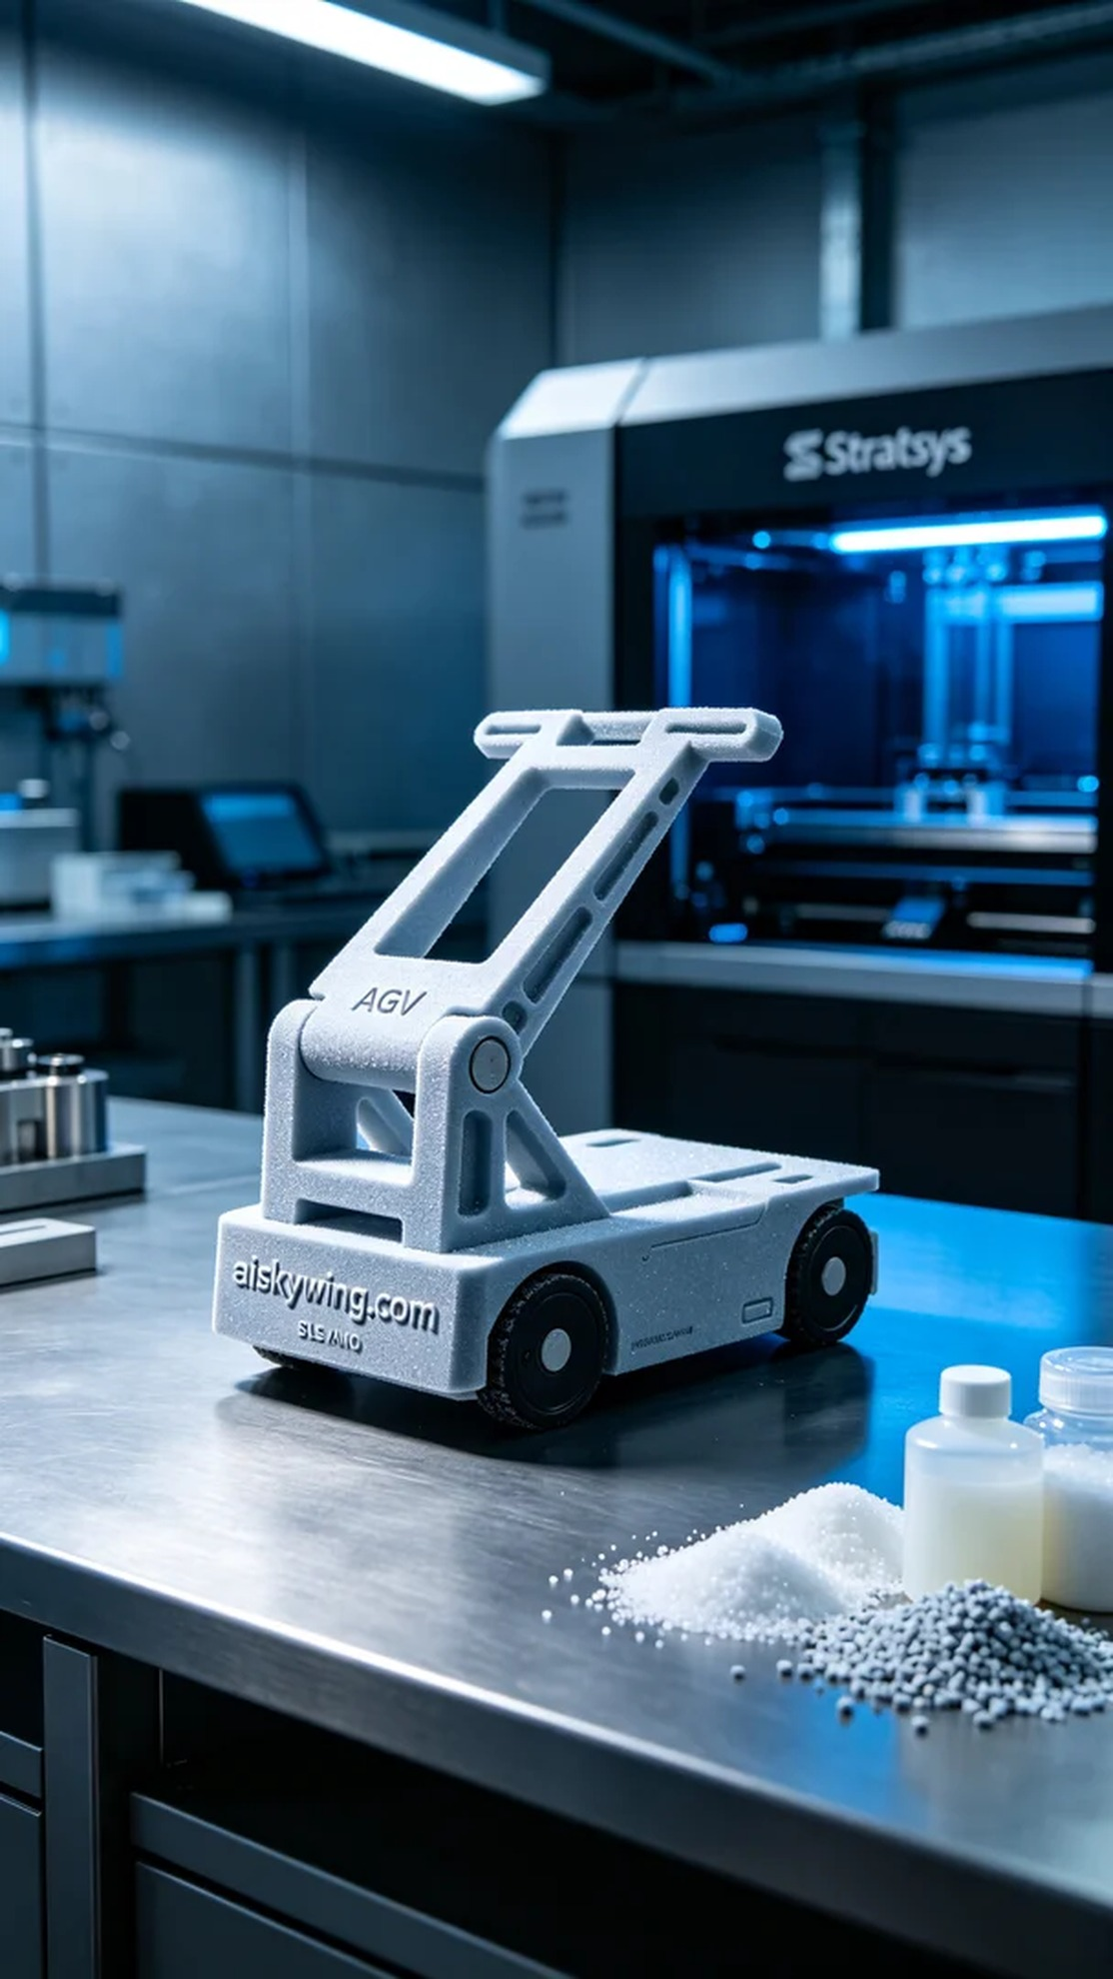
Recently, someone approached us through Facebook with a need for a high-quality AGV bracket. The bracket not only needed to be durable but also had to convey a professional appearance suitable for an industrial setting.
For material selection, we opted for SLS nylon due to its excellent strength and flexibility, making it particularly suitable for a load-bearing AGV bracket. We used a Stratasys 3D printer, setting a layer thickness of 0.1mm, maintaining a print temperature of 180 degrees Celsius, with a power setting of 90% and a print speed of 50mm/s, estimating a total print time of 6 hours.
During the printing process, the equipment operated smoothly. We closely monitored the print status to ensure each layer's sintering met expectations. As the printing progressed, the outline of the AGV bracket gradually became clear, with fine sintering textures appearing strikingly under the cold light. We conducted regular quality checks to ensure no defects emerged.
Once the printing was complete, the post-processing steps were equally crucial. We began with cleaning, using a specialized solution to remove uncured powder from the surface, followed by sanding to achieve a smoother finish. During curing, the bracket was placed under UV light to ensure all corners received adequate exposure. Finally, after rigorous inspection, we confirmed that the product met all quality standards.
In the end, this AGV bracket was not only successfully printed but also showcased the excellent properties of SLS nylon, proving its reliability in an industrial environment and receiving high praise from its users.
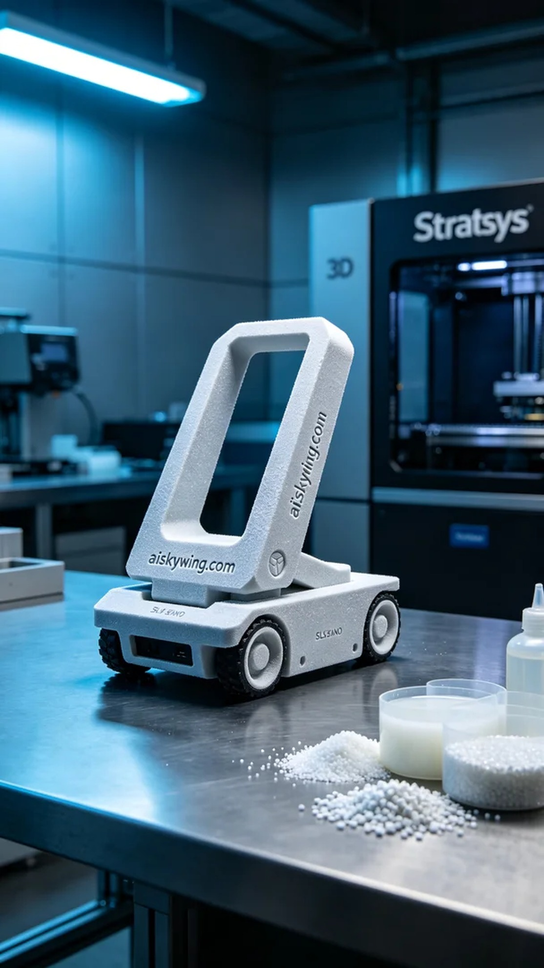
日前，有人因为对自动化物流的需求，找到我们，希望能打印一款高质量的AGV支架。这个支架不仅需要坚固耐用，还要在视觉上给人以专业的感觉，满足工业环境的要求。
在材料选择上，我们决定使用SLS尼龙，因为这种材料具备良好的强度和灵活性，特别适合承受高负荷的AGV支架。为了确保打印效果，我们使用了Stratasys的3D打印机，设置了0.1mm的层厚，打印温度保持在180摄氏度，功率设定为90%，打印速度为50mm/s，整个打印过程预计耗时6小时。
打印过程中，设备运行得相当顺利。我们严格监控打印状态，确保每一层的烧结都符合预期。随着打印的进行，AGV支架的轮廓逐渐清晰，细微的烧结纹理在冷光下显得格外动人。我们还定期进行质量检查，确保没有出现任何缺陷。
打印完成后，后处理工序同样重要。我们开始了清洗，使用专用的清洗剂去除表面的未固化粉末，然后进行打磨，使表面更加光滑。在固化过程中，将支架放在UV灯下，确保每个角落都能得到充分的固化。最后，经过严格的检验，我们确认产品符合所有的质量标准。
最终，这个AGV支架不仅成功打印出来，还充分展现了SLS尼龙的优良特性，能够在工业环境中稳定工作，得到了使用者的高度认可。
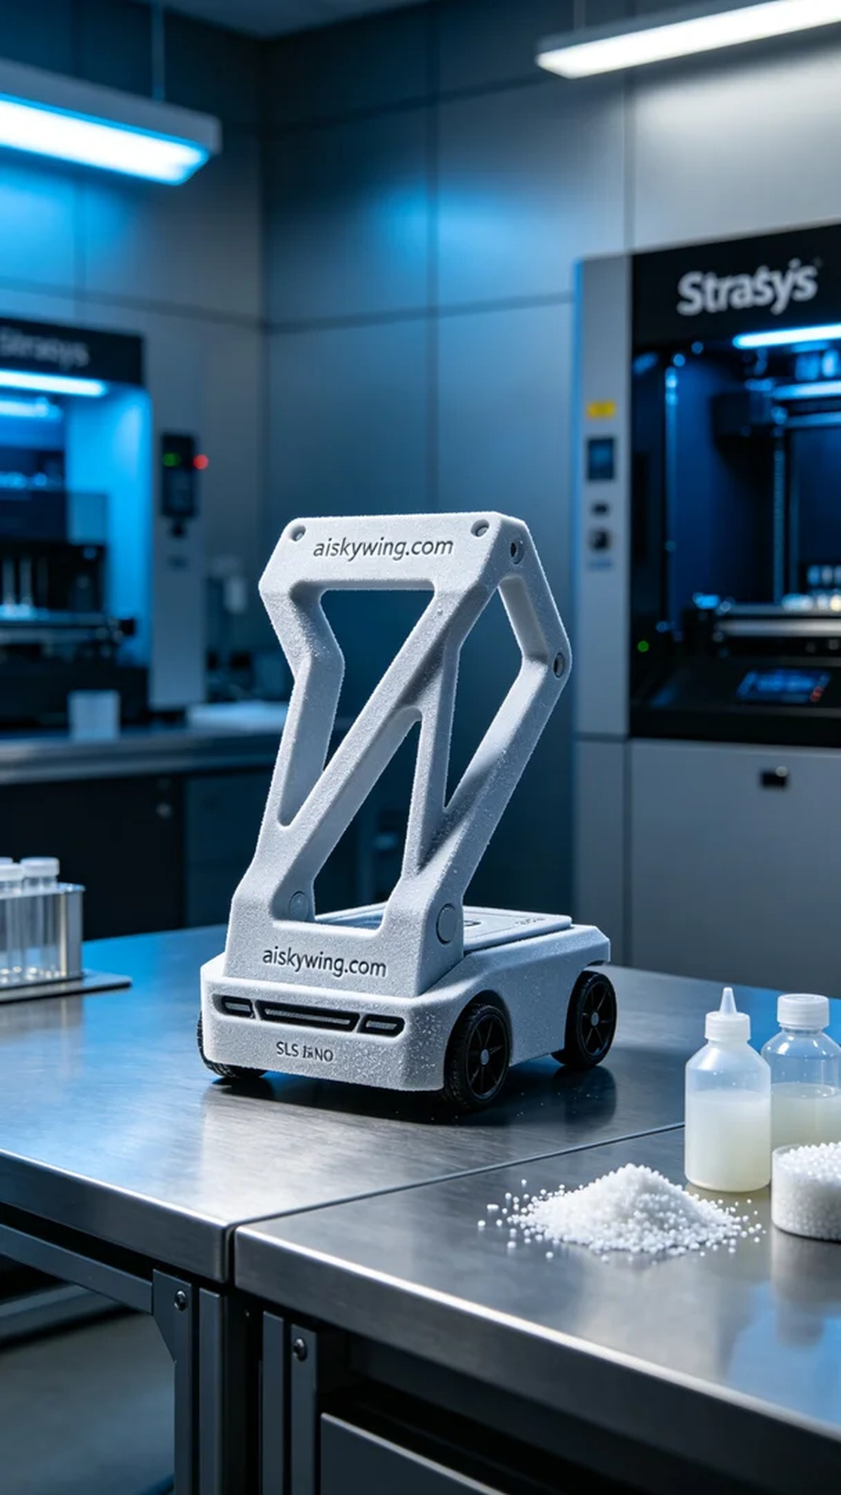
Aiskywing Industrial 3D Printing
AGV Bracket


