1009-AGV框架的3D打印生产记录
AGV Framework
🖨️ SLS尼龙烧结
🖥️ 打印机: EOS
📦 材料: SLS尼龙
生活再难，也别停下脚步。就像接下这个AGV框架的活儿，有人因为生产效率的问题找上我们，希望通过3D打印来提升他们的运营能力。
No matter how difficult life gets, don't stop moving forward. Just like when we took on this AGV framework project; someone approached us due to issues with production efficiency, hoping to enhance their operational capabilities through 3D printing.
________________________________________________________________________________
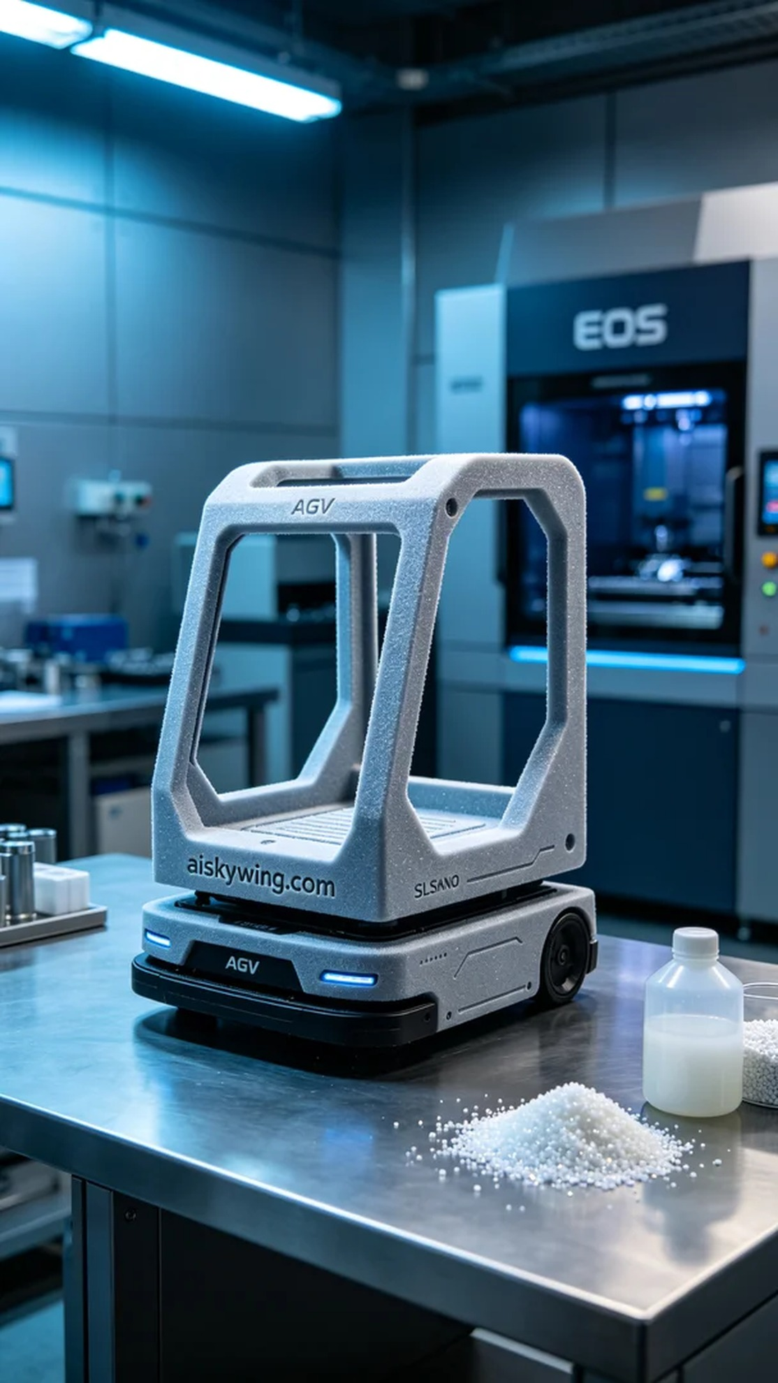
Life can be tough, but we should never stop moving forward. Just like when we took on the task of producing an AGV frame, someone reached out to us because they wanted to enhance their production efficiency through 3D printing.
We opted for SLS nylon as the primary material for this project. This material is not only lightweight but also boasts high strength and durability, making it ideal for the construction of AGV frames. We utilized an EOS brand 3D printer, setting a layer thickness of 0.1 mm, with a printing temperature of 220°C, a laser power of 40W, and a printing speed of 400 mm/s. This parameter combination ensured high precision and a smooth surface finish.
During the printing process, the EOS printer ran smoothly, with the print head accurately sintering the SLS nylon powder. We conducted periodic checks on the printing status to ensure there were no clumping of powder or deviation of the laser. The entire printing process took around 12 hours, resulting in a lightweight yet sturdy AGV frame, with the engraved "aiskywing.com" clearly visible on the surface.
Once printing was completed, the post-processing began. We first removed the AGV frame from the printer and cleaned it to eliminate any excess powder. After that, we sanded the surface for a smooth finish, followed by a curing process under UV light to enhance its durability. Throughout the inspection, we meticulously examined every detail to ensure there were no flaws, and all tests met the required standards.
This production experience reinforced my belief in the power of technology. We are not just printing an AGV frame; we are contributing to the future of intelligent manufacturing.
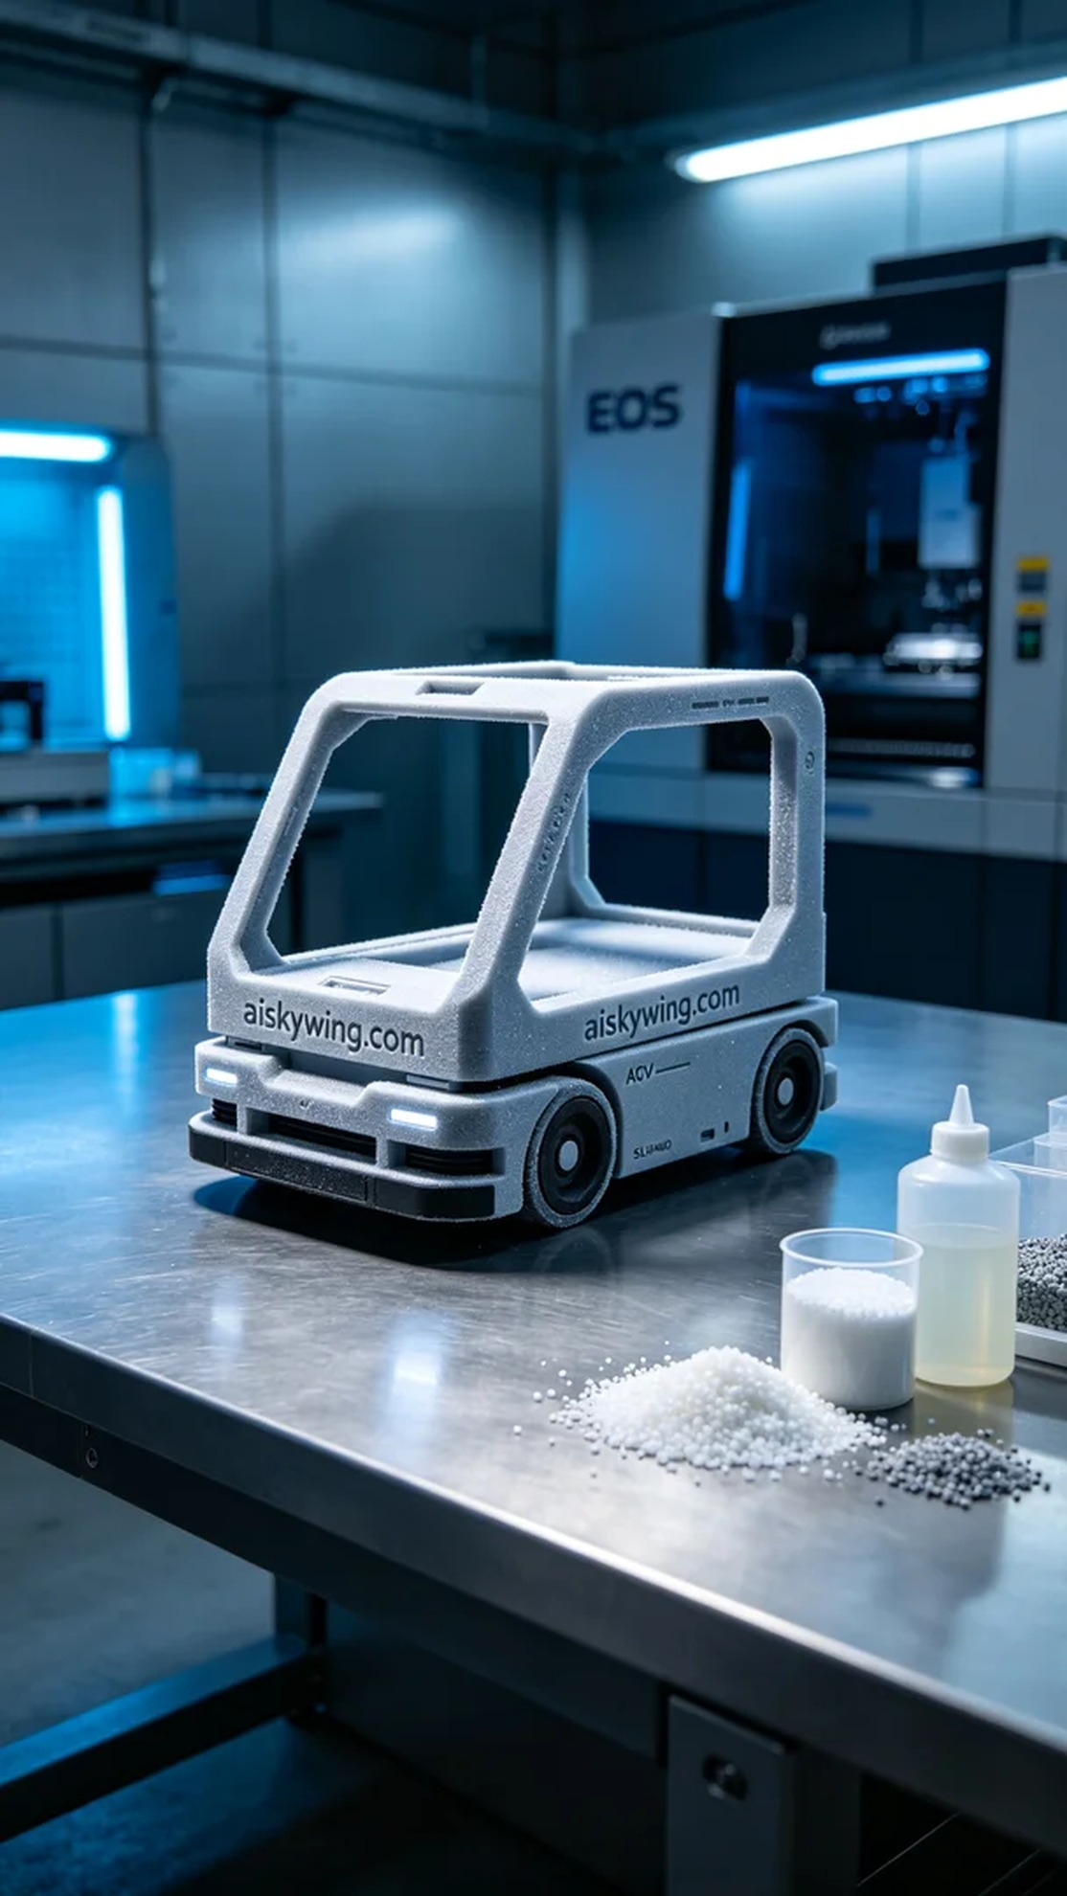
我们在Facebook上接到一位顾客的求助，想要为新项目定制一款AGV框架。随着自动化运输的需求日益增加，他们面临着生产效率提升的挑战，这促使他们希望通过3D打印技术来实现更加灵活的生产解决方案。
为此，我们准备了SLS尼龙作为主要材料。这种材料不仅具有轻量化的特性，而且强度高、耐磨性好，适合用于AGV框架的制造。我们使用的是EOS品牌的3D打印机，设置了每层0.1毫米的层厚，打印温度控制在220℃，激光功率为40W，打印速度为400mm/s。这个参数组合确保了高精度和良好的表面质量。
打印过程中，EOS打印机稳定运行，打印头在SLS尼龙粉末上精确激光烧结。我们每隔一定时间就会检查打印状态，确保没有出现粉末结块或激光偏离的情况。整个打印时间大约耗时12个小时，最终得到了一个轻盈而坚固的AGV框架，表面雕刻的“aiskywing.com”字样也清晰可见。
打印完成后，后处理工作便紧接着进行。首先将AGV框架从打印机中取出，进行清洗，去除多余的粉末。然后用砂纸对表面进行打磨，确保每个细节都光滑，最后在UV灯下进行固化处理，以提高其耐用性。检验过程中，我们仔细观察每一个细节，确保没有瑕疵，所有的测试都达标。
通过这次的生产，我深刻感受到技术的力量，我们不仅仅是在打印一个AGV框架，更是在为未来的智能制造贡献一份力量。
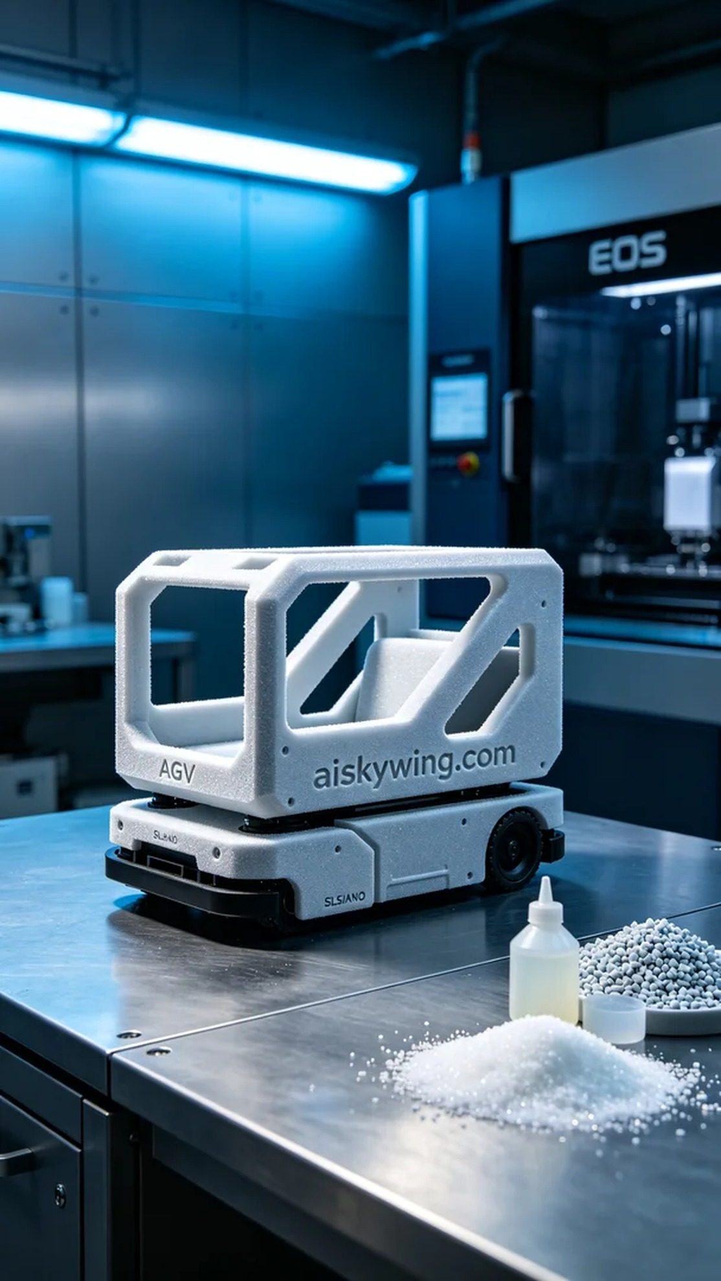
Aiskywing Industrial 3D Printing
AGV Framework


