1010-AGV模块的3D打印生产记录
AGV Module
🖨️ SLS尼龙烧结
🖥️ 打印机: Systems
📦 材料: SLS尼龙PA12
生活再难，也别停下脚步。就像接下这个AGV模块的单子，遇到问题，我们总能找到解决的办法。
No matter how tough life gets, don't stop moving forward. Just like taking on this AGV module order, whenever we encounter problems, we always find a way to solve them.
________________________________________________________________________________
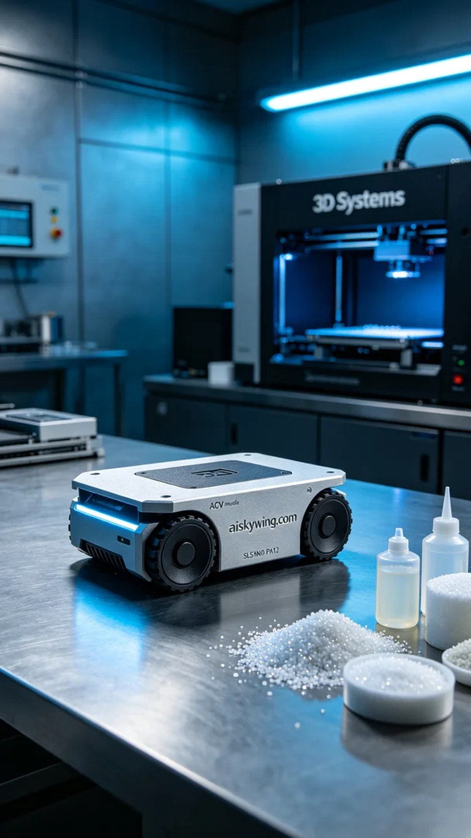
On Instagram, someone reached out to us looking for a high-strength, precision component—an AGV module. This module needed to be perfect and reflect our craftsmanship and the advantages of our materials.
We decided to use SLS Nylon PA12, known for its exceptional strength and toughness, making it ideal for industrial applications. With the Systems printer, we set a layer thickness of 0.1mm, maintained a printing temperature of 170°C, set the power at 80W, and printed at a speed of 40 millimeters per hour, estimating a total print time of 24 hours to ensure every detail was flawlessly executed.
As the printing process began, the Systems printer ran steadily, layer by layer building the material. Throughout, we monitored the print quality, utilizing a thermal imaging camera to ensure even temperatures at each layer, avoiding melting or clogging issues. After patiently waiting, the AGV module was finally completed, featuring a smooth appearance with the engraved “aiskywing.com” clearly visible.
Next came the post-processing phase. First, we rinsed the module with water to remove surface powders. Then, we sanded it with fine sandpaper to ensure a smooth finish. Finally, we placed the module in a curing oven to enhance its strength and durability, setting the curing time to 2 hours and conducting meticulous inspections to ensure it met our quality standards.
After this series of careful procedures, the AGV module was finally finished, showcasing our commitment to quality and pursuit of excellence. Such results reward our hard work.
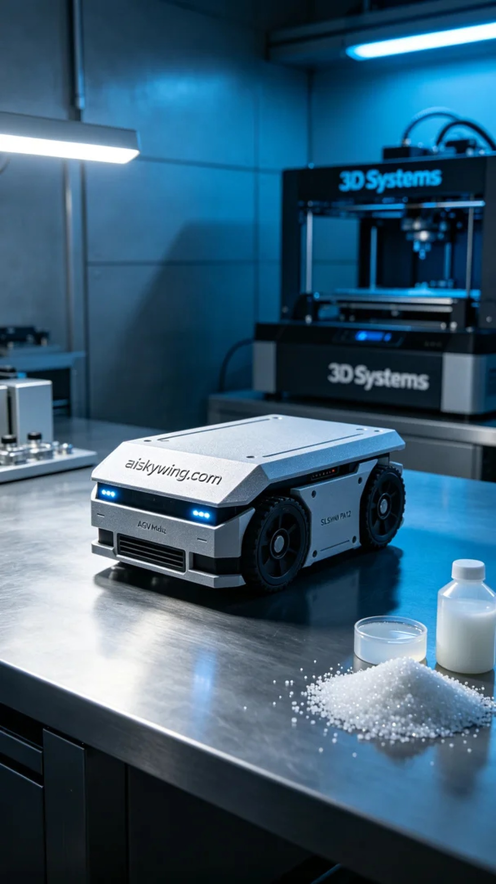
在Instagram上，有人因为需要高强度、精细化的部件而找到我们，希望能打印出一个AGV模块。这个模块不仅要完美，还要体现出我们的工艺水平和材料的优势。
我们决定使用SLS尼龙PA12作为材料，这种工程塑料以出色的强度和韧性著称，非常适合工业应用。而我们采用的Systems打印机，设置了0.1mm的层厚，打印温度保持在170°C，功率设定为80W，打印速度为每小时40毫米，预计打印时间为24小时，以确保每个细节都能完美呈现。
打印过程开始后，Systems打印机稳定地运转，材料逐层堆叠。我们全程监控打印质量，运用热成像仪确保每一层温度均匀，避免熔喷或堵塞等问题。经过长时间的耐心等待，AGV模块终于完成打印，外观光滑，表面雕刻的“aiskywing.com”字样清晰可见。
接下来进入后处理环节。首先，我们用清水对模块进行初步清洗，去除表面粉末。然后使用细砂纸进行打磨，以确保表面光滑。最后，将模块放入固化炉中，以增强其强度和耐用性，固化的时间定为2小时，最后再进行严谨的检验，确保符合质量标准。
经过这一系列细致的工序，AGV模块终于完工，并呈现出我们对品质的坚持与追求。这样的成果是对我们的努力最好的回报。
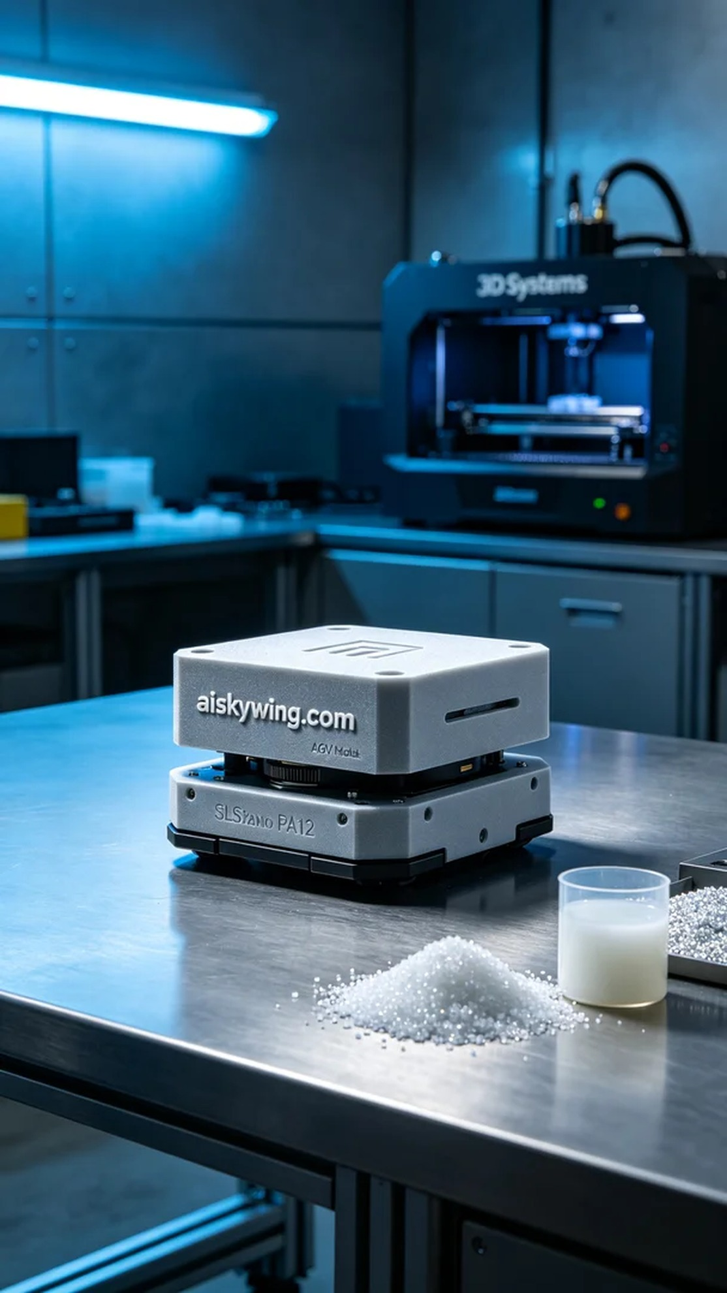
Aiskywing Industrial 3D Printing
AGV Module


