1011-AGV组件3D打印生产记录
AGV Components
🖨️ SLS尼龙烧结
🖥️ 打印机: Voxeljet
📦 材料: SLS尼龙
生活再难，也别停下脚步。就像接下这个AGV组件的单子，我们始终相信每个难题背后都是新的机遇。
No matter how difficult life gets, don't stop moving forward. Just like taking on this AGV component order, we always believe that behind every challenge lies a new opportunity.
________________________________________________________________________________
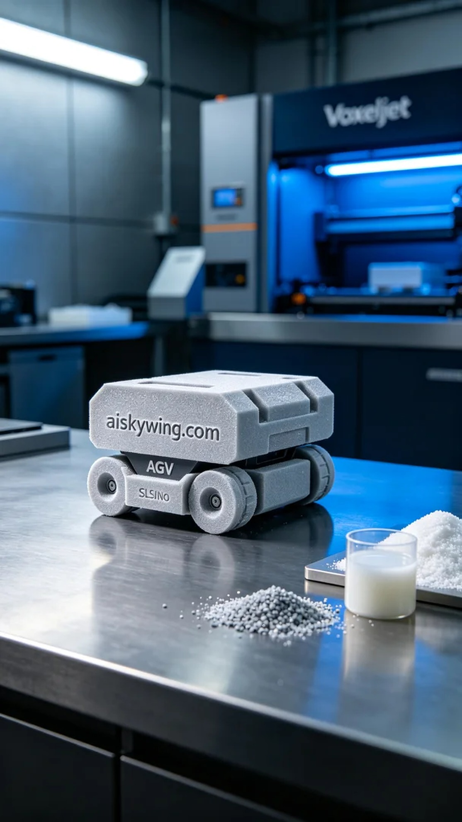
On TikTok, someone reached out to us due to challenges in automating their production line, seeking a solution for their AGV component's design bottlenecks. The manufacturing process of this product embodies the perfect blend of our team's expertise and experience.
We selected SLS nylon as the raw material. This material possesses excellent strength and toughness, and its surface is finely sintered, making it suitable for complex industrial requirements. To ensure optimal printing results, we utilized a Voxeljet printer, with a layer thickness set at 0.1 mm, a temperature of 180 degrees Celsius, power at 80%, and a printing speed of 5 mm per hour, with an estimated total printing time of 8 hours.
The printing process went smoothly, with stable machine operation. We conducted quality monitoring at every critical stage to ensure that each layer's sintering met the standards. As the process unfolded, fine powder particles fused under the laser's influence, forming a robust AGV component. Additionally, we continually monitored the printer's status to prevent any issues.
Once printing was complete, we carried out rigorous post-processing procedures. First, we placed the formed AGV components into a cleaning tank and used a specialized solvent to remove excess powder from the surface. Next, we employed fine sanding to enhance the smoothness of the surface, ensuring the component's mechanical properties. Finally, we performed curing treatments and conducted strict inspections on each component to ensure compliance with industrial standards.
This entire process not only enabled us to complete the production task for the AGV component but also reaffirmed the significance of 3D printing technology in modern industry. Behind these results lies meticulous operation and unwavering perseverance.
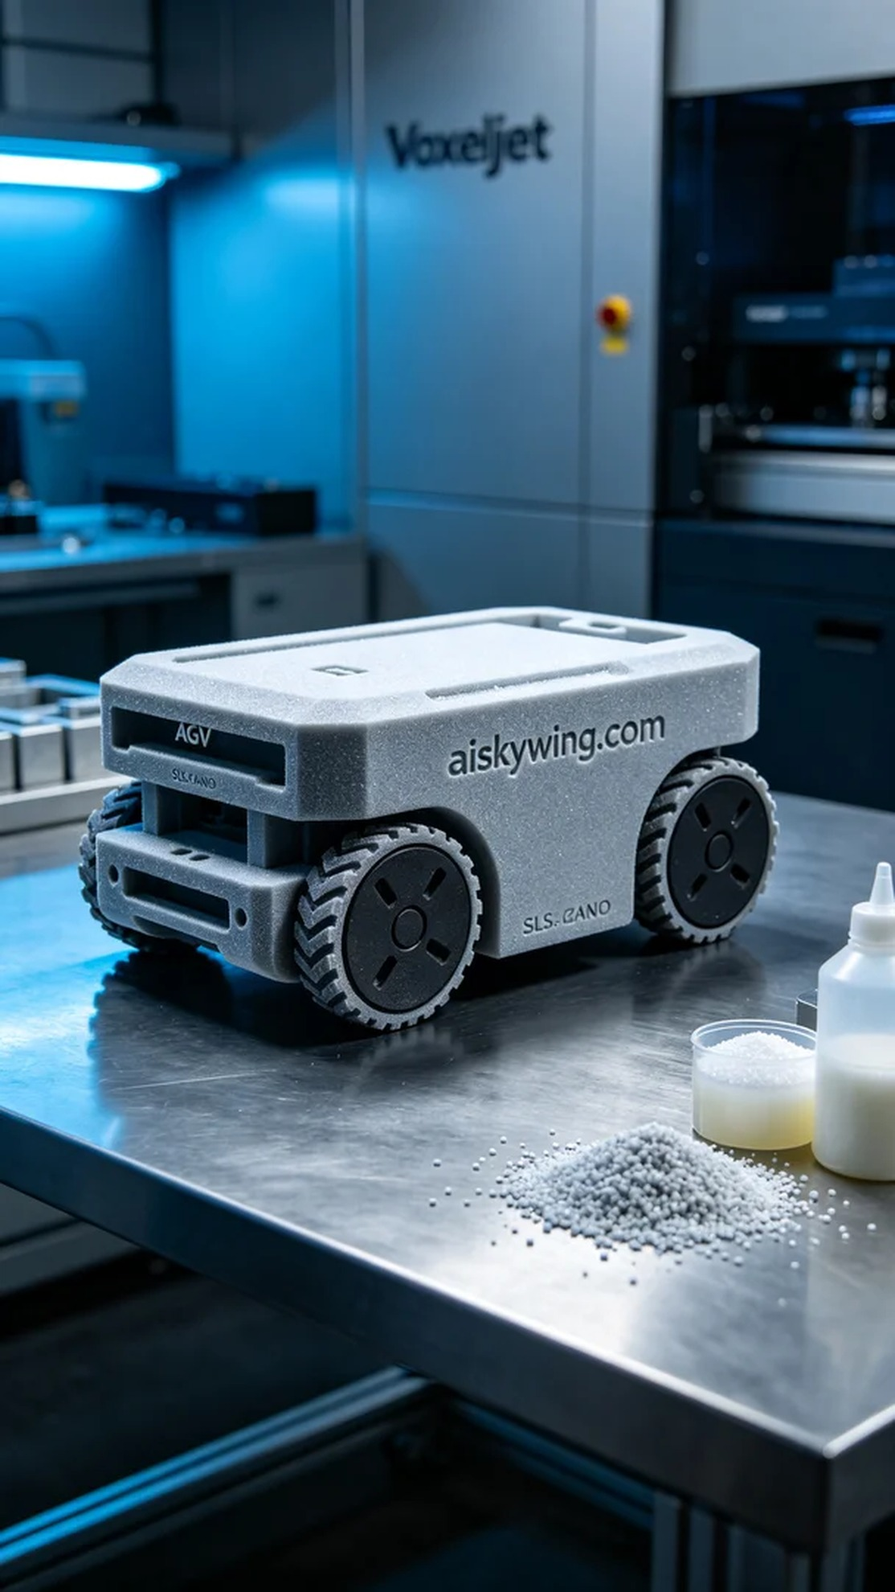
在TikTok上，有人因为生产线自动化的问题找到了我们，希望能够用3D打印解决现有AGV组件的设计瓶颈。这个产品的制造过程，正是我们团队技术与经验的完美结合。
我们选择了SLS尼龙作为原材料。这种材料具有优良的强度和韧性，且表面经过细微的粉末烧结处理，能够适应复杂的工业需求。为确保打印效果，我们使用了Voxeljet打印机，设定层厚为0.1毫米，温度保持在180摄氏度，功率设定为80%，打印速度为每小时5毫米，总打印时间预计为8小时。
打印过程相对顺利，设备运行稳定。我们在每一个关键环节进行质量监控，确保每一层的烧结都达到标准。打印过程中，细微的粉末颗粒在激光的作用下逐渐融合，形成了坚固的AGV组件。我们在打印的同时，也对设备的运行状态进行实时监控，确保没有出现任何问题。
打印完成后，我们进行了严格的后处理工序。首先，将成型的AGV组件放在清洗槽中，使用专用溶剂去除表面多余的粉末。之后，采用精细打磨，提升表面光滑度，确保组件的机械性能。最后，我们进行固化处理，并对每个组件进行严格的检验，以确保符合工业标准。
这一过程不仅让我们完成了AGV组件的生产任务，也再次证明了3D打印技术在现代工业中的重要性。成果的背后，是每一次细致的操作与不懈的坚持。
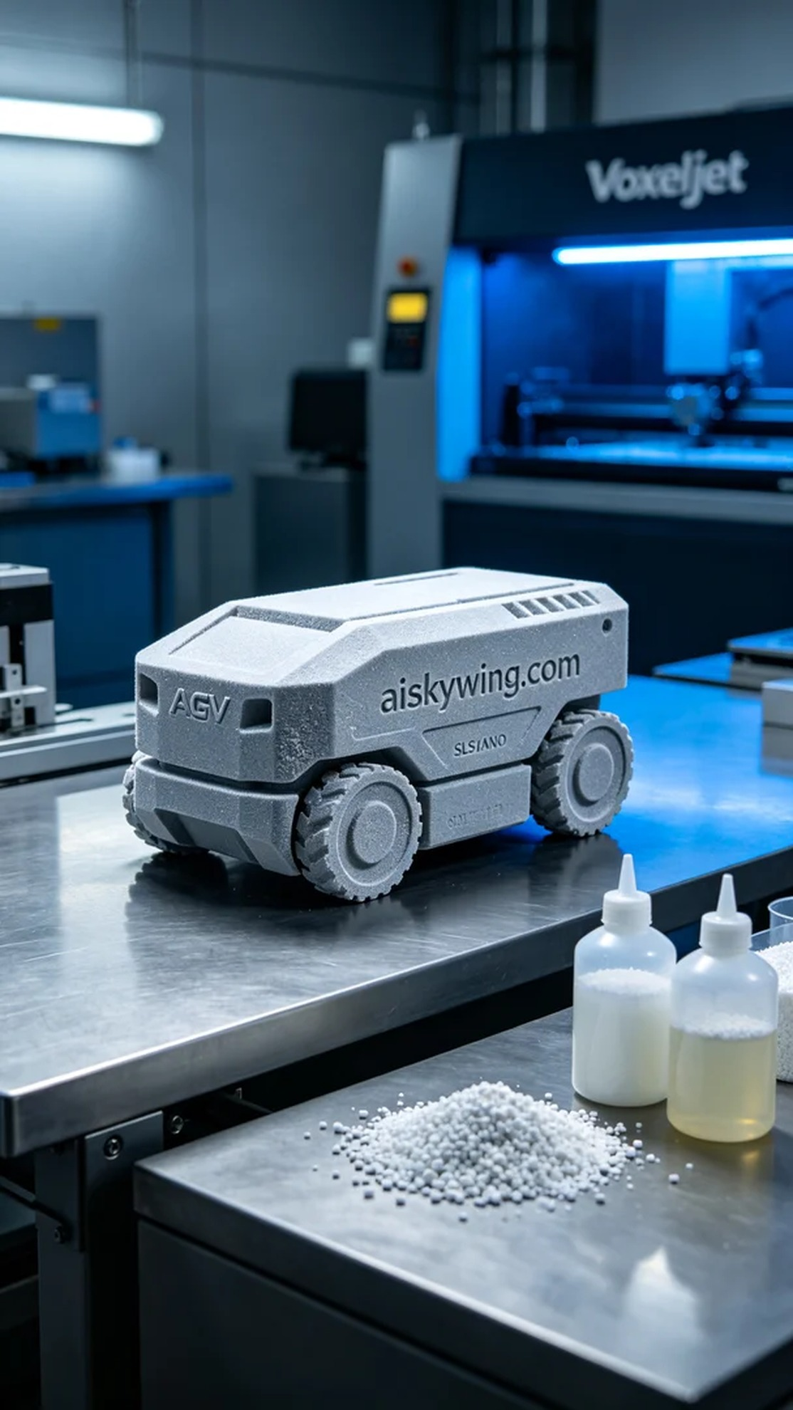
Aiskywing Industrial 3D Printing
AGV Components


