1012-AGV连接件置于画面正中央的SLS尼龙烧结之旅
AGV connector
🖨️ SLS尼龙烧结
🖥️ 打印机: Carbon
📦 材料: SLS耐高温尼龙
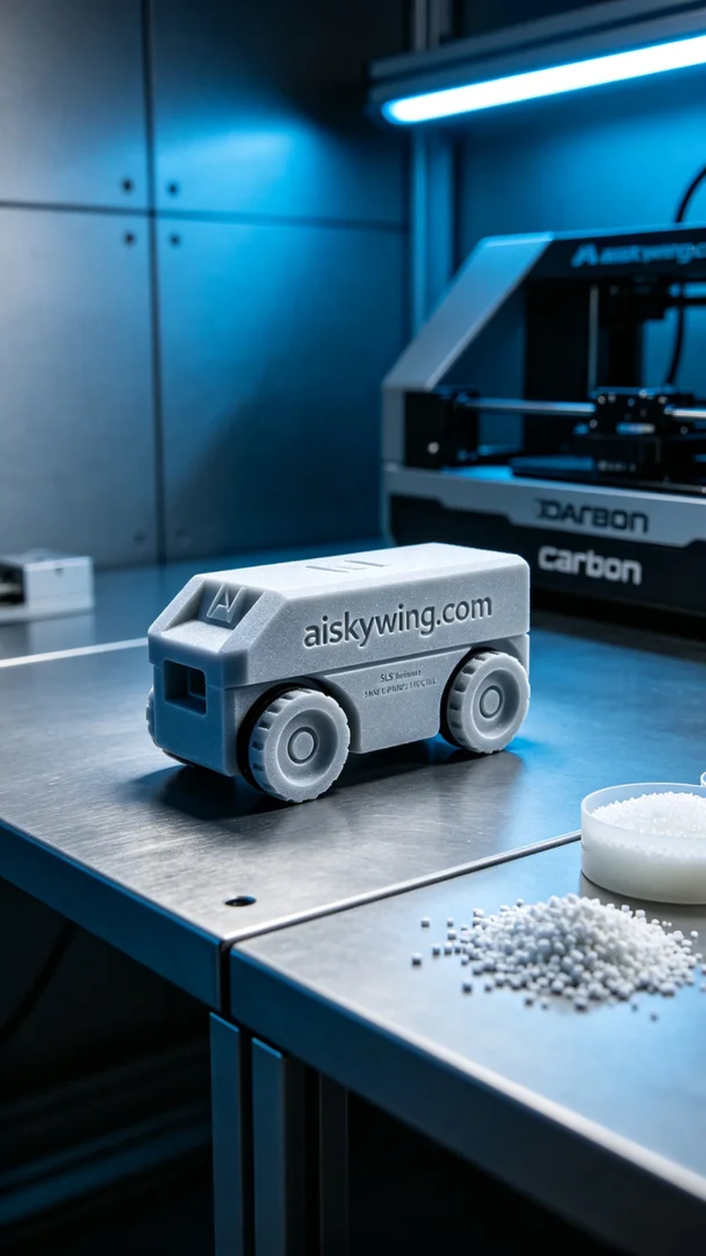
Someone on Twitter reached out to us, saying that they couldn't get the AGV connector positioned in the center of the screen after three attempts. The issue has been persistent, and it was made using SLS nylon sintering technology.
The material used is SLS high-temperature nylon, with moderate viscosity, and it should be preheated to an appropriate temperature before printing. The layer thickness is set to 0.05mm, and the bottom layer exposure time is extended to ensure a strong adhesion to the platform.
The Carbon printer ran for about seven hours without interruption. During the printing process, we couldn't walk away; we had to keep an eye on the adhesion of the first layer.
For post-processing, we first cleaned it with alcohol to remove excess resin from the surface. Then, it went into the UV curing box at 60 degrees for forty minutes to achieve the required hardness. Finally, we polished it, and the surface became shiny.
We sent three sets over, and they said only this one was usable.
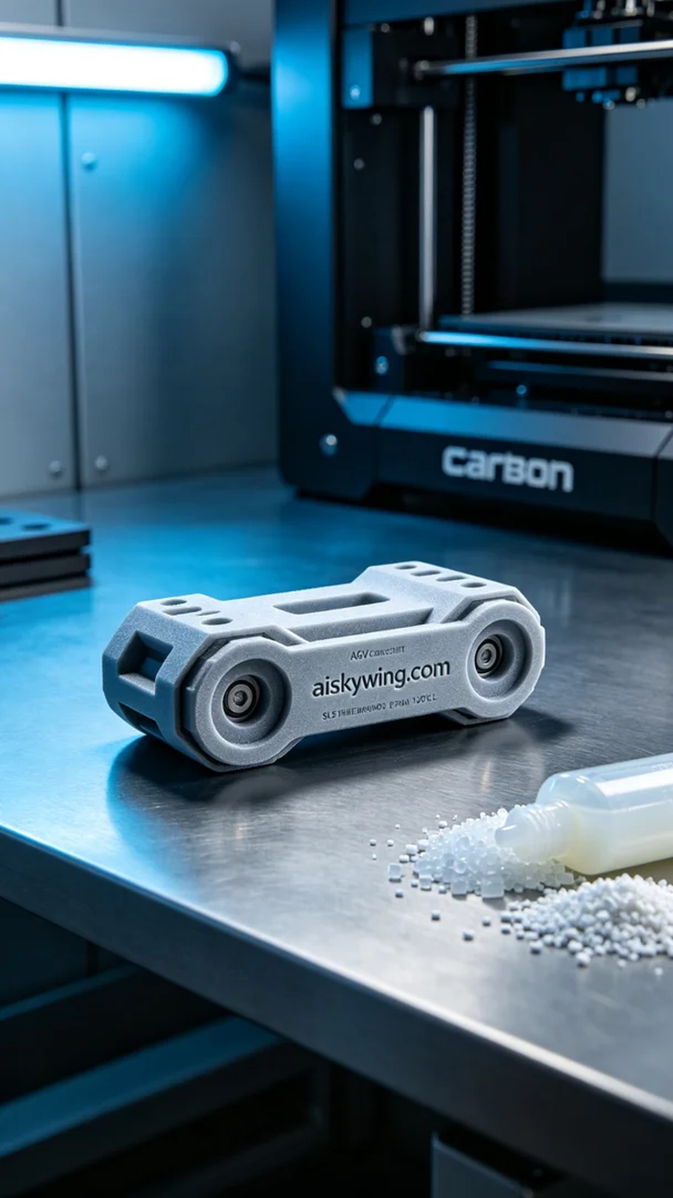
Twitter上有人找我们，说AGV连接件置于画面正中央打了三回都搞不定，SLS尼龙烧结工艺做的，问题一直解决不了。
材料用SLS耐高温尼龙，黏度适中，上机前预热到合适温度。层厚设的0.05mm，底层曝光加长，保证粘平台粘得牢。
Carbon打印机跑了大概7个多小时，中间没断。机子跑的时候人也不能走远，得盯着第一层的附着情况。
后处理先用酒精清洗，把表面多余的树脂洗掉。然后进UV固化箱，60度烘四十分钟，硬度才能达标。最后打磨抛光，表面就亮了。
发了三套过去，人家说就这个能用。
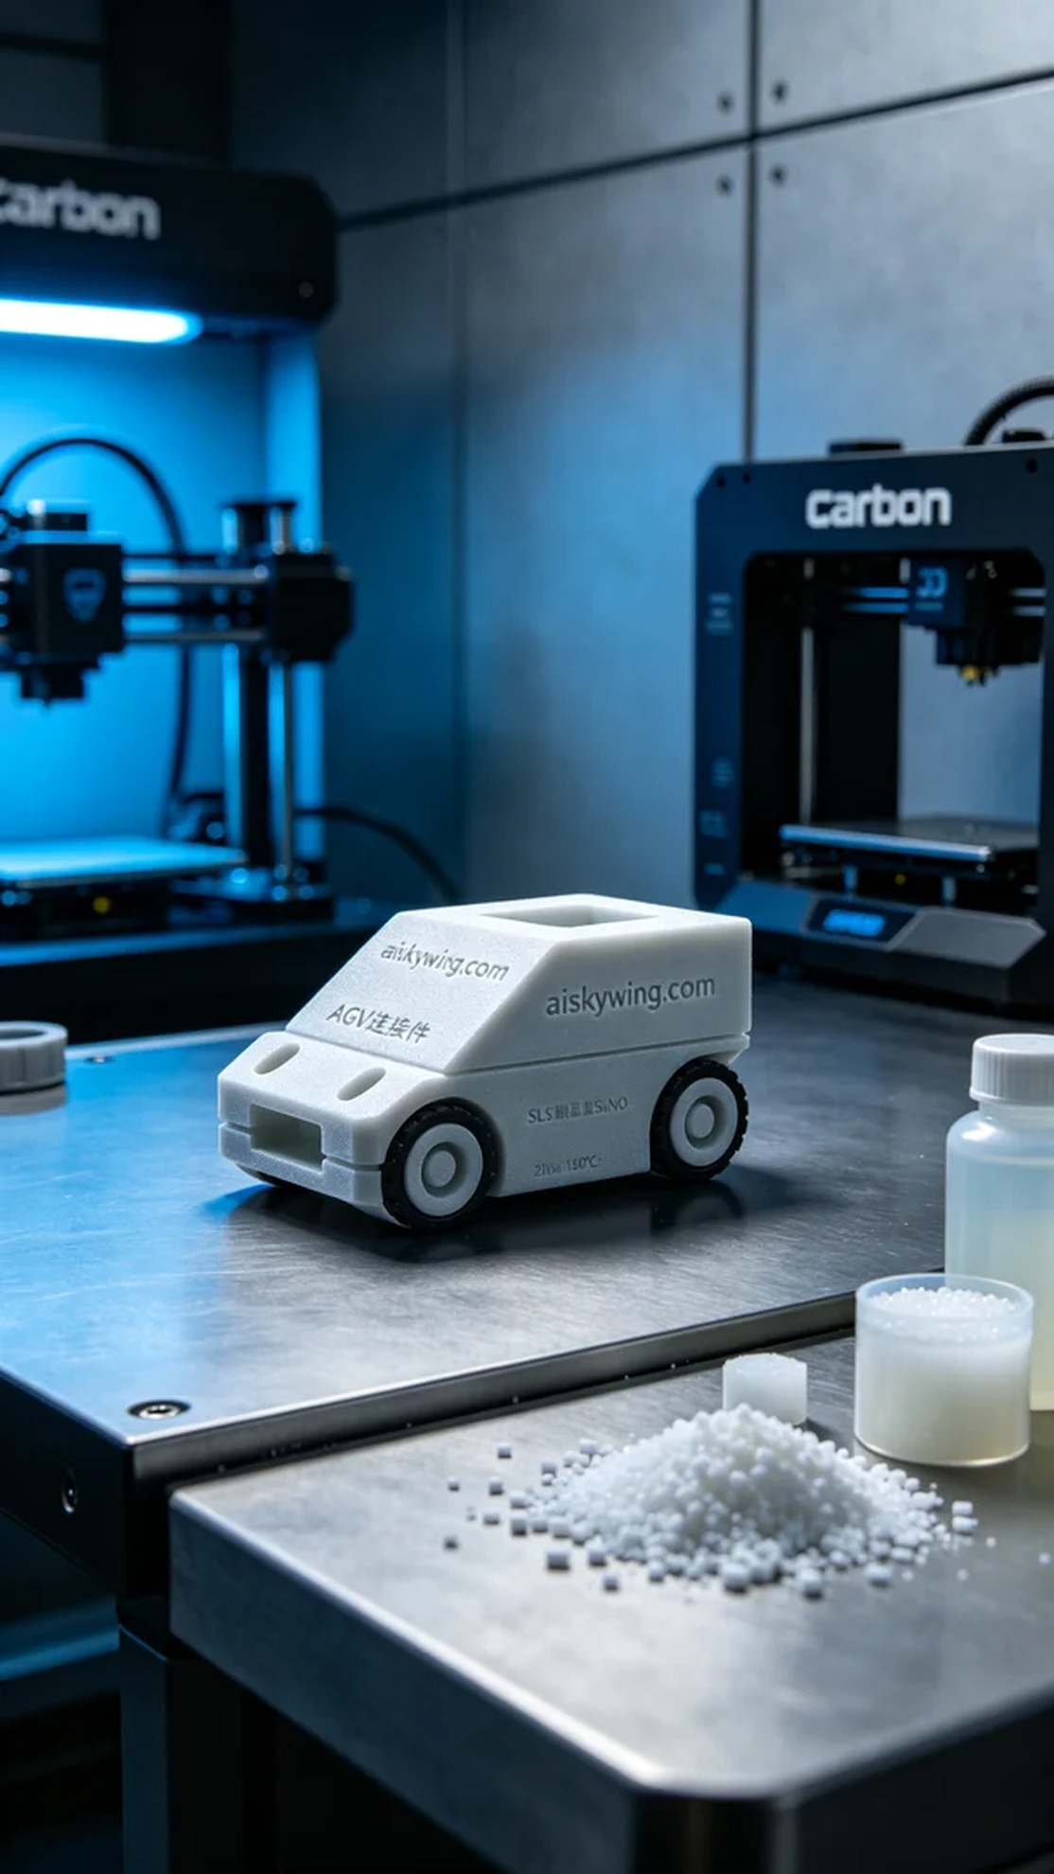
Aiskywing Industrial 3D Printing
AGV connector


