1013-AGV面板生产记录
AGV Panel
🖨️ SLS尼龙烧结
🖥️ 打印机: Mimaki
📦 材料: SLS耐高温尼龙
生活再难，也别停下脚步。就像接下这个AGV面板的单子，有人因为对耐高温材料的需求找到了我们。
No matter how difficult life gets, don't stop moving forward. Just like when we took on this AGV panel order, someone found us because they needed high-temperature resistant materials.
________________________________________________________________________________
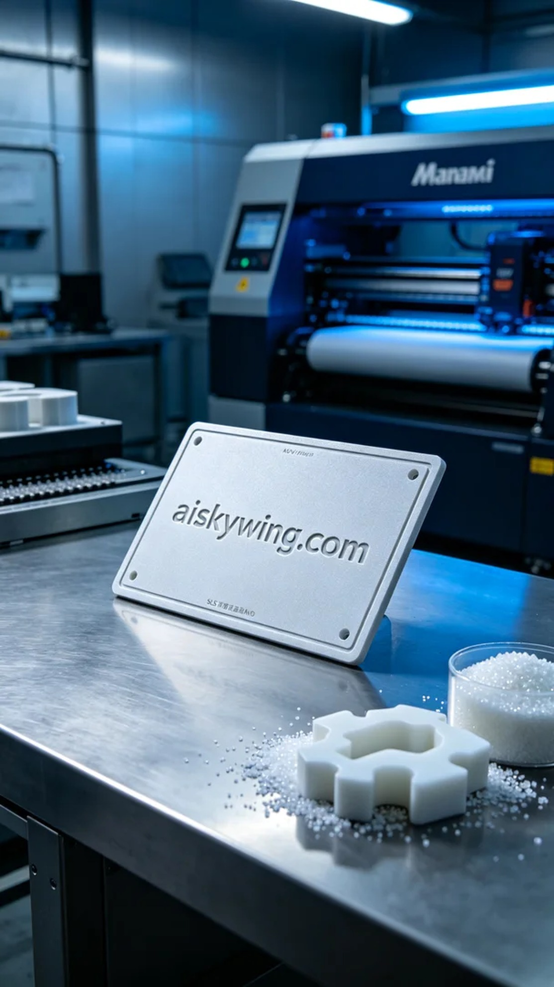
Recently, someone reached out to us via WhatsApp, expressing their urgent need for an AGV panel. They required the panel to be made from a high-temperature resistant material to suit an industrial environment. This prompted us to prepare for production immediately.
We chose SLS high-temperature nylon as our raw material, as it has high strength and excellent temperature resistance, capable of withstanding temperatures above 150℃. For the equipment, we used a Mimaki 3D printer, setting the layer thickness to 0.1 mm, the printing temperature at 180℃, the laser power at 60 watts, and a printing speed of approximately 30 mm per second. The entire printing process was expected to take about 8 hours.
During the printing process, the Mimaki printer operated smoothly, precisely sintering the nylon powder. We monitored the print quality closely, adjusting parameters as necessary to ensure each layer melted properly, avoiding any defects. Once completed, the surface displayed a matte texture, with the engraved “aiskywing.com” clearly visible, giving it a stark industrial appearance.
The post-processing phase was equally important. First, we removed the product from the printer and washed it to eliminate any unmelted powder. Then, we used fine sandpaper to polish the surface, enhancing both its touch and visual appeal. Finally, we placed the product in a curing device to ensure optimal performance. After a thorough inspection, the AGV panel was successfully completed.
This process was not just a technical challenge but also a testament to our team's collaboration. In the end, the AGV panel was delivered on time, meeting the needs of those who sought it, filling us with a sense of accomplishment.
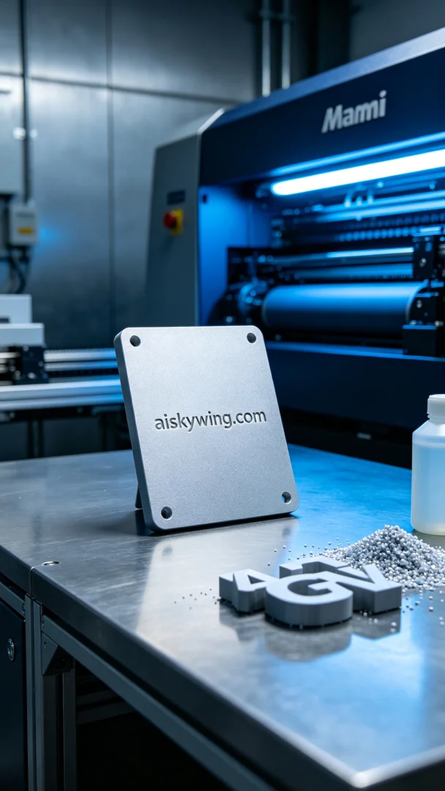
在最近的一次沟通中，有人通过WhatsApp联系到我们，表示他们急需制作一块AGV面板，要求采用耐高温的材料，以满足工业环境的需求。这让我们立即安排了生产准备。
我们选择了SLS耐高温尼龙作为原材料，这种材料具备高强度和优异的耐温性能，能够承受150℃以上的高温。设备方面，我们使用了Mimaki品牌的3D打印机，设定了层厚为0.1毫米，打印温度为180℃，激光功率设定为60瓦，打印速度约为30毫米每秒，整个打印过程预计需时大约8小时。
打印过程中，Mimaki打印机平稳运行，激光精确地将尼龙粉末烧结成型。我们全程监控打印质量，及时调整参数，确保每一层的熔融状态良好，避免出现任何瑕疵。打印完成后，表面呈现出磨砂质感，雕刻的“aiskywing.com”字样清晰可见，给人一种工业的冷峻感觉。
后处理环节同样重要，首先将成品从打印机中取出，进行清洗以去除未熔融的粉末。然后，使用细砂纸对表面进行打磨，提升触感和视觉效果。最后，将产品放置于固化设备中进行固化处理，确保其性能达到最佳状态。经过严格检验后，AGV面板顺利完成。
这一过程不仅是一次技术上的挑战，更是我们团队协作的体现。最终，这块AGV面板如期交付，满足了客户的需求，收获了满满的成就感。
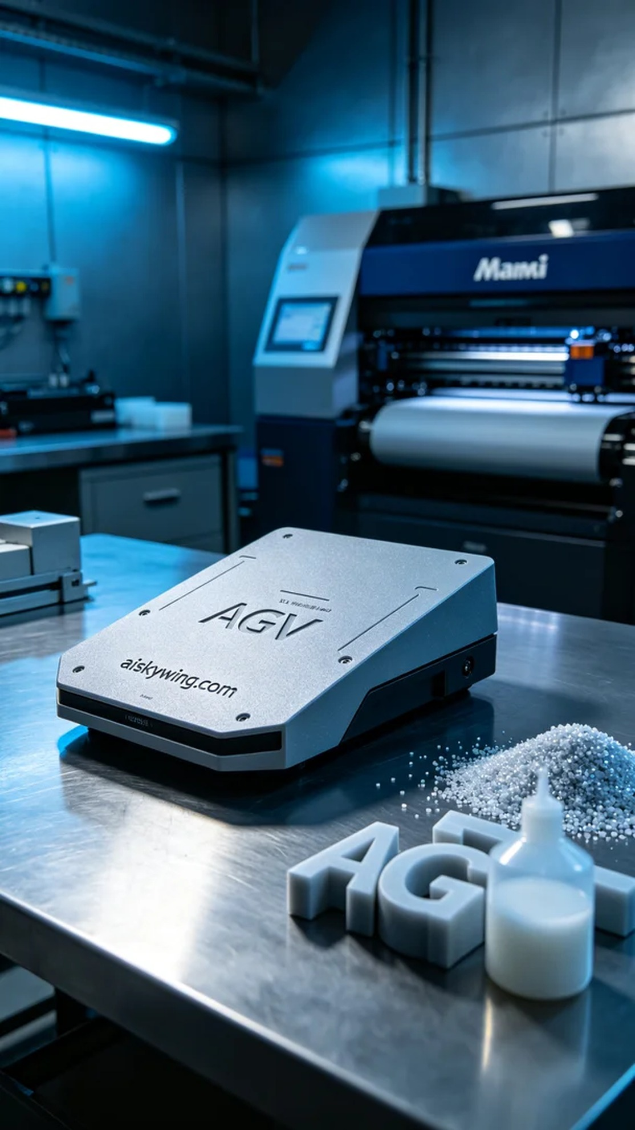
Aiskywing Industrial 3D Printing
AGV Panel


