1015-传感器保护罩3D打印生产记录
Sensor protective cover
🖨️ SLS尼龙烧结
🖥️ 打印机: Systems
📦 材料: SLS尼龙
生活再难，也别停下脚步。就像接下这个传感器保护罩的单子，面对的每一个挑战，都是成长的机会。
No matter how difficult life gets, don't stop moving forward. Just like taking on this sensor protective cover order, every challenge faced is an opportunity for growth.
________________________________________________________________________________
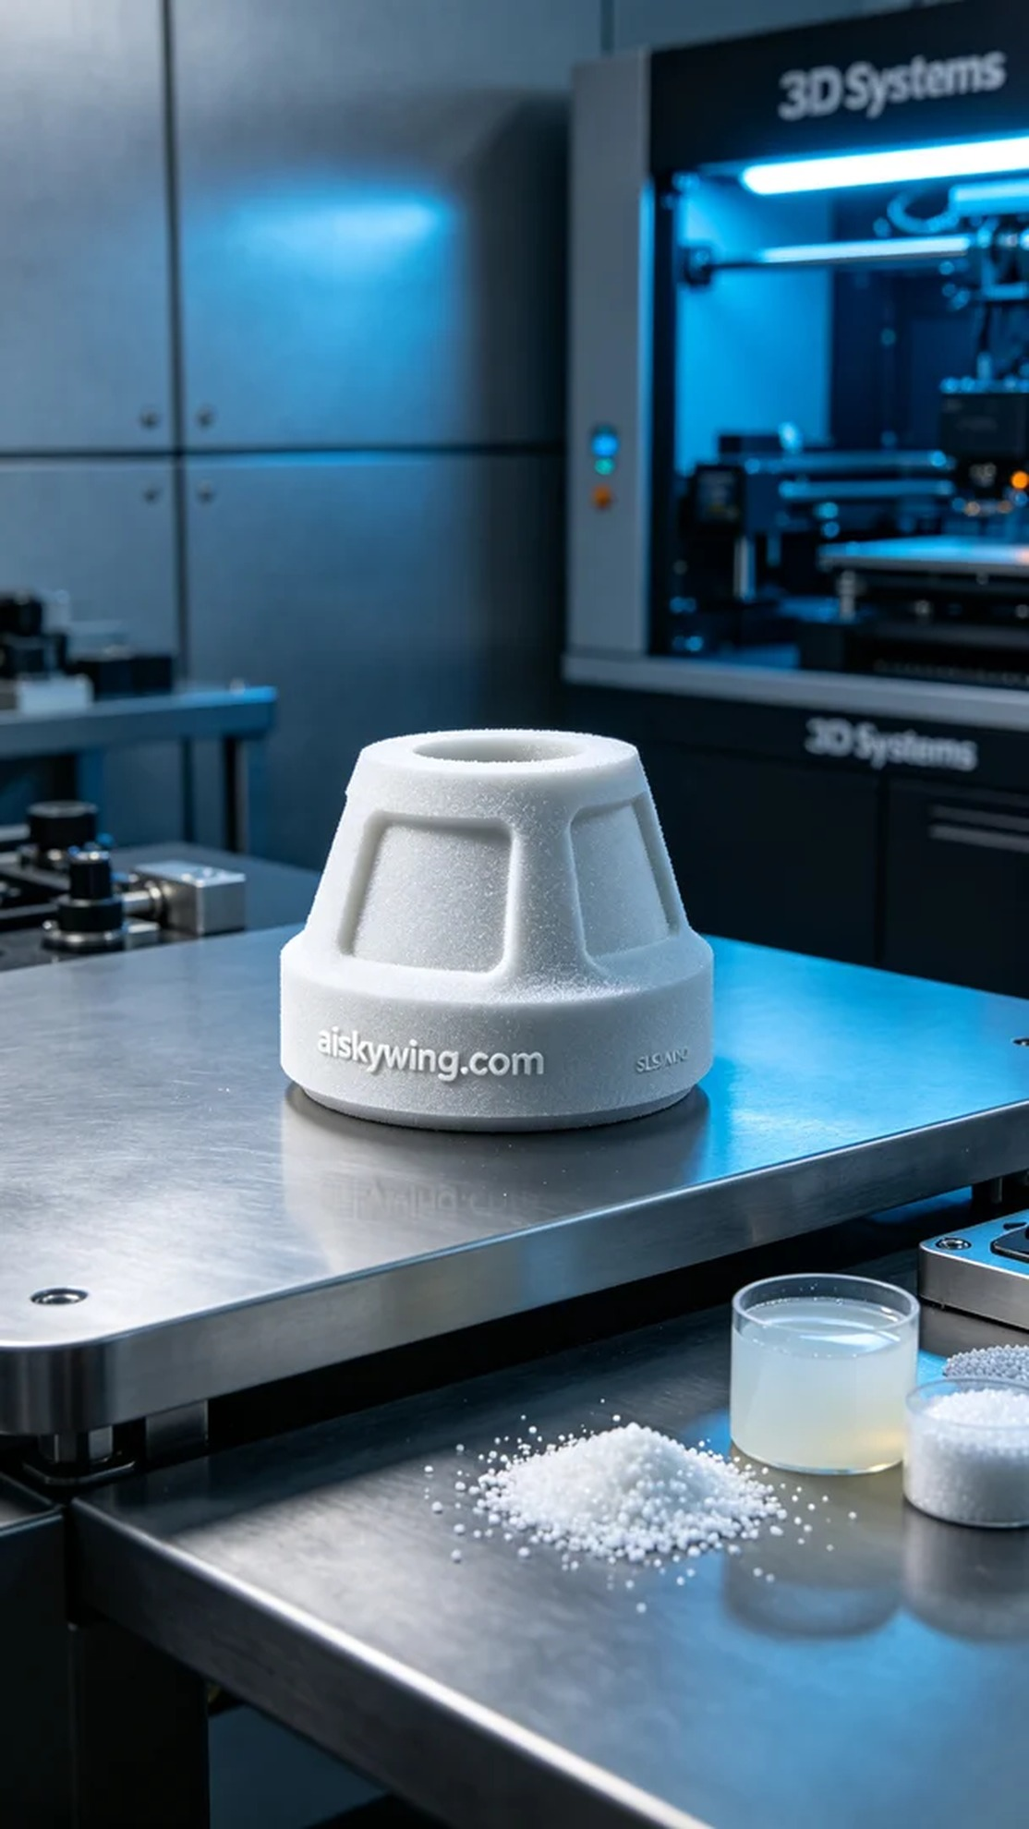
Despite the challenges we face in life, we must keep moving forward. Just like when someone approached us for a sensor protective cover, every challenge is an opportunity for growth.
Today, someone reached out to us due to their sensors being affected by external environments and requested a durable protective cover. Thus, I decided to print a sensor protective cover to take on the responsibility of safeguarding their equipment.
To ensure the product meets the requirements, I chose SLS nylon as the printing material. SLS nylon offers excellent strength and toughness, ideal for high-precision industrial applications. Preparing the equipment, I utilized a Systems brand 3D printer, setting the print parameters to a layer thickness of 0.1 mm, temperature at 170°C, power at 30W, printing speed at 20 mm per hour, with an estimated total print time of about 5 hours.
During the printing process, the machine operated smoothly, and I regularly checked the device's status to ensure temperature and pressure remained within the ideal range. As the printing progressed, the details of the protective cover gradually took shape, with the engraved "aiskywing.com" text clearly visible, and the overall result was satisfying.
After printing, the post-processing steps were crucial. Firstly, I used an ultrasonic cleaner to wash the printed piece, removing excess powder. Next, I sanded it down to ensure a smooth surface. Finally, I placed the protective cover in a UV curing device for solidification. After a thorough inspection, I confirmed that its quality met the standards before it could be delivered.
In the end, after a series of rigorous processes, the sensor protective cover was successfully completed. Every print is a new experience, and I look forward to more challenges and opportunities in the future.
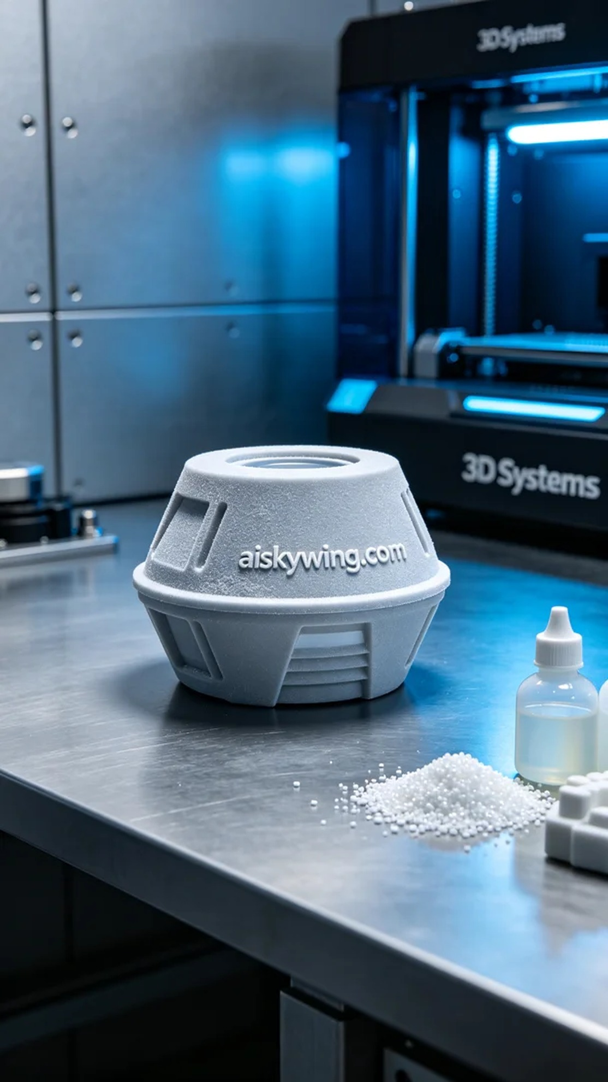
在今天的工作中，有人因为传感器受到外界环境的影响而找上我们，希望能制作一个耐用的保护罩。于是，我决定为他们打印一款传感器保护罩，承担起保护设备的重任。
为了确保产品符合要求，我选择了SLS尼龙作为打印材料。SLS尼龙具有优良的强度和韧性，适合用于高精度的工业应用。准备设备时，我使用的是Systems品牌的3D打印机，设置打印参数为层厚0.1毫米，温度为170°C，功率为30W，打印速度为每小时20毫米，预计耗时大约5小时。
打印过程中，机器运转平稳，我定期检查设备状态，确保温度和压力保持在理想范围内。随着打印的逐步推进，保护罩的细节逐渐显现，表面雕刻的“aiskywing.com”字样清晰可见，整体效果令人满意。
完成打印后，后处理工序是至关重要的。首先，我用超声波清洗机对打印件进行清洗，以去除多余的粉末。之后，进行打磨处理，确保表面光滑。最后，将保护罩放在UV固化设备中进行固化，经过一番检验，确认其质量达标后，方可交付使用。
最终，经过一系列严格的流程，这款传感器保护罩顺利完成。每一次打印都是一次新体验，期待未来更多的挑战与机遇。
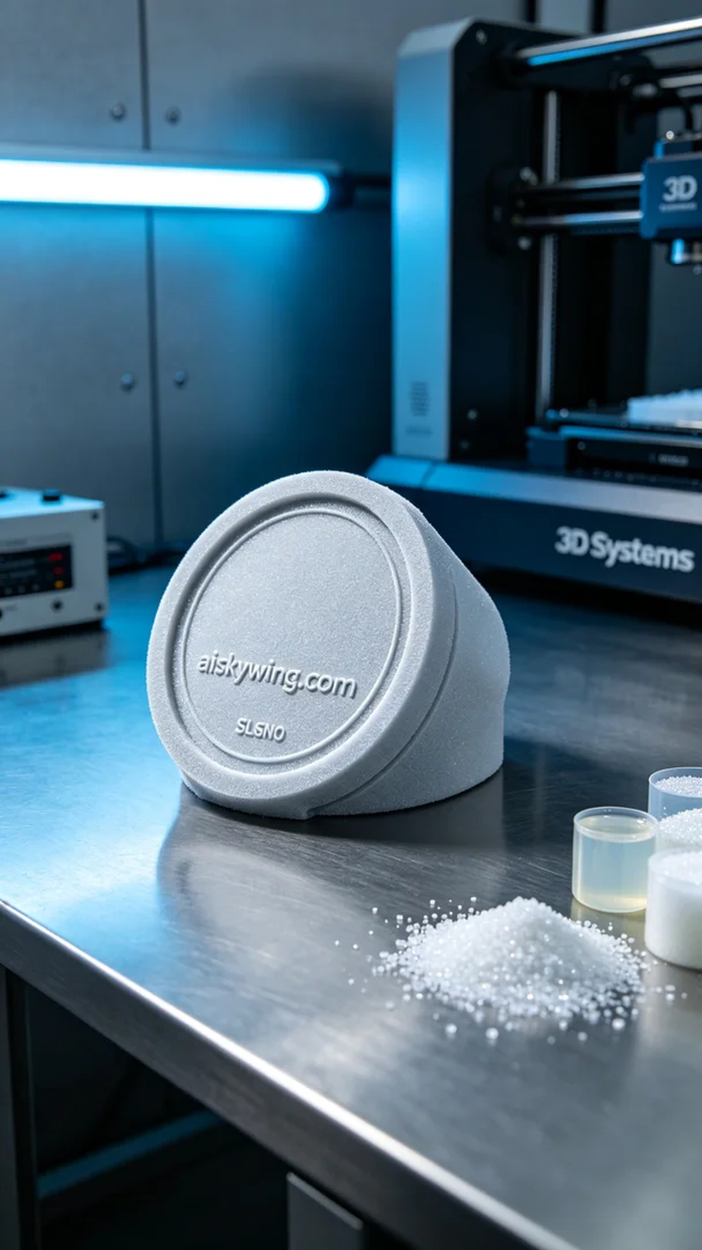
Aiskywing Industrial 3D Printing
Sensor protective cover


