1016-传感器外壳3D打印生产记录
Sensor housing
🖨️ SLS尼龙烧结
🖥️ 打印机: HP
📦 材料: SLS耐高温尼龙
生活再难，也别停下脚步。就像接下这个传感器外壳的单子，有人在LinkedIn上找到我，急需一款高性能的产品。
No matter how difficult life gets, don't stop moving forward. Just like when I took on this sensor housing project; someone found me on LinkedIn, urgently needing a high-performance product.
________________________________________________________________________________
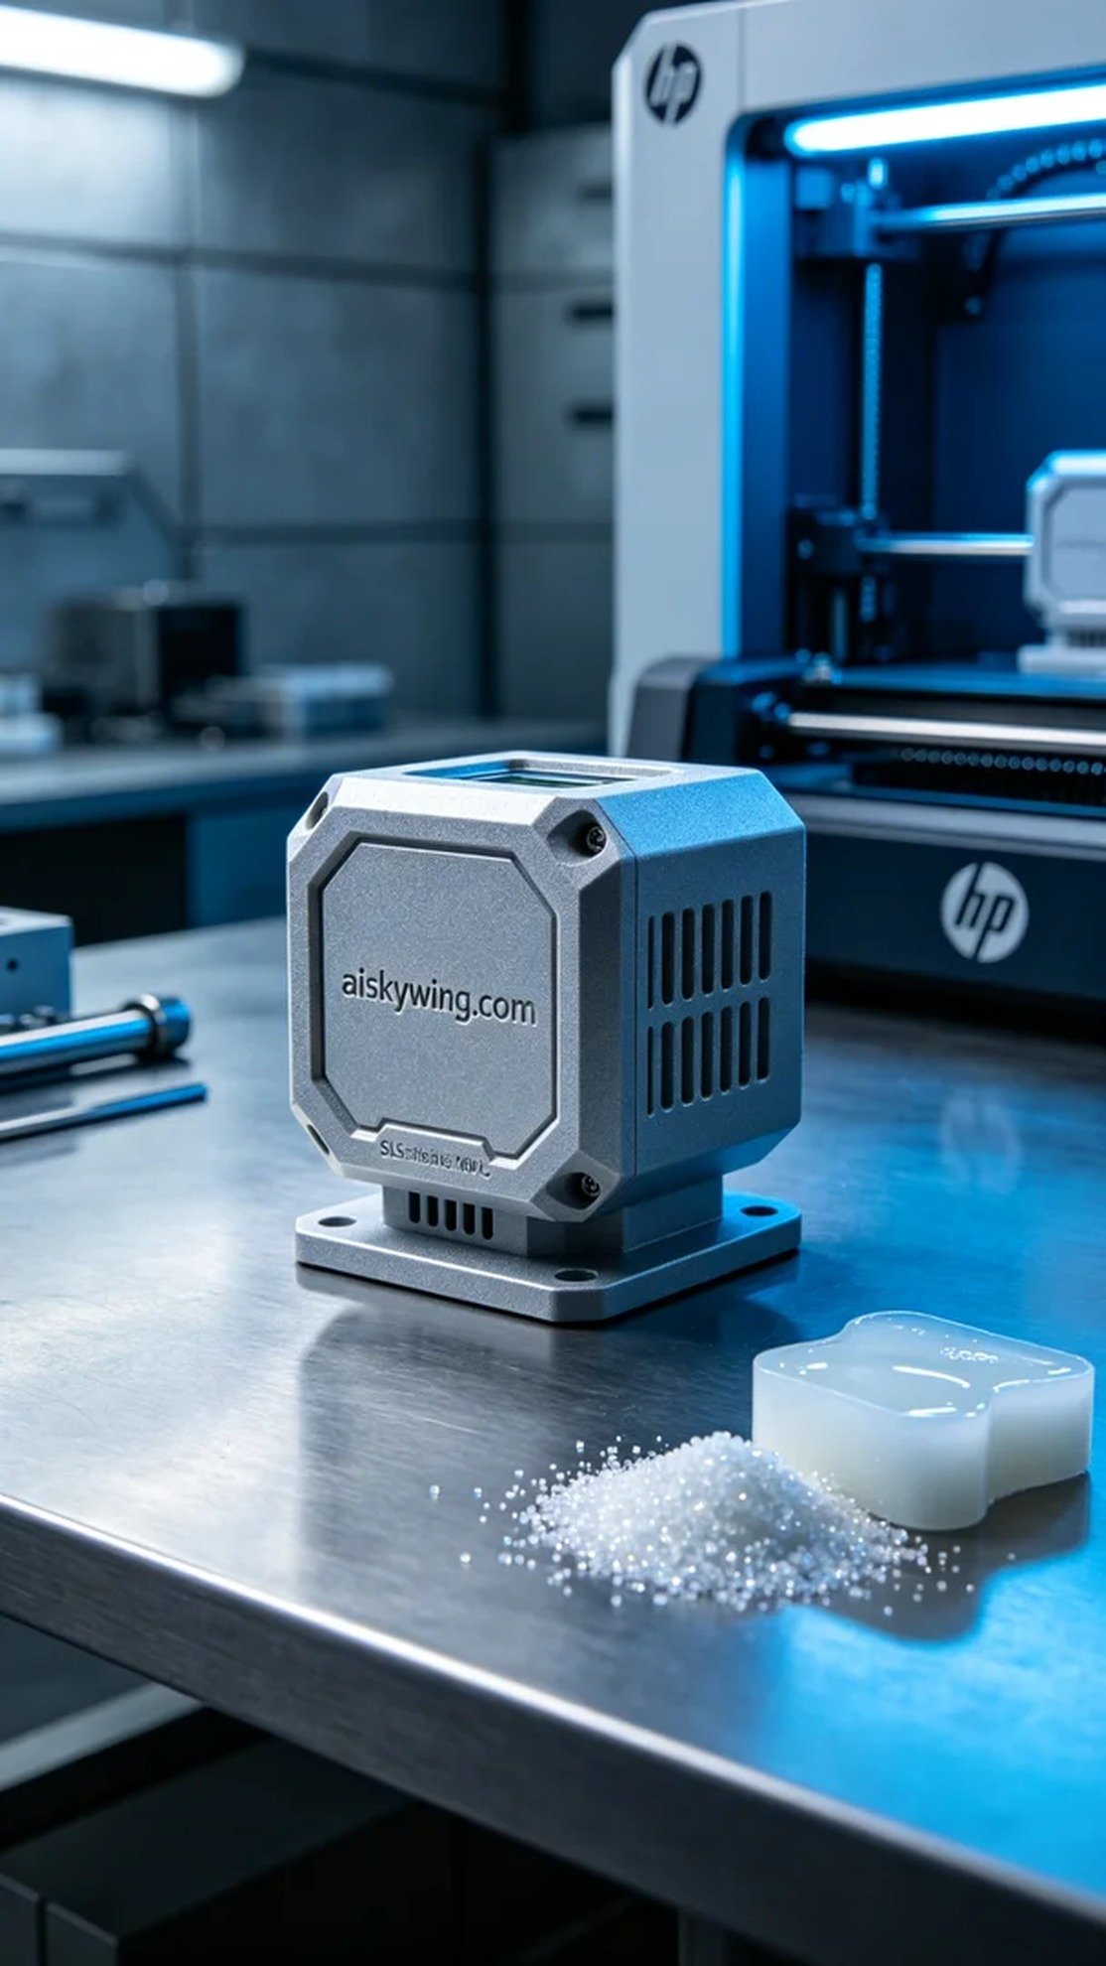
Life can be tough, but we must keep moving forward. Just like taking on the project for the sensor shell, someone reached out to me on LinkedIn, urgently needing a high-performance product.
On LinkedIn, someone contacted us with a requirement for a heat-resistant sensor shell. After understanding their specific needs, we decided to use SLS nylon to ensure we met their expectations.
During the preparation phase, we selected an HP brand 3D printer and ensured that the raw material was SLS nylon. This material can withstand temperatures above 150℃, features a matte finish, and effectively resists harsh industrial conditions. For the printing parameters, we set the layer thickness to 0.1mm, the printing temperature to 175℃, the power to 80%, and the speed to 40mm/s, expecting a total printing time of 6 hours.
Once the printing process began, the HP printer operated smoothly. Throughout the entire printing process, I closely monitored the device status to ensure every detail met expectations. As layers of material built up, I witnessed the sensor shell gradually taking shape, feeling satisfied while documenting each phase.
Post-processing is a crucial step. First, we placed the printed shell into a cleaning tank to remove excess powder. Then, we proceeded with sanding to ensure a smooth surface and achieve the desired aesthetic. After that, a curing process was undertaken to enhance the material's physical properties, followed by rigorous inspections to ensure all standards were met.
This production process not only improved our technical capabilities but also strengthened our team collaboration. Ultimately, the sensor shell was completed on schedule and met the expected quality standards, bringing great satisfaction.
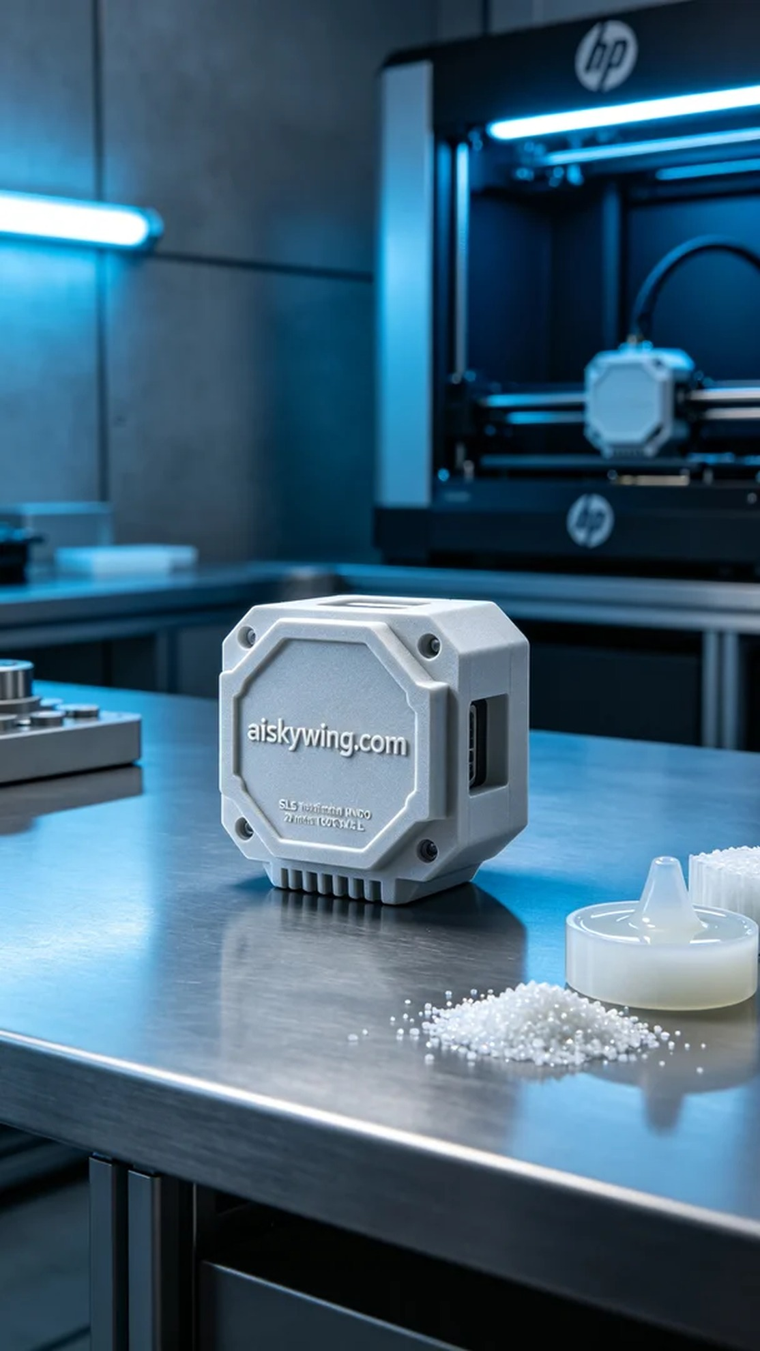
在LinkedIn上，有人因为对高温耐受性的需求找到我们，希望能够制作出一款抗热、耐用的传感器外壳。在了解了他们的具体要求后，我们决定使用SLS耐高温尼龙进行打印，以满足他们的需求。
在准备阶段，我们挑选了HP品牌的3D打印机，并确保原材料为SLS耐高温尼龙。这种材料的耐温性能可达150℃以上，表面磨砂质感，能够有效抵御工业环境中的严苛条件。打印参数设置方面，我们设定了层厚为0.1mm、打印温度为175℃、功率为80%，打印速度为40mm/s，预计打印时间为6小时。
打印过程开始后，HP打印机的运行相当平稳。在整个打印过程中，我时刻监控设备状态，确保每个细节都能达到预期效果。随着一层层材料的堆叠，我能看到传感器外壳的形状逐渐逼近设计图纸，满意的同时也不忘记录每个阶段的细节。
完成后处理是至关重要的一步。首先，我们将打印好的外壳放入清洗槽，去除多余的粉末。接着，进行打磨，以确保表面光滑，并达到所需的视觉效果。之后，再进行固化处理，以增强材料的物理性能，最终进行严格的检验，确保所有指标均符合要求。
这次生产过程不仅提升了我们的技术水平，也增强了团队的协作能力。最终，传感器外壳如期完成，达到预期质量标准，让人倍感欣慰。
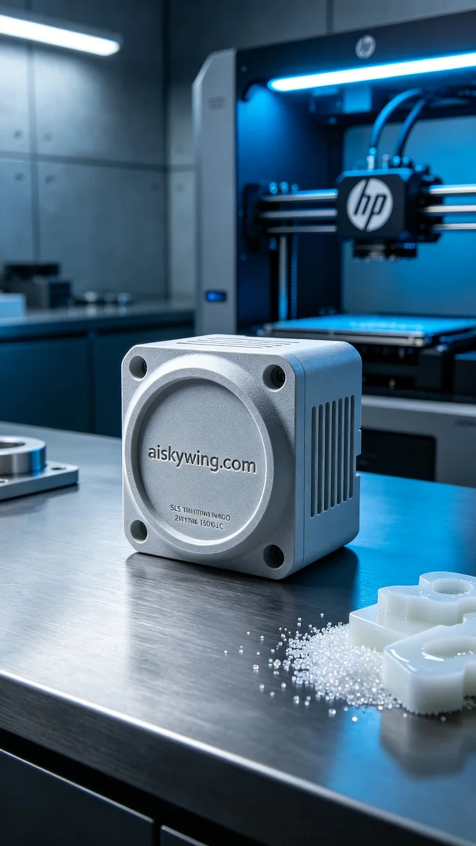
Aiskywing Industrial 3D Printing
Sensor housing


