1017-传感器底座的3D打印生产记录
Sensor base
🖨️ SLS尼龙烧结
🖥️ 打印机: Carbon
📦 材料: SLS耐高温尼龙
在YouTube上，有人因为寻找理想的传感器底座而找到了我们，正如人生的每一次探索，我们都在不断追求更好的成果。
On YouTube, someone found us while searching for the perfect sensor base. Just like every exploration in life, we are constantly striving for better outcomes.
________________________________________________________________________________
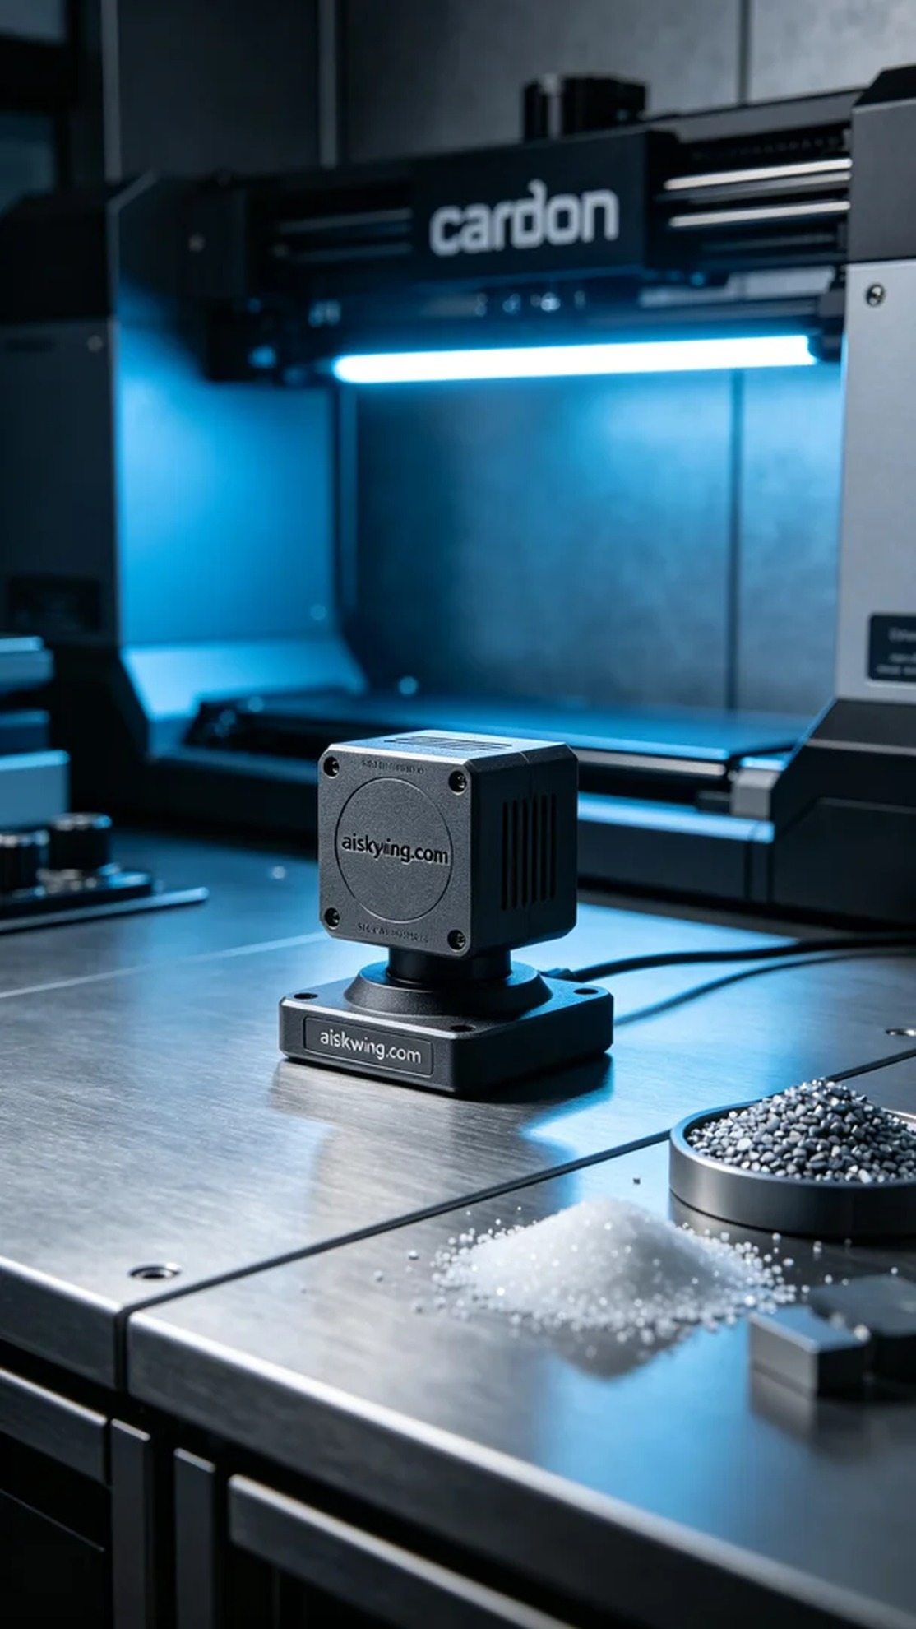
Recently, we were tasked with producing a sensor base after someone saw our technology showcase on YouTube. They were in search of a base with high temperature resistance to ensure functionality in harsh environments. To meet these requirements, we decided to employ SLS nylon sintering, ensuring the product had enhanced temperature and wear resistance.
For materials, we chose SLS high-temperature nylon. This material boasts excellent thermal stability, withstanding temperatures above 150°C, while providing outstanding impact resistance for the product. In terms of equipment, we used the Carbon brand 3D printer, setting the layer thickness to 0.1 mm and maintaining a printing temperature of 220°C. The power and speed were adjusted based on the complexity of the printed model, with an estimated total print time of 4 hours.
During the printing process, we strictly monitored the operation of the equipment to ensure the quality of each layer. The Carbon printer’s monitoring system provided real-time feedback on the printing status, allowing us to promptly identify and adjust any issues. As the printing progressed, the base gradually took shape, with its delicate matte texture becoming more evident, which filled us with satisfaction.
After printing, we carried out a series of post-processing steps. First, the printed base was placed in a cleaning solution to remove excess powder. Next, we sanded the base to enhance its surface smoothness and tactile feel. Then, it was placed in a curing device, exposed to UV light to further strengthen it, and finally underwent a thorough inspection to ensure every detail met the standards.
The sensor base was successfully completed, and with the properties of SLS high-temperature nylon, the quality and performance of the product were guaranteed. We always believe that striving for excellence is the best way to interpret each task we undertake.
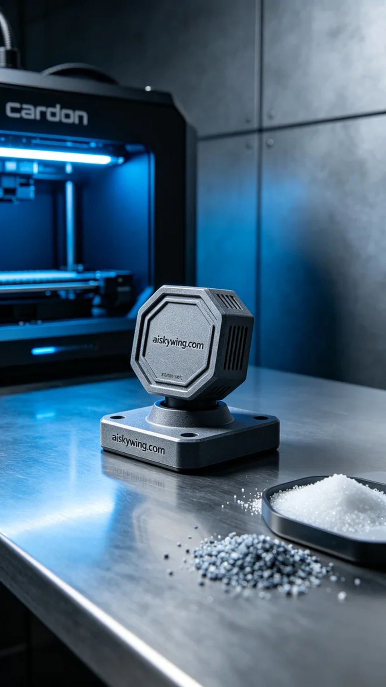
这次的任务是为一位客户制作传感器底座，主要是在YouTube上看到我们的技术展示后，主动联系了我们。他们对底座的耐高温性能有很高的要求，希望能在恶劣环境下稳定工作。为了满足他们的需求，我们决定采用SLS尼龙烧结工艺，确保产品具有更强的耐温和耐磨性。
在材料方面，我们选择了SLS耐高温尼龙。这种材料不仅具有良好的热稳定性，耐温可达到150℃以上，还能为产品提供出色的抗冲击性能。在设备准备上，我们使用了Carbon品牌的3D打印机，设置了层厚为0.1毫米，打印温度保持在220℃，功率和速度根据打印模型的复杂程度进行适当调节。整个打印过程预计需要4小时完成。
打印过程中，我们严格监控设备的运行状态，确保每一层的打印质量。Carbon打印机配备的监控系统能够实时反馈打印状态，使我们能够及时发现问题并进行调整。随着打印的进行，底座逐渐成型，表面细腻的磨砂质感也在逐步显现，这让我们倍感欣慰。
完成打印后，我们进行了一系列后处理工序，首先将打印好的底座投入清洗液中，去除多余的粉末。接着，我们对底座进行打磨，以提升其表面光洁度和触感。然后，底座被放入固化设备中，经过UV照射进一步增强其强度，最后进行全面检验，确保每一个细节都符合标准。
这次的传感器底座成功打印完成，凭借SLS耐高温尼龙的特性，产品的质量和性能都得到了保证。我们始终相信，精益求精才是对每一次工作的最好诠释。
Aiskywing Industrial 3D Printing
Sensor base


