1018-医用微量离心管架3D打印生产记录
Medical micro centrifuge tube rack
🖨️ SLA光固化
🖥️ 打印机: Carbon
📦 材料: SLA光固化树脂
生活再难，也别停下脚步。就像接下这个医用微量离心管架的单子，有人希望通过3D打印来解决医疗器械的需求。
No matter how difficult life gets, don't stop moving forward. Just like taking on the order for this medical micro centrifuge tube rack, some people hope to meet the demand for medical devices through 3D printing.
________________________________________________________________________________
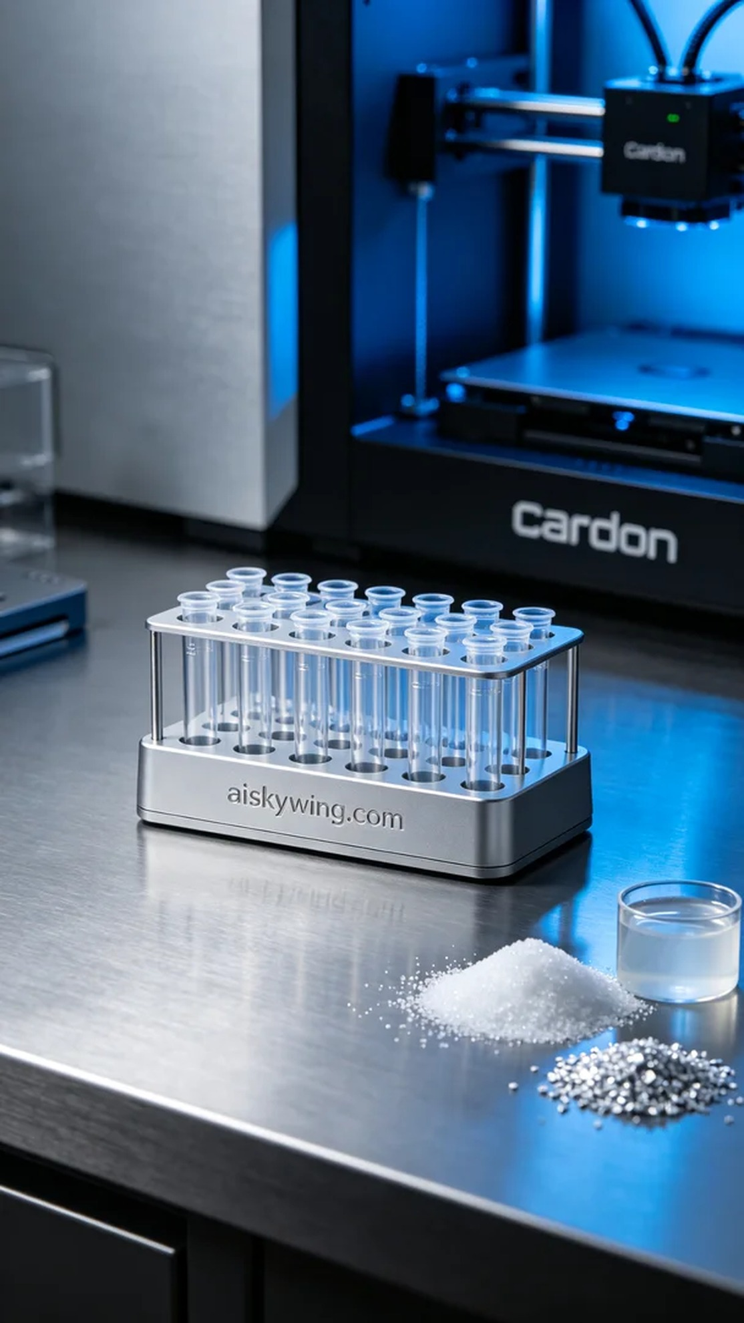
Life can be tough, but we should never stop moving forward. Just like taking on the task of printing a medical microcentrifuge tube rack, someone sought our help to address the needs of medical equipment through 3D printing.
For this project, we selected SLA (Stereolithography) resin as our raw material. This resin offers excellent fluidity and precision, making it ideal for producing intricate medical devices. During the equipment preparation phase, we utilized a Carbon 3D printer, setting a layer thickness of 50 microns, a printing temperature of 25 degrees Celsius, a power level of 40 milliwatts, and a print speed of 90 mm per second. The overall expected printing time was around 5 hours.
Throughout the printing process, the equipment operated smoothly, with the photosensitive resin solidifying layer by layer under the light source. We maintained rigorous quality monitoring, regularly checking the contact between the print head and the resin to ensure the accuracy and detail of the print were beautifully rendered.
Once the printing was complete, we proceeded with post-processing. Initially, the printed tube rack was placed in a cleaning solution to thoroughly remove any uncured resin from the surface. Next, we meticulously sanded the product to ensure a smooth, flawless surface. Finally, we cured it under UV light to enhance the hardness and durability of the material, followed by a comprehensive inspection to ensure every detail met medical standards.
After a series of production steps, the medical microcentrifuge tube rack was completed on schedule, successfully delivered to someone, showcasing the immense potential and value of 3D printing technology in the medical field.
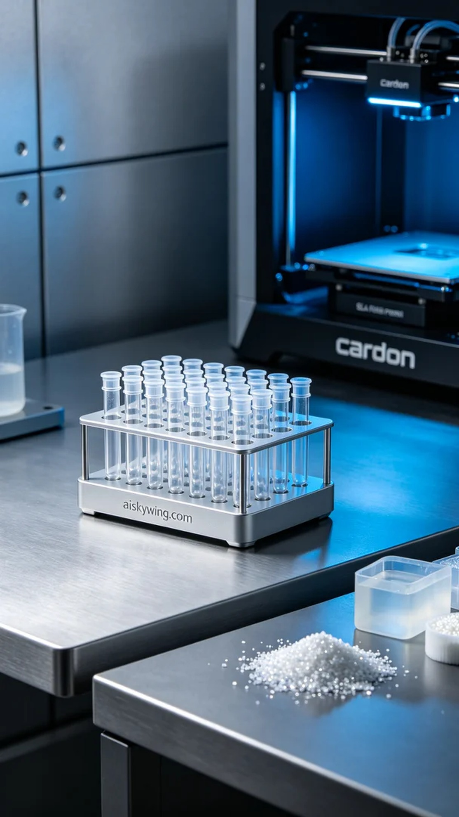
有人找到我们，希望通过3D打印技术解决医用微量离心管架的生产问题，尤其是在效率和精度方面。通过YouTube，他们了解到我们的服务，并希望能制造出高质量的产品。
为此，我们选择了SLA光固化树脂作为原材料，这种树脂具有良好的流动性和精度，适合制作精细的医疗器械。设备准备阶段，我们使用了Carbon品牌的3D打印机，设置了层厚为50微米，打印温度为25摄氏度，功率为40毫瓦，打印速度为90毫米每秒。整体打印时间预计在5小时左右。
打印过程中，设备稳定运行，光敏树脂在光源照射下逐层固化，整个过程保持了良好的质量监控。我们定期检查打印头与树脂的接触情况，以确保打印过程中的精度与细节被完美展现。
完成打印后，我们进行了后处理工序。首先，将打印好的离心管架置于清洗液中，彻底去除表面未固化的树脂。接着，我们对产品进行了细致的打磨，确保表面光滑无瑕疵。最后，在UV灯下固化，以增强材料的硬度和耐久性，最终进行全面检验，确保每个细节都符合医疗标准。
经过一系列的生产流程，医用微量离心管架如期完成，成功交付给有人，展现了3D打印技术在医疗领域中的巨大潜力与价值。
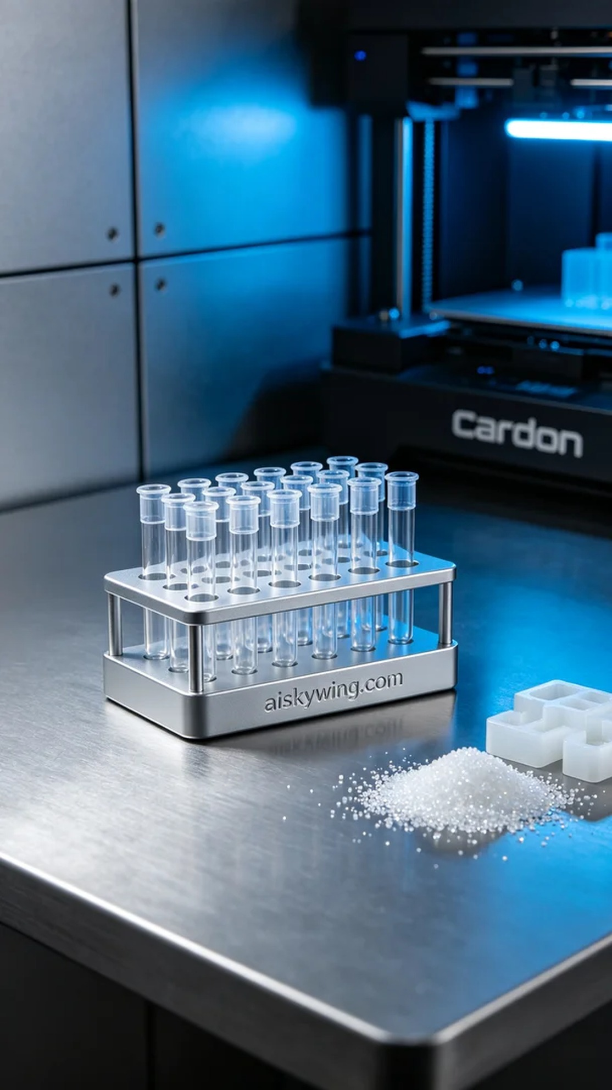
Aiskywing Industrial 3D Printing
Medical micro centrifuge tube rack


