1021-医用心电图电极夹3D打印记录
Medical ECG electrode clip
🖨️ SLA光固化
🖥️ 打印机: Mimaki
📦 材料: SLA光固化树脂
生活就像3D打印，过程虽长，但只要坚持，总能成型。最近有人在Facebook上寻求我们的帮助，想制作医用心电图电极夹，解决医疗仪器方面的问题。
Life is like 3D printing; the process may be long, but as long as you persist, you will eventually see results. Recently, someone reached out to us on Facebook seeking assistance in creating medical ECG electrode clips to address issues in medical instruments.
________________________________________________________________________________
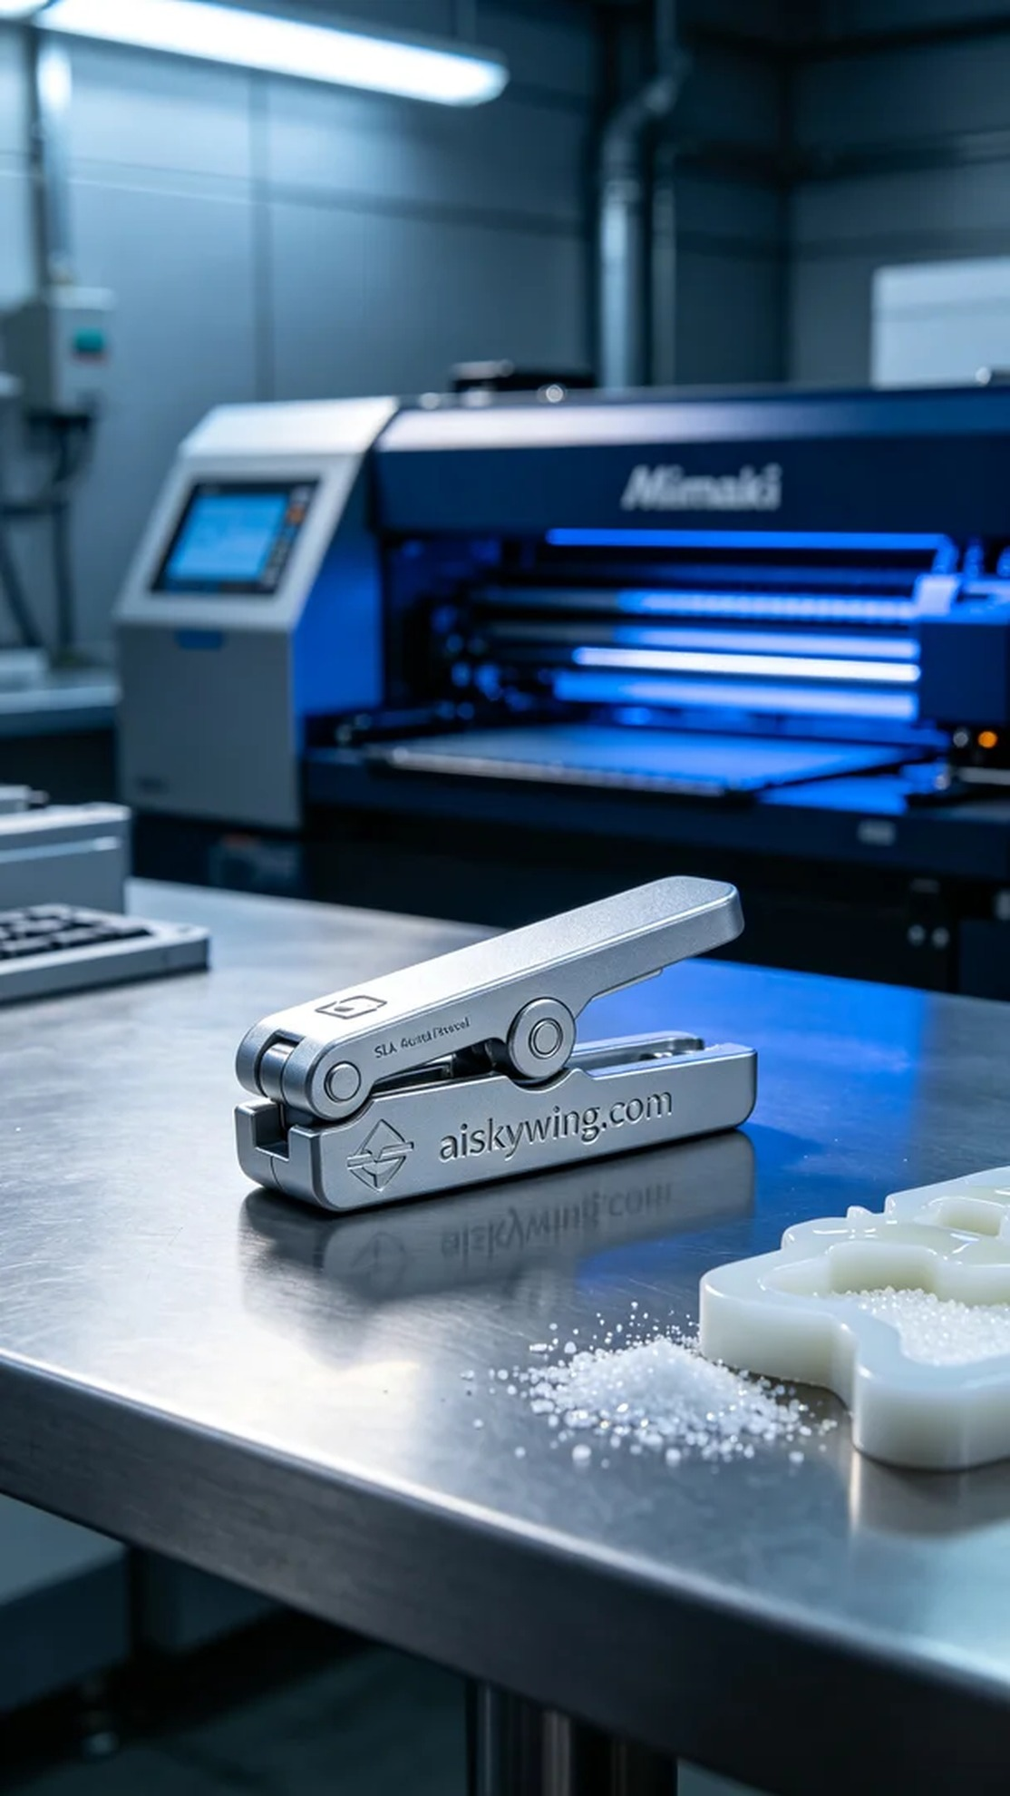
Life is like 3D printing; the process may be long, but persistence leads to results. Recently, someone reached out through Facebook seeking our help to produce ECG electrode clips for medical instruments, addressing a critical issue.
We chose SLA photosensitive resin for the printing material due to its excellent detailing and strength. During the preparation phase, we calibrated the Mimaki printer, setting the printing parameters to a layer thickness of 0.05mm, maintaining a temperature of 25 degrees Celsius, using a power setting of 30%, and a print speed of 50 mm/s, with an estimated printing time of 6 hours for each electrode clip.
During the printing process, the Mimaki printer operated smoothly, with the photosensitive resin curing layer by layer under UV light. We closely monitored the print quality to ensure no bubbles or layer adhesion issues occurred. Every detail needed to be meticulously controlled to ensure the final product met medical standards.
After printing, we conducted thorough post-processing procedures. First, the printed electrode clips were placed in a cleaning tank filled with isopropanol to remove uncured resin from the surface. We then meticulously polished them to enhance surface smoothness, followed by curing under UV light to ensure strength, and conducted a detailed inspection to guarantee every aspect was flawless.
After a series of precise efforts, the ECG electrode clips were successfully completed, showcasing outstanding quality. Witnessing each piece take shape in our hands brought a genuine sense of accomplishment.
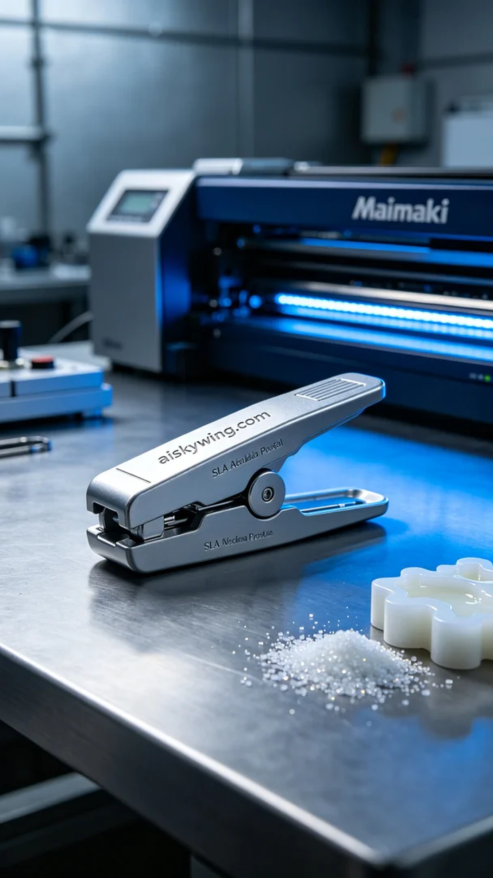
在一次偶然的机会中，有人通过Facebook联系了我们，寻求帮助制作医用心电图电极夹。这种产品在医疗器械中至关重要，然而现有供应链的延迟让他们迫切需要我们的支持。
我们选用了SLA光固化树脂作为打印材料，因其具备极佳的细节表现和强度。在准备阶段，我们对Mimaki打印机进行了一系列的调试，设置打印参数为0.05毫米的层厚，温度保持在25摄氏度，使用功率为30%，打印速度为50毫米每秒，预计打完每个电极夹需约6小时。
打印过程中，Mimaki打印机平稳运行，光固化树脂在紫外光照射下逐层成型。我们全程监控打印质量，确保无气泡和层间结合不良等问题。每个细节都需严格把控，以确保最终产品质量达到医疗标准。
打印完成后，我们进行了严格的后处理工序。首先将打印好的电极夹放入清洗槽中，使用异丙醇进行清洗，去除表面未固化的树脂。随后对其进行了细致的打磨，以提升表面光滑度，最后还需在紫外线固化机内进行固化，确保其强度满足使用需求，最后进行了逐一检验，确保每一个细节都完美无瑕。
经过一系列的精细工作，医用心电图电极夹顺利完成，展现出极佳的质量。看着这一件件产品在我们手中成型，感到真正的成就感。
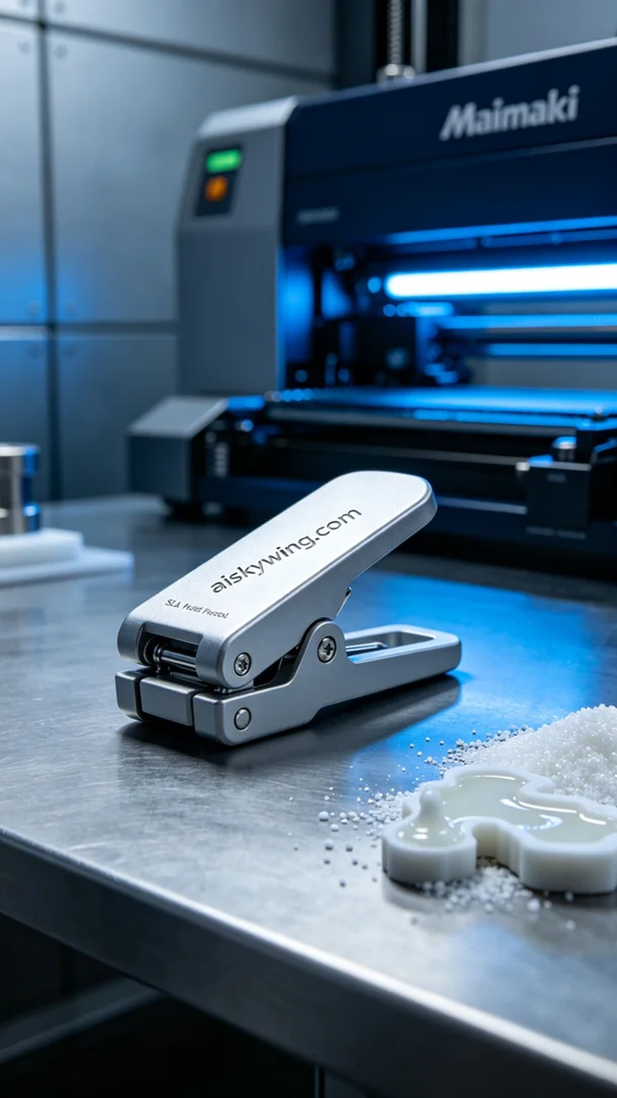
Aiskywing Industrial 3D Printing
Medical ECG electrode clip


