1024-充电头外壳3D打印记录
Charging head shell
🖨️ SLA光固化
🖥️ 打印机: Stratasys
📦 材料: SLA光固化树脂
生活就像一场3D打印，有时需要精雕细琢。最近，有人通过LinkedIn找到我们，希望制作一个充电头外壳。
Life is like a 3D print; sometimes it requires meticulous craftsmanship. Recently, someone reached out to us through LinkedIn, hoping to create a charging head shell.
________________________________________________________________________________
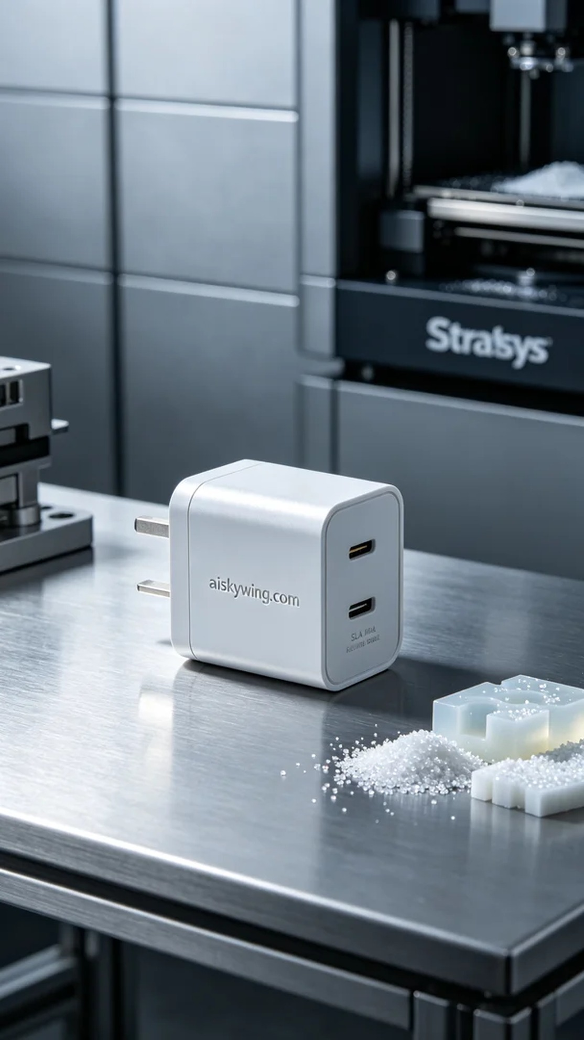
Life is like a 3D print, sometimes requiring meticulous refinement. Recently, someone reached out to us through LinkedIn, hoping to create a charging head shell.
We chose SLA photopolymer resin as the material since it has excellent flowability and forming precision, making it suitable for printing complex details. We used a Stratasys 3D printer, setting the layer thickness to 0.1 mm, with a printing temperature of 25°C, a laser power of 150mW, and a printing speed of 30 mm/s to enhance the smoothness and detail of the finished product.
During the printing process, the machine ran very smoothly. We monitored the printing status in real-time to ensure each layer bonded perfectly. As the printing progressed, the contours of the shell became clearer, and the details became more pronounced, which was quite gratifying.
After printing, we carried out detailed post-processing. First, we cleaned the shell with IPA solution to remove excess resin. Then, we meticulously sanded it down to achieve a matte finish, minimizing light reflection. Finally, the shell was placed in a curing unit for UV curing to ensure its strength and durability, followed by final inspection to confirm that every detail was flawless.
With this meticulous production process, the charging head shell was finally completed. Each step was a test of our craftsmanship, and the final result made me feel a sense of pride.
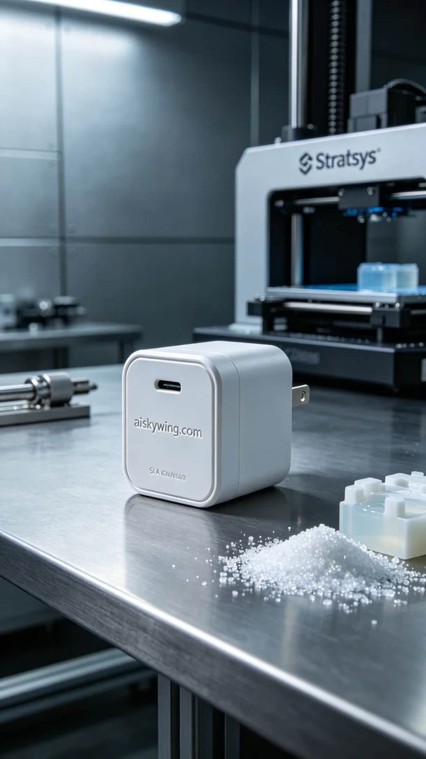
为了满足某人的需求，我们开始了这个充电头外壳的3D打印项目。他们希望外壳在工艺和外观上都能达到高标准，这让我想起了我们的责任和使命感。
我们选择了SLA光固化树脂作为原材料，这种树脂的流动性和成型精度都非常好，适合用于打印复杂的细节。为了确保打印质量，我们使用了Stratasys品牌的3D打印机，设置了0.1毫米的层厚，并将打印温度设定在25°C，激光功率为150mW，打印速度为30毫米每秒，这样可以有效提高成品的光滑度和细致度。
在打印过程中，设备运行非常平稳。我们实时监控打印状态，确保每一层都能完美结合。随着打印的逐渐深入，外壳的轮廓越来越清晰，细节也愈加显著，令人倍感欣喜。
打印完成后，我们进行了详细的后处理工序。首先，使用IPA溶液对外壳进行清洗，以去除多余的树脂。随后，我们进行了精细打磨，力求表面达到哑光质感，尽量减少光线的反射。最后，将外壳放入固化设备中进行紫外线固化，确保其强度和耐用性，然后进行最终检验，确认每一个细节无误。
通过这样的制作流程，这个充电头外壳终于完成了。每一个环节都是对我们工艺的考验，最终的成果让我充满自豪。
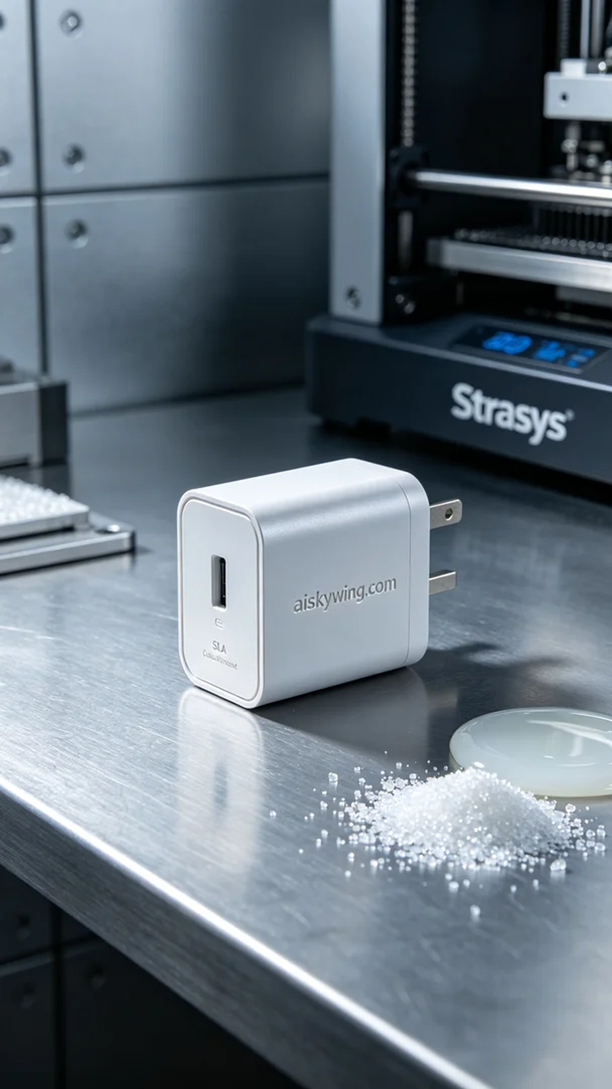
Aiskywing Industrial 3D Printing
Charging head shell


