1025-全向麦外壳置于画面正中央的SLA光固化之旅
Omnidirectional Wheat Husk
🖨️ SLA光固化
🖥️ 打印机: Rize
📦 材料: SLA光固化树脂
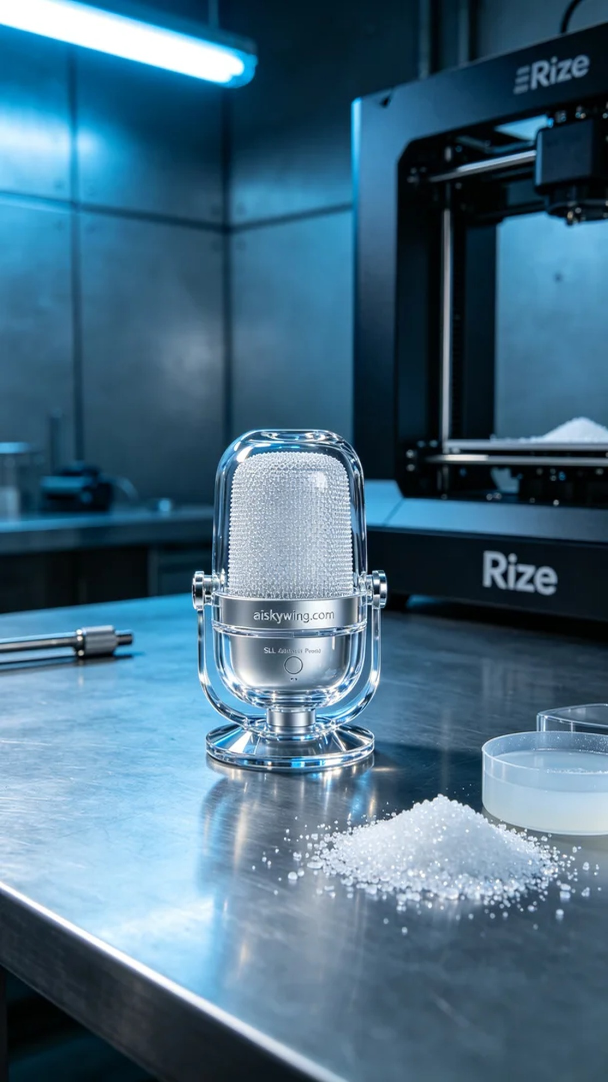
Someone contacted us on WhatsApp, saying that they couldn't get the omnidirectional microphone shell to print properly in the center of the screen after trying three times. It was made using SLA light-curing technology, and the issue has not been resolved.
The material used is SLA light-curing resin with moderate viscosity, and it should be preheated to an appropriate temperature before printing. The layer thickness is set to 0.05mm, with extended exposure for the bottom layer to ensure strong adhesion to the platform.
The Rize printer ran for about seven hours straight without interruption. During the printing process, we couldn't leave the area and had to monitor the attachment of the first layer closely.
For post-processing, we first cleaned the surface with alcohol to remove excess resin. Then, we placed it in the UV curing chamber at 60 degrees for forty minutes to ensure it reaches the required hardness. Finally, we polished it, and the surface became shiny.
In total, it took five days to get it done.
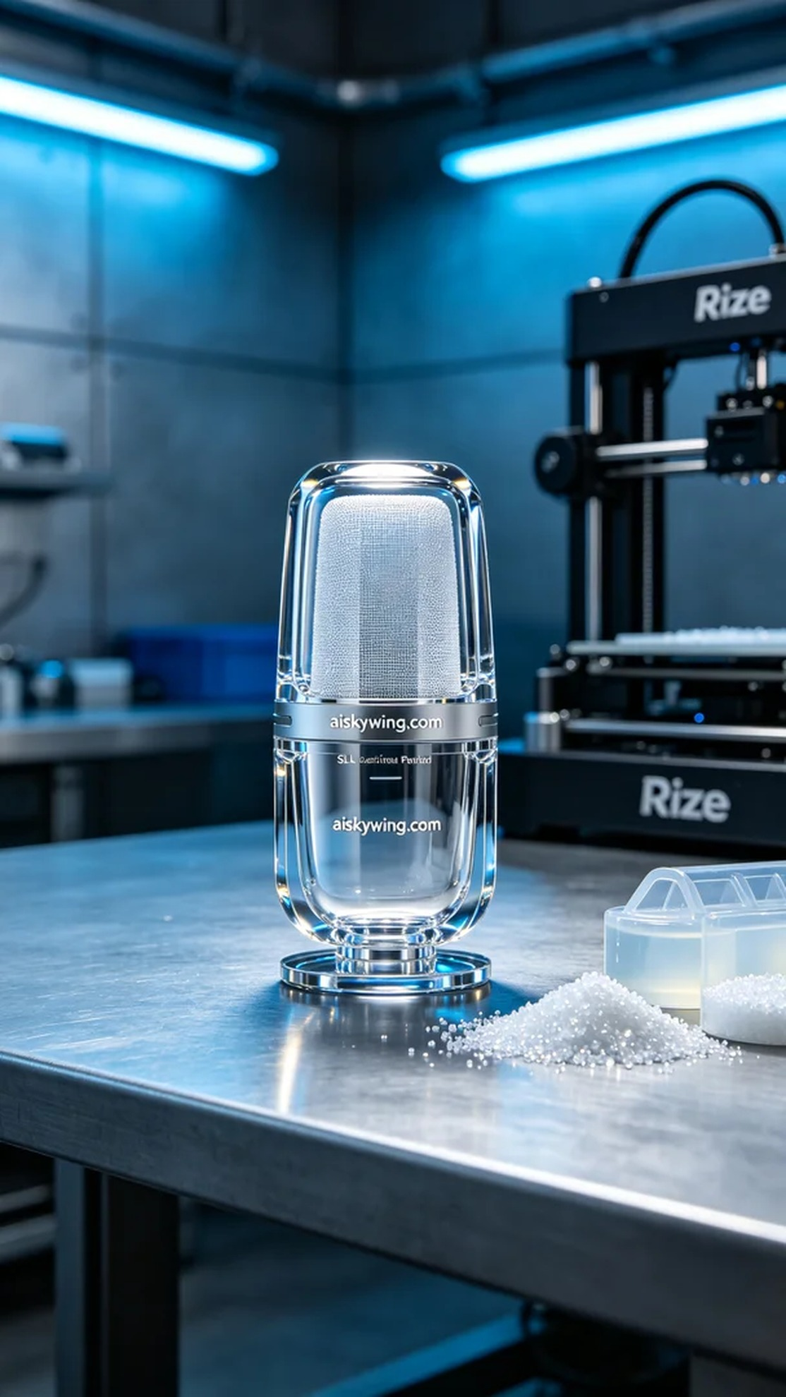
WhatsApp上有人找我们，说全向麦外壳置于画面正中央打了三回都搞不定，SLA光固化工艺做的，问题一直解决不了。
材料用SLA光固化树脂，黏度适中，上机前预热到合适温度。层厚设的0.05mm，底层曝光加长，保证粘平台粘得牢。
Rize打印机跑了大概7个多小时，中间没断。机子跑的时候人也不能走远，得盯着第一层的附着情况。
后处理先用酒精清洗，把表面多余的树脂洗掉。然后进UV固化箱，60度烘四十分钟，硬度才能达标。最后打磨抛光，表面就亮了。
前后五天，搞定。
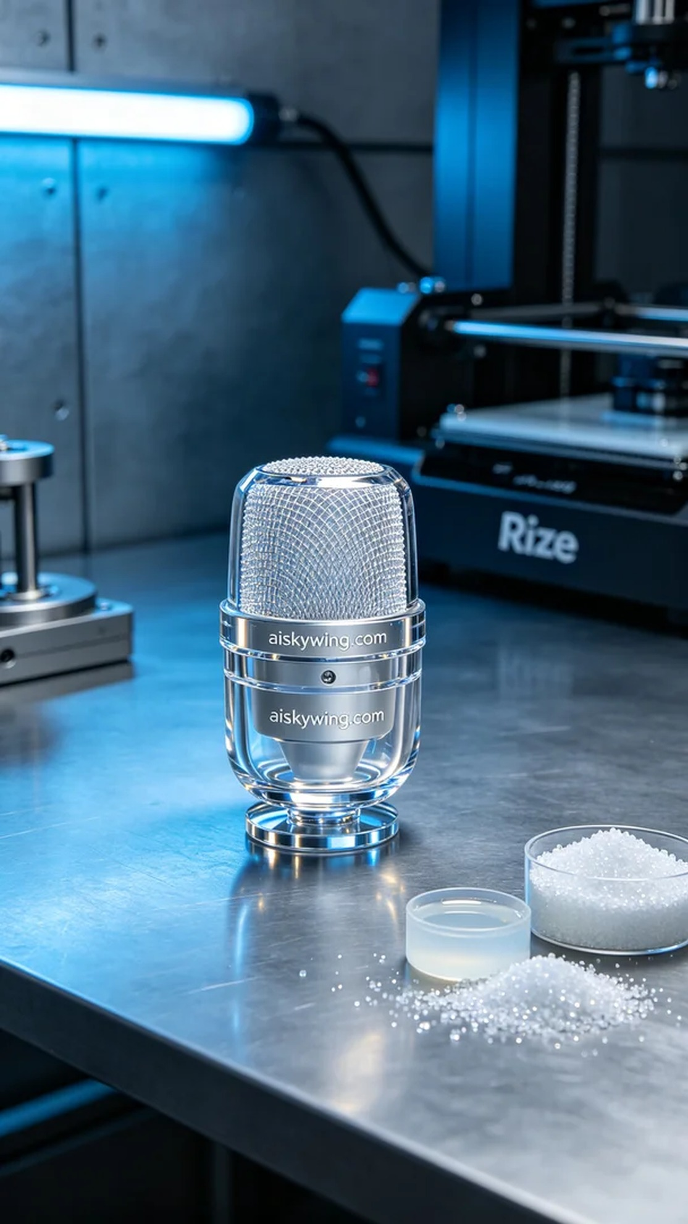
Aiskywing Industrial 3D Printing
Omnidirectional Wheat Husk


