1026-冰箱门把手制作记录
Refrigerator door handle
🖨️ SLA光固化
🖥️ 打印机: Stratasys
📦 材料: SLA光固化树脂
生活就像这冰箱门把手的制作过程，虽有挑战，但坚持下去就能迎来成果。有位朋友在WhatsApp上联系我，想要解决一个设计上的难题。
Life is like the process of making this refrigerator door handle; although there are challenges, persistence will lead to results. A friend contacted me on WhatsApp, wanting to solve a design problem.
________________________________________________________________________________
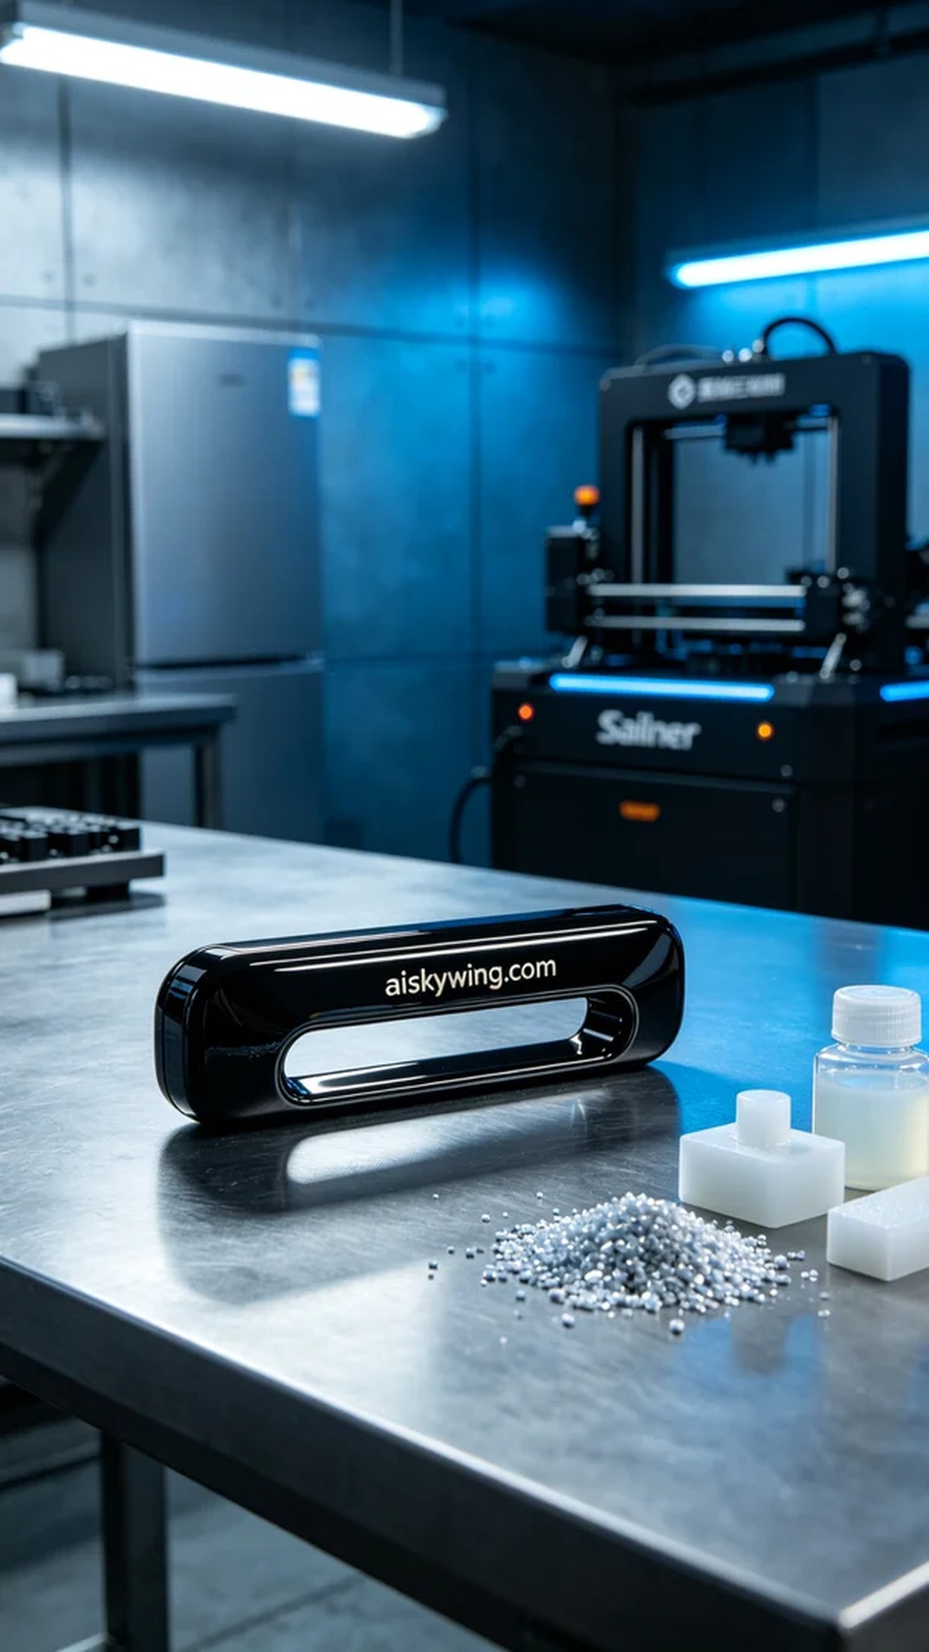
Life is much like the process of making this refrigerator door handle; it presents challenges, but perseverance leads to rewarding outcomes. A friend reached out on WhatsApp, seeking solutions for a design dilemma regarding the handle.
We utilized SLA photopolymer resin for this project, known for its excellent precision and detail. In preparation, I calibrated the Stratasys printer, setting the layer thickness to 0.05mm, maintaining a printing temperature of 25℃, adjusting the laser power to 50mW, and setting the print speed to 30mm/s. These settings strike a good balance between detail and strength.
The printing process was underway, with the Stratasys printer humming steadily as the resin cured layer by layer. I monitored the print quality closely, ensuring every detail met the expected standards. The entire process lasted about 6 hours, and as the final layer completed, the outline of the handle became distinctly visible.
For post-processing, we first immersed the printed handle in isopropyl alcohol for cleaning, removing any residual resin. After cleaning, the component was polished to achieve a smoother surface. Next, we placed it in a UV curing box to ensure optimal strength. Finally, the completed product underwent inspection, ensuring every detail met our design criteria.
After a series of meticulous steps, the refrigerator door handle was finally completed. Despite the challenges faced along the way, every effort was worthwhile when seeing the finished product.
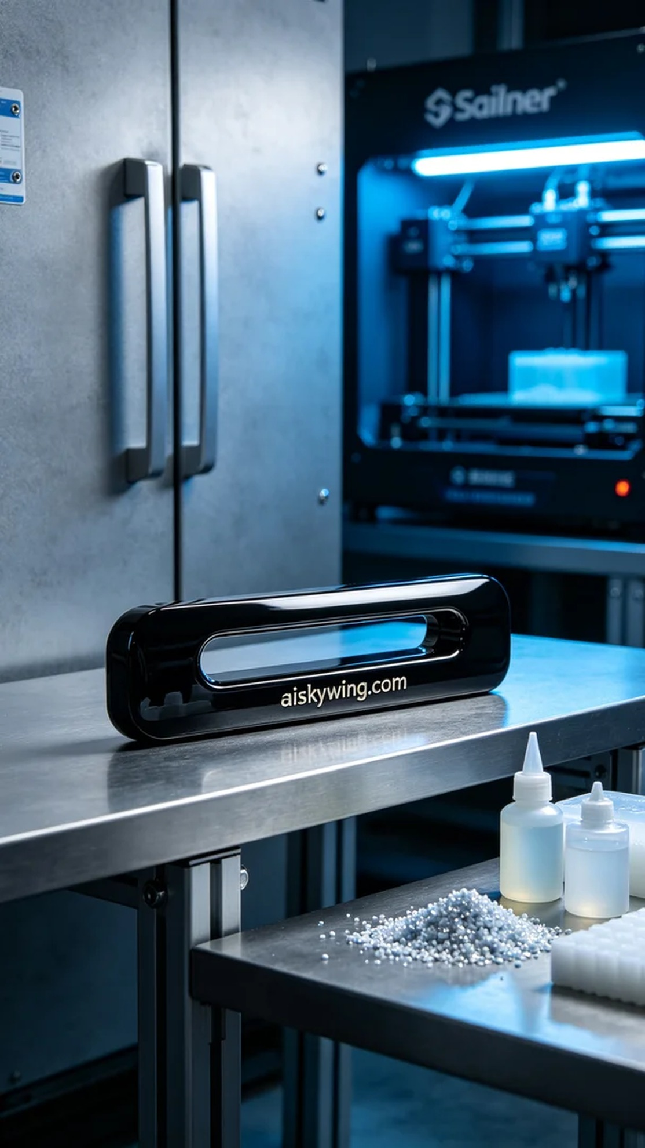
在WhatsApp上，有人请教我们关于冰箱门把手的制作问题，想要实现一个新颖而独特的设计。这个把手不仅要美观，还要具备实用性，于是我们开始了这项新的挑战。
我们使用的是SLA光固化树脂，这种材料具备优异的精度和细节呈现能力。准备工作中，我调试了Stratasys打印机，设置了层厚为0.05mm，打印温度保持在25℃，激光功率调至50mW，打印速度为30mm/s。这样的参数能够确保在细节与强度之间达到良好的平衡。
打印过程如火如荼，Stratasys打印机在运行时发出平稳的嗡嗡声，树脂逐层被固化成型。与此同时，我时刻监控打印质量，确保每个细节都达到预期标准。整个打印过程持续了约6小时，当最后一层完成时，成品的轮廓已经清晰可见。
后处理方面，我们首先将打印好的把手放入异丙醇中进行清洗，以去除残留的树脂。清洗后，拿出部件进行打磨，将表面处理得更加光滑。接着，将其放入UV固化箱中，进行固化，确保把手强度达到最佳状态。最后，我们对成品进行检验，确保每一处细节都符合设计要求。
经过一系列的生产步骤，这个冰箱门把手终于完成了。虽然过程中困难重重，但每一步都是值得的，看到成品时，所有的努力都化为了满足。
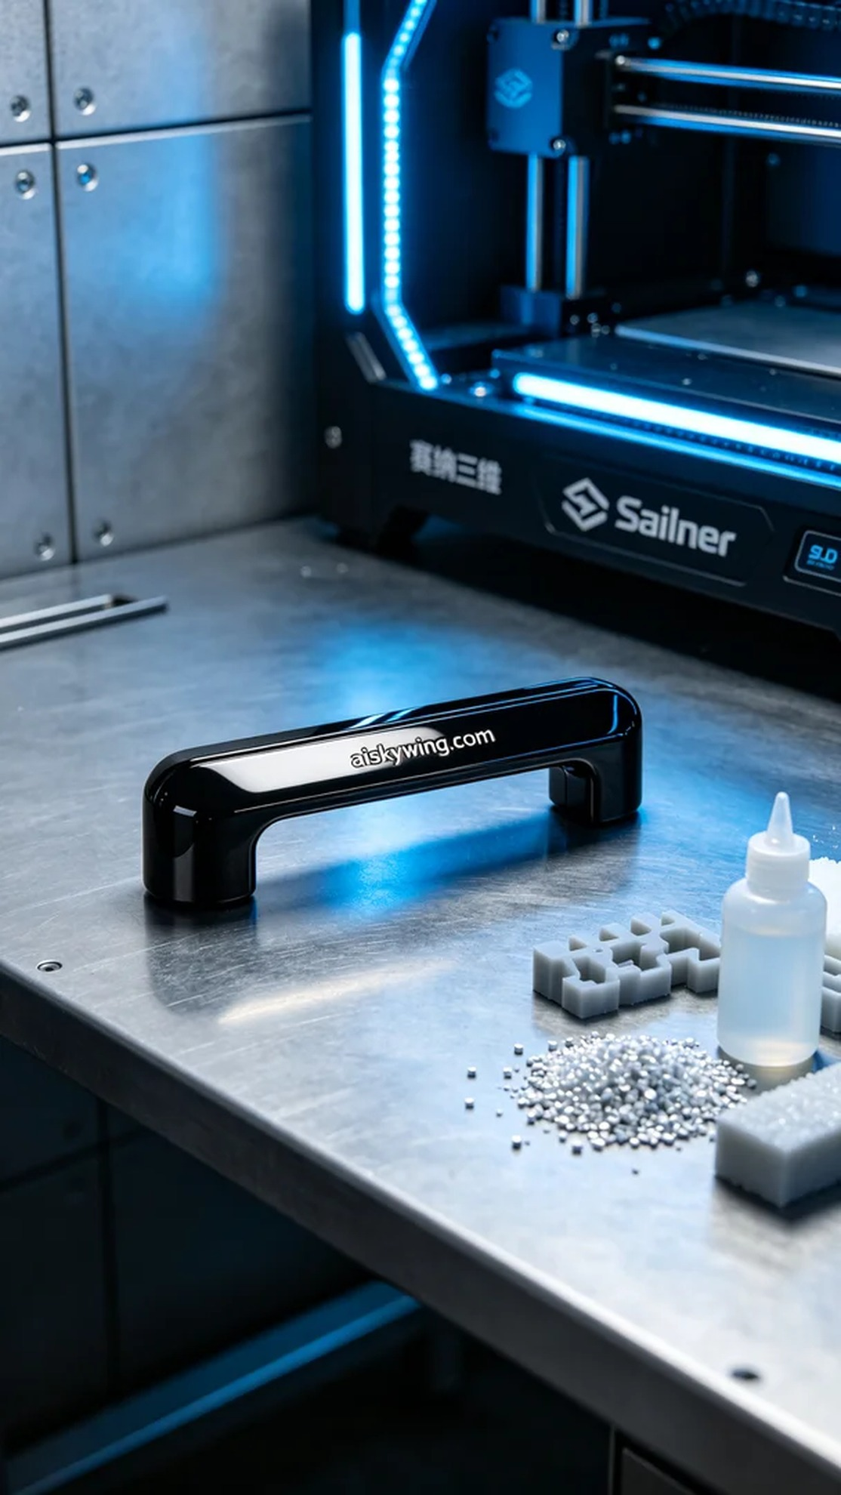
Aiskywing Industrial 3D Printing
Refrigerator door handle


