1027-冲牙器手柄3D打印生产记录
Water flosser handle
🖨️ SLA光固化
🖥️ 打印机: Carbon
📦 材料: SLA光固化树脂
生活就像3D打印，任何细节都需认真对待。有人因冲牙器手柄的问题找到了我们，希望通过精细的工艺解决他们的需求。
Life is like 3D printing; every detail must be taken seriously. Someone reached out to us regarding an issue with their water flosser handle, hoping to address their needs through meticulous craftsmanship.
________________________________________________________________________________
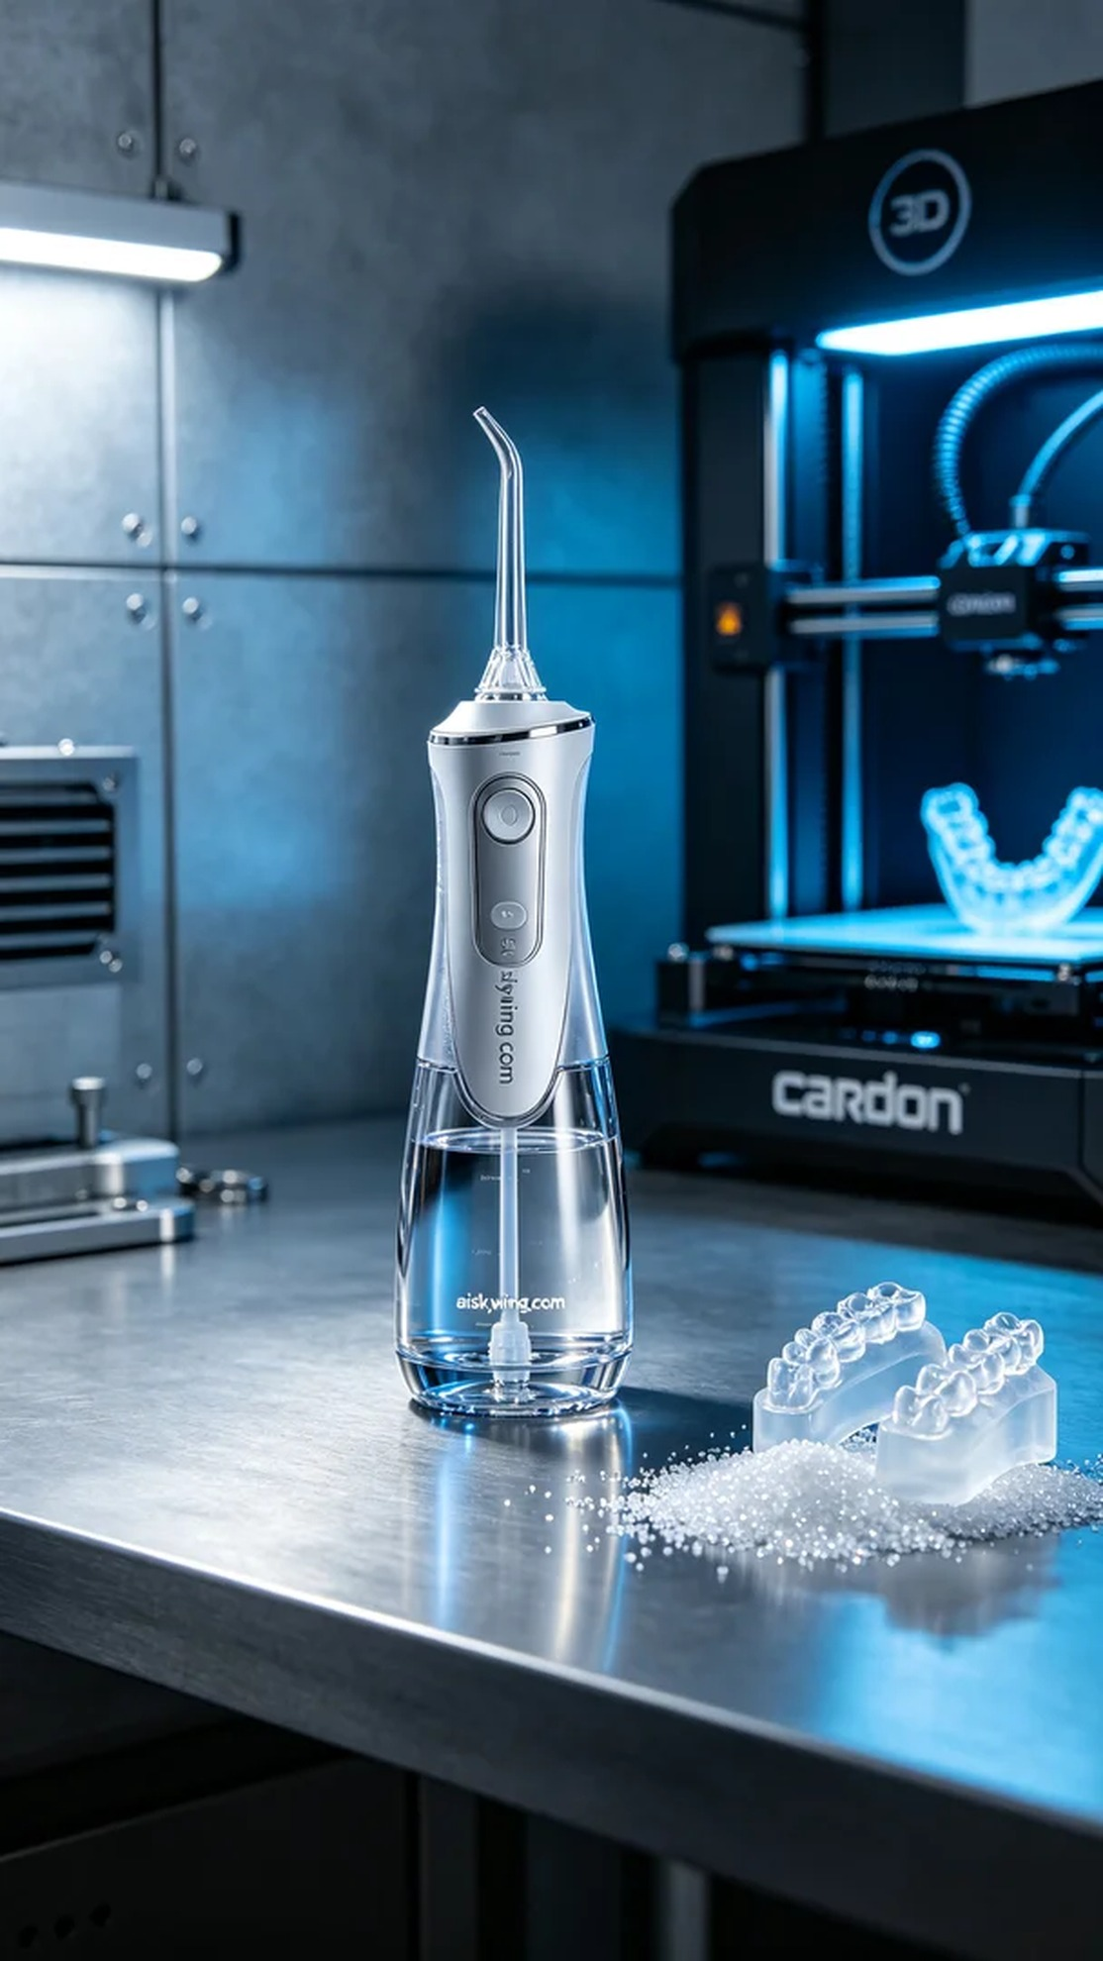
Life is like 3D printing; every detail must be taken seriously. Someone reached out to us with an issue regarding a dental water flosser handle, believing our precise craftsmanship could address their needs.
For the production, we opted for SLA photopolymer resin as our material due to its high precision and excellent transparency. We set the layer thickness to 0.05mm, maintained a printing temperature of 25 degrees Celsius, utilized a UV power of 50mW, and set the printing speed to 40mm/s. Using the Carbon 3D printer, we proceeded fully prepared into the printing stage.
As the printing process began, the Carbon printer operated steadily, with the liquid resin gradually forming each layer. I closely monitored the printing progress to ensure every detail was captured clearly. As time elapsed, the contours of the dental flosser handle began to emerge, which was quite exhilarating.
Once printing was complete, we placed the product into a cleaning station to remove any uncured resin on the surface. After cleaning, we meticulously sanded down the handle for a smoother finish and better tactile experience. Next, it was placed in a curing chamber to enhance its durability and stability. We conducted a final quality check to ensure it met our standards before organizing it for delivery.
This process of printing the dental water flosser handle deepened my understanding of the importance of detail, and I felt a great sense of satisfaction with the results. Through our professional 3D printing technology, we successfully completed this task.
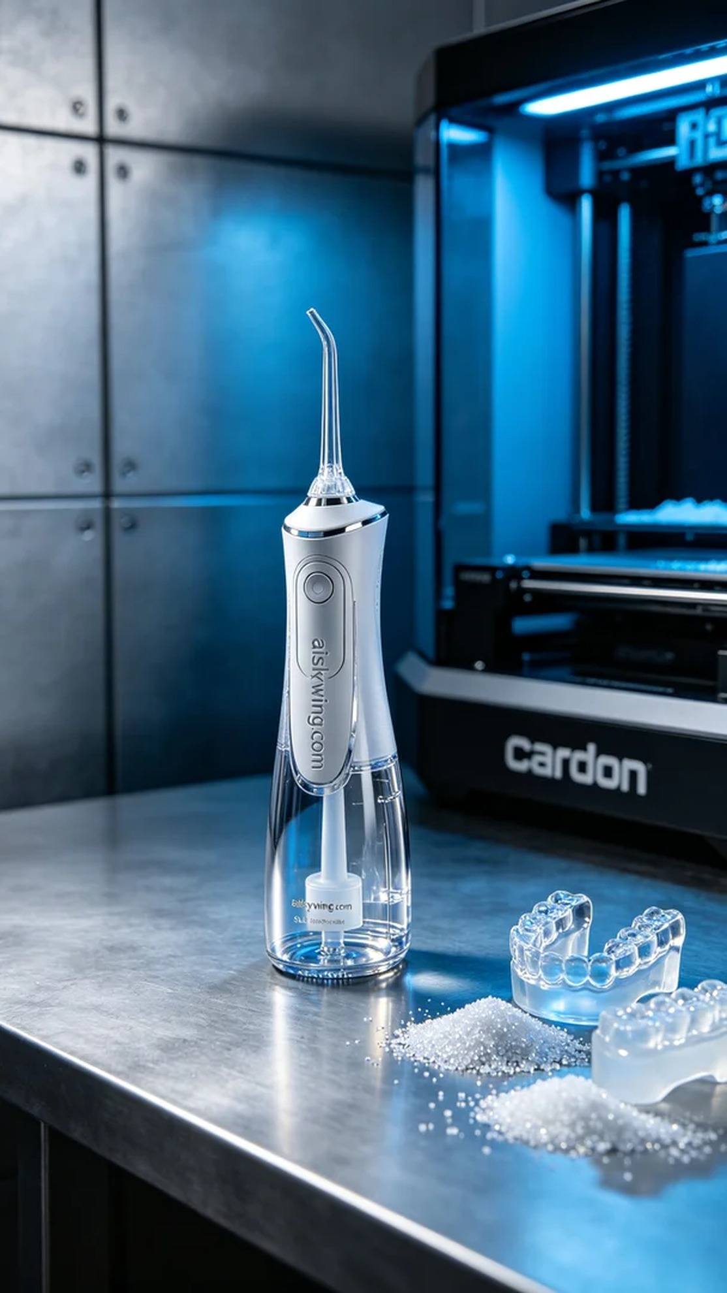
这次制作冲牙器手柄的任务是从YouTube上的一段视频中提炼出来的。有人看到市场上现有产品的不足，认为我们的专业3D打印技术可以填补这一空白，因此联系我们。我们开始了这次充满期待的打印之旅。
我们选择了SLA光固化树脂作为原材料，这种材料的优点在于其高精度和良好的透明度。为了确保打印质量，设置了层厚为0.05mm，打印温度维持在25摄氏度，紫外光功率为50mW，打印速度设置为40mm/s。设备是Carbon品牌的3D打印机，经过充分准备后，进入了打印阶段。
打印过程开始后，Carbon打印机稳定地运转着，液态树脂在每一层的固化中逐渐形成。为了保证质量，我一直在监控打印进程，确保每个细节都能清晰呈现。随着时间的推移，冲牙器手柄的轮廓逐渐显现，令人振奋。
打印完成后，首先将成品放入清洗槽中进行清洗，去除表面的未固化树脂。清洗后，我们对手柄进行了细致的打磨，使其表面更加光滑，手感更佳。接着，将手柄放入固化箱中进行固化，以确保其耐用性和稳定性。最后，对成品进行检验，确认其符合标准后，我们才会将其整理好。
这次的冲牙器手柄打印过程让我深刻体会到细节的重要性，成果也让我倍感满足。通过专业的3D打印技术，我们顺利完成了这一任务。
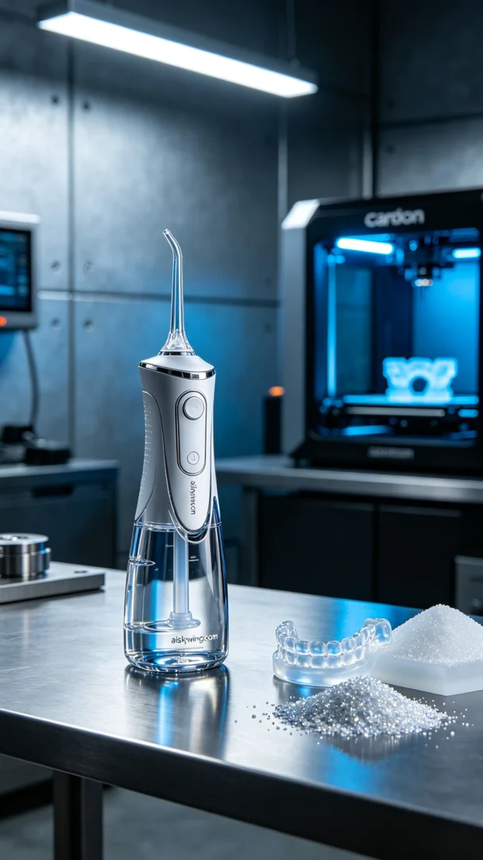
Aiskywing Industrial 3D Printing
Water flosser handle


