1028-剃须刀刀头支架3D打印生产记录
Razor head holder
🖨️ SLA光固化
🖥️ 打印机: Xjet
📦 材料: SLA光固化树脂
生活再难，也别停下脚步。就像接下这个剃须刀刀头支架的单子，许多人都在寻找高品质的产品，而我们正是他们的选择。
No matter how tough life gets, don't stop moving forward. Just like taking on this order for razor head holders, many people are looking for high-quality products, and we are their choice.
________________________________________________________________________________
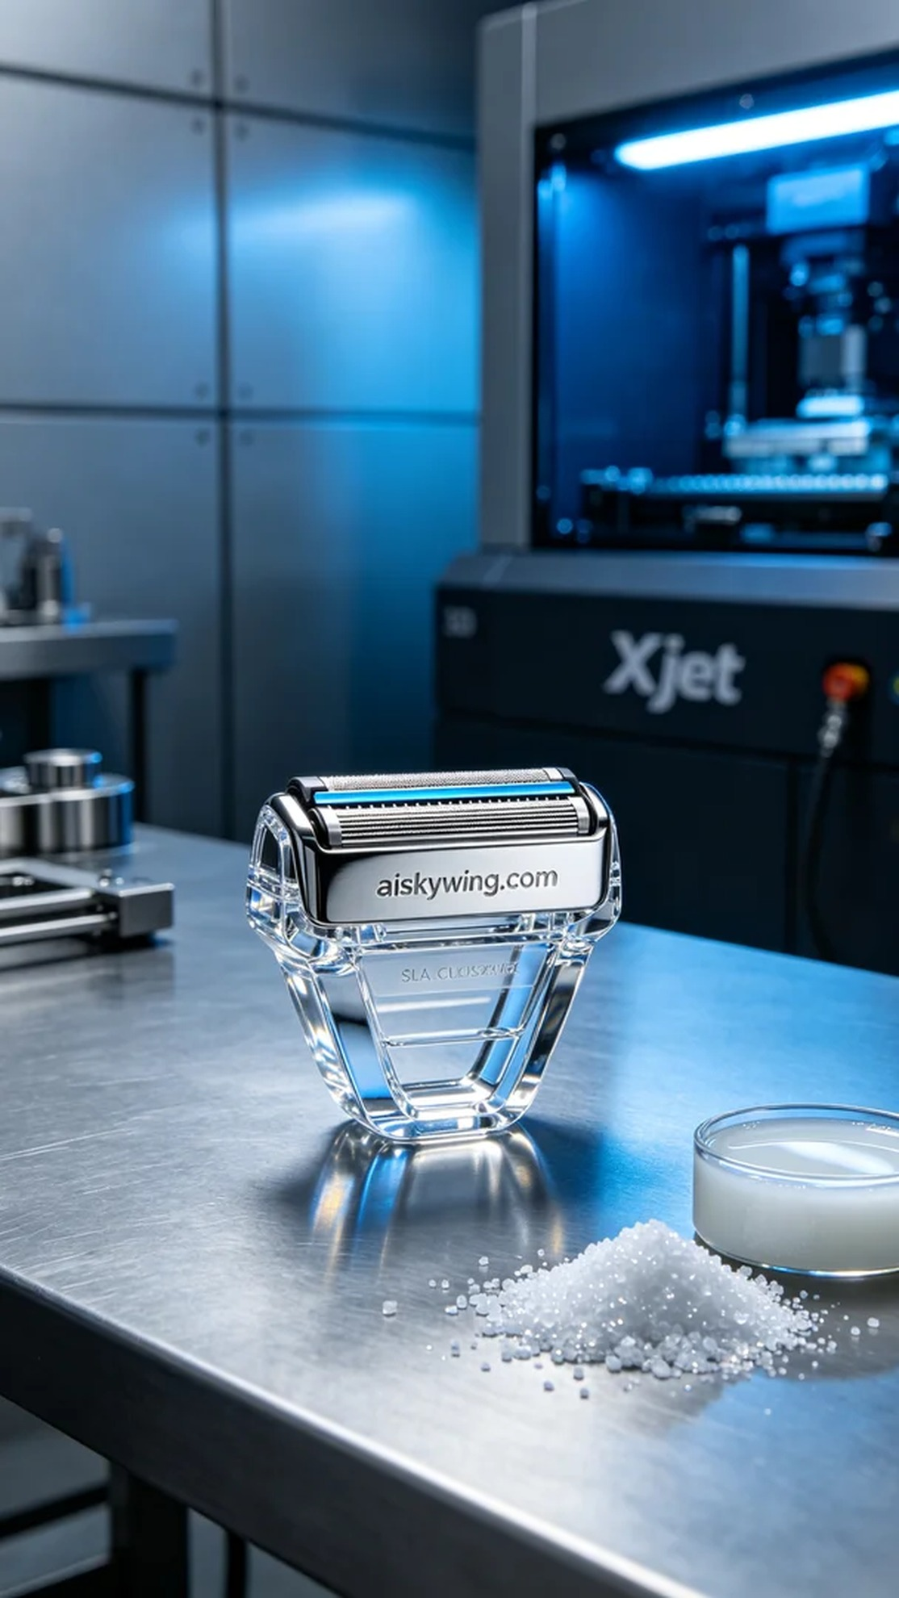
On Facebook, someone reached out to us looking for a durable razor head holder. They had high expectations for product quality and hoped to achieve precise design and outstanding durability through 3D printing.
We chose SLA photopolymer resin as the raw material, which offers excellent transparency and high gloss, allowing for ultimate clarity in details. Before printing, we meticulously set the printing parameters, opting for a layer thickness of 0.05mm, a printing temperature of 25°C, a power setting of 80%, and a speed of 30mm/s to ensure a perfect output.
During the printing process, the performance of the Xjet printer impressed me. The machine operated steadily, and the entire process took about 4 hours. We monitored the quality at all times, ensuring that each layer cured smoothly, resulting in a razor head holder with a smooth surface and sharp details.
After printing, we carried out a series of post-processing procedures. First, we soaked the finished product in a cleaning solution to remove any uncured resin. Then, we used fine sandpaper for sanding to make the surface even smoother. Finally, we performed UV curing to enhance the strength and durability of the product, and conducted a rigorous inspection to ensure that each item met our standards.
Overall, the production process of this razor head holder went smoothly. We not only completed the task but also ensured quality, ultimately delivering the product to those in need.
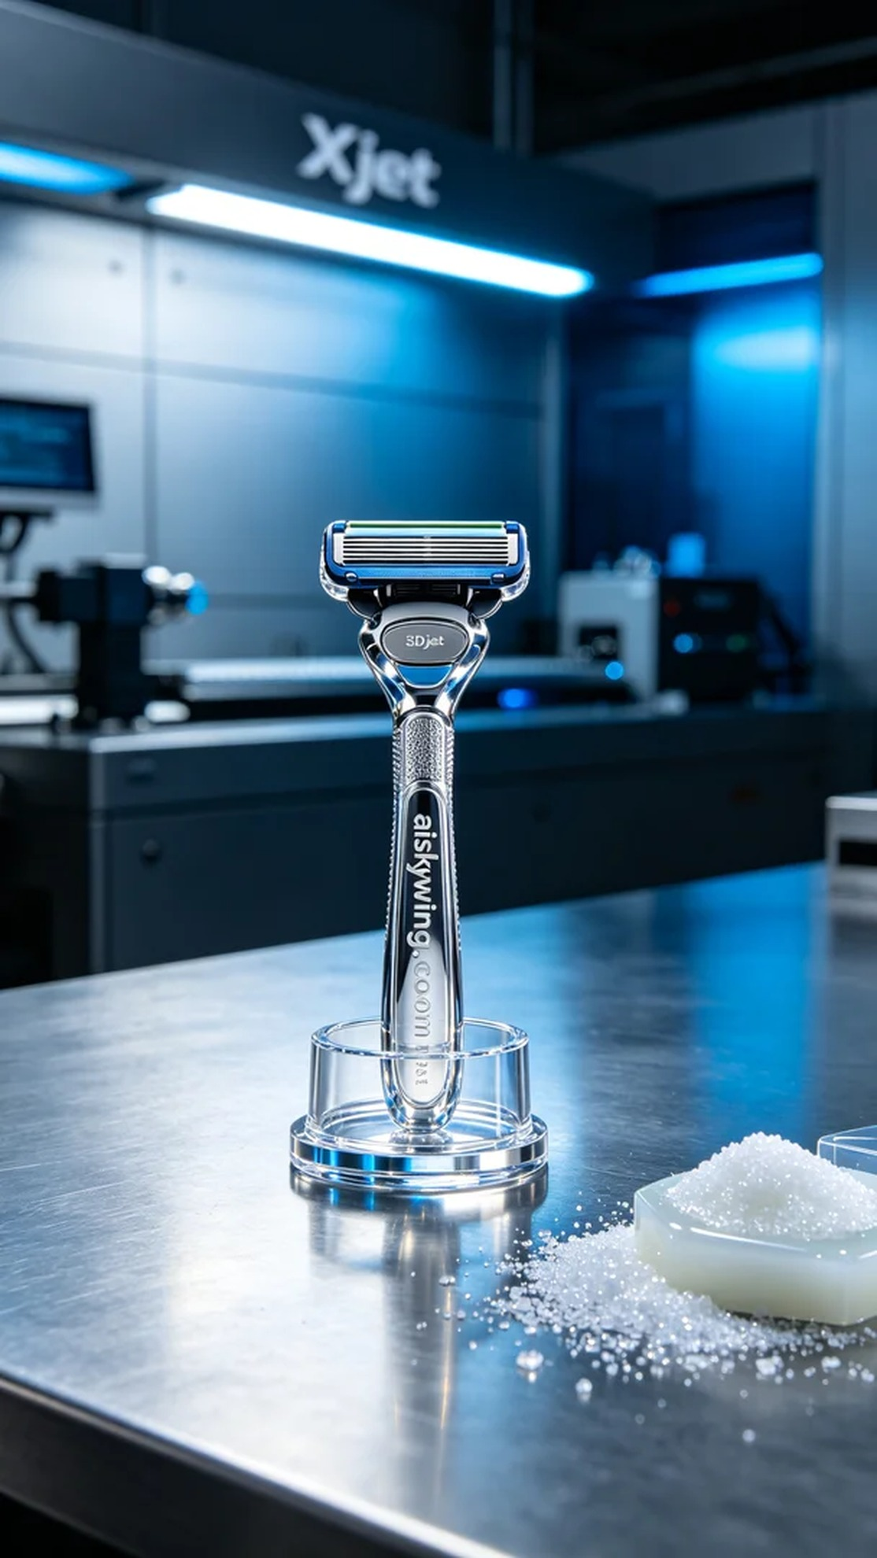
在Facebook上，有人因为希望找到一款坚固耐用的剃须刀刀头支架而联系到我们。他们对产品质量的要求很高，希望能够通过3D打印工艺实现精准的设计和卓越的耐用性。
我们选择了SLA光固化树脂作为原材料，这种材料具有优良的透明度和高光泽性，能够呈现出极致清晰的细节。在准备打印之前，我们仔细设置了打印参数，选择了0.05mm的层厚，打印温度设定在25°C，功率为80%，速度维持在30mm/s，以确保打印效果的完美。
在打印过程中，Xjet打印机的表现令我印象深刻。机器稳定运行，整个过程持续了大约4个小时。我们时刻监控质量，确保每一层的固化都顺利进行，最终得到了一个表面光滑、细节清晰的剃须刀刀头支架。
打印完成后，我们进行了一系列后处理工序。首先是将成品浸泡在清洗液中，去除未固化的树脂。接着，使用细砂纸进行打磨，使表面更加光滑。最后，我们进行了UV固化，使产品的强度和耐用性达到最佳状态，并进行了严格的检验，确保每一件产品都符合标准。
总的来说，这个剃须刀刀头支架的生产过程顺利，我们不仅完成了任务，还确保了质量，最终交付给了有需求的人。
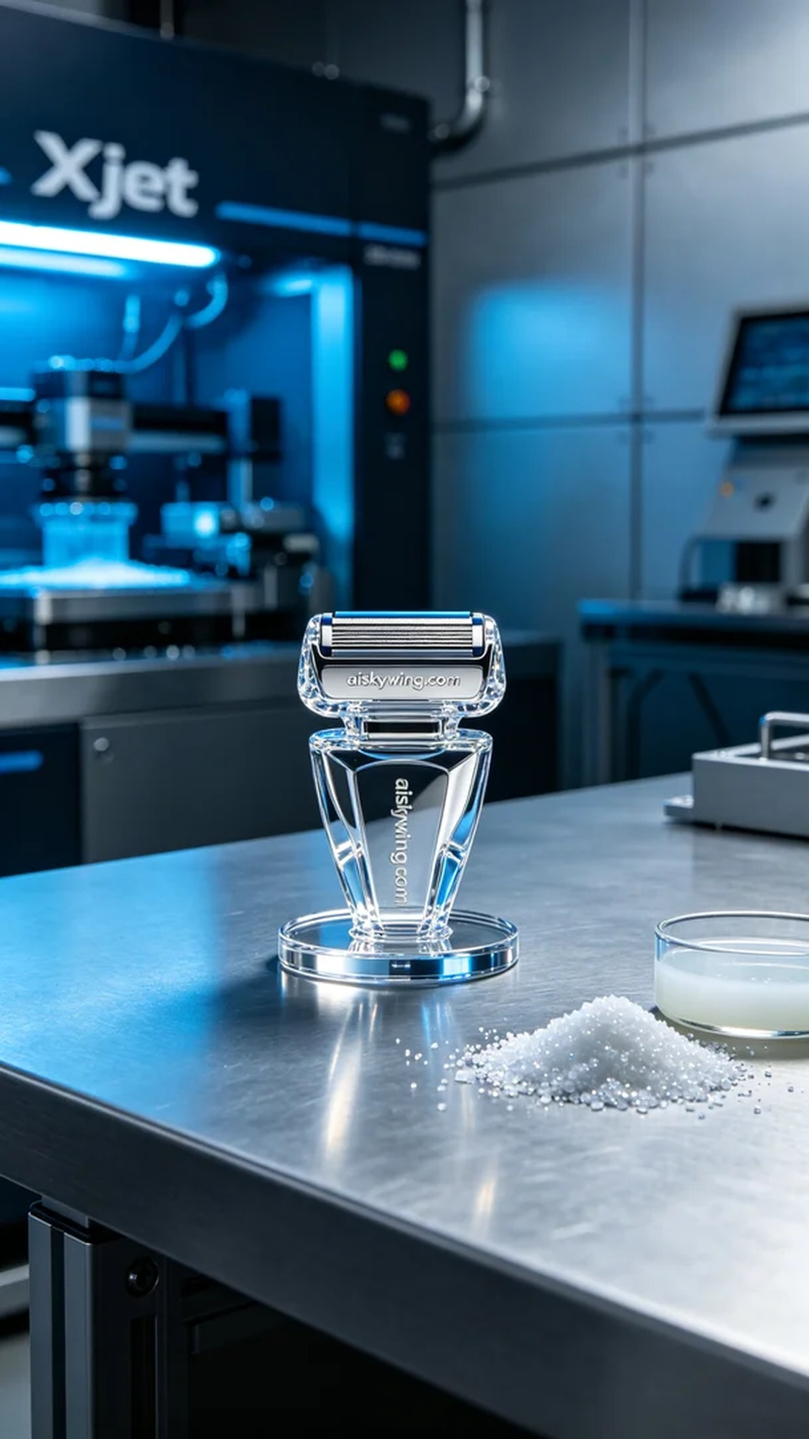
Aiskywing Industrial 3D Printing
Razor head holder


