1029-功放机面板的3D打印历程
Amplifier panel
🖨️ SLA光固化
🖥️ 打印机: EOS
📦 材料: SLA光固化树脂
在TikTok上，有人寻找我们因为想要一块精致的功放机面板，期待展现他们的专业和热情。就像人生，追求完美的过程，总是值得的。
On TikTok, some people seek us out because they want a refined amplifier panel, eager to showcase their professionalism and passion. Just like in life, the pursuit of perfection is always worthwhile.
________________________________________________________________________________
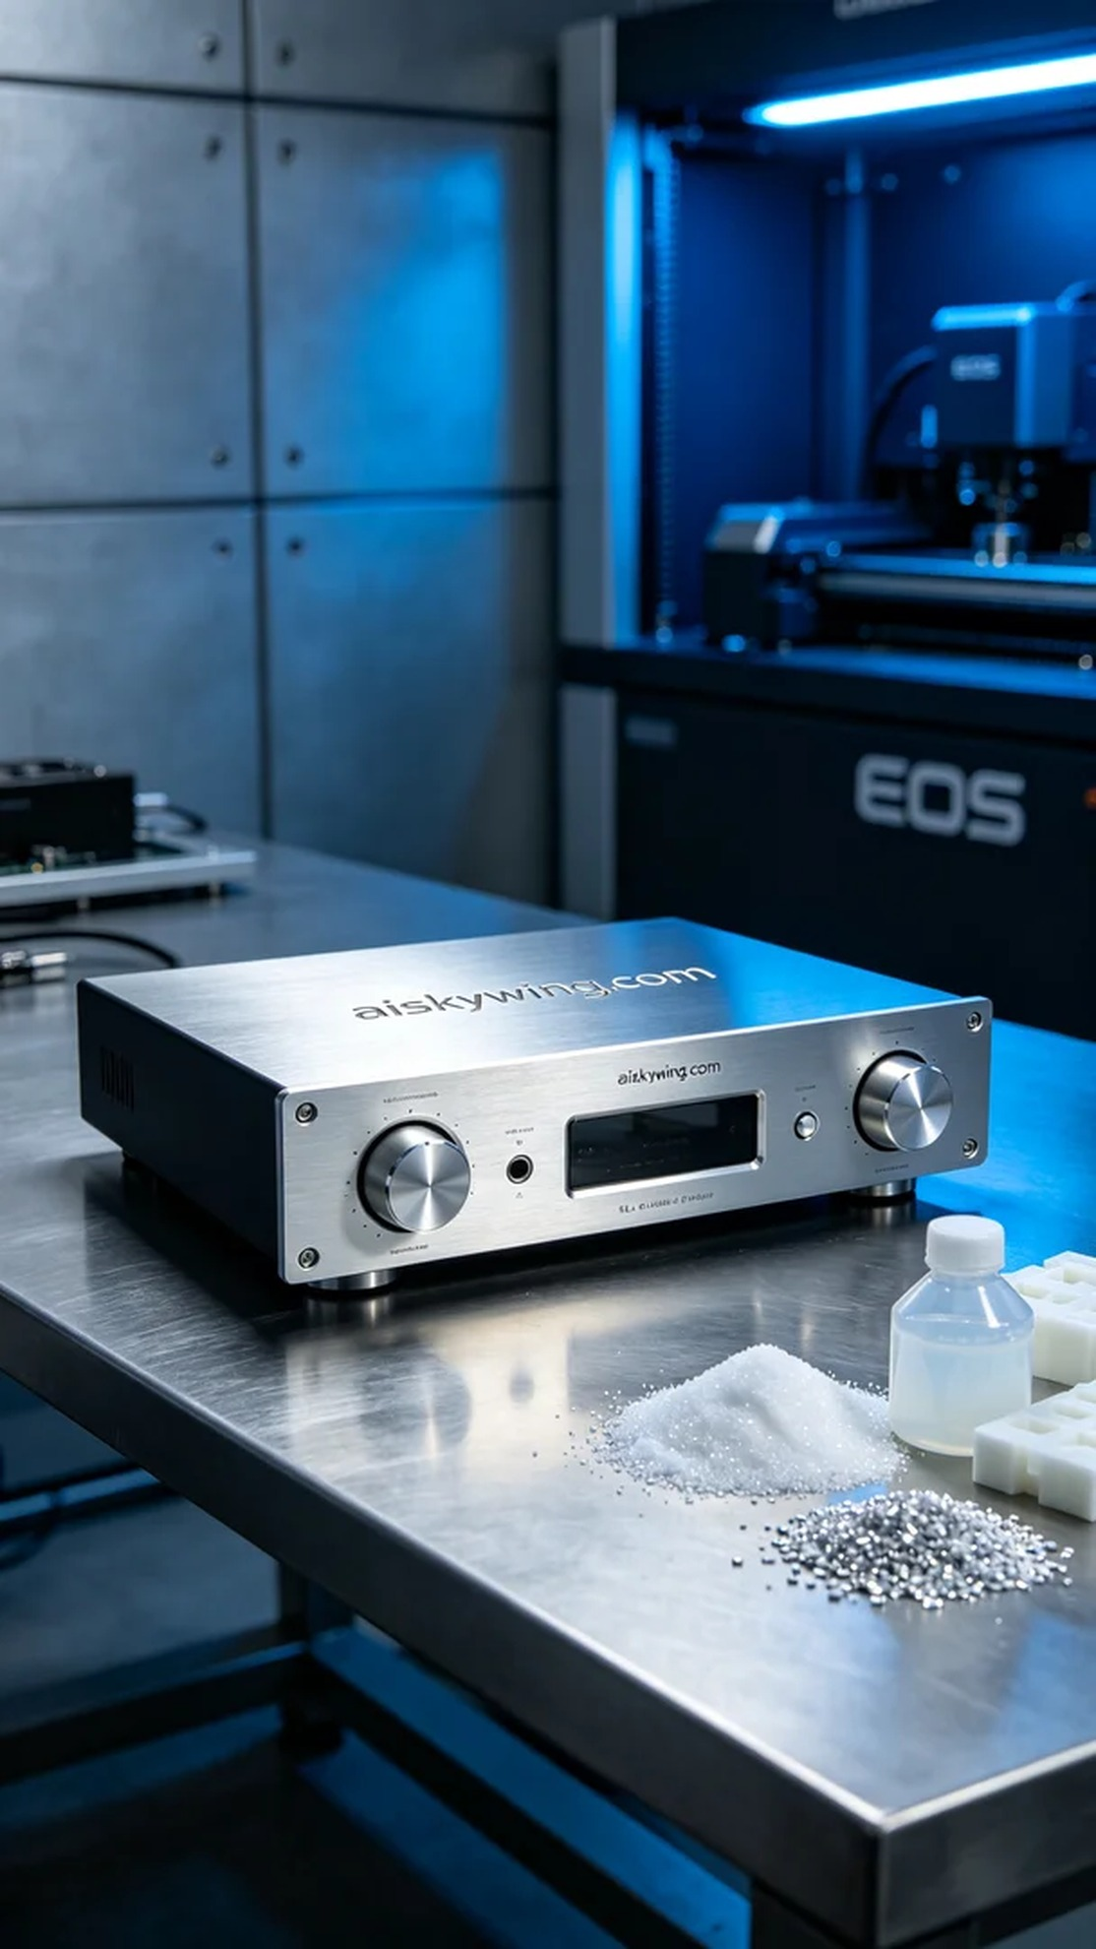
Today, we received an order for a power amplifier panel, aimed at adding a touch of technological sophistication to a project. Someone hoped that this panel would not only be visually striking but also functionally impeccable. To achieve this goal, we decided to use SLA photopolymer resin for 3D printing to ensure that every detail is perfectly rendered.
In the preparation stage, we used high-quality SLA photopolymer resin, which not only achieves extreme clarity but also displays a mirrored metallic sheen. The EOS 3D printer was thoroughly inspected, and we set the layer thickness to 0.05mm, maintained a printing temperature of 25°C, and set the power to 80% for optimal results, controlling the speed at 40mm/s. After multiple adjustments, we finalized all parameters to ensure the production of an ideal finished product.
As the printing process commenced, the EOS printer operated steadily, accompanied by a faint buzzing sound as the resin cured layer by layer. We monitored the print quality throughout the process to ensure that each layer met standards, especially the engraving of "aiskywing.com" on the panel, which needed to be clearly visible. During the print, we observed the equipment operations in real-time, ensuring that no issues arose; after eight hours of printing, the panel's outline gradually emerged.
Once printing was complete, we entered the post-processing phase. First, we cleaned the finished product with isopropyl alcohol to remove excess resin. Next, we sanded the surface with fine sandpaper to ensure a smooth finish. Finally, we placed the panel in a UV curing machine to ensure it was fully cured in a controlled environment, enhancing durability and gloss. After a rigorous quality inspection, we successfully completed the manufacturing of this power amplifier panel.
Every production process is a new learning experience. This power amplifier panel is not just an order but a testament to our pursuit and passion for craftsmanship. We look forward to seeing it shine in future projects.
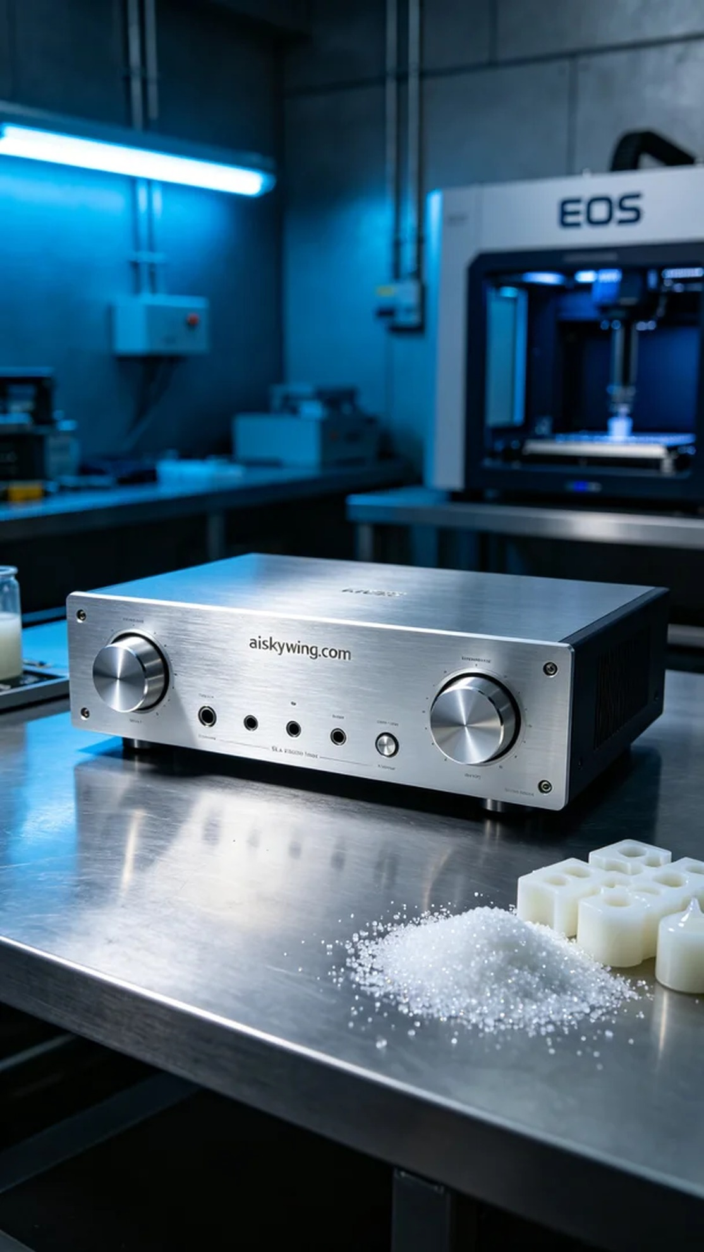
今天，我们接到了一个关于功放机面板的订单，它的目标是为某个项目增添一抹科技感。有人希望这块面板不仅在视觉上引人注目，还能在功能上无可挑剔。为了实现这个目标，我们决定使用SLA光固化树脂进行3D打印，确保所有细节都能完美呈现。
在准备阶段，我们使用了高品质的SLA光固化树脂，这种材料不仅能达到极致的清晰度，还能展现出镜面光泽的金属质感。打印所需的EOS 3D打印机经过彻底检验，设置了层厚为0.05mm，打印温度保持在25℃，功率设定为80%以达到最佳效果，速度则控制在40mm/s。经过多次调试，我们最终确定了所有参数，以确保制造出理想的成品。
打印过程开始后，EOS打印机稳定地运作，伴随着轻微的嗡嗡声，树脂逐层固化。我们全程监控打印质量，确保每一层都符合标准，特别是面板上雕刻的"aiskywing.com"字样，需做到清晰可辨。打印过程中，我们实时观察设备运行，确保没有问题出现，最终经过了八个小时的打印，面板的轮廓逐渐显现。
打印完成后，我们进入了后处理环节。首先，我们用异丙醇对成品进行清洗，以去除多余的树脂。随后，使用细砂纸进行了打磨，确保表面光滑。最后，我们将面板放入UV固化机中，确保它在酷燥环境下得到充分固化，增加耐用性和光泽感。经过严格的质量检验后，终于完成了这块功放机面板的制作。
每一次的生产都是一次新的学习和体验。这块功放机面板，不仅是一项订单，更是我们对工艺的追求与热爱。期待它在未来的项目中熠熠生辉。
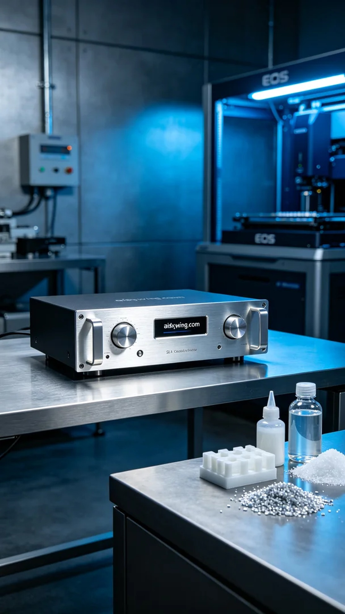
Aiskywing Industrial 3D Printing
Amplifier panel


