1030-卷发棒手柄的3D打印记录
Curling iron handle
🖨️ SLA光固化
🖥️ 打印机: Carbon
📦 材料: SLA光固化树脂
生活就像3D打印，有时需要耐心与细致。最近有人在Twitter上提到，想要制作一个卷发棒手柄，这让我想起了我们的项目。
Life is like 3D printing; sometimes it requires patience and attention to detail. Recently, someone mentioned on Twitter that they wanted to create a curling iron handle, which reminded me of our project.
________________________________________________________________________________
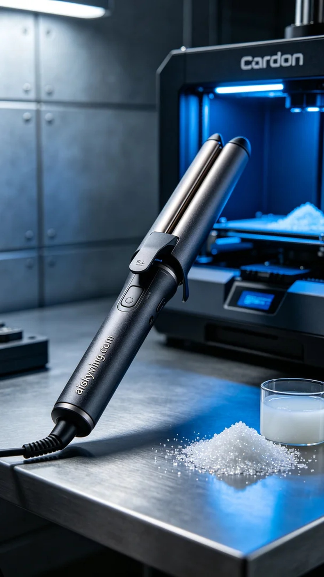
Life is like 3D printing; sometimes, it requires patience and attention to detail. Recently, someone mentioned on Twitter their desire to create a curling wand handle, which reminded me of our upcoming project.
We chose SLA photopolymer resin as the raw material. This material is known for its high precision and smooth surface finish, making it ideal for intricate shapes and fine details. For the best results, the settings on the Carbon printer were adjusted to: layer thickness of 0.05mm, temperature at 25°C, power at 70%, and a printing speed of 30mm/s, with an estimated printing time of about 2 hours.
During the printing process, the Carbon printer operated steadily. I periodically monitored the printing status to ensure each layer formed correctly. The device's high precision filled me with confidence about the final product's quality, as the curling wand handle slowly took shape on the platform, with intricate details emerging beautifully.
After printing, we moved into the post-processing phase. First, I removed the formed handle and placed it in a cleaning solution to eliminate excess resin. After cleaning, I meticulously sanded the handle to further enhance its smoothness. Finally, I placed it in a UV curing box to improve its hardness and durability. During thorough inspection, I ensured every detail met the standards.
Overall, this curling wand handle project not only enhanced our technical skills but also laid a solid foundation for future custom demands. Looking forward to the next challenge.
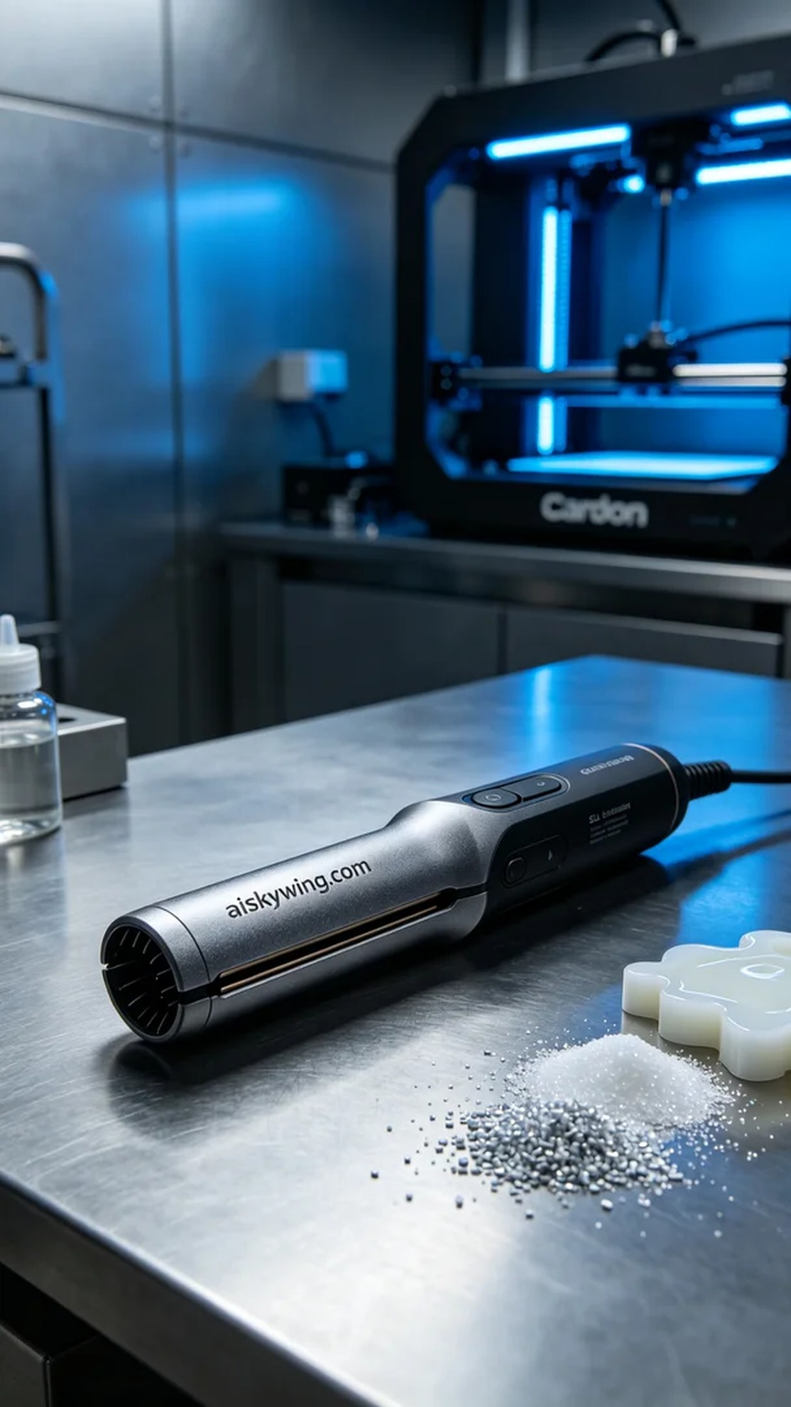
在社交媒体Twitter上，最近有人询问，是否可以定制一个卷发棒手柄。他们希望这个手柄不仅外观精美，还要具备良好的使用体验。结合他们的需求，我们决定使用SLA光固化工艺来实现这个目标。
我们选择了SLA光固化树脂作为原材料。这种材料的优点在于其高精度和良好的表面光滑度，适合制作复杂形状和细节丰富的产品。为了实现最佳效果，Carbon打印机的打印参数设置为：层厚0.05mm，温度设定为25°C，功率为70%以及打印速度为30mm/s，预计打印时间约为2小时。
在打印过程中，Carbon打印机稳定地运行。我定期监控打印状态，以确保每一层都能顺利成型。设备的高精度让我对成品的质量充满信心，随着时间的推移，卷发棒手柄逐渐在平台上显现出轮廓，细节部分也展现得淋漓尽致。
打印完成后，我们进入后处理阶段。首先，我将成型的手柄取下，放入清洗液中进行清洗，确保去除多余的树脂。清洗后，我对手柄进行了细致的打磨，进一步提升了表面光滑度。最后，我将其放入固化箱中进行UV固化，以提高其硬度和耐用性。在严格的检验过程中，确保每个细节都达到标准。
总的来说，这次的卷发棒手柄项目不仅提升了我们的技术水平，也为未来的定制需求打下了良好的基础。期待下一次的挑战。
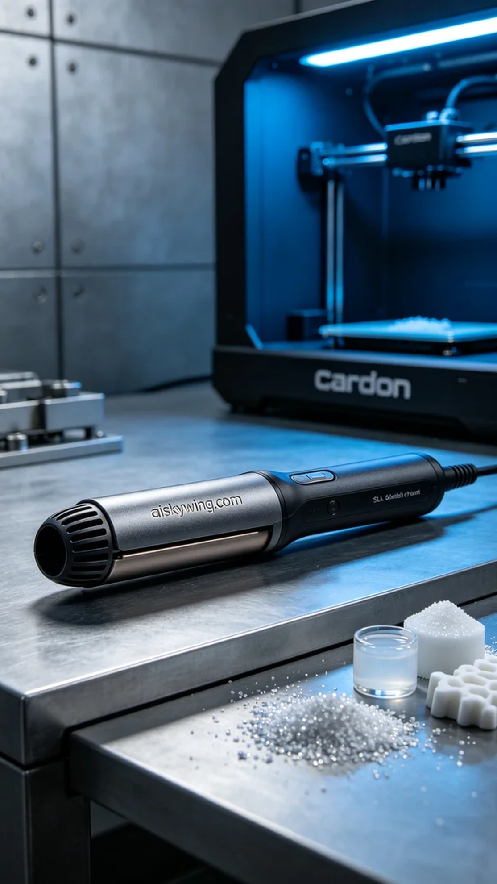
Aiskywing Industrial 3D Printing
Curling iron handle


