1031-厨房秤外壳的3D打印记录
Kitchen scale casing
🖨️ SLA光固化
🖥️ 打印机: Rize
📦 材料: SLA光固化树脂
在WhatsApp上，有人因厨房秤外壳的设计找上了我们，让我想起了3D打印的乐趣与挑战。
On WhatsApp, someone reached out to us about the design of a kitchen scale's casing, which reminded me of the fun and challenges of 3D printing.
________________________________________________________________________________
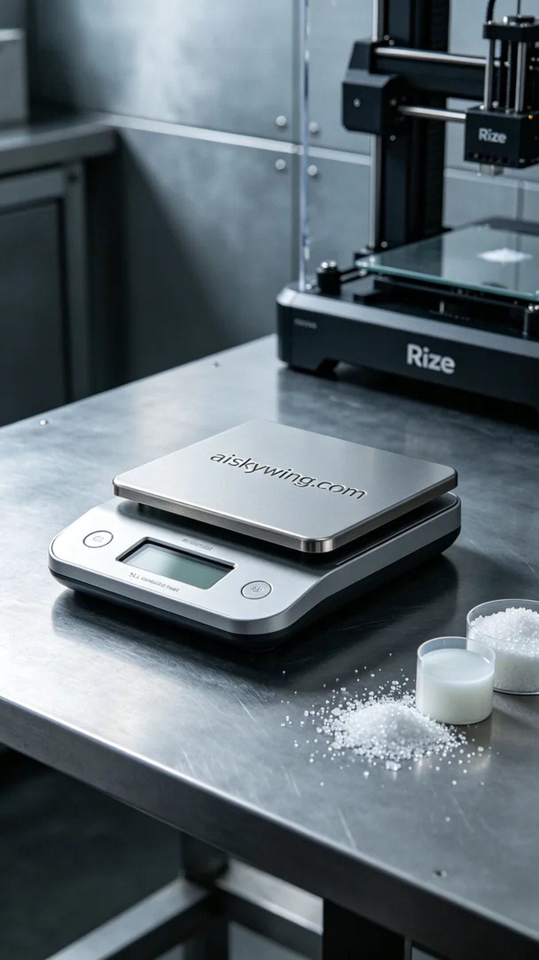
Today’s task was to 3D print a shell for a kitchen scale. Someone approached us looking for a design that was not only aesthetically pleasing but also functional. The unique aspect of this project was our choice to use SLA photopolymer resin to ensure the detail and strength of the shell.
In the preparation stage, we used high-quality SLA photopolymer resin. This material has excellent fluidity and curing properties, making it suitable for intricate designs. On the Rize printer, we set the printing parameters with a layer thickness of 0.1mm, a printing temperature of 25°C, a power setting of 80%, and a speed of 50mm/s, with an expected printing time of 4 hours.
During the printing process, the Rize printer operated smoothly. We closely monitored the device's status, ensuring that each layer cured to perfection. The photopolymer resin spread evenly on the printing platform, and after curing, the details of the shell gradually emerged. The entire process went well, with no issues arising.
Once the printing was completed, we performed detailed post-processing. First, the printed shell was placed in a cleaning solution to remove any excess resin. We then used fine sandpaper to smooth the surface further, followed by a UV curing process to ensure the strength and stability of the material. Finally, we carefully inspected every detail, ensuring the shell was flawless.
After a full day of effort, the 3D printing of the kitchen scale shell was successfully completed. Each print is a new challenge that makes me appreciate this technology even more.
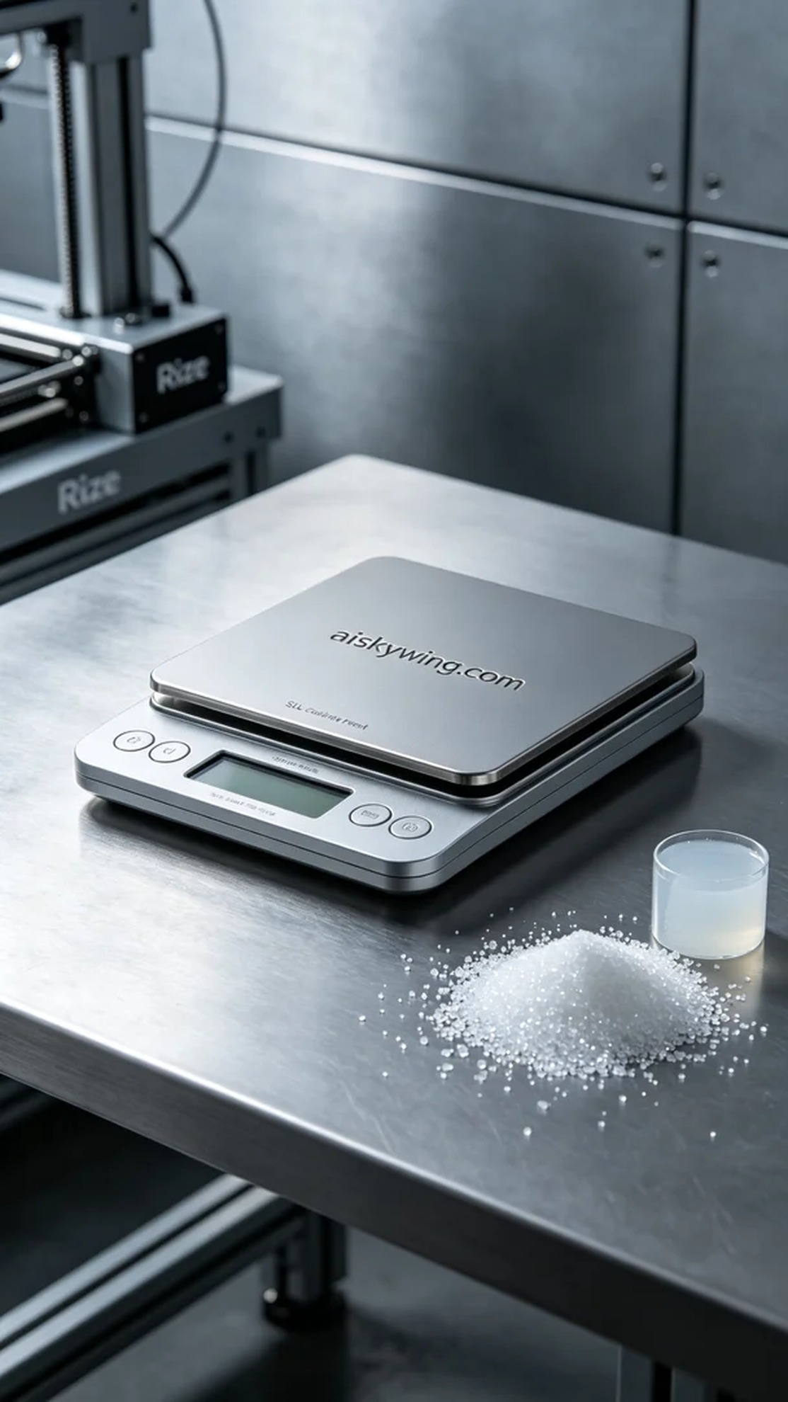
今天的工作是为一个厨房秤外壳进行3D打印。有人找到我们，希望能制作出这种外壳，要求不仅要美观，还要具备良好的使用体验。这个项目的特殊之处在于，我们选择了SLA光固化树脂材质，以确保外壳的细节和强度。
在准备阶段，我们使用了高质量的SLA光固化树脂。这种材料具有出色的流动性和固化性能，适合细节丰富的设计。在Rize打印机上，我们设置了打印参数，层厚设置为0.1mm，打印温度保持在25°C，功率设定为80%，速度则是50mm/s，预计打印时间为4小时。
打印过程中，Rize打印机的运行非常平稳。我们仔细监控设备的状态，确保每一层的固化都达到最佳效果。打印过程中，光敏树脂均匀地在打印平台上铺展，经过光固化后，外壳的细节渐渐显露出来。整个过程顺利，没有出现任何异常。
完成打印后，我们进行了详细的后处理。首先将打印好的外壳放入清洗液中，清理掉表面的多余树脂。然后使用细砂纸进行打磨，使表面更加光滑，最后将其放在UV固化设备中进行固化，确保材料的强度和稳定性。最后，我们仔细检查每一个细节，确保外壳没有瑕疵。
经过一整天的努力，这个厨房秤外壳的3D打印工作圆满完成。每一次打印都是一次新的尝试，也让我更加热爱这门技术。
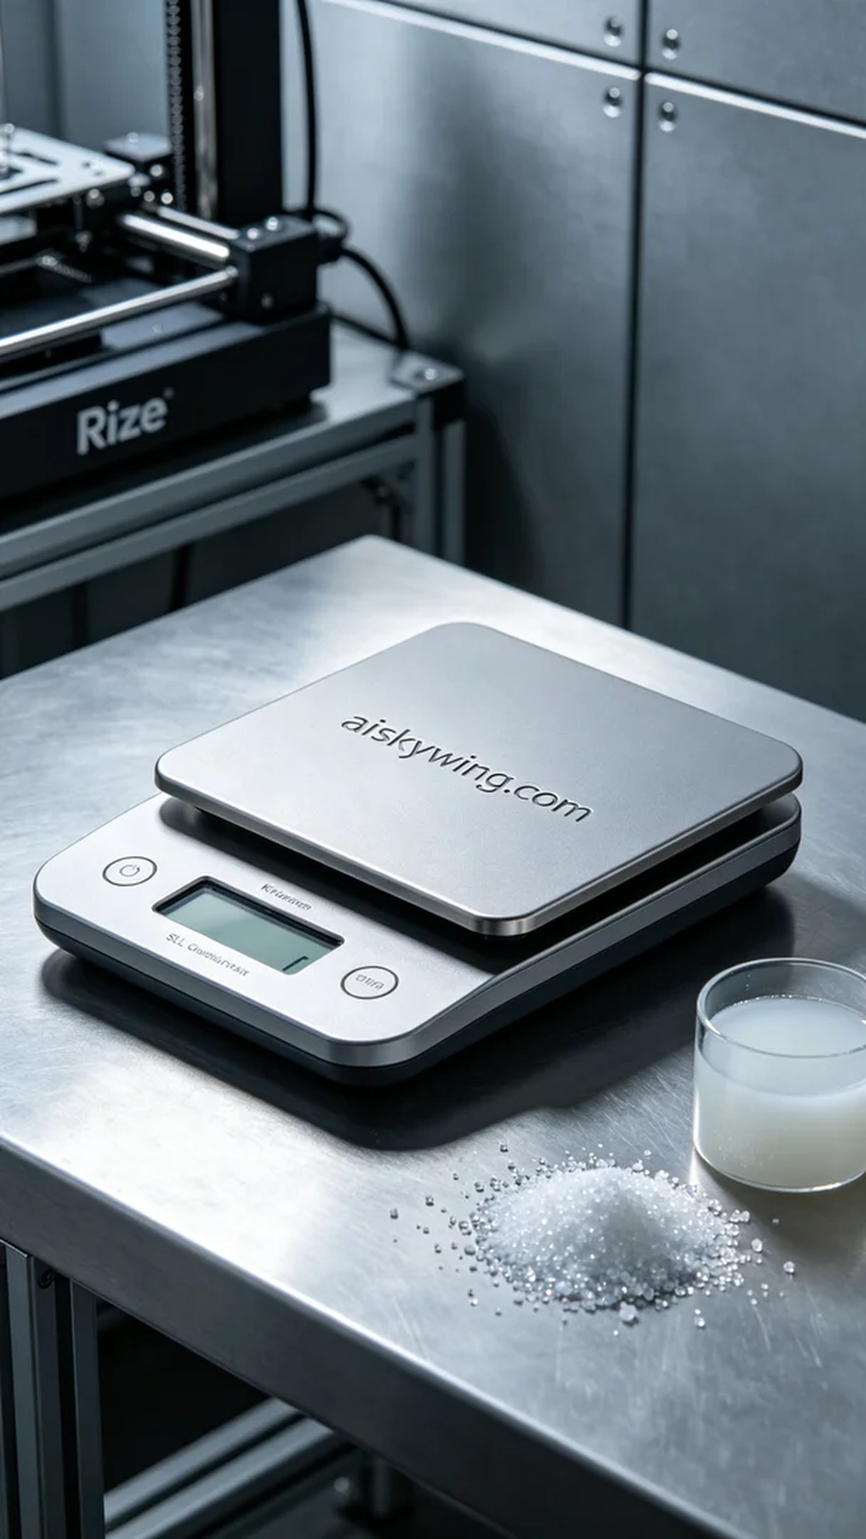
Aiskywing Industrial 3D Printing
Kitchen scale casing


