1032-3D打印吉他效果器外壳的生产记录
Guitar effects pedal enclosure
🖨️ SLA光固化
🖥️ 打印机: Systems
📦 材料: SLA光固化树脂
生活就像3D打印，层层叠叠，终会成型。最近有人在LinkedIn上找到我们，希望制作一个吉他效果器外壳。
Life is like 3D printing, layer by layer, it will eventually take shape. Recently, someone reached out to us on LinkedIn, hoping to create a guitar effects pedal casing.
________________________________________________________________________________
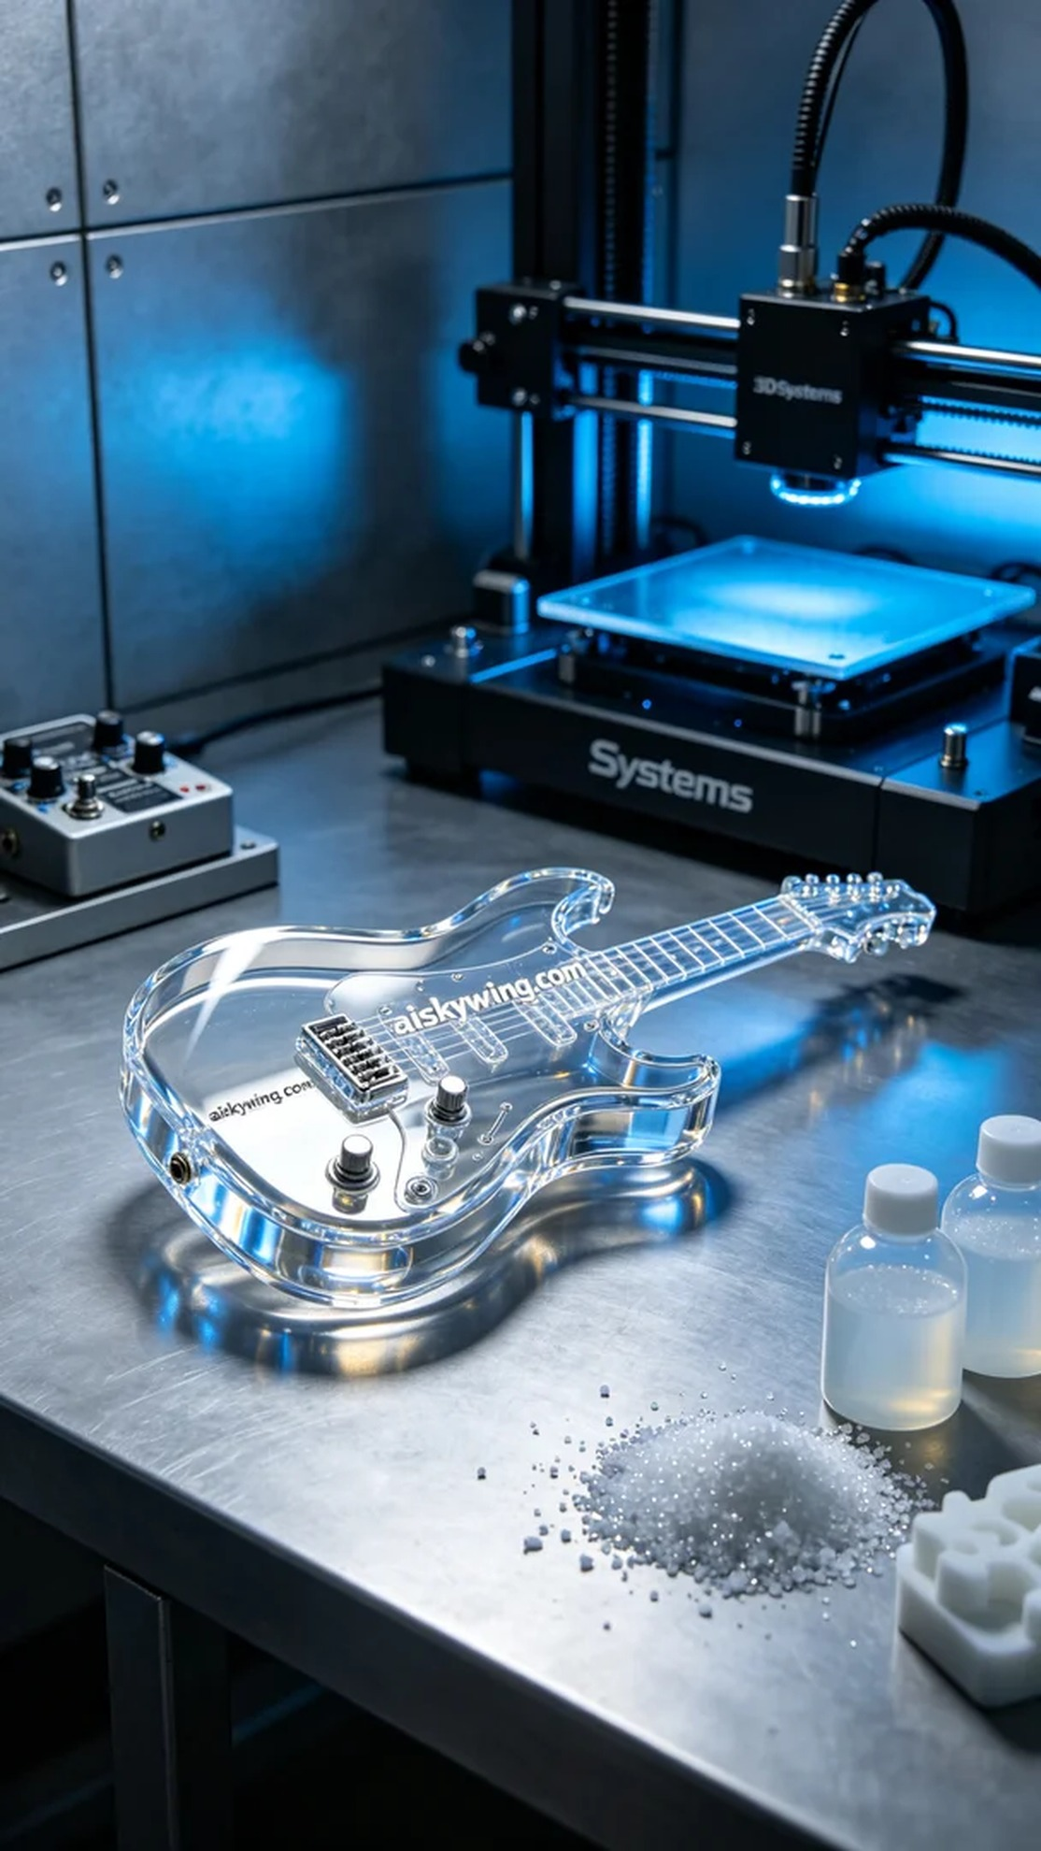
Life is like 3D printing, layer by layer, it eventually takes shape. Recently, someone found us on LinkedIn, seeking the production of a guitar effects pedal housing.
The production of this guitar effects pedal housing arose because someone faced a shortage of suitable housings. We chose SLA (Stereolithography) technology to achieve this product, ensuring exquisite appearance and delicate details.
The material we used was SLA photopolymer resin. This material has excellent transparency and high gloss, making it ideal for producing high-end product housings. We utilized a Systems brand printer, setting the layer thickness to 0.1mm, maintaining a temperature of 25°C, with a power setting of 80mW and a printing speed of 30mm/s. The entire printing process was estimated to take about six hours.
During the printing process, the machine operated smoothly, and quality monitoring was in place. We closely observed the printing progress to ensure that each layer cured evenly, adjusting parameters to address any potential issues. After several hours of hard work, the initial shaping of the guitar effects pedal housing was successfully completed, with a smooth surface and clear lettering.
Next, we proceeded with the post-processing. First, the printed piece was placed in a cleaning tank and washed with isopropyl alcohol to remove any uncured resin on the surface. Then, the housing was sanded to enhance its gloss and tactile quality, ensuring that there were no blemishes. During the curing phase, we placed it under UV light to increase its hardness and durability, followed by strict quality inspection.
Through this production, we successfully completed the manufacturing of the guitar effects pedal housing, showcasing the charm of SLA photopolymer technology. We look forward to the next challenge.
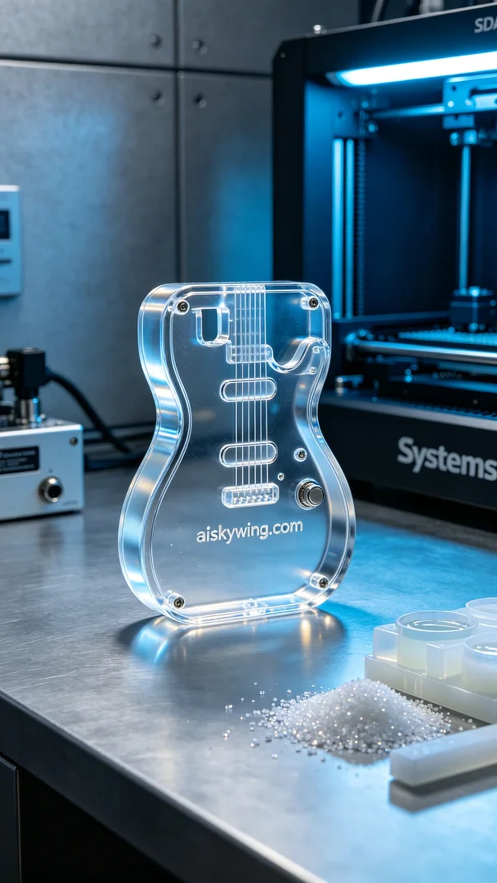
首先，这个吉他效果器外壳的生产，是因为有人遇到了效果器外壳需求不足的问题，于是找到了我们。我们采用SLA光固化工艺来实现这一产品，确保可以达到精致的外观和细腻的细节。
我们所使用的原材料是SLA光固化树脂。这种材料具有极佳的透明度和高光泽度，非常适合制作高档产品外壳。在设备方面，我们使用的是Systems品牌的打印机，设置了0.1mm的层厚，打印温度维持在25°C，功率设置为80mW，打印速度则为30mm/s，整个打印过程预估耗时约为6小时。
在打印过程中，机器运行平稳，质量监控也十分到位。我们密切观察打印进程，确保每层都能均匀固化，并及时调整参数以应对任何潜在的问题。最终，经过几个小时的努力，吉他效果器外壳的初步成型顺利完成，表面光滑，字样清晰可见。
接下来，我们进行了后处理。首先，将打印好的件放入清洗池中，使用异丙醇清洗，去除表面的未固化树脂。然后，对外壳进行打磨，以进一步提升光泽度和手感，确保没有任何瑕疵。固化环节中，我们将其放在UV灯下进行照射，以增强其硬度和耐用性，最后进行了严格的质量检验。
通过这次生产，我们成功完成了吉他效果器外壳的制作，展现出SLA光固化技术的魅力。期待下一次的挑战。
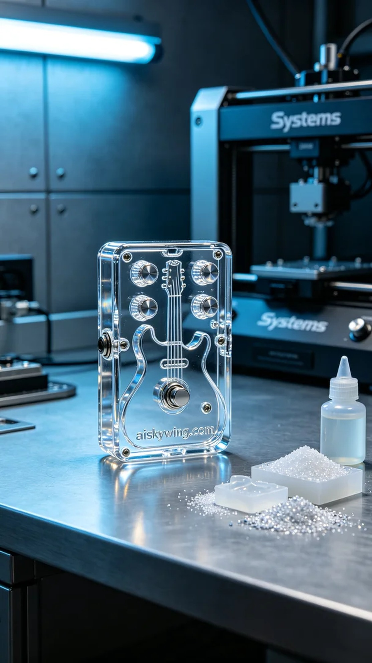
Aiskywing Industrial 3D Printing
Guitar effects pedal enclosure


