1033-吸尘器风道管的3D打印生产记录
Vacuum cleaner duct pipe
🖨️ SLA光固化
🖥️ 打印机: HP
📦 材料: SLA光固化树脂
生活就像3D打印的过程，充满细节和挑战。最近，有人找到我们，希望我们为他们制作吸尘器风道管，解决他们在产品开发上的难题。
Life is like the process of 3D printing, filled with details and challenges. Recently, someone approached us, hoping that we could create vacuum cleaner ducts for them to solve their product development issues.
________________________________________________________________________________
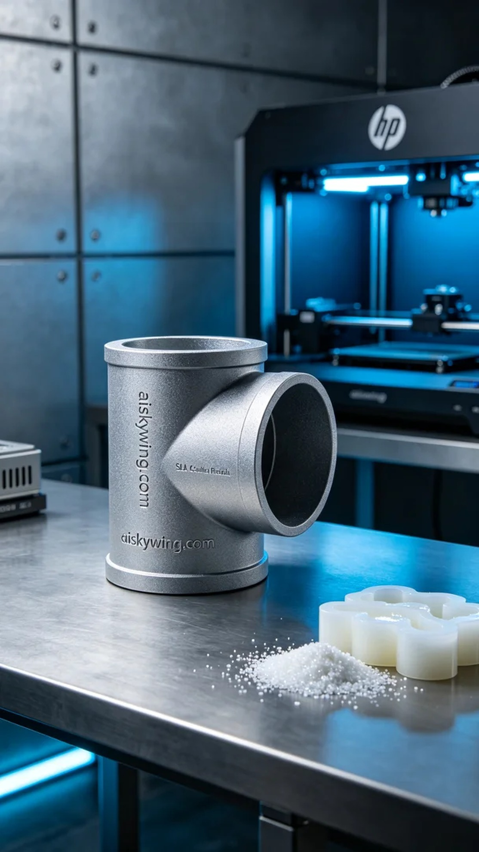
Life is like a 3D printing process, filled with details and challenges. Recently, someone reached out to us, hoping we could create a vacuum cleaner duct to solve their issues in product development.
For this task, we chose SLA photopolymer resin as our material due to its excellent detail resolution. In preparation, we used an HP printer, setting the layer thickness to 0.1mm, working temperature at 25°C, power at 50%, and print speed at 30mm/s. These parameters ensured the clarity and strength of the final product.
During the printing process, the equipment operated smoothly, with the SLA resin curing layer by layer under the light source. After each layer was completed, we carefully monitored the print quality to ensure no bubbles or defects occurred, resulting in a vacuum cleaner duct with a smooth surface and clear engravings.
The post-processing stage is equally important. First, we cleaned the printed duct to remove any residual liquid resin, then meticulously sanded it to ensure a fine and smooth feel. The curing process was conducted under UV light to harden the material. Finally, after inspection, we confirmed that the product met the expected standards.
Through this printing task, we successfully produced a batch of high-quality vacuum cleaner ducts, meeting production needs and providing strong support for further product optimization. Each creation is a new experience.
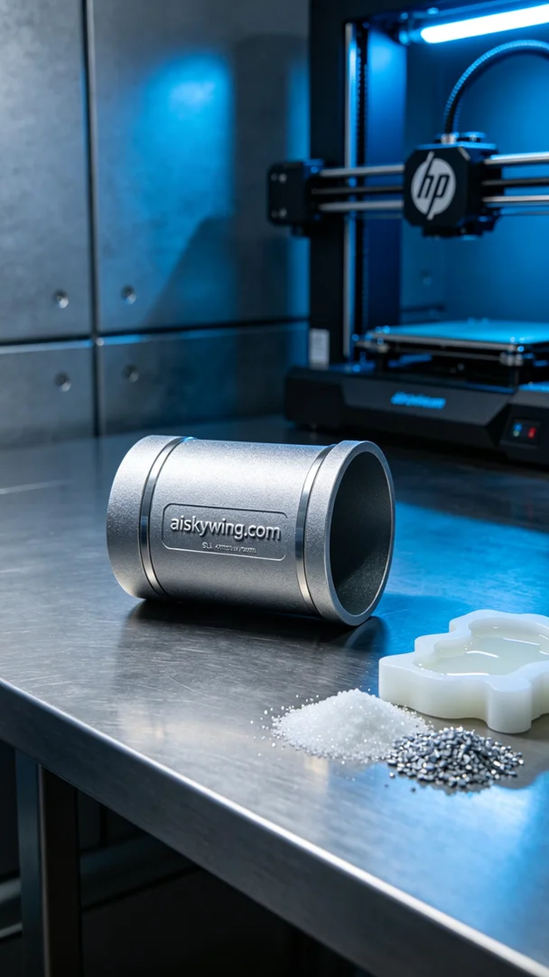
这次的工作缘起于LinkedIn，有人因为吸尘器的风道管设计问题求助我们。他们希望通过3D打印技术快速制作出高精度的样品，以便在后续的产品开发中进行测试和验证。
我们选择了SLA光固化树脂作为原材料，这种材料在细节成型方面表现出色。准备过程中，我们使用HP打印机，设定了层厚0.1mm，打印温度为25摄氏度，功率设置为50%，打印速度控制在30mm/s。这些参数能够确保成品的清晰度和强度。
打印的过程中，设备运行平稳，SLA树脂在光源的照射下逐层固化。在每层打印完成后，我们都会仔细监控打印质量，确保没有气泡或缺陷产生，最终形成的吸尘器风道管，表面光滑，雕刻的细节也十分清晰。
后处理环节的工作同样重要。首先对打印好的风道管进行清洗，去除表面残留的液态光敏树脂，接着对其进行细致打磨，以确保手感的细腻和光滑。固化过程则是在紫外线下进行，确保材料的硬度。最后，经过检验，确认产品达到了预期的标准。
通过这次的打印，我们成功制作了一批高质量的吸尘器风道管，满足了客户的生产需求，为后续的产品优化提供了有力支持。每一次的制作，都是一次新的体验。
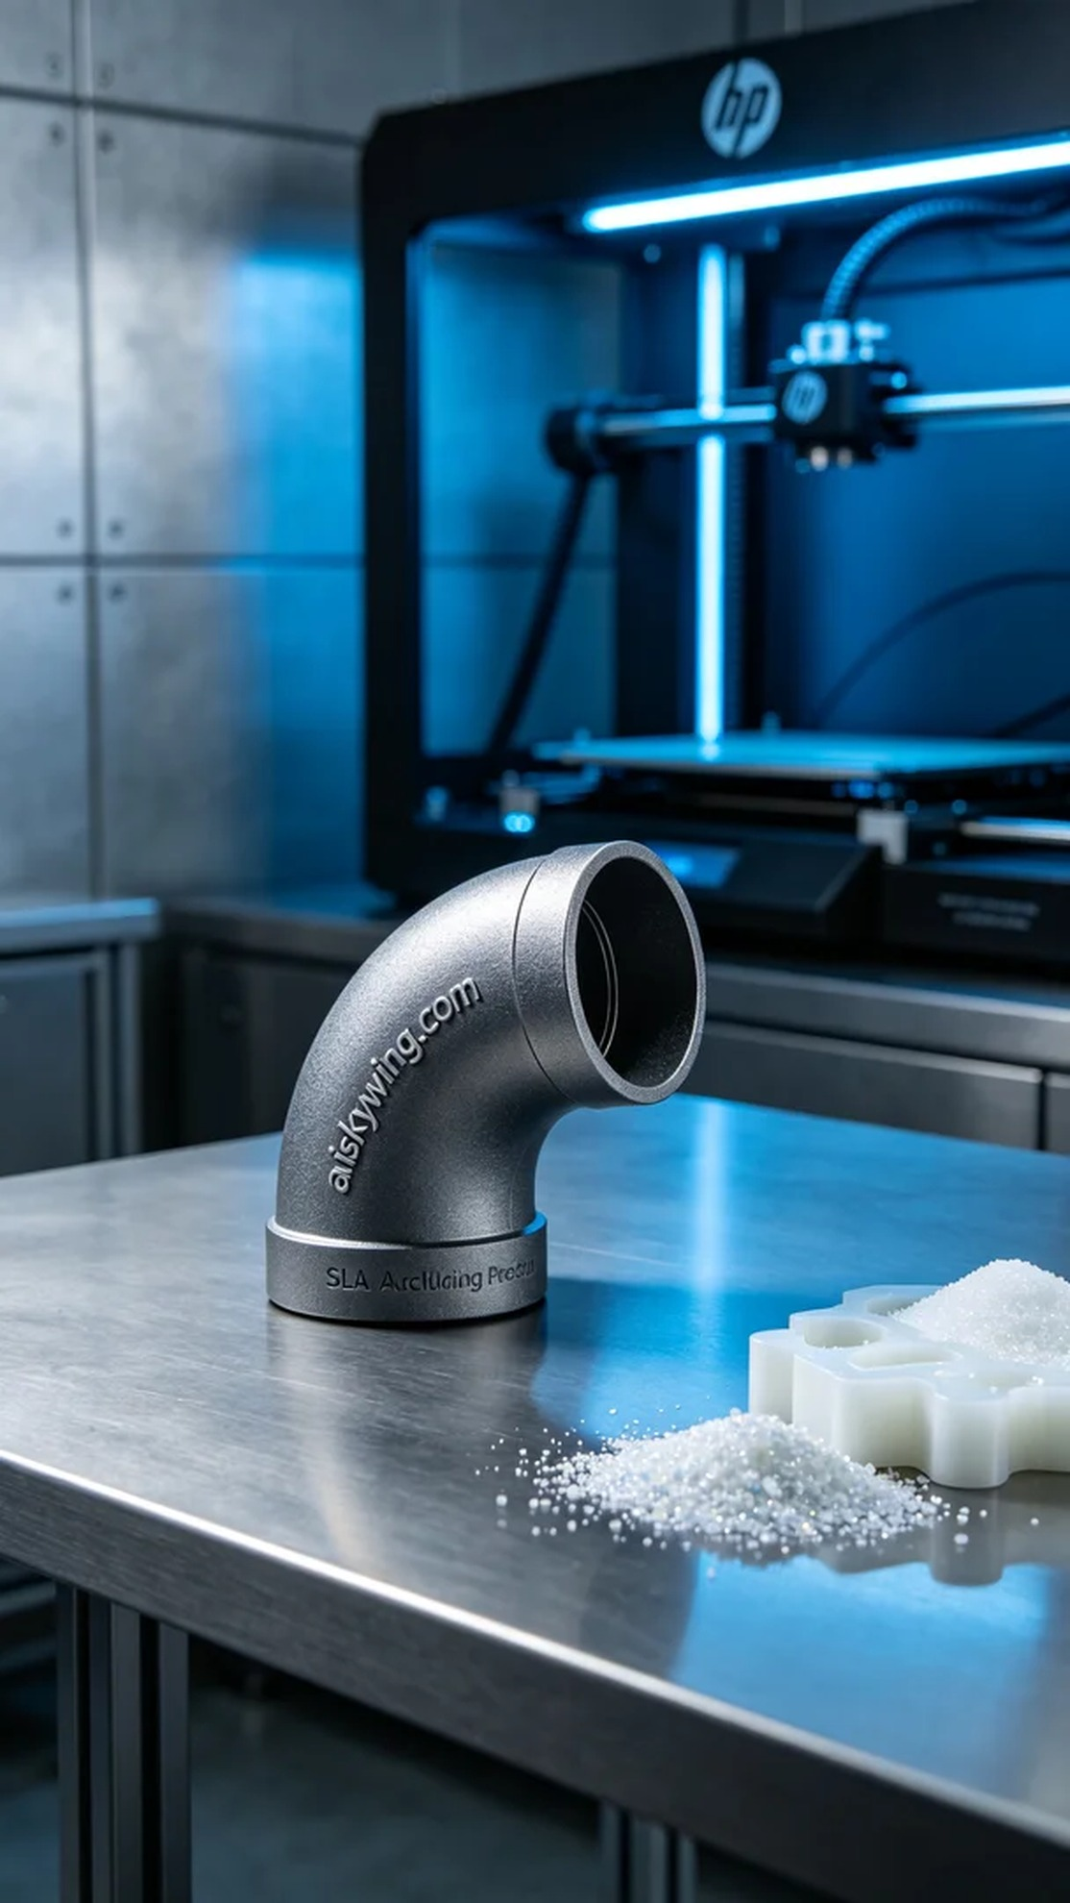
Aiskywing Industrial 3D Printing
Vacuum cleaner duct pipe


