1034-完美吹风机风嘴的3D打印记录
Blow dryer nozzle
🖨️ SLA光固化
🖥️ 打印机: HP
📦 材料: SLA光固化树脂
在TikTok上，人们因为想要提升吹风机的性能而找到我们。于是我们开始制作这个吹风机风嘴，力求完美。
On TikTok, people came to us because they wanted to enhance the performance of their hair dryers. So we started creating this hair dryer nozzle, striving for perfection.
________________________________________________________________________________
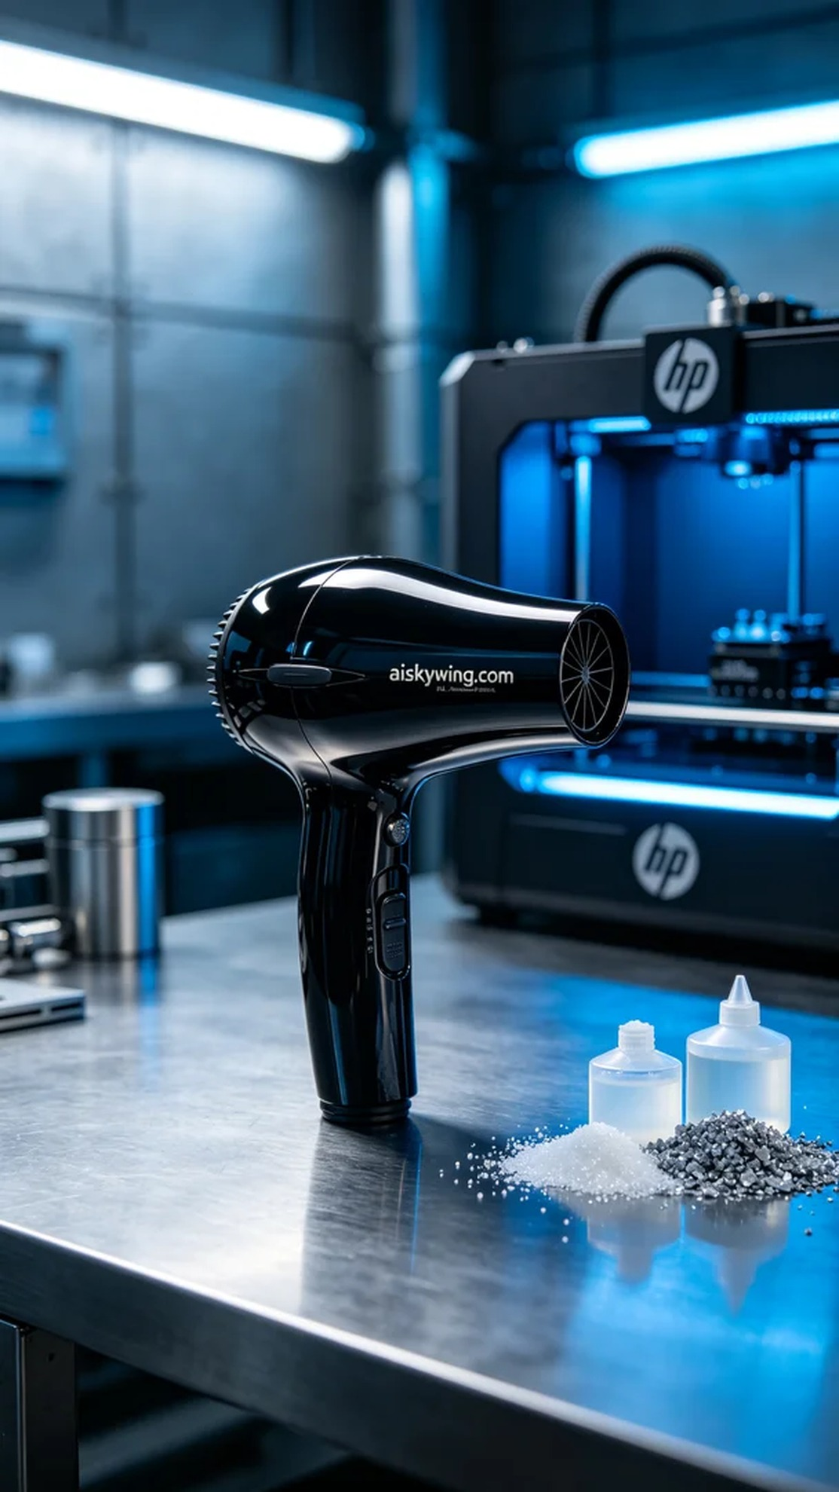
This project aimed to address the issue of someone finding their hair dryer nozzle lacking in precision, which led to the decision to create a custom hair dryer nozzle. The goal was to enhance the user experience, prompting us to utilize the SLA resin printing method to ensure detailed and precise results.
We chose high-quality SLA photopolymer resin as the raw material for this task. This resin is known for its excellent flow properties and superior gloss finish after curing, providing the desired high-shine effect. Our HP 3D printer was calibrated to optimal settings, with a layer thickness of 0.05mm, maintaining a print temperature of 25°C, and setting the power at 50% to prevent overheating of the material. The print speed was controlled at 30mm/s to ensure precision in every layer.
During the printing process, the HP 3D printer operated steadily, and each layer was monitored. We ensured that there were no anomalies with the equipment, observing the curing process of the material in real time. After approximately two hours of printing, the nozzle's contours began to take shape, and the entire procedure was smooth and efficient.
Once printing was complete, we moved on to the post-processing phase. First, the molded nozzle was placed in an ultrasonic cleaner to remove any excess resin from the surface. Next, we sanded the surface with sandpaper to achieve a smoother finish. Following that, the nozzle was placed in a UV curing chamber to ensure its strength and durability. Finally, careful inspection was performed to ensure every detail met the standards.
After completing these steps, the final hair dryer nozzle was not only aesthetically refined but also functionally impeccable. This entire process highlighted the charm of 3D printing while reinforcing the lesson that details make all the difference.
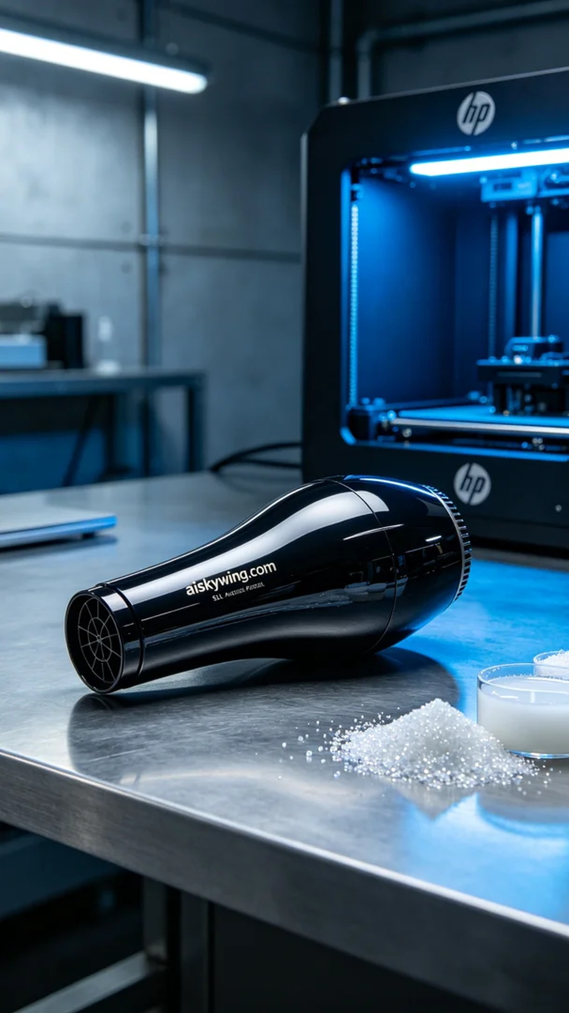
这次的项目是为了解决有人在使用吹风机时发现风嘴不够精准的问题。定制一个适合的吹风机风嘴，能够提升使用体验，便成了我们的任务。于是我们决定采用SLA光固化工艺来制作这个产品，以确保其细节和精度。
在准备阶段，我们选用了高质量的SLA光固化树脂作为原材料。这种树脂具有出色的流动性和固化后优异的光泽度，能够呈现出理想的高光效果。我们的HP 3D打印机被调试到最佳状态，层厚设置为0.05mm，打印温度保持在25℃，功率设定为50%以避免材料过热，同时打印速度控制在30mm/s，以确保每一层的精细。
打印过程中，HP 3D打印机稳定运行，每一层的成型都在监控之中。我们确保设备没有任何异常，实时观察材料的固化情况。经过约两个小时的打印，风嘴的轮廓逐渐显现出来，整个过程顺利而高效。
打印完成后，便进入了后处理工序。首先将成型的风嘴放在超声波清洗器中清洗，以去除表面多余的树脂。接着，我们用砂纸对其表面进行了打磨，使其更加光滑。之后，将风嘴放入UV固化箱中进行固化处理，确保其强度和耐用性。最后，进行了仔细的检验，确保每一个细节都达到标准。
经过这几道工序，最终的吹风机风嘴不仅外观精致，性能更是无懈可击。整个过程让我感受到3D打印的魅力，也明白了细节决定成败的道理。
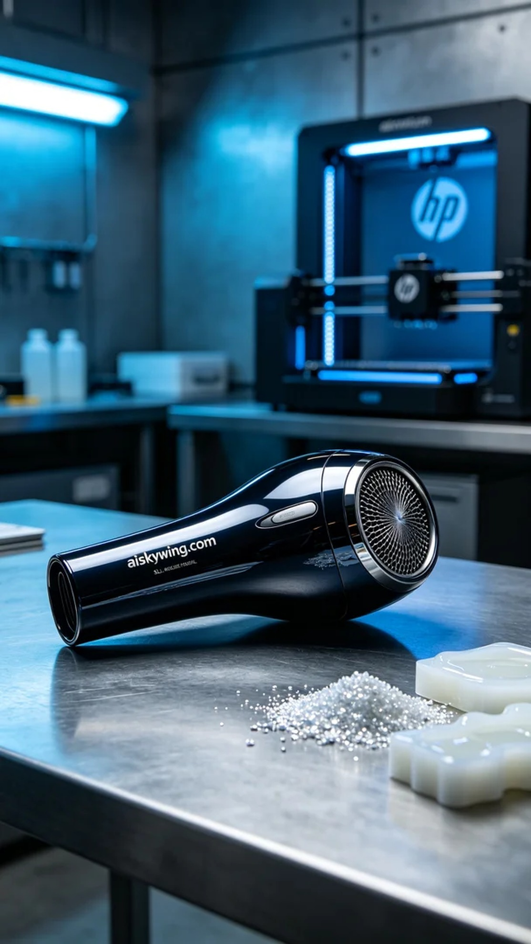
Aiskywing Industrial 3D Printing
Blow dryer nozzle


