1035-咖啡机豆仓3D打印生产记录
Coffee machine bean hopper
🖨️ SLA光固化
🖥️ 打印机: Carbon
📦 材料: SLA光固化树脂
在这个充满创造力的时代，像咖啡机豆仓这样的产品，让我们在工艺中找到乐趣。最近，有人在TikTok上求助，我们接下了这个挑战。
In this creative era, products like coffee machine bean hoppers allow us to find joy in craftsmanship. Recently, someone sought help on TikTok, and we took on this challenge.
________________________________________________________________________________
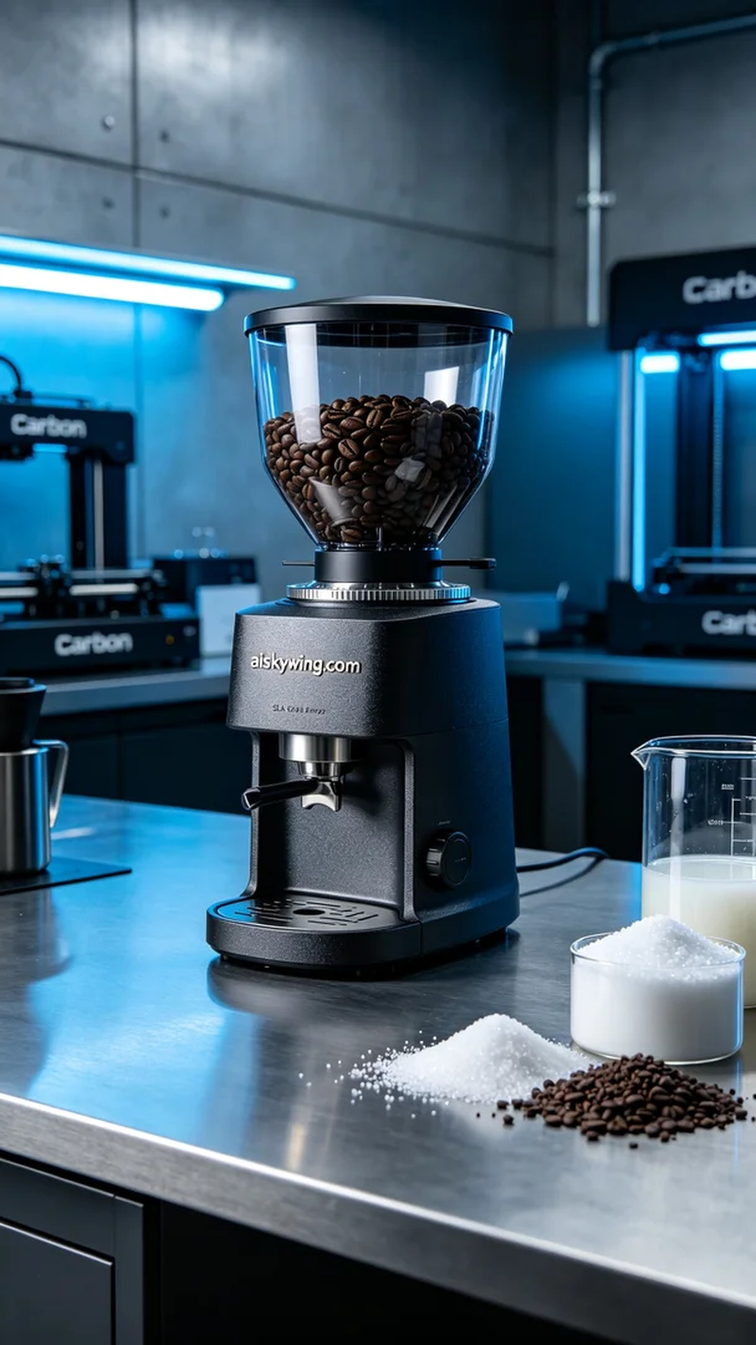
The project started simply when someone saw our previous works on TikTok and inquired if we could print a coffee bean hopper for him. He wanted the hopper to be not only aesthetically pleasing but also functional. Thus, we embarked on this creative journey of 3D printing.
We chose SLA photopolymer resin as our material because it showcases extreme detail and surface smoothness during the curing process. Using a Carbon 3D printer, we set the printing parameters to a layer thickness of 0.1 mm, maintained a temperature of 25 degrees Celsius, adjusted the power to 50 mW, and set the print speed to 90 mm per second. These parameters ensured a high-quality, finely detailed model of the hopper.
During the printing process, the printer operated smoothly, automatically adjusting for the details of each layer. We continuously monitored the printing progress to ensure there were no material blockages or light source instabilities. After approximately 6 hours of printing, the entire hopper model was successfully completed, presenting a delicate matte finish that was quite satisfying.
Next came the post-processing steps. Firstly, we placed the model into a cleaning tank, using isopropyl alcohol to wash away the uncured resin. Then, through meticulous sanding, we smoothed out the surface, improving its touch. The curing process was also essential; we placed the model in a UV curing machine for 30 minutes to ensure its strength and durability. Finally, we conducted a comprehensive inspection to ensure every detail met the standards.
After a series of production and post-processing steps, the coffee bean hopper was fully formed, not only modern in appearance but also practical. This printing experience allowed us to deeply appreciate the infinite possibilities and charm of 3D printing.
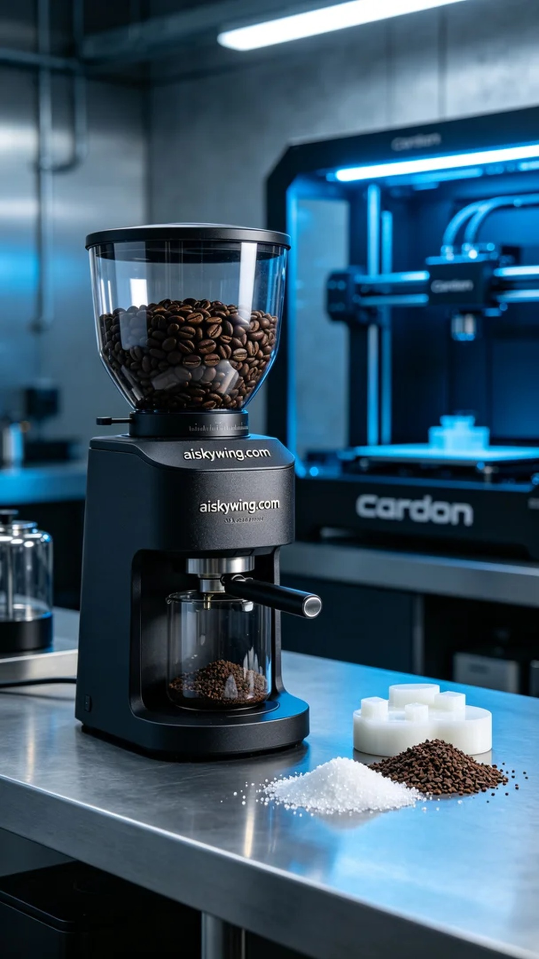
这个项目的起因很简单，有人在TikTok上看到我们之前的作品，询问是否能为他打印一个咖啡机豆仓。他希望这个豆仓不仅要美观，还要具备良好的使用功能。于是，我们开始了这次充满创意的3D打印之旅。
我们选用了SLA光固化树脂作为原材料，这种材料在光固化的过程中可以展现出极致的细节和表面光滑度。使用Carbon品牌的3D打印机，我们将打印参数设置为层厚0.1毫米，温度保持在25摄氏度，功率调整为50毫瓦，打印速度设定为90毫米每秒。这些参数可以确保打印出高质量、精细的豆仓模型。
在打印过程中，打印机的运行相当平稳，自动调整每个层面的细节。我们时刻监控打印进程，以确保没有出现材料堵塞或光源不稳定的问题。经过大约6小时的打印，整个豆仓模型顺利完成，表面呈现出细腻的磨砂效果，令人满意。
接下来是后处理的工序，首先我们将模型放入清洗槽，使用异丙醇清洗去除未固化的树脂。然后，通过细致的打磨处理，使表面更加光滑，并提升其触感。固化环节也必不可少，我们将模型放入UV固化机中，进行30分钟的固化，以确保其强度和耐用性。最后，我们进行了全面的检验，确保每个细节都符合要求。
经过一系列的制作和后处理，咖啡机豆仓已然成型，不仅外观现代，还具备良好的实用性。这次打印经历让我们深刻体会到3D打印的无限可能和魅力。
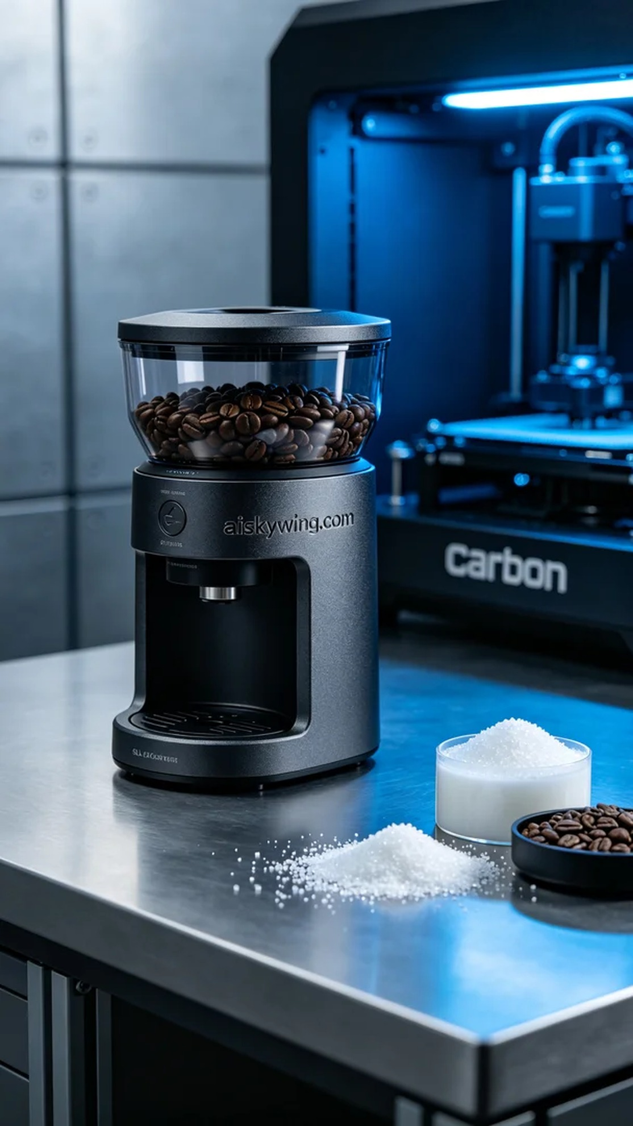
Aiskywing Industrial 3D Printing
Coffee machine bean hopper


