1036-声卡外壳3D打印生产记录
Sound card casing
🖨️ SLA光固化
🖥️ 打印机: Carbon
📦 材料: SLA光固化树脂
生活总会给我们带来挑战，就像在LinkedIn上有人找我们制作这个声卡外壳一样，我们需要迎接每一个新的项目。
Life will always present us with challenges, just like when someone on LinkedIn asked us to create this sound card casing; we need to embrace every new project.
________________________________________________________________________________
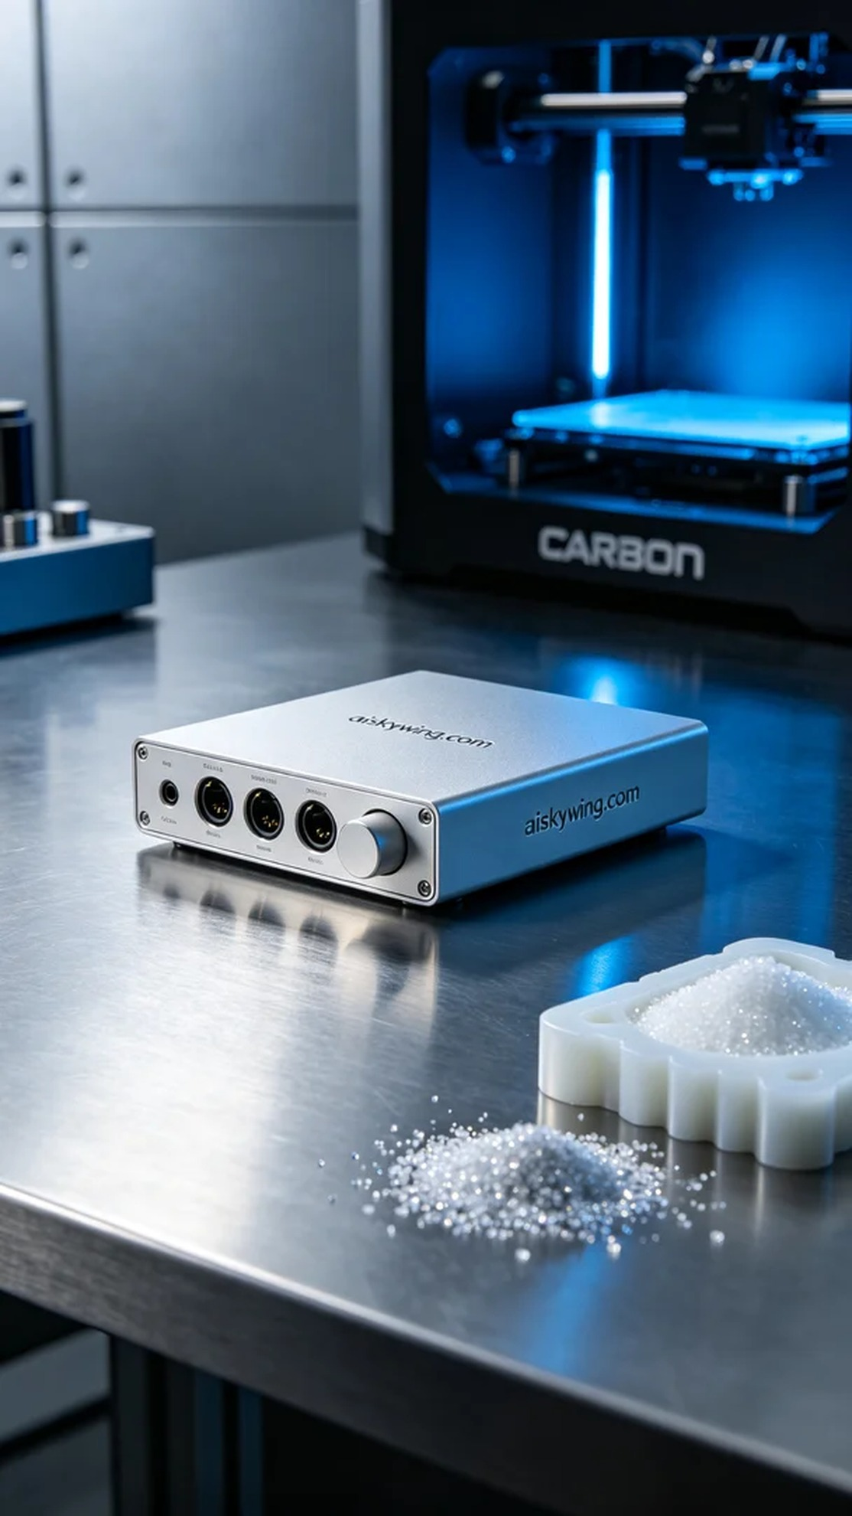
On LinkedIn, someone approached us for creating a sound card casing. They were facing challenges with commercially available products not meeting their needs, and they hoped we could provide a refined and unique solution. Thus, this project began.
To ensure product quality, we chose SLA photopolymer resin as the raw material. This resin offers excellent detail retention and superior surface finish. We utilized a Carbon brand 3D printer for the printing process, setting the layer thickness at 0.1 mm, maintaining the printing temperature at 25°C, adjusting the power to 80% for the best results, and setting the printing speed at 50 mm per second, with an estimated overall printing time of 3 hours.
During the printing process, the Carbon machine operated smoothly, and the automatic monitoring system provided real-time feedback on the printing status. We conducted regular checks on the progress of the printed piece to ensure that each layer cured properly, striving for extreme clarity and sharpness.
In the post-processing phase, we carried out a series of operations on the completed sound card casing. First, it underwent cleaning to remove any residual liquid resin, then we meticulously polished it to achieve a matte finish. In the curing stage, we placed it under UV light to ensure the strength and stability of the materials, followed by a comprehensive quality inspection to guarantee that each product met our standards.
In the end, the production of this sound card casing was successfully completed, showcasing extreme detail and quality, just as we promised. This work was not only a technical challenge but also a testament to our craftsmanship.
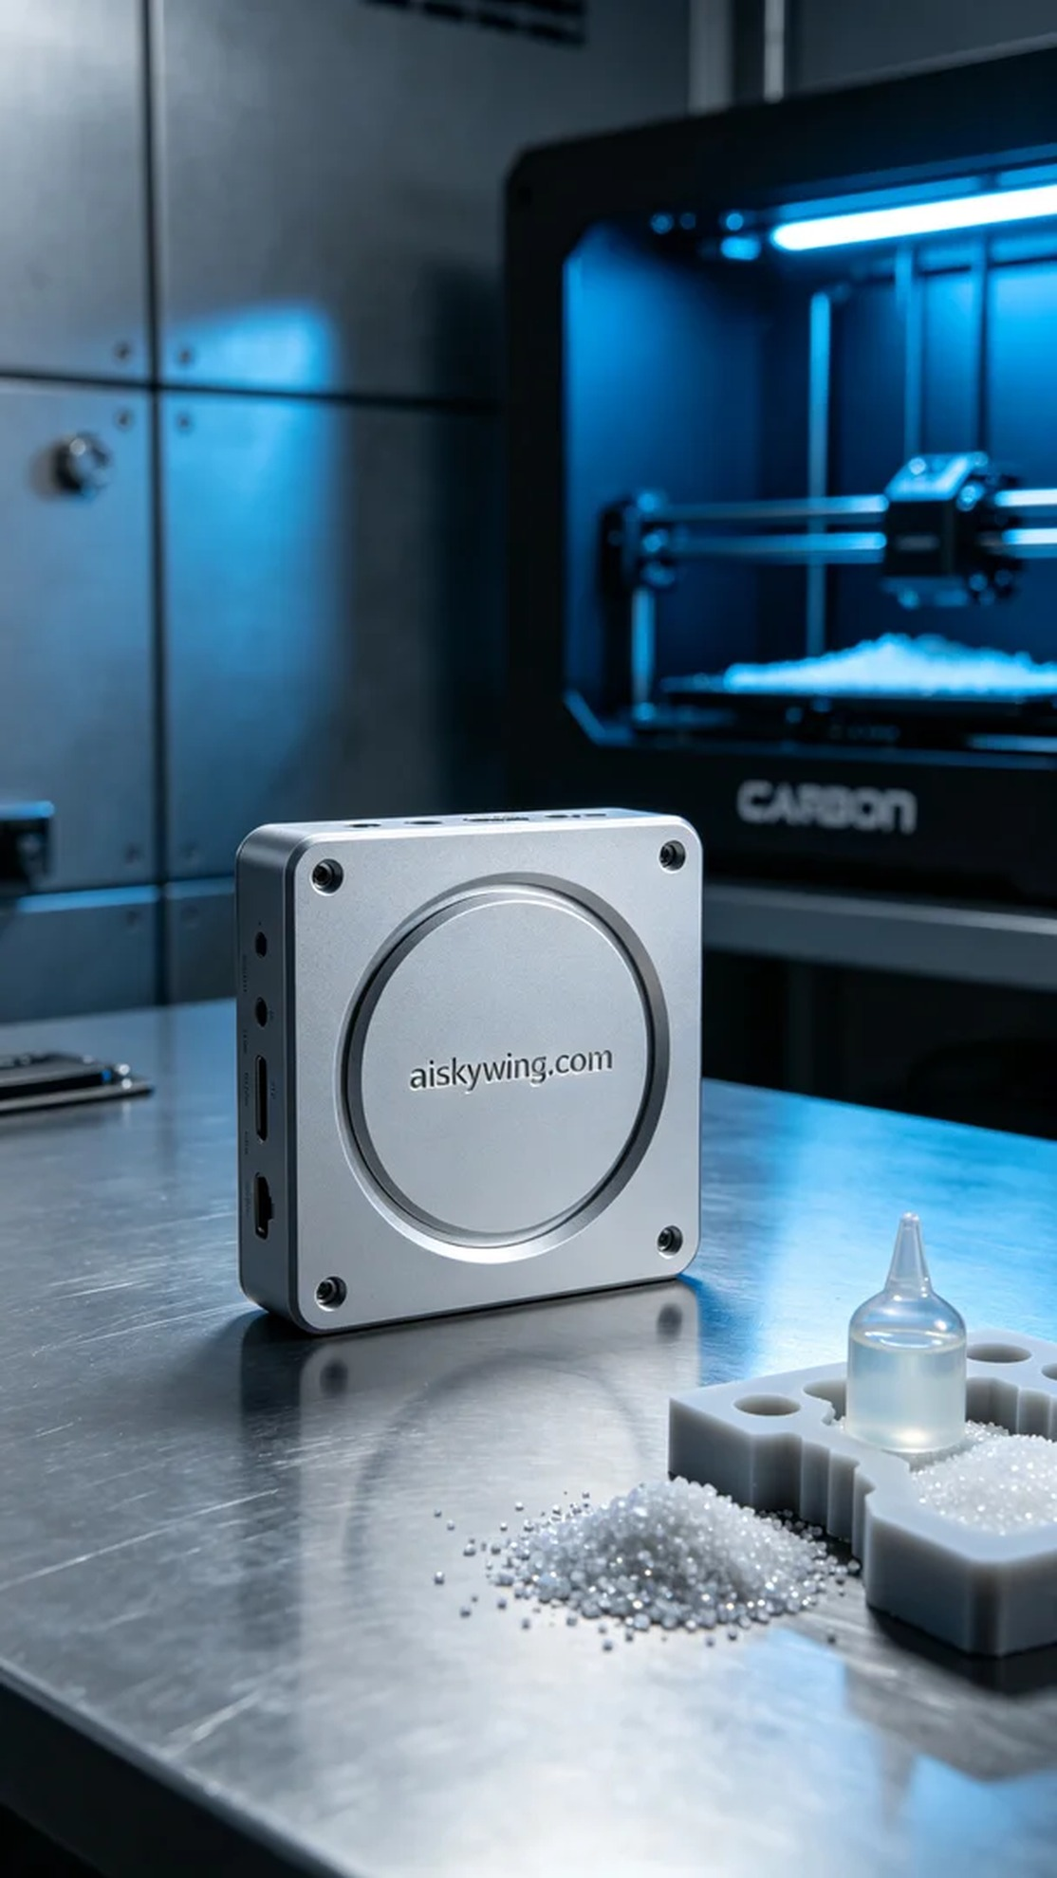
在LinkedIn上，有人找我们制作声卡外壳。他们面临着市售产品无法满足需求的问题，希望我们能提供一个精致且独特的解决方案。这正是我们擅长的领域，于是这个项目便顺势开始了。
为确保产品质量，我们选用了SLA光固化树脂作为原材料。这种树脂具有出色的细节还原能力和优异的表面光洁度。我们使用Carbon品牌的3D打印机进行打印，设定层厚为0.1毫米，打印温度控制在25℃，功率调整为80%以达到最佳效果，打印速度则设定在50毫米每秒，预计整体打印时间为3小时。
在打印过程中，Carbon设备的运行情况良好，机器的自动监控系统及时反馈了打印状态。我们定期检查打印件的进度，确保每一层的固化效果都达到标准，追求极致的清晰和锐利。
后处理阶段，我们对打印完成的声卡外壳进行了一系列工序。首先进行清洗，以去除残余的液态树脂，然后经过细致打磨，达到哑光质感的效果。在固化环节，我们将其放置在UV灯下，确保材料的强度和稳定性，最后进行了全面的质量检验，以确保每一件产品都符合我们的标准。
最终，这个声卡外壳的制作顺利完成，呈现出极致的细节和品质，正如我们所承诺的。这次的工作不仅是对技术的挑战，也是对我们匠心精神的体现。
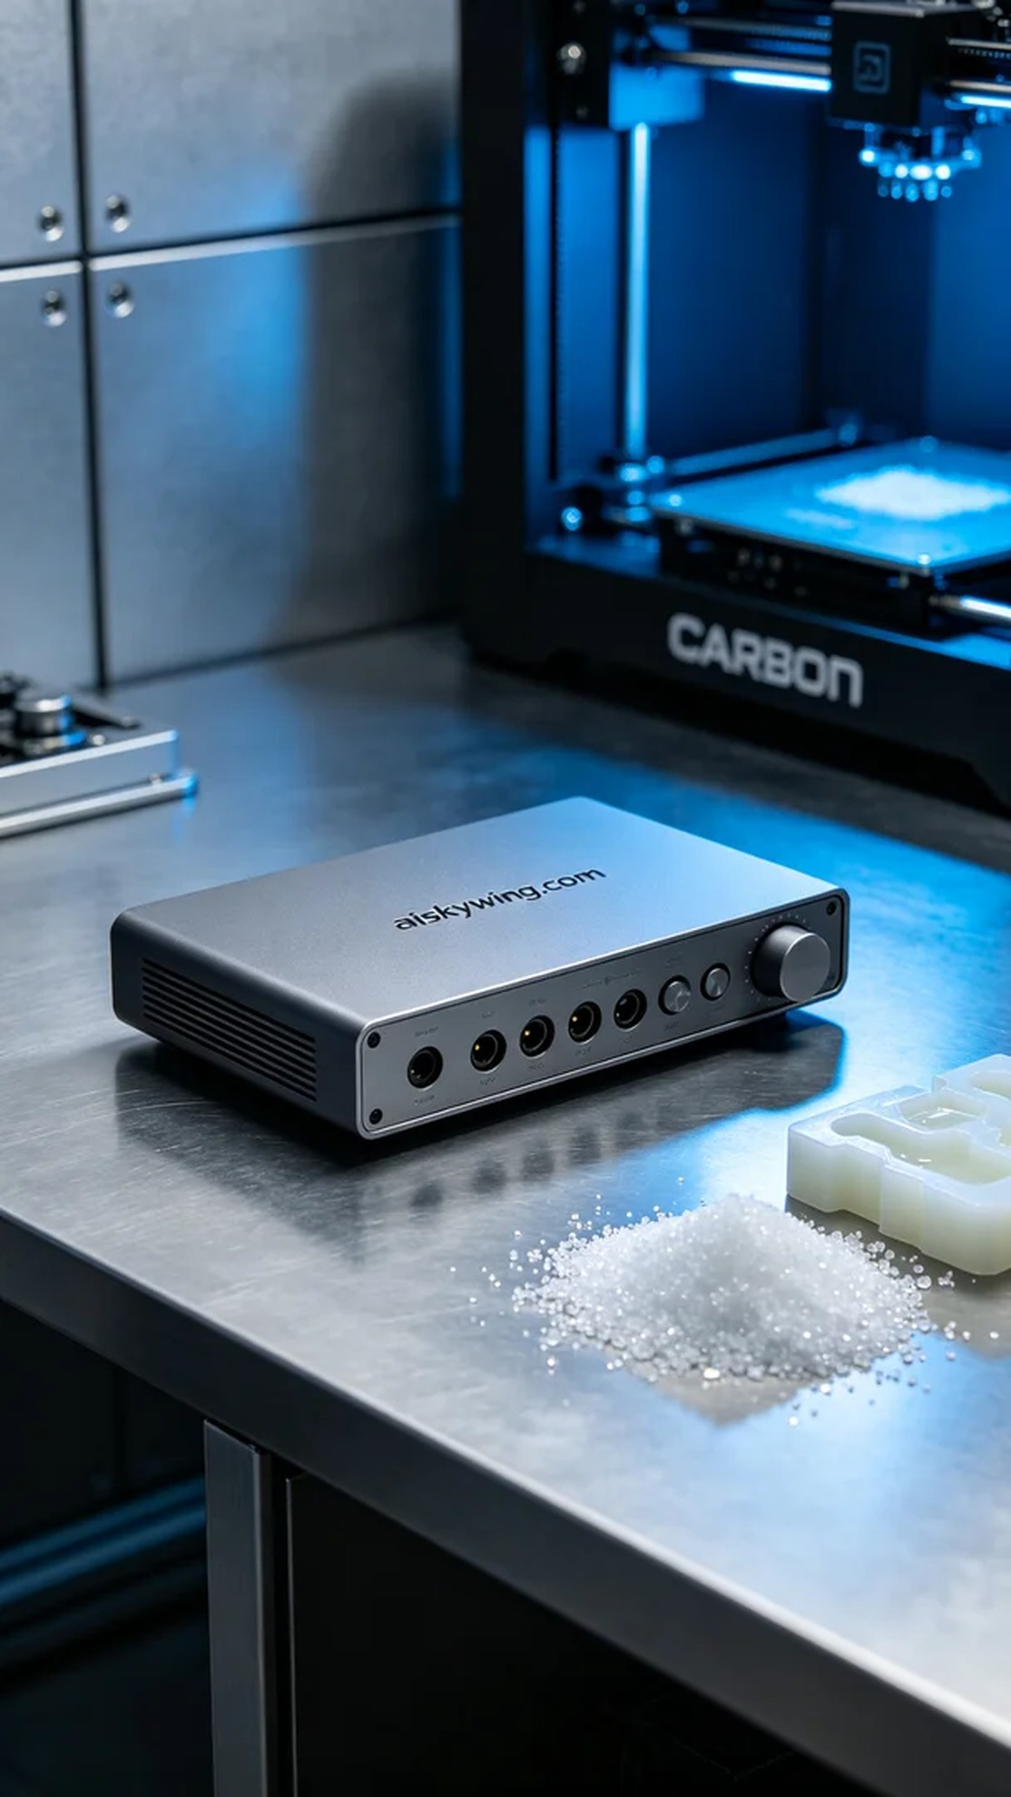
Aiskywing Industrial 3D Printing
Sound card casing


