1037-头戴式耳机头梁3D打印生产记录
Headband of headphones
🖨️ SLA光固化
🖥️ 打印机: Xjet
📦 材料: SLA光固化树脂
生活再难，也别停下脚步。就像接这个头戴式耳机头梁的单子，我知道它承载的不仅是技术的进步，还有人们对音乐的渴望。
No matter how difficult life gets, don't stop moving forward. Just like taking on this order for the headband of these headphones, I know it carries not only the advancement of technology but also people's yearning for music.
________________________________________________________________________________
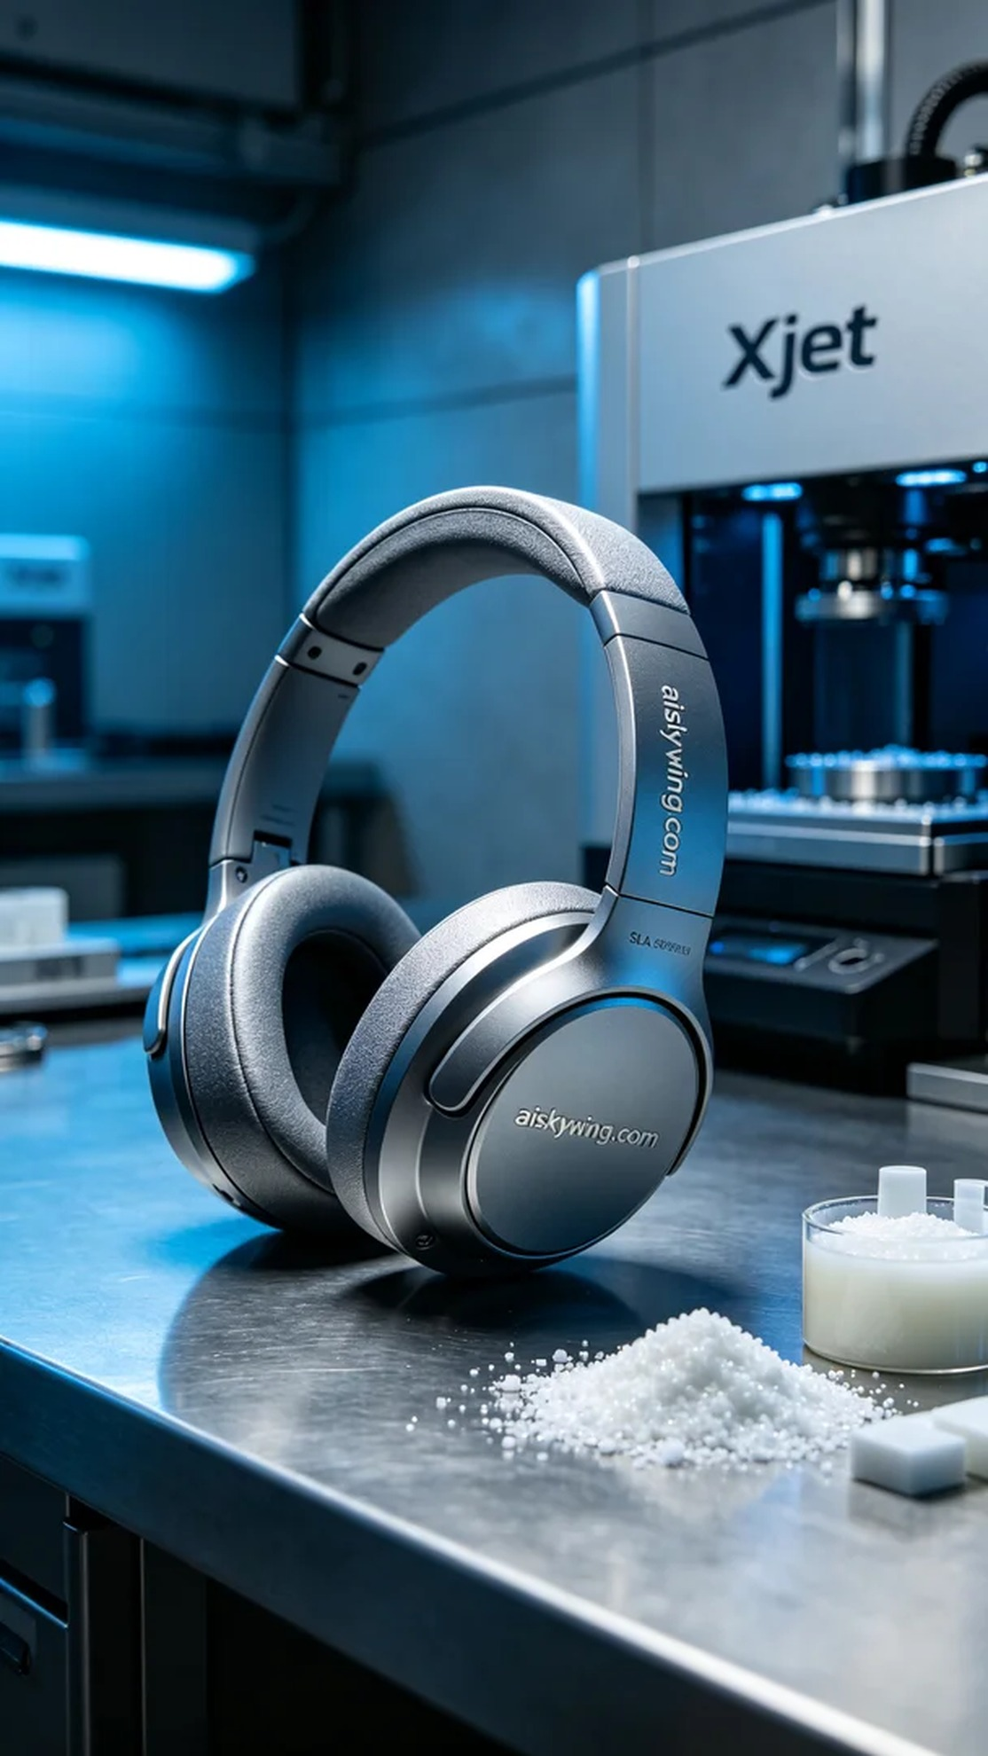
On Facebook, someone reached out to us because they wanted a unique headband for their headphones. They hoped this headphone would not only deliver excellent sound quality but also embody a distinctive look that showcases their personality.
To achieve this goal, we chose SLA photopolymer resin as the material. This type of resin offers high resolution and excellent surface smoothness, making it suitable for creating intricate headphone structures. During our equipment preparation, we used an Xjet brand printer, setting parameters to a layer thickness of 0.05 mm, maintaining the temperature at 25 degrees Celsius, with power set at 70% and a printing speed of 40 mm per second. The estimated printing time was around 4 hours.
During the printing process, the Xjet printer operated steadily, building layer by layer. We constantly monitored the print quality to ensure each layer adhered perfectly, avoiding bubbles or defects. As the printing progressed, the details of the headband gradually emerged, with the engraved "aiskywing.com" clearly visible on the surface.
After completing the print, we moved into post-processing. First, the printed headband was placed in a cleaning chamber, where we used a specialized solvent to thoroughly wash away any resin residue. Next, we performed meticulous sanding on the surface to eliminate minor imperfections, followed by a curing process to ensure strength and durability. Finally, we conducted a comprehensive inspection of the final product to ensure every detail met our standards.
After a series of precise production steps, this headband for headphones was finally complete. Seeing the finished product filled us with pride; it was not only a reflection of our technical capabilities but also a testament to our relentless pursuit of quality.
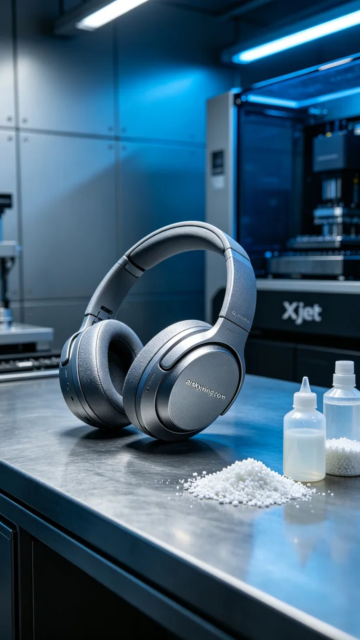
在Facebook上，有人因为想要一款独特的头戴式耳机头梁而找到了我们。他们希望这款耳机不仅能提供卓越的音质，还要在外观上独具匠心，彰显个性。
为了实现这个目标，我们选用了SLA光固化树脂作为材料。这种材料具有极高的分辨率和优良的表面光滑度，适合制作精细的耳机结构。设备准备时，我们使用了Xjet品牌的打印机，设置参数为层厚0.05毫米，温度保持在25摄氏度，功率设置为70%，打印速度为40毫米每秒，预计打印时间约为4小时。
在打印过程中，Xjet打印机稳定运行，逐层积累。我们时刻监控打印质量，确保每一层都完美粘合，避免出现气泡或瑕疵。随着打印进程的推进，头梁的细节逐渐显现，表面雕刻的"aiskywing.com"字样也清晰可见。
完成打印后，进入后处理阶段。首先将打印好的头梁放入清洗槽，使用专用溶剂进行彻底清洗，去除树脂残留。接着，我们对其表面进行细致打磨，以消除任何小的瑕疵，随后进行固化处理，确保其强度和耐用性。最后，我们对成品进行全面检验，确保每一处细节都符合标准。
经过一系列精细的制作流程，这款头戴式耳机头梁终于完成。看到成品，我们都感到无比自豪，这不仅是技术的体现，更是对品质的不懈追求。
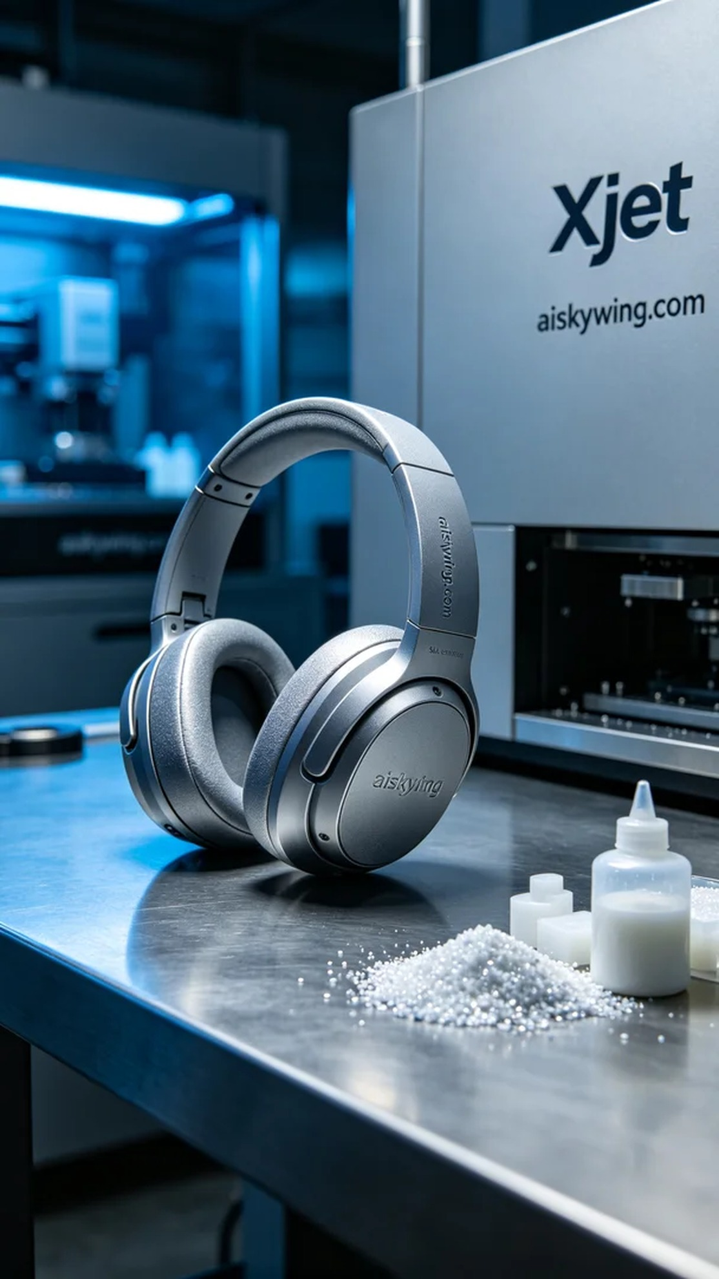
Aiskywing Industrial 3D Printing
Headband of headphones


