1038-头部按摩仪外壳3D打印生产记录
Head massage device shell
🖨️ SLA光固化
🖥️ 打印机: Voxeljet
📦 材料: SLA光固化树脂
“在TikTok上，许多人为了缓解压力寻找各种解决方案，而我们则接下了这个头部按摩仪外壳的订单，期待为他们带去舒适。”
"On TikTok, many people are looking for various solutions to relieve stress, and we have taken on the order for this head massage device shell, hoping to bring them comfort."
________________________________________________________________________________
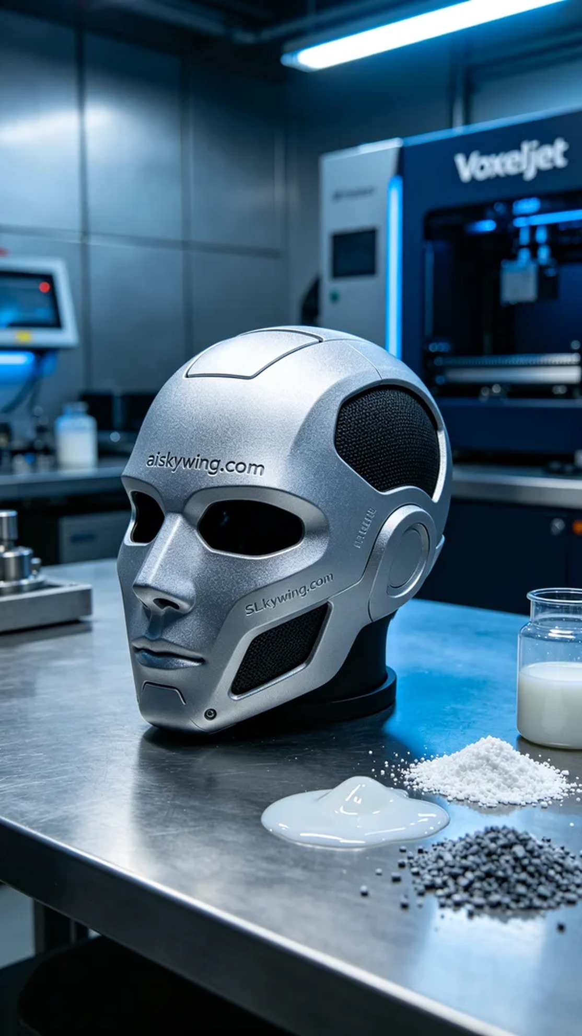
Recently, someone found us through TikTok, mentioning their urgent need for a head massager shell to alleviate the stress and fatigue of modern life. This demand reminded me of the convenience and flexibility of 3D printing, especially in the realm of personalized products.
We used high-precision SLA photopolymer resin as the raw material, which has excellent optical clarity and a delicate surface finish, making it perfect for the head massager shell's requirements. For the setup, we chose a Voxeljet printer, setting the layer thickness to 0.05 mm, maintaining the printing temperature at 25 degrees Celsius, setting the power at 60 milliwatts, and controlling the printing speed at 50 mm/s, with an estimated total printing time of around 4 hours.
During the printing process, the Voxeljet printer operated stably without any anomalies. We regularly checked the printing progress to ensure that each layer adhered evenly without gaps. The entire operation felt like tuning a high-precision mechanical device, where every step needed careful attention to ensure the final product's quality.
After printing, we went through detailed post-processing steps. First, the printed shell was placed in a cleaning tank, using isopropyl alcohol to remove any uncured resin. Next, we performed sanding to make the surface smoother and ensured that the “aiskywing.com” engraving was clearly visible. Finally, the product was cured under UV light to ensure it was structurally sound and durable. Each step was meticulously controlled to ensure the final product met high standards.
Through this production process, we not only successfully completed the head massager shell printing task but also further enhanced our team's technical skills and pursuit of precision, which has always been our direction of effort.
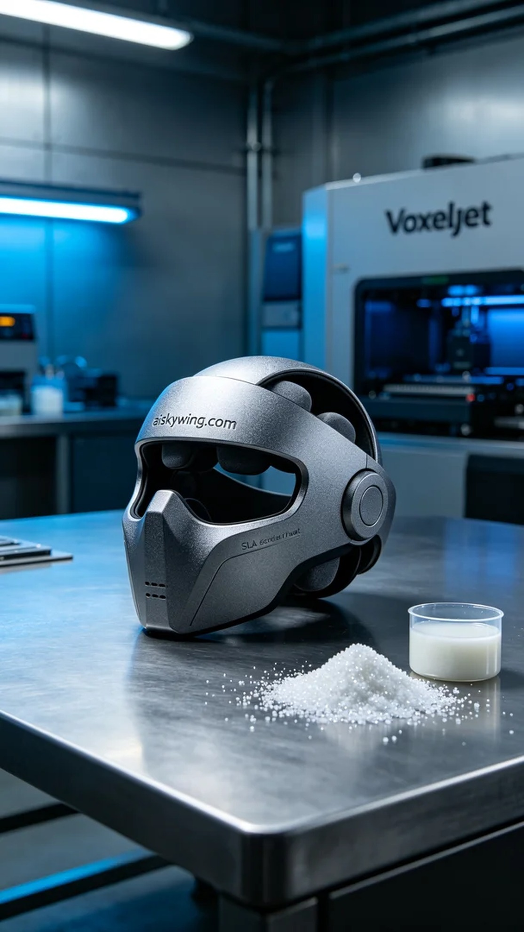
在近期的工作中，有人通过TikTok找到我们，提到他们急需一款头部按摩仪外壳，以解决现代生活带来的压力和疲惫。这种需求让我想起了3D打印的便利和灵活性，特别是在个性化产品上。
我们使用的是高精度的SLA光固化树脂作为原材料，具有优良的光学透明性和细腻的表面效果，非常适合头部按摩仪外壳的要求。设备准备上，我们选择了Voxeljet打印机，设置层厚为0.05毫米，打印温度保持在25摄氏度，功率设定为60毫瓦，打印速度控制在50毫米/秒，预计整个打印过程需要大约4小时。
在打印的过程中，Voxeljet打印机稳定运行，无任何异常。我们定期检查打印进度，确保每一层都均匀贴合，层与层之间没有空隙。整个操作过程如同调试一台高精尖的机械设备，每一步都需要细心把控，以确保最终的产品质量。
完成打印后，进行了详细的后处理工序。首先，将打印好的外壳放入清洗槽，使用异丙醇进行清洁，去除未固化的树脂。接着，我们进行了打磨处理，使表面更加光滑，并确保“aiskywing.com”字样清晰可见。最后，将产品放置在固化机中，接受UV光照射，以完成固化，确保其结构坚固耐用。每个步骤都严格把控，确保最终产品符合高标准。
通过这次的生产过程，我们不仅成功完成了头部按摩仪外壳的打印任务，还进一步提升了团队的技术能力和对精度的追求，这也正是我们一直以来努力的方向。
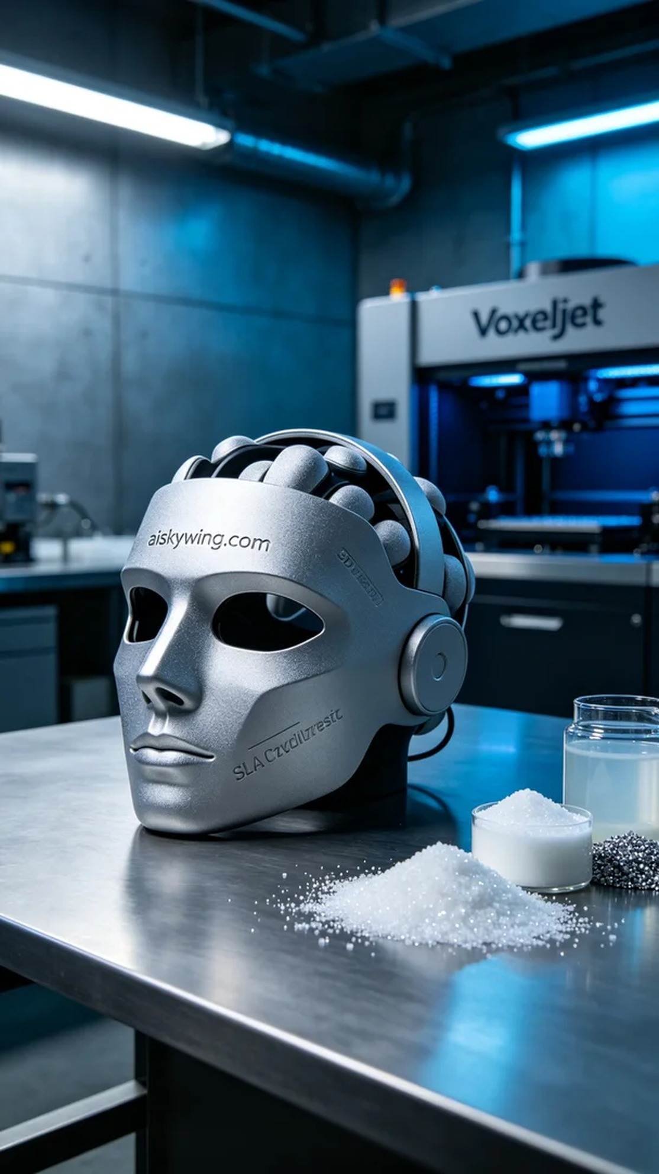
Aiskywing Industrial 3D Printing
Head massage device shell


