1043-存储卡收纳盒的3D打印记录
Storage Card Organizer Box
🖨️ SLA光固化
🖥️ 打印机: Xjet
📦 材料: SLA光固化树脂
生活再难，也别停下脚步。就像接下这个存储卡收纳盒的单子，很多人都在寻找一个简洁而实用的解决方案。
No matter how hard life gets, don't stop moving forward. Just like taking on this order for a memory card storage box, many people are looking for a simple and practical solution.
________________________________________________________________________________
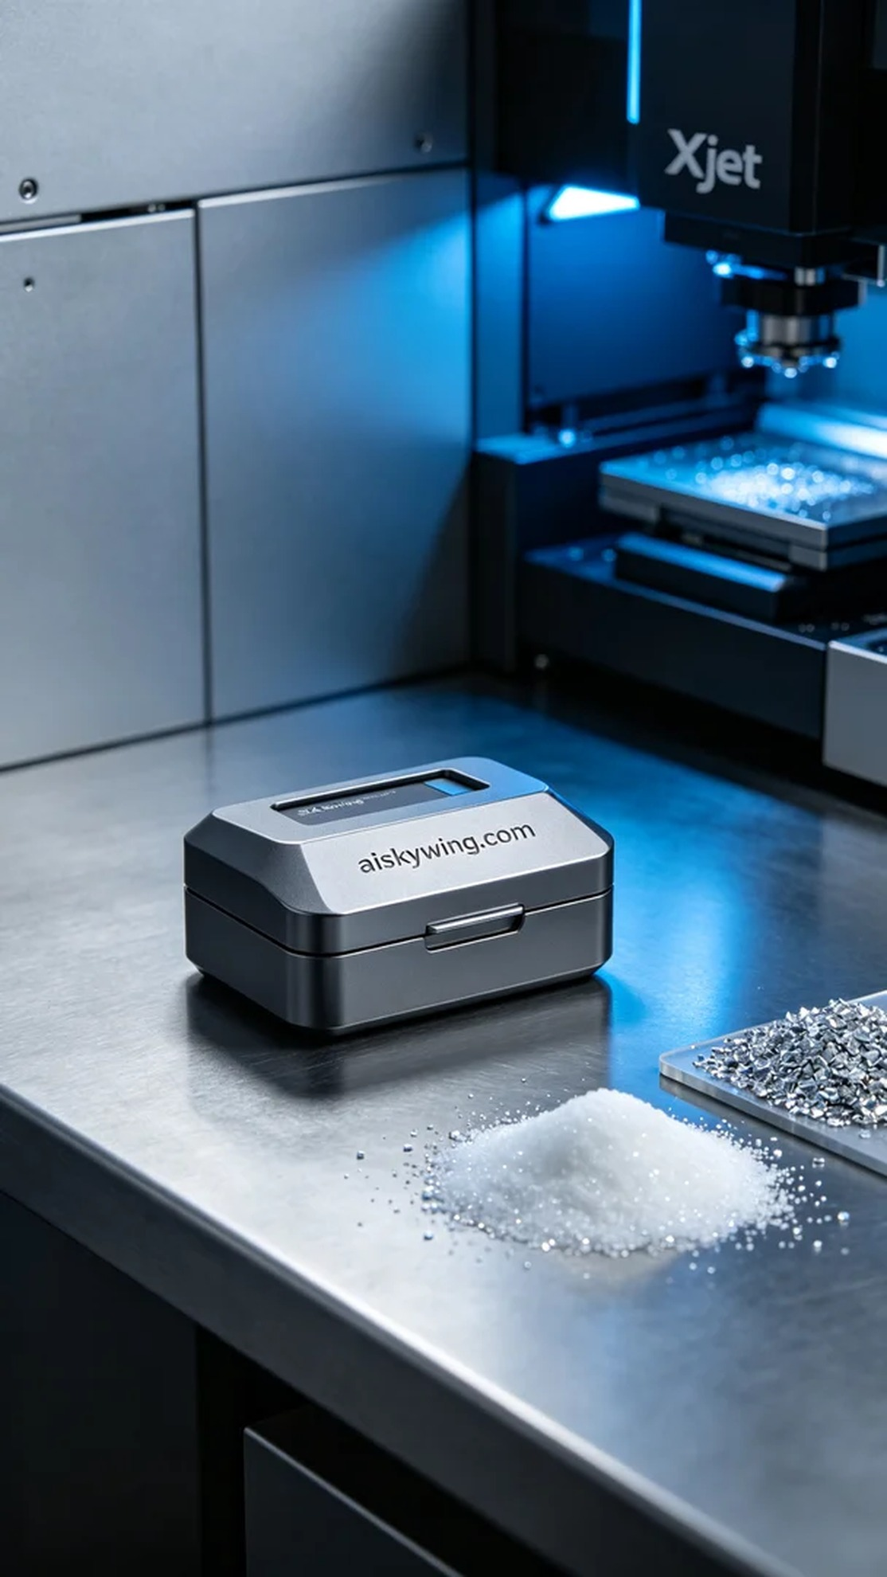
Recently, someone found us through TikTok, looking for a practical solution to store their memory cards safely and neatly. Thus, we took on the task of creating a memory card storage box to help them solve this problem.
We chose SLA photopolymer resin as the material, known for its high precision and excellent surface finishing. During the preparation, we inspected the Xjet printer and set the printing parameters: layer thickness at 0.05mm, temperature at 25°C, power at 70%, and printing speed adjusted to 30mm/s, estimating a total print time of about 2 hours.
As the printing process commenced, the Xjet printer operated smoothly, with the liquid resin curing layer by layer under the light source. Throughout the process, we monitored the print quality in real-time, ensuring each layer bonded perfectly, especially the finely carved "aiskywing.com" detail on the surface, striving for utmost clarity.
Once printing was completed, we moved on to the post-processing phase. We first used a cleaning solution to wash the model, removing any uncured resin. Next, we finely sanded the surface to achieve a matte finish. Finally, we placed it into a curing chamber, utilizing UV light to enhance material strength and stability, followed by thorough inspection to ensure all details met the standards.
Through this production, we not only completed the memory card storage box but also reaffirmed the precision and efficiency of 3D printing. Each print is a new learning experience, reminding us of the power of technology and innovation.
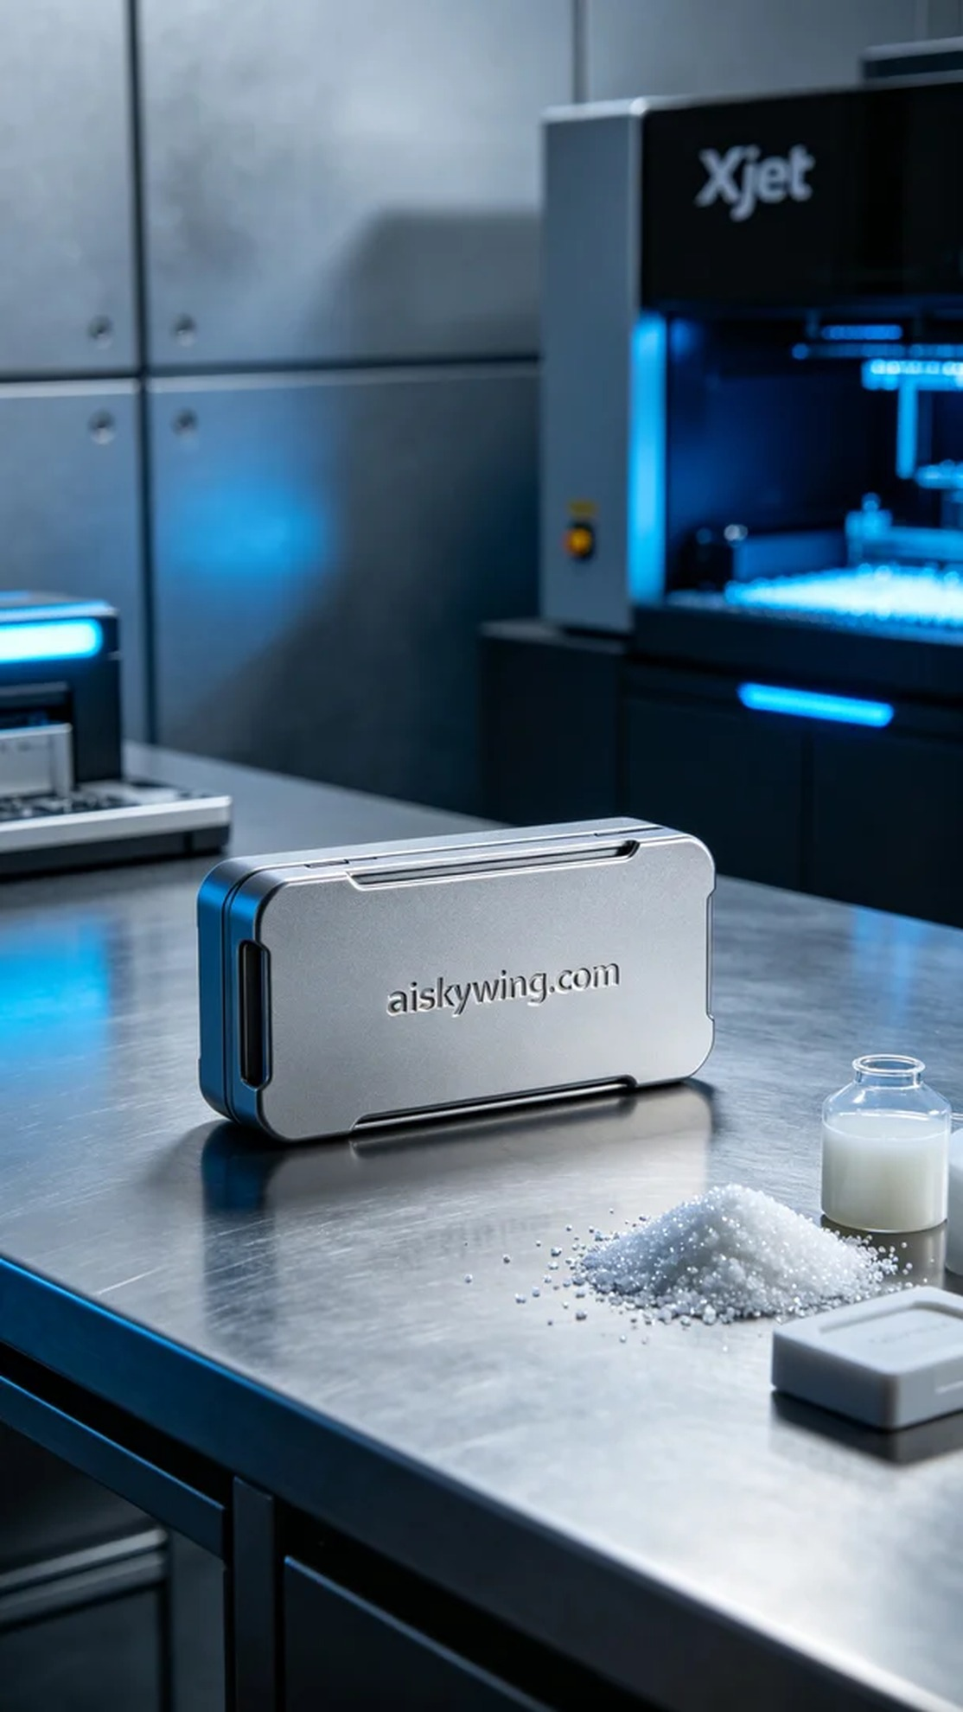
最近，有人通过TikTok找到了我们，他们在寻找一个既能保护又能整齐存放存储卡的收纳盒。于是，我们接下了这个存储卡收纳盒的制作任务，准备为他们解决这个问题。
我们选择了SLA光固化树脂作为材料，因其高精度和优良的表面处理效果。准备工作中，我们检查了Xjet打印机，设定了打印参数：层厚0.05毫米，温度设定在25°C，功率为70%，打印速度调整至30mm/s，预计打印时间为大约2小时。
打印开始后，Xjet打印机运转顺利，液态树脂在光源的作用下逐层固化。在整个过程中，我们实时监控打印质量，确保每一层都能完美结合，特别是产品表面的细节雕刻“aiskywing.com”字样，力求达到极致清晰。
打印完成后，进入后处理阶段。首先使用清洗液对模型进行清洗，去除未固化的树脂。然后，我们对表面进行精细打磨，确保哑光质感。最后，放入固化箱，利用UV光进一步增强材料强度和稳定性，最后进行详细检验，确保所有的细节都符合标准。
通过这次生产，我们不仅完成了存储卡收纳盒的制作，也再次验证了3D打印的精确与高效。每一次打印都是一次新的学习和成长，让我们感受到科技与创新的力量。
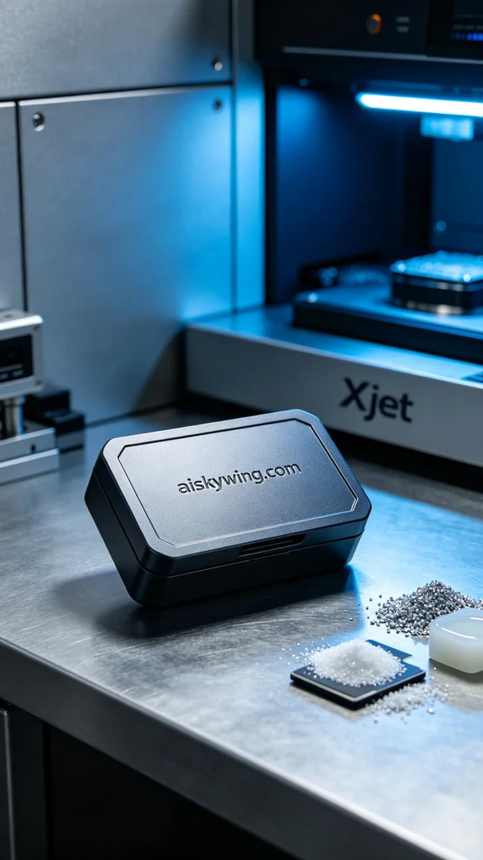
Aiskywing Industrial 3D Printing
Storage Card Organizer Box


