1044-精密家用摄像头外壳的3D打印记录
Home camera casing
🖨️ SLA光固化
🖥️ 打印机: Stratasys
📦 材料: SLA光固化树脂
生活就像3D打印，细节决定成败。有人在TikTok上找到了我们，想要制作家用摄像头外壳，解决他在设计上的烦恼。
Life is like 3D printing; details determine success or failure. Someone found us on TikTok and wanted to create a case for a home camera to solve his design troubles.
________________________________________________________________________________
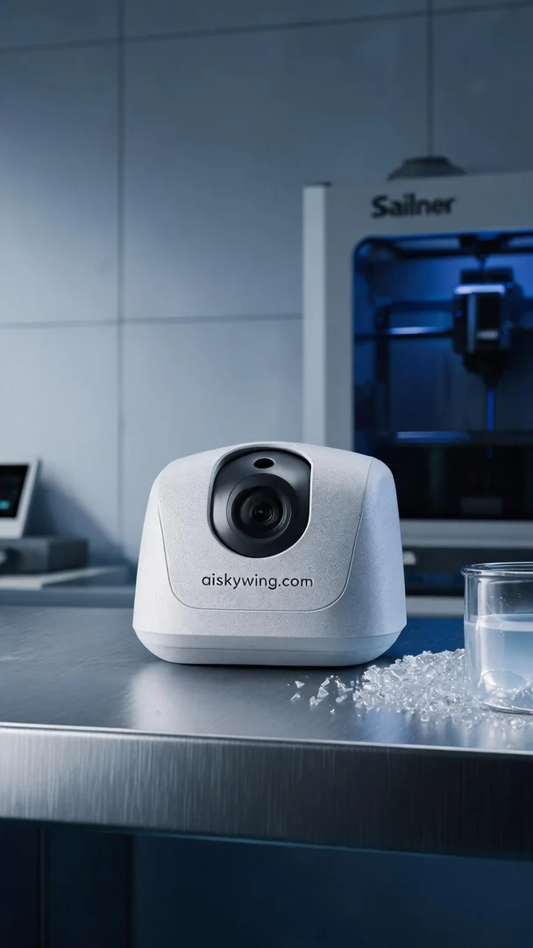
Life is like 3D printing, where details determine success. Someone found us on TikTok, looking to create a home camera shell to solve his design dilemmas.
This order involves a home camera shell, which has been gaining attention on TikTok for its aesthetic design. He hopes we can provide a shell that is both visually appealing and functional to enhance his product's market competitiveness. The design requires not only good looks but also durability and functionality.
To ensure print quality, we chose SLA photopolymer resin as the material. This resin offers high precision and smooth surface finish. We prepared the Stratasys 3D printer with parameters set to a layer thickness of 0.1mm, a printing temperature of 25°C, a laser power of 50mW, and a print speed of 40mm/s, with an estimated print time of 8 hours.
During the printing process, the Stratasys printer performed smoothly. We monitored the device status in real-time to maintain laser stability and avoid any printing failures. Each layer's curing was carefully observed to ensure accuracy in shaping. After printing, we closely inspected the finished product, confirming that the contours and details were clearly visible.
The following post-processing work was equally important. We first placed the product in a cleaning tank, thoroughly washing it with isopropanol to remove uncured resin. After that, we sanded it down to ensure a smooth surface free from blemishes, and finally, we cured it under UV light to enhance its strength and durability. Upon completion, we performed a comprehensive quality check to ensure every detail met the design standards.
Through this project, we not only successfully printed the home camera shell but also deepened our understanding of SLA processes, making us look forward to future projects.
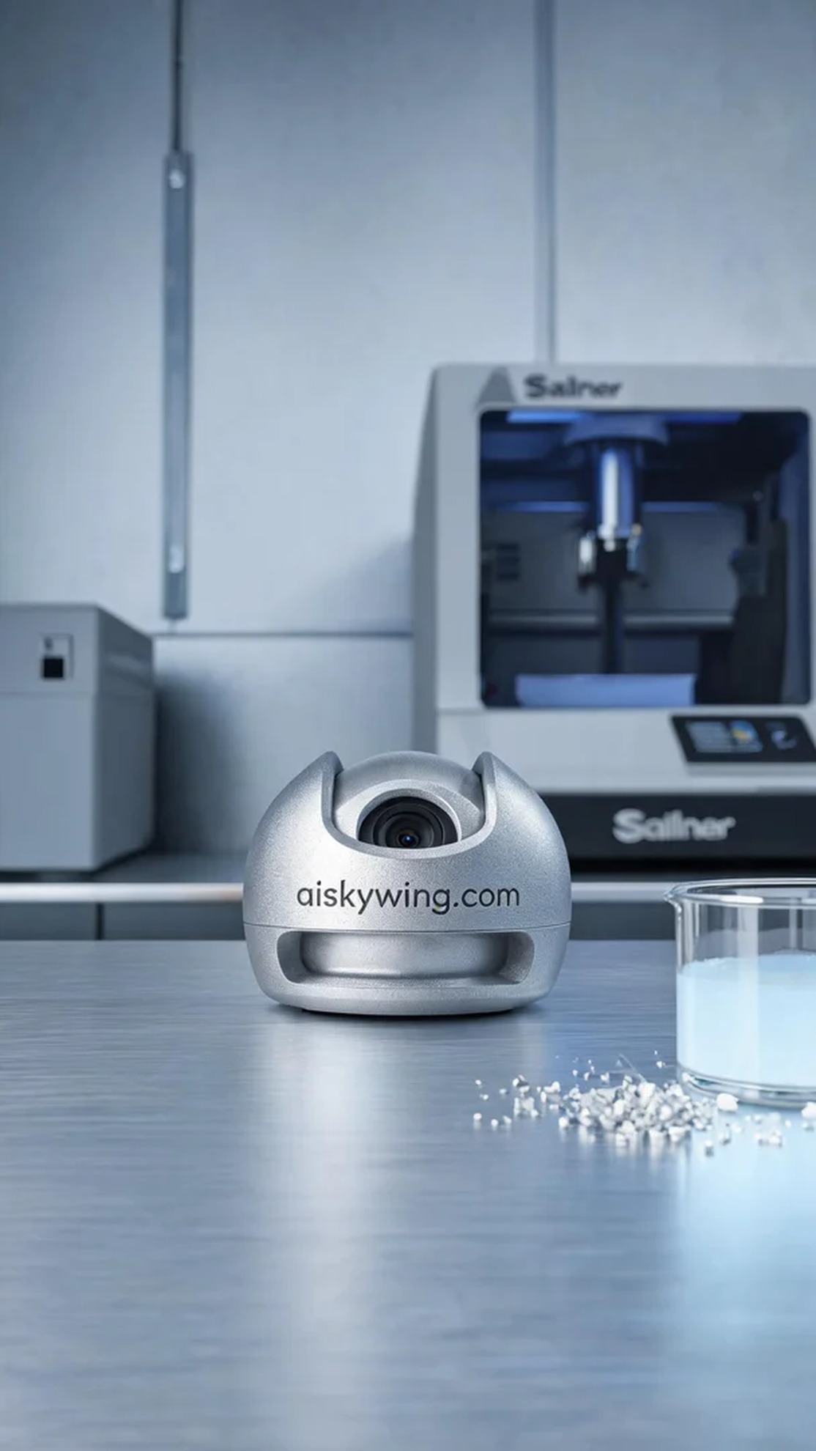
这次的订单是一个家用摄像头外壳，最近在TikTok上看到人们对摄像头外观设计的关注，因此他希望我们能够提供一款既美观又实用的外壳来提升其产品的市场竞争力。这个外壳的设计不仅要求良好的视觉效果，还要确保耐用性和功能性。
为了确保打印质量，我们选用了SLA光固化树脂作为材料。该材料能够提供高精度和光滑的表面效果。我们准备了Stratasys品牌的3D打印机，设置参数为0.1mm的层厚，打印温度保持在25°C，激光功率为50mW，打印速度设定为40mm/s，预计打印时间为8小时。
在打印过程中，Stratasys打印机运行得非常顺利。我们实时监测设备状态，保持激光的稳定性，以避免任何可能的打印失败。每一层的固化都被仔细观察，确保成型的准确性。打印结束后，我们仔细检查成品，确认外壳的轮廓和细节清晰可见。
接下来的后处理工作同样重要。我们首先将成品放入清洗槽中，使用异丙醇对其进行彻底清洗，以去除未固化的树脂。随后，我们用砂纸进行打磨，确保表面平滑且无瑕疵，最后进行紫外线固化，以增强其强度和耐久性。完成后，我们进行了全面的质量检验，确保每个细节都达到设计标准。
通过这次的制作，我们不仅顺利完成了家用摄像头外壳的打印，还提升了对SLA工艺的理解，让我们对未来的项目充满期待。
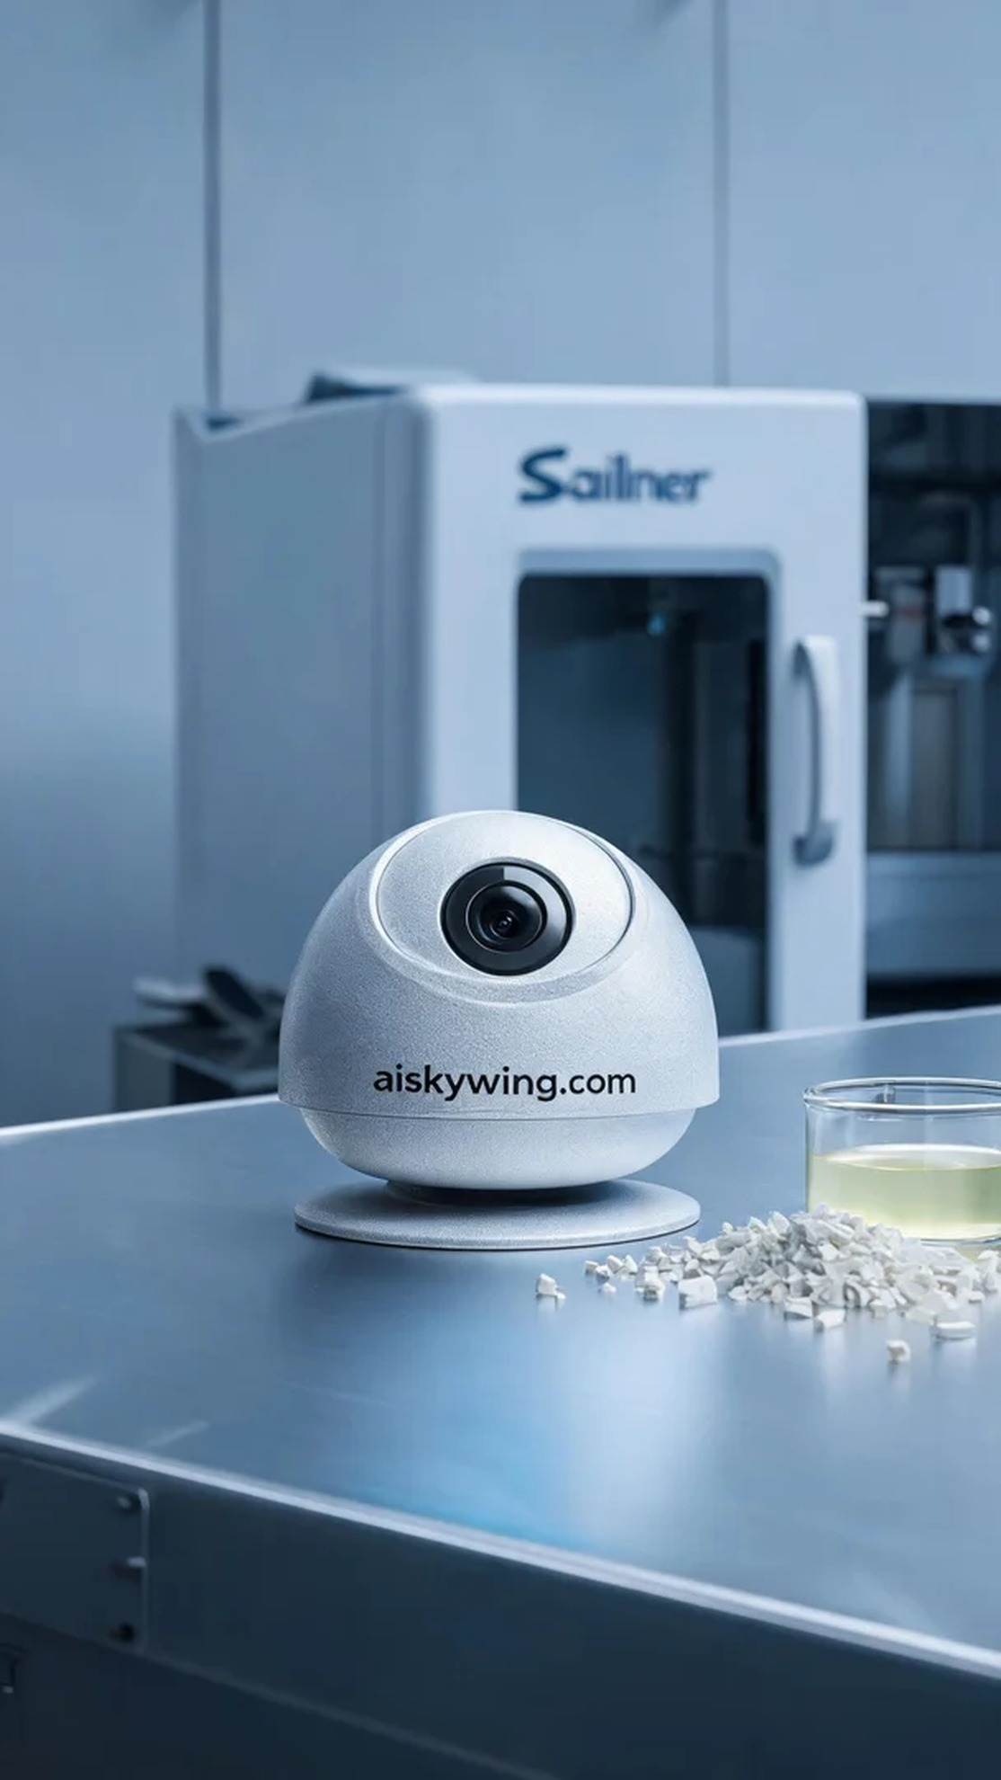
Aiskywing Industrial 3D Printing
Home camera casing


