1045-精密3D打印对讲机外壳
Intercom shell
🖨️ SLA光固化
🖥️ 打印机: Systems
📦 材料: SLA光固化树脂
生活就像3D打印，层层叠加，才能成就完美。有人通过TikTok找上我们，希望制作一款对讲机外壳，确保质量与工艺。
Life is like 3D printing, built layer by layer to achieve perfection. Someone reached out to us through TikTok, hoping to create a walkie-talkie shell, ensuring quality and craftsmanship.
________________________________________________________________________________
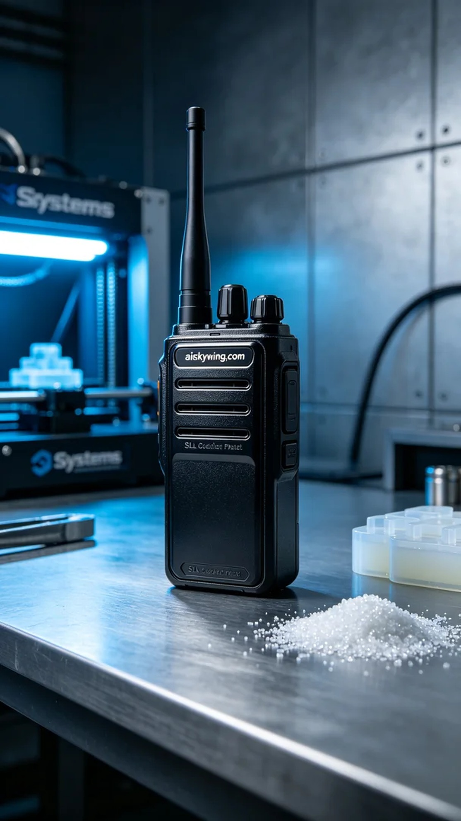
Life is like 3D printing; it takes layers to achieve perfection. Recently, someone reached out to us through TikTok, wanting a custom intercom shell, ensuring quality and craftsmanship.
For the material, we chose SLA photopolymer resin. This material provides excellent detail and a smooth surface, ideal for creating visually appealing products. We utilized a Systems 3D printer, setting a layer thickness of 4.5 microns, a printing temperature of 25°C, with power set to 100% and a speed of 40mm/s. The entire printing process was expected to take around 5 hours, ensuring every detail is crystal clear.
As the printing began, the Systems printer operated quietly and efficiently. Quality monitoring during this process was crucial. We regularly checked the print progress, ensuring each layer was even and accurate. As the print progressed, we watched the intercom shell gradually take shape, with intricate engravings and curves showing remarkable precision.
After printing, we moved to the post-processing stage. First, we thoroughly cleaned the finished piece using water and isopropyl alcohol to remove any residual resin. Next, we sanded the shell to achieve a smoother surface and eliminate any potential imperfections. Finally, we placed the piece in a UV curing machine for about 60 minutes to increase its hardness and durability. Upon inspection, all processes met our expectations.
In the end, this intercom shell was successfully completed, boasting visual impact and functionality. Every step was filled with craftsmanship, and we are proud of this creation.
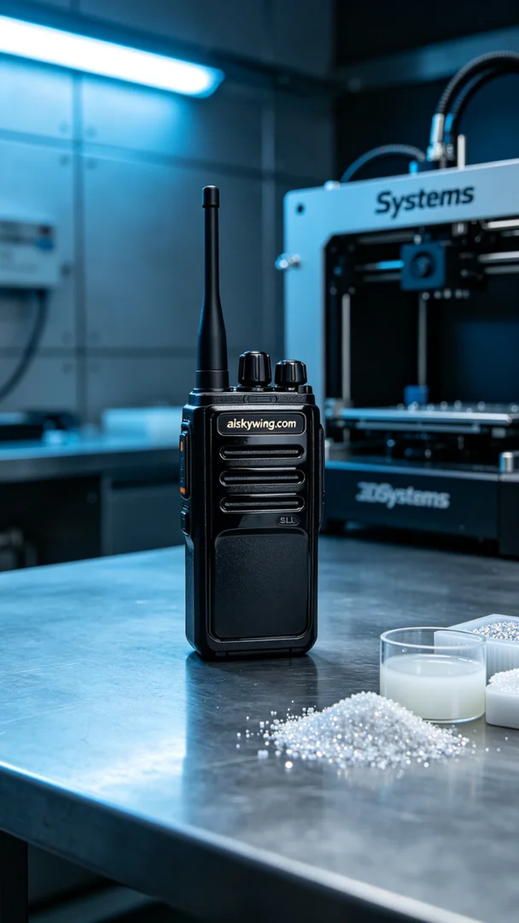
我们最近接到一个有趣的需求，有人希望制作一款对讲机外壳，通过TikTok找到我们，提出了对材质和外观的高要求。要求不仅要符合实际使用，还要在视觉上引人注目，所以我们开始了这项工作。
在材料选择上，我们决定使用SLA光固化树脂。这种材料具有优良的细节呈现能力和表面光滑度，适合制作外观精致的产品。为了确保打印质量，我们使用了Systems品牌的3D打印机，设置了4.5微米的层厚，打印温度为25°C，功率调至100%，速度保持在40mm/s。整个打印过程预计耗时约5小时，确保每个细节都清晰可见。
打印开始后，Systems打印机安静高效地运行，整个过程的质量监控至关重要。我们定期检查打印进度，确保每一层都均匀无误。随着打印的推进，我们看到对讲机外壳逐渐成型，细节之处的雕刻和曲线都显示出极高的精度，令人满意。
完成打印后，我们进入了后处理工序。首先，使用清水和异丙醇对成品进行彻底清洗，以去除表面残留的树脂。接着，我们对外壳进行打磨，使其表面更加光滑，并去除可能存在的瑕疵。最后，将成品放入UV固化机中固化约60分钟，以增强其硬度和耐用性。经过验证，所有工序都达到了我们预期的标准。
最终，这款对讲机外壳成功完成，既有视觉冲击力，也具备实用性。每一步都充满了工匠精神，让我们为这份作品感到自豪。
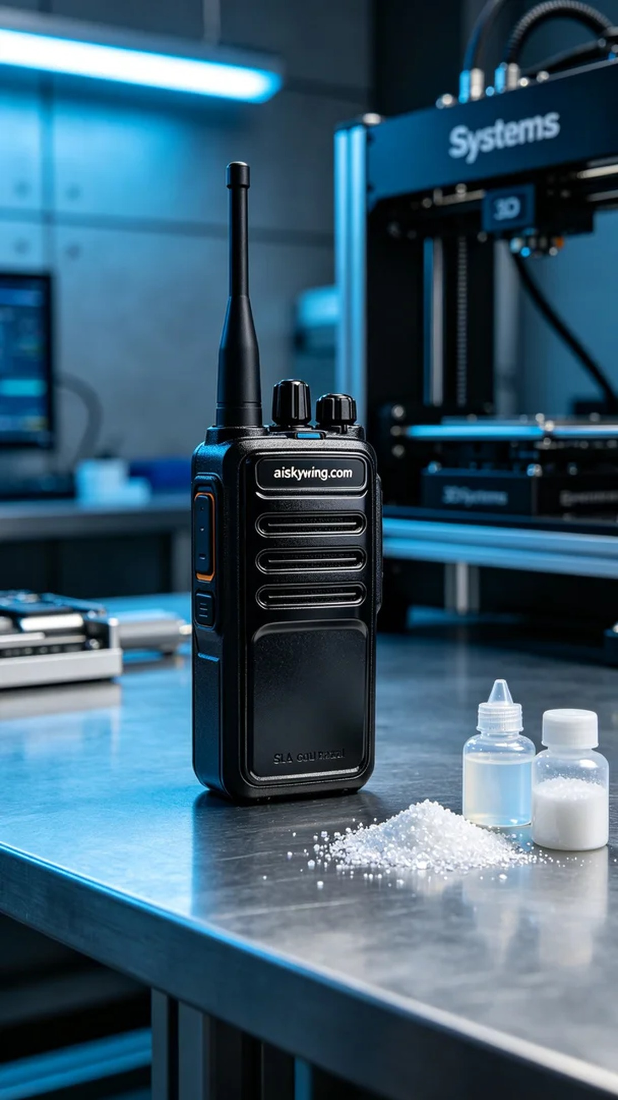
Aiskywing Industrial 3D Printing
Intercom shell


