1046-平板电脑支架生产记录
Tablet stand
🖨️ SLA光固化
🖥️ 打印机: Rize
📦 材料: SLA光固化树脂
在TikTok上，有人因为寻找一款实用的平板电脑支架而找上我们。这个需求，让我想到了生活中的点滴坚持与努力。
On TikTok, someone reached out to us in search of a practical tablet stand. This need reminded me of the little perseverances and efforts in life.
________________________________________________________________________________
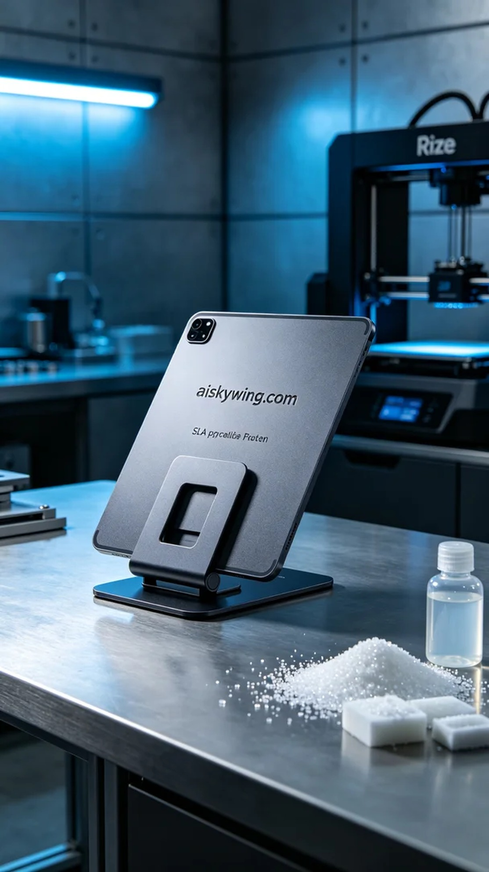
Today, we received a task to produce a tablet stand. This stand needs to have good stability and visual appeal, suitable for use in various environments. To meet the requirements, we chose SLA photopolymer resin as the material, as it is suitable for high-precision printing and can present a nice texture after surface treatment.
During the preparation phase, we used the Rize printer for printing, setting the layer thickness to 0.05 mm, controlling the printing temperature at 25 degrees Celsius, setting the power at 80W, and the printing speed at 60 mm per second, with an estimated total printing time of around 8 hours. This configuration ensures high-quality details and a smooth surface.
As printing began, the device ran very smoothly. We continuously monitored every detail in the printing process to ensure the photopolymerization effect met expectations. As the printing progressed, the shape of the stand gradually became clear. The stability of the device and the precision of the print were satisfying, with minimal support structures, which reduced subsequent processing workload.
After the printing was completed, we began the post-processing steps. First, we placed the stand in a cleaning tank to wash away the excess liquid photopolymer resin with alcohol, then gently sanded it to ensure a smooth surface while maintaining a fine matte texture. Finally, we placed the stand in a curing machine to ensure its strength and durability meet the standards. Each step requires patience, and after a final inspection, the overall effect of the stand made us very satisfied.
Today's work concluded successfully; after meticulous printing and processing, we finally completed this tablet stand, and we look forward to seeing it showcase its value in different settings.
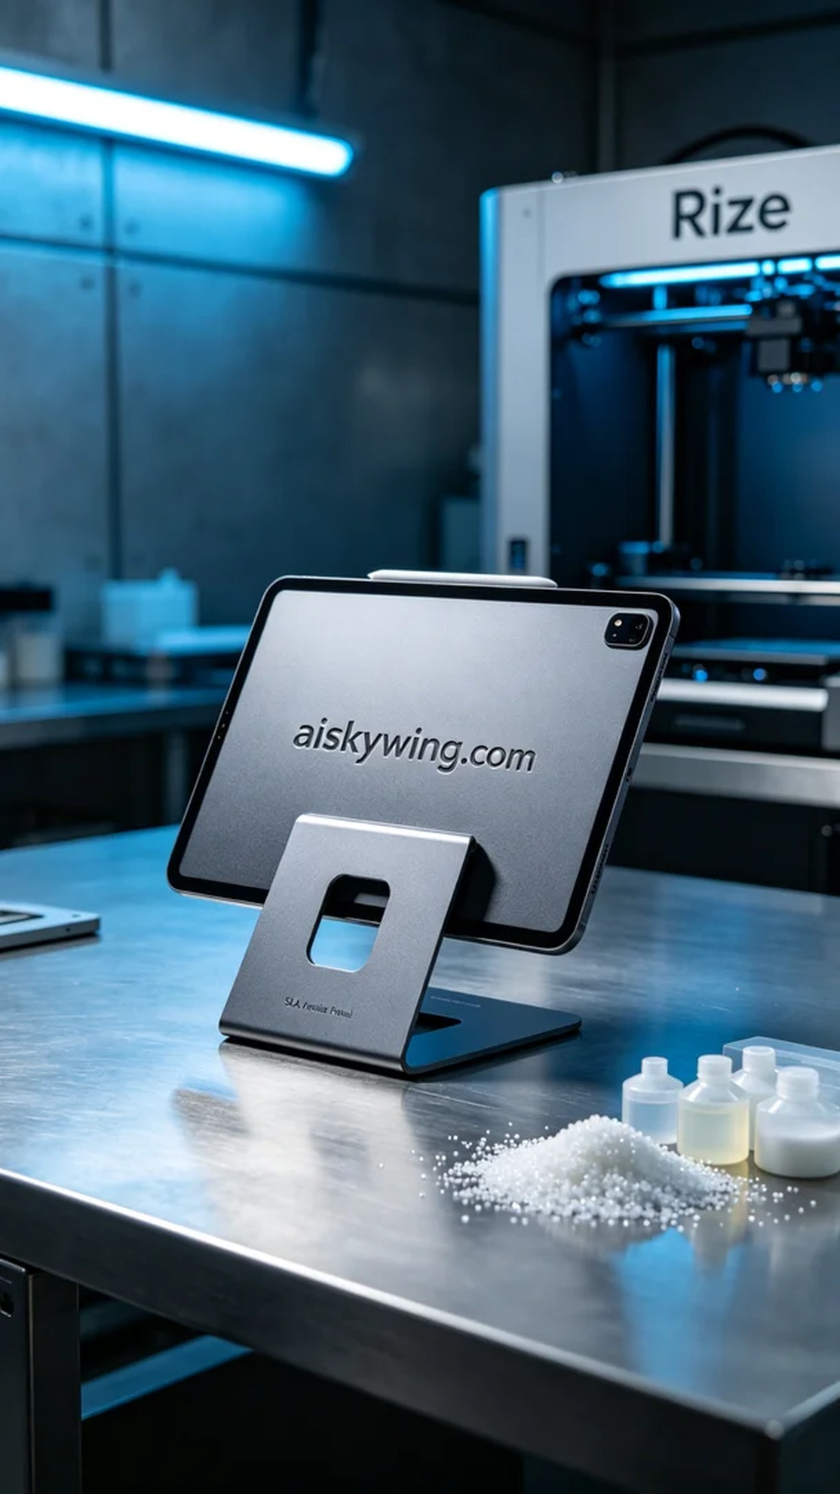
今天我们接到一个制作平板电脑支架的任务。这款支架需要具备良好的稳定性和视觉效果，适合在各种环境中使用。为了满足客户的需求，我们选择了SLA光固化树脂作为材料，因为它适合高精度的打印，并且表面处理后能够呈现出不错的质感。
在准备阶段，我们选用了Rize打印机进行打印，设置的层厚为0.05毫米，打印温度控制在25摄氏度，功率设置为80W，打印速度设定为60毫米每秒，总的打印时间预估在8个小时。这样的参数配置可以确保打印出高质量的细节和光滑的表面。
打印开始后，设备运行得非常顺利。我们持续监控打印过程中的每一个细节，确保光固化效果达到预期。随着打印的进行，支架的形状逐渐清晰可见。设备的稳定性和打印精度令人满意，没有出现过多的支撑结构，也减少了后续的处理工作量。
打印完成后，我们开始后处理工序。首先将支架放入清洗槽，用酒精清洗去除多余的液态光敏树脂，然后用砂纸轻轻打磨，确保表面光滑并保持细腻的磨砂质感。最后，我们将支架放入固化机中进行固化，确保其强度和耐用性达到标准。每一步都需要耐心，最终的检验通过后，支架的整体效果让我们十分满意。
今天的工作圆满结束，经过细致的打印和处理，我们终于完成了这款平板电脑支架，期待它能在不同的场合展现出应有的价值。
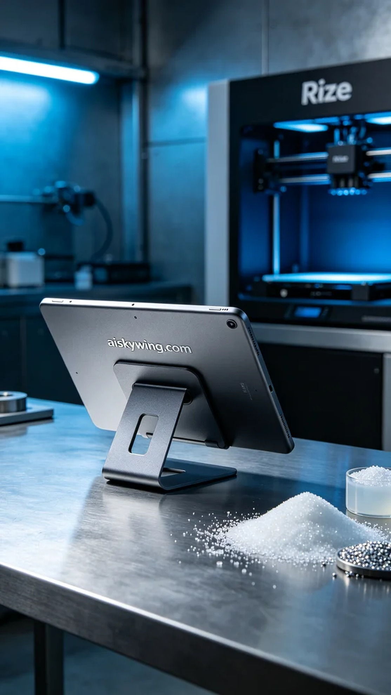
Aiskywing Industrial 3D Printing
Tablet stand


