1047-3D打印录音笔外壳工艺记录
Voice recorder casing
🖨️ SLA光固化
🖥️ 打印机: Rize
📦 材料: SLA光固化树脂
生活就像3D打印，有时候需要耐心和细致。最近，有人找我们做这个录音笔外壳，希望能呈现出完美的效果。
Life is like 3D printing; sometimes it requires patience and attention to detail. Recently, someone approached us to create a shell for a voice recorder, hoping to achieve a perfect result.
________________________________________________________________________________
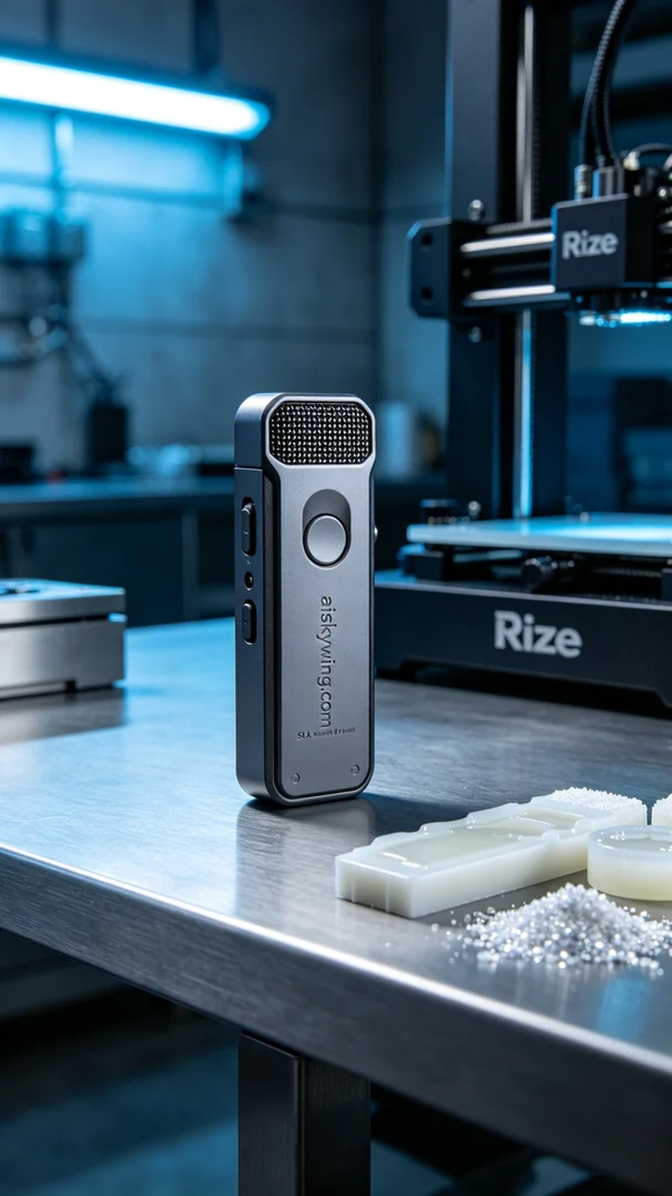
Life is a lot like 3D printing; it requires patience and attention to detail. Recently, someone reached out to us through Twitter, looking for a recording pen shell, hoping to achieve a perfect result.
For this project, we prepared SLA photopolymer resin as the material. This type of resin possesses excellent flow characteristics and optical clarity, making it ideal for high-precision printing. Using the Rize printer, we set the layer thickness to 0.1 mm, maintained a temperature of 25 degrees Celsius, and set the power to 50% to ensure even curing of the resin. The printing speed was adjusted to 50 mm per hour, ensuring the quality and details of each layer.
The printing process went smoothly, and the equipment operated steadily. We closely monitored each phase of the print to ensure there were no bubbles or layer adhesion issues. After two hours of continuous operation, the recording pen shell was successfully formed, and the surface textures were clearly visible, which was satisfying.
Next came the post-processing steps. First, we placed the finished product into a cleaning tank, using a specialized solvent to thoroughly clean the surface and remove uncured resin. After cleaning, we carefully sanded it down with fine sandpaper to ensure the shell was smooth and flaw-free. Finally, we placed it into a curing machine for light curing, ensuring that every detail reached the best quality, followed by a strict inspection.
In the end, this recording pen shell was completed on time, perfectly showcasing the designer's intent and our craftsmanship. A successful print leaves us feeling fulfilled, and we look forward to the next challenge.
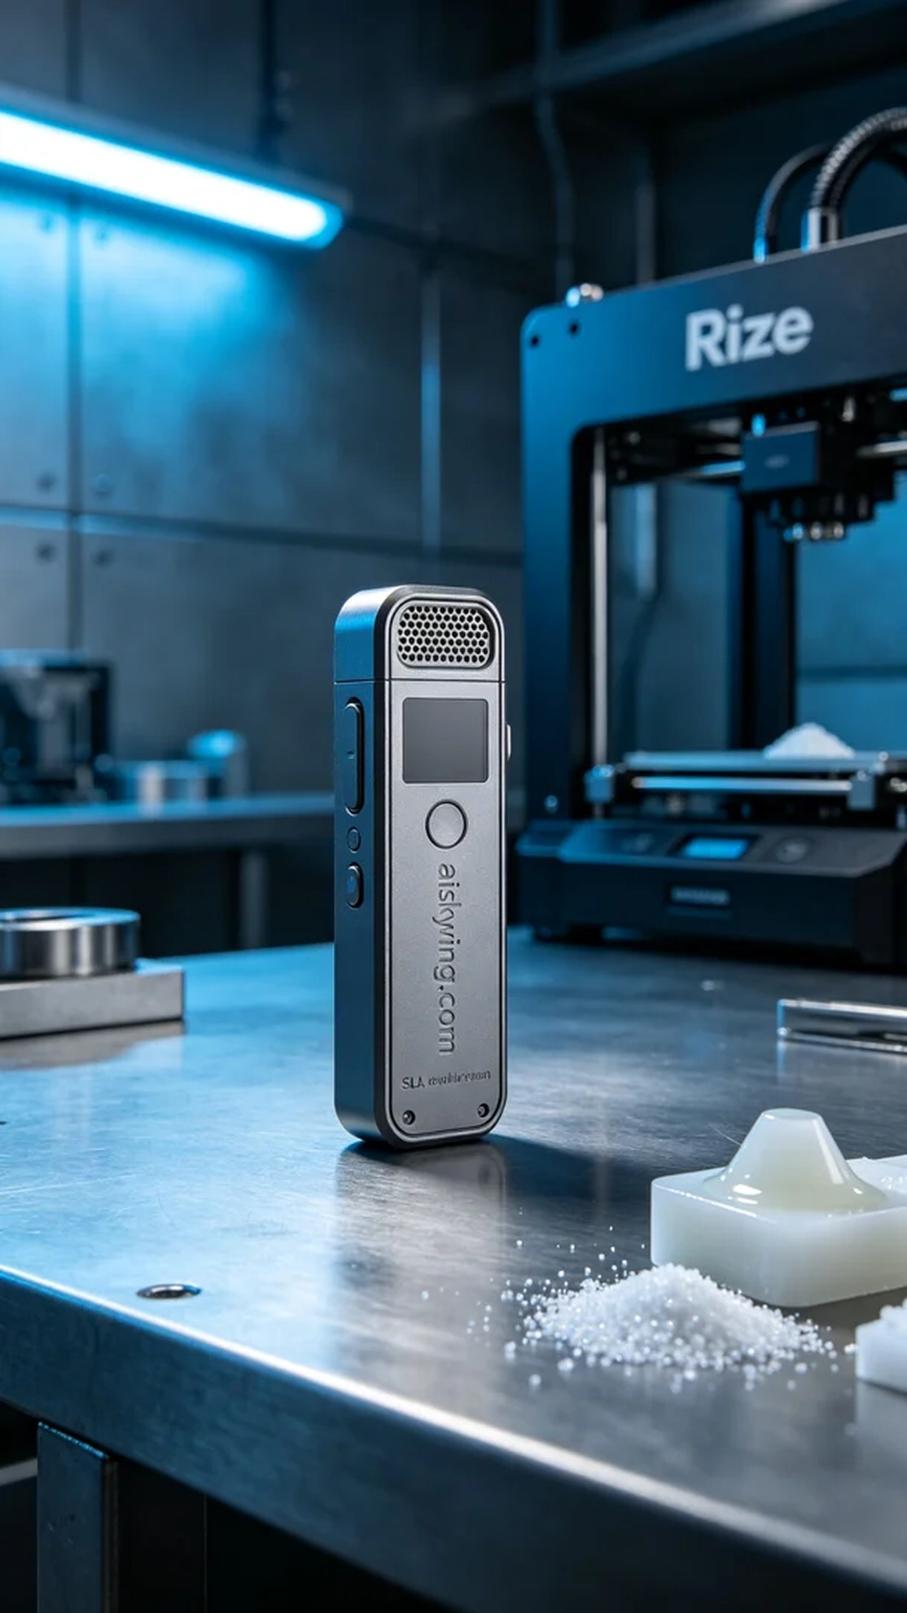
这次，我们接到一个来自Twitter上的请求，有人希望制作一款录音笔外壳，遇到了一些设计上的挑战。他们希望能用SLA光固化技术来实现这款产品，强调其高精度和细腻的外观，特别是希望展现表面雕刻的“aiskywing.com”字样。
为此，我们准备了SLA光固化树脂作为原材料。这种材料具有优良的流动性和光学透明度，适合高精度打印。使用的Rize打印机设置了层厚0.1毫米，温度保持在25摄氏度，功率设置为50%以确保树脂能够均匀固化。打印速度调整为每小时50毫米，这样可以确保每层的质量和细节都得到很好的展现。
打印过程顺利进行，设备运行稳定。我们密切监控每个打印阶段，确保没有出现气泡或层间粘连的问题。经过两个小时的持续工作，录音笔外壳已成功成型，表面纹理清晰可见，令人满意。
接下来进行后处理工序。首先，我们将成品放入清洗槽中，使用专用溶剂彻底清洗表面以去除未固化的树脂。清洗完成后，再用细砂纸仔细打磨，确保外壳光滑且无瑕疵。最后，我们将其放入固化机中进行光固化，确保每一个细节都达到最佳效果，随后进行了严格的检验。
最终，这款录音笔外壳如期完成，完美展示了设计师的初衷和我们的工艺水平。一次成功的打印，让我们倍感欣慰，期待下一次的挑战。
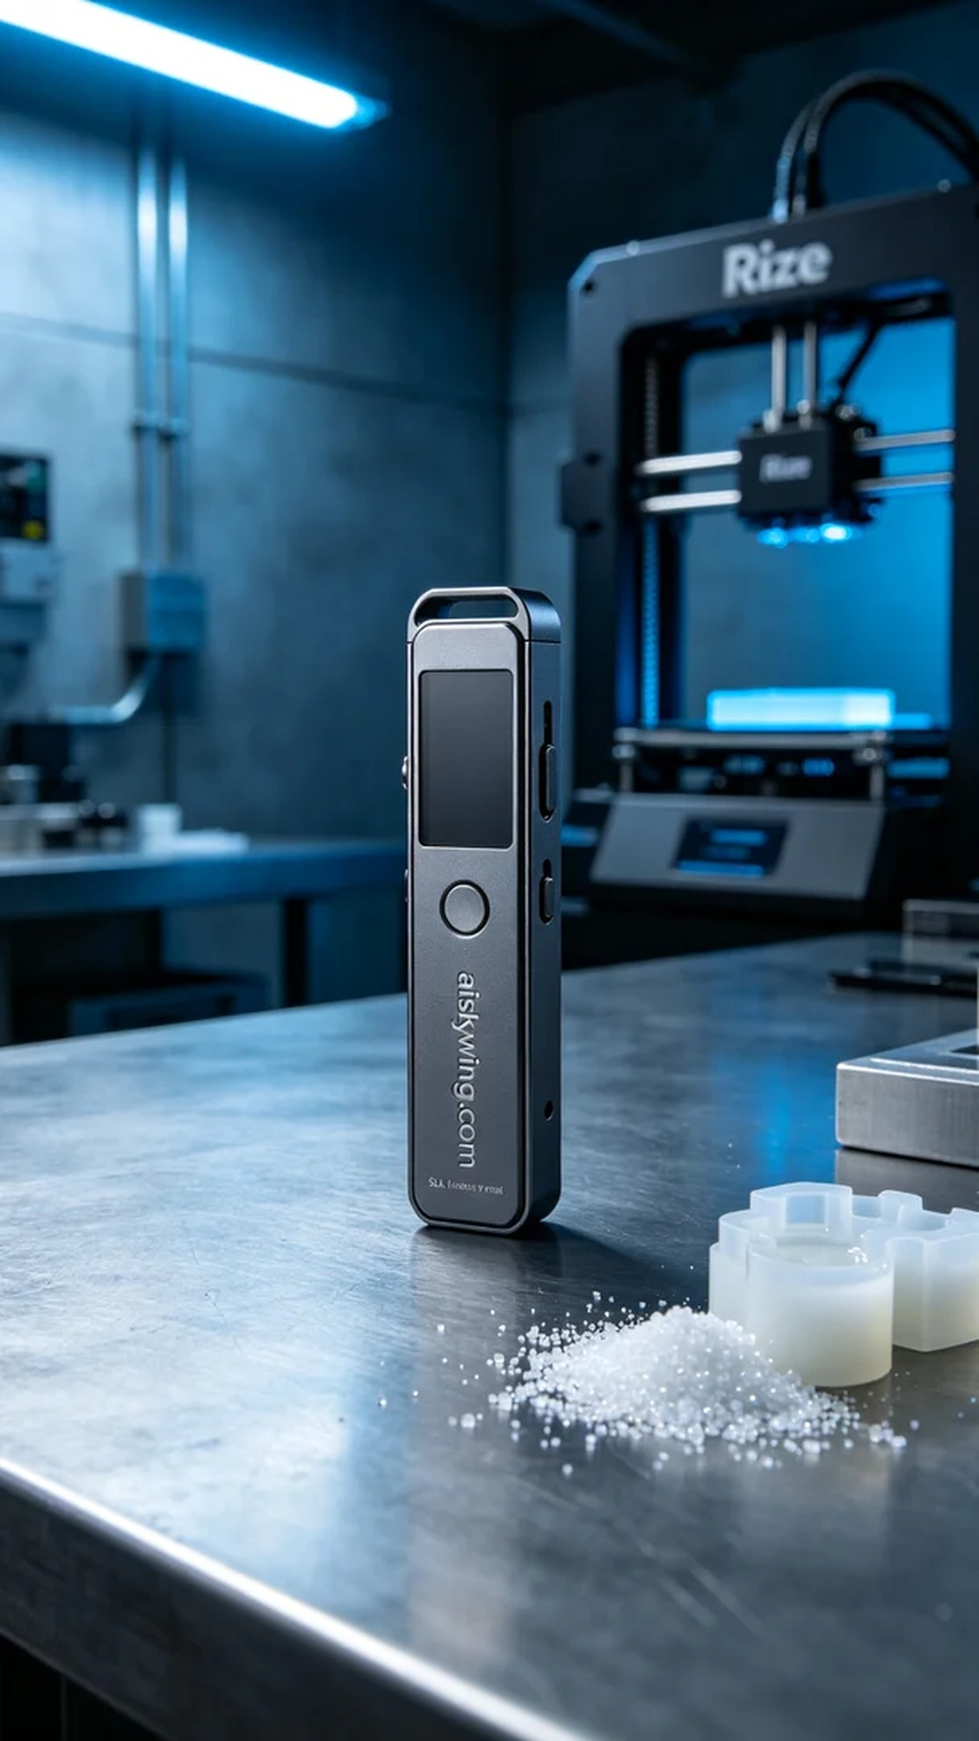
Aiskywing Industrial 3D Printing
Voice recorder casing


