1052-微波炉门把手的3D打印记录
Microwave door handle
🖨️ SLA光固化
🖥️ 打印机: Rize
📦 材料: SLA光固化树脂
生活的每一步都是一次探索，就像有人在Twitter上向我们求助，想要一个微波炉门把手的完美复制。
Every step in life is an exploration, just like when someone reaches out to us on Twitter seeking a perfect replica of a microwave door handle.
________________________________________________________________________________
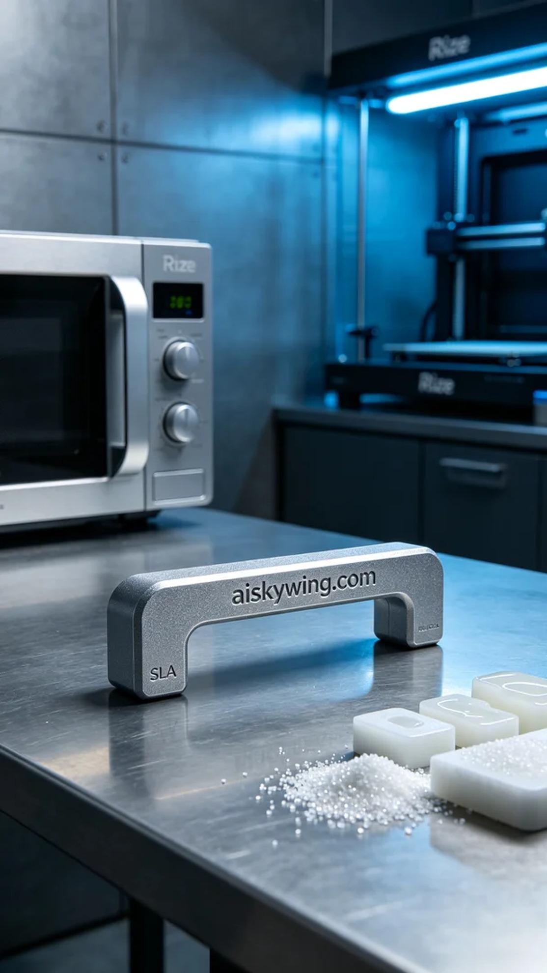
Life is a journey of exploration, just like when someone reached out to us on Twitter, looking for the perfect replica of a microwave oven door handle.
This task came from social media, where someone requested a microwave oven door handle that needed to be precise, durable, and with clear surface details. So, we decided to utilize 3D printing technology to tackle this project, with a clear goal of perfection.
To ensure the printing quality, we selected SLA photopolymer resin as the material. This material boasts high transparency and good mechanical properties for precise detail printing. When using the Rize printer, we set the layer thickness to 0.05mm, maintained a temperature of 25°C, set the power to 50mW, and adjusted the print speed to 40mm per second, estimating a total print time of around 4 hours.
The printing process progressed smoothly, with the Rize printer running steadily, building the microwave oven door handle layer by layer. We monitored the print quality to ensure each layer adhered perfectly, especially focusing on the surface detail engraving to maintain clarity.
Once printing was complete, we began the post-processing work. First, we carefully removed the product from the print platform, then placed it into an ultrasonic cleaner to remove excess resin. After cleaning, we used fine sandpaper for polishing to ensure a delicate touch. Finally, we cured the product in a UV curing oven to enhance its durability. After a thorough inspection, the final result was satisfying, with clear details visible and a smooth feel.
This project of creating the microwave oven door handle fully showcased the charm of 3D printing and the power of technology, leaving us eagerly anticipating the next challenge.
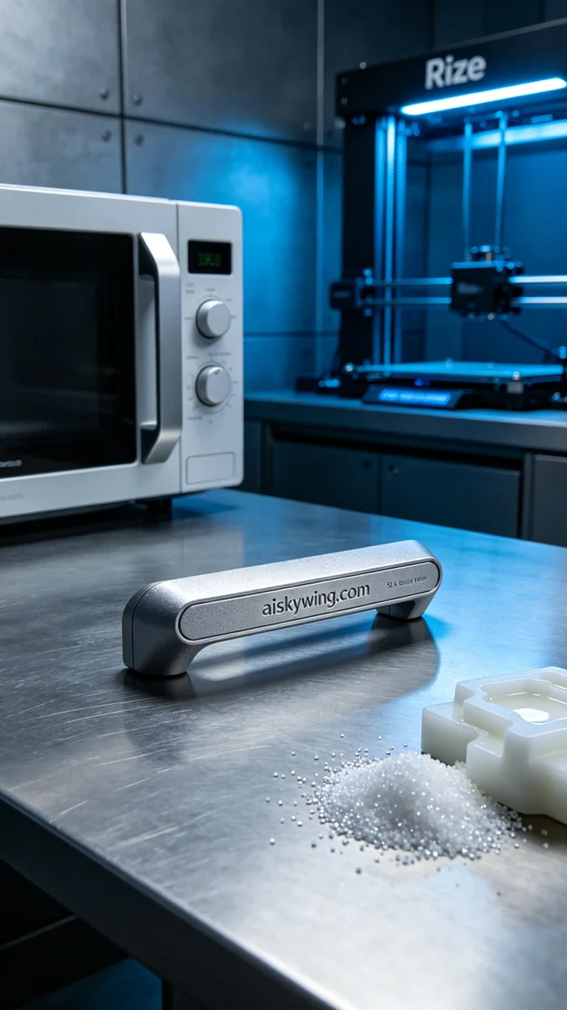
这次的任务来自于社交媒体，有人发消息说他们需要一个微波炉门把手，要求精准、耐用，表面还要有清晰的细节。于是，我们决定使用3D打印技术来完成这个项目，目标直接明确，就是要做到完美。
为了确保打印效果，我们选择了SLA光固化树脂作为原材料。该材料具有极高的透明性和较好的机械性能，打印细节精确。使用Rize打印机时，我们设定了层厚0.05毫米，温度控制在25摄氏度，功率设为50毫瓦，打印速度则调整为40毫米每秒，预计打印时间大约需要4小时。
打印过程进行得相当顺利，Rize打印机稳定地运转，逐层构建出微波炉门把手的形状。我们时刻监控着打印质量，确保每一层都能完美贴合，特别是在表面细节的雕刻上，保持清晰度至关重要。
打印完成后，后处理工作开始了。首先将成品从打印平台上小心取下，接着放入超声波清洗机中清洗，以去除多余的树脂。清洗完成后，使用细砂纸进行打磨，确保手感细腻。最后，将成品放置在UV固化炉中进行固化，使其更加坚固。经过严格的检验后，最终结果令人满意，门把手的细节清晰可见，手感也很顺滑。
这次的微波炉门把手制作，充分展现了3D打印的魅力与技术的力量，满怀期待再迎接下一个挑战。
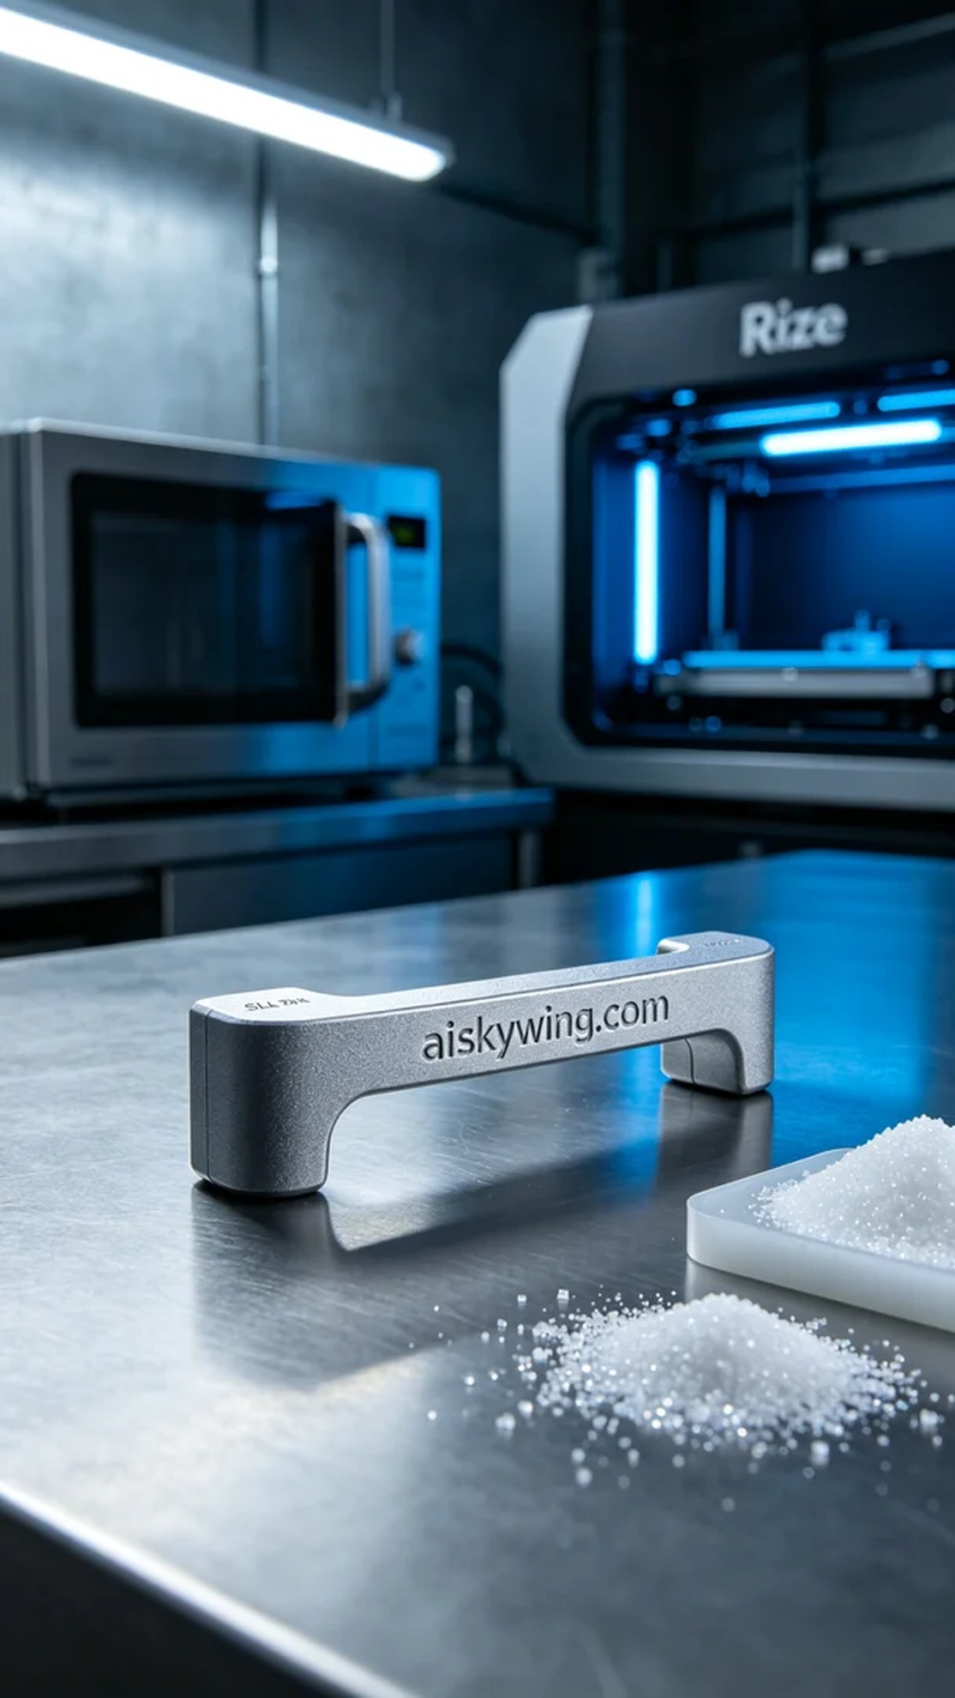
Aiskywing Industrial 3D Printing
Microwave door handle


