1053-心率监测仪外壳的3D打印过程记录
Heart Rate Monitor Case
🖨️ SLA光固化
🖥️ 打印机: EOS
📦 材料: SLA光固化树脂
在WhatsApp上，有人找我们说，希望能生产一款心率监测仪外壳，要求高精度与质感。对于这样的挑战，我们总是充满信心。
On WhatsApp, someone reached out to us expressing the desire to produce a high-precision and high-quality casing for a heart rate monitor. We are always confident in facing such challenges.
________________________________________________________________________________
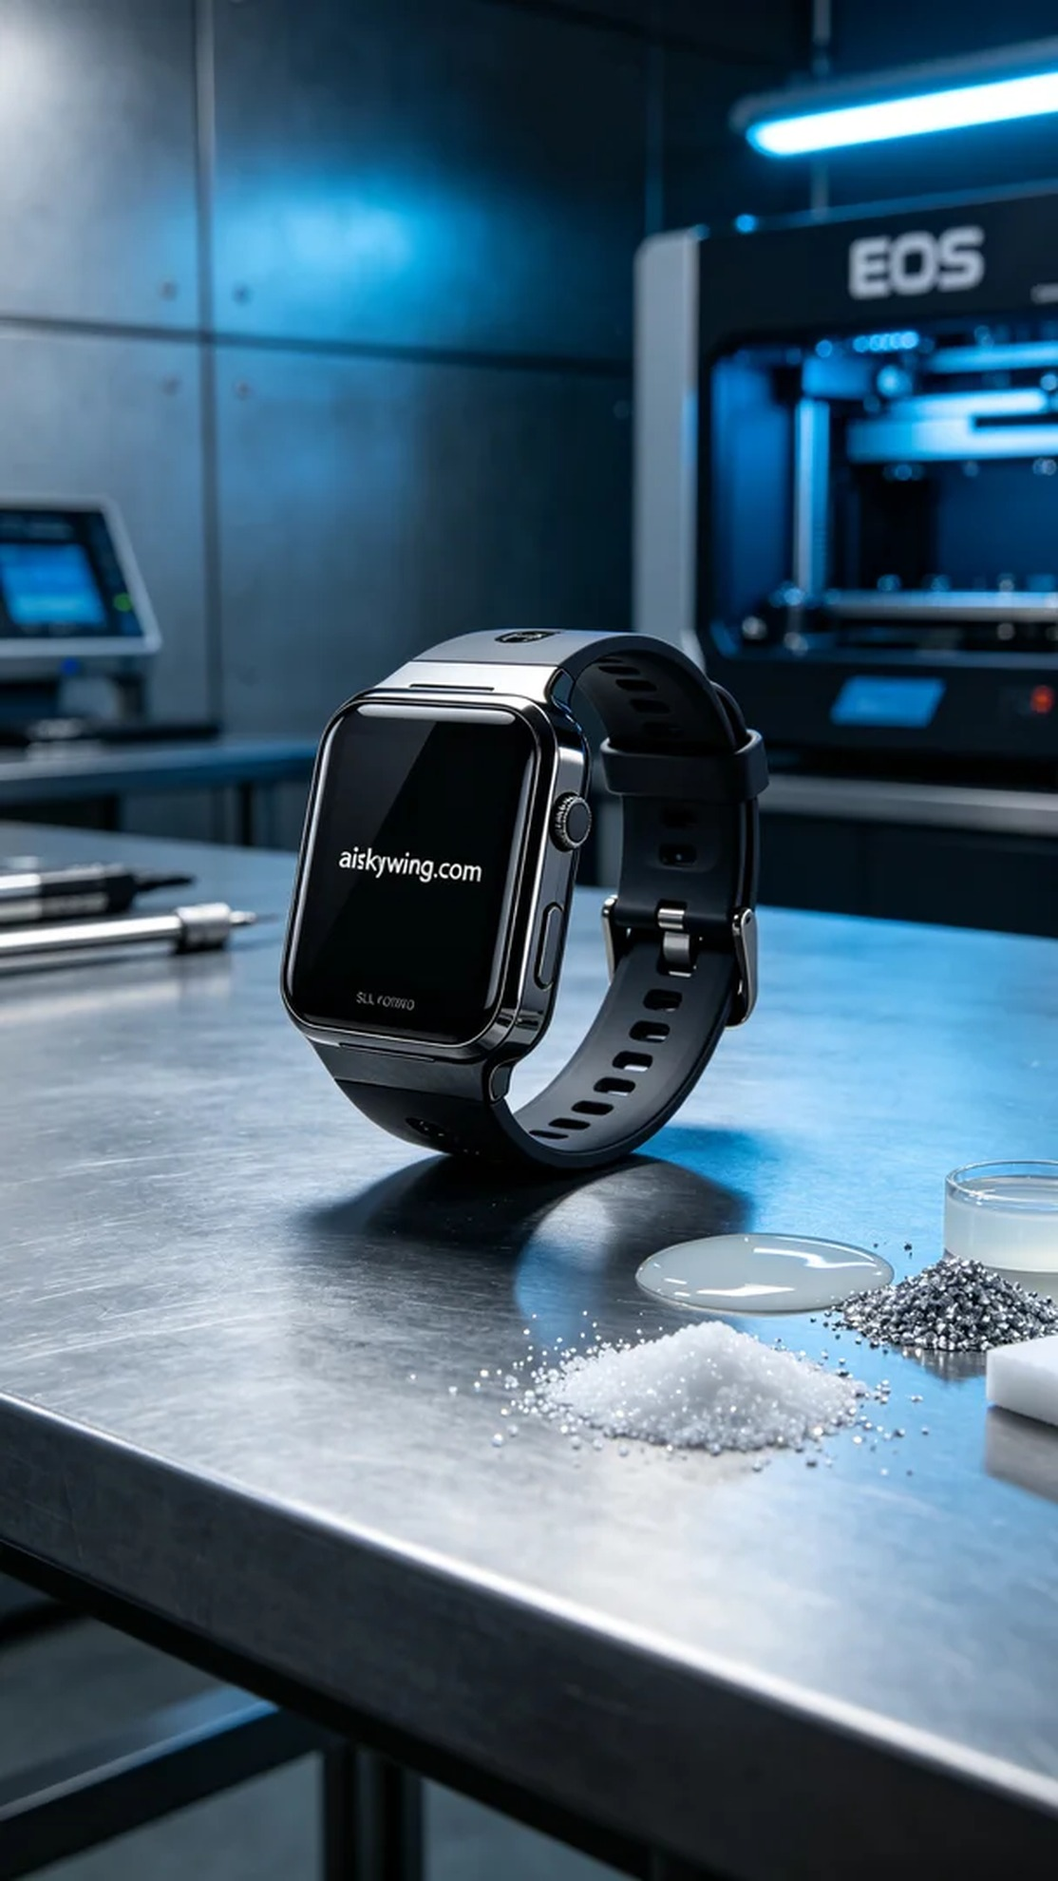
Through WhatsApp, someone reached out looking for a high-precision and aesthetically pleasing heart rate monitor case. For such challenges, we always have confidence.
To meet the requirement, we selected high-quality SLA photopolymer resin as the material. This resin has excellent forming characteristics and a delicate surface effect, making it suitable for products requiring high precision and smoothness. In terms of equipment, we used an EOS brand 3D printer, setting the layer thickness at 50 microns, maintaining a printing temperature of 25°C, setting the power to 80% to ensure photopolymerization, with a printing speed of about 25mm/h and an estimated printing time of 6 hours.
During the printing process, the equipment ran continuously, with a stable light source and smooth operation. We monitored the print quality in real-time to ensure that each layer’s curing met the set standards, avoiding defects. We also noticed the impact of ambient humidity and temperature on print quality, maintaining an appropriate workshop environment to ensure printing results.
After printing, the case required a series of post-processing steps. First, we placed the formed case into a cleaning tank and used isopropyl alcohol to remove excess resin from the surface. After cleaning, the case underwent treatment in an ultrasonic cleaner to ensure every detail was pristine. Next, we performed sanding to carefully smooth every corner, ensuring a sleek surface. Finally, the case was placed in a UV curing machine for hardening, enhancing its strength and durability, followed by rigorous inspection to ensure that each product met the standards.
After this series of processes, we successfully produced a high-quality heart rate monitor case that met functional requirements and achieved industrial design standards in appearance. Each print is an accumulation of experience and learning, making our technology more mature.
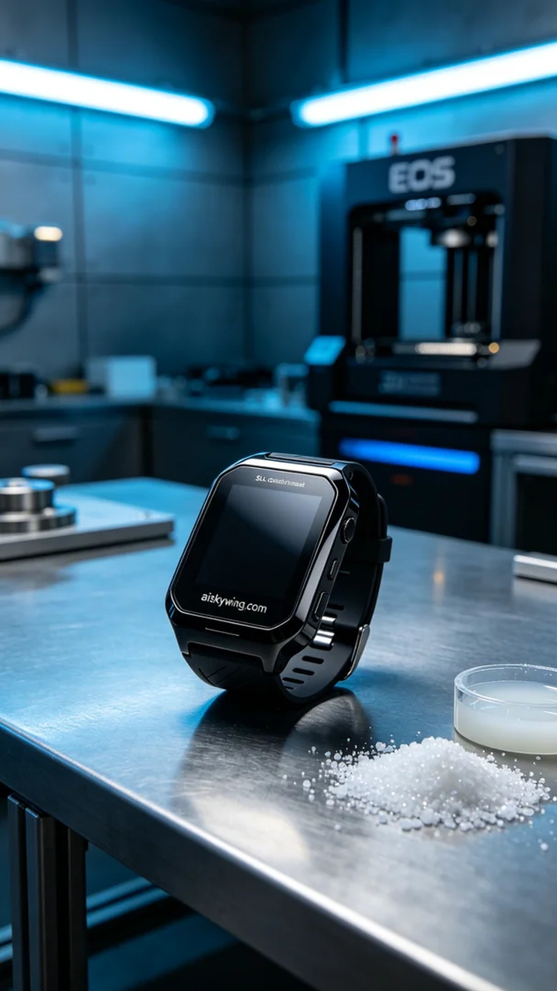
为了满足需求，我们选择了高质量的SLA光固化树脂作为原材料。这种树脂具有优异的成型特性和细腻的表面效果，适合制作需要高精度和光滑度的产品。在设备方面，我们使用了EOS品牌的3D打印机，设置层厚为50微米，打印温度保持在25℃，功率设定为80%以确保光固化效果，打印速度约为25mm/h，预计打印时间为6小时。
打印过程中，设备持续运行，光源稳定，设备运行平稳。我们实时监控打印质量，确保每一层的固化都达到设定标准，避免出现缺陷。同时，我们也注意到环境湿度和温度对打印质量的影响，保持车间环境适宜，确保打印成果。
打印完成后，外壳需要经过一系列后处理工序。首先，我们将成型的外壳放入清洗槽中，用异丙醇进行清洗，去除表面多余的树脂。清洗后，外壳在超声波清洗机中进行处理以保证每个细节的干净。接着，我们进行打磨处理，细心打磨每一个角落，确保表面光滑。最后，将外壳放入UV固化机中，进行固化处理，以提高其强度和耐用性，最后进行严格的检验，确保每个产品都符合标准。
经过这一系列的过程，我们成功地生产出了高质量的心率监测仪外壳，既满足了功能需求，也在外观上达到了工业设计的要求。每一次打印都是一种沉淀与经验的积累，让我们的技术更加成熟。
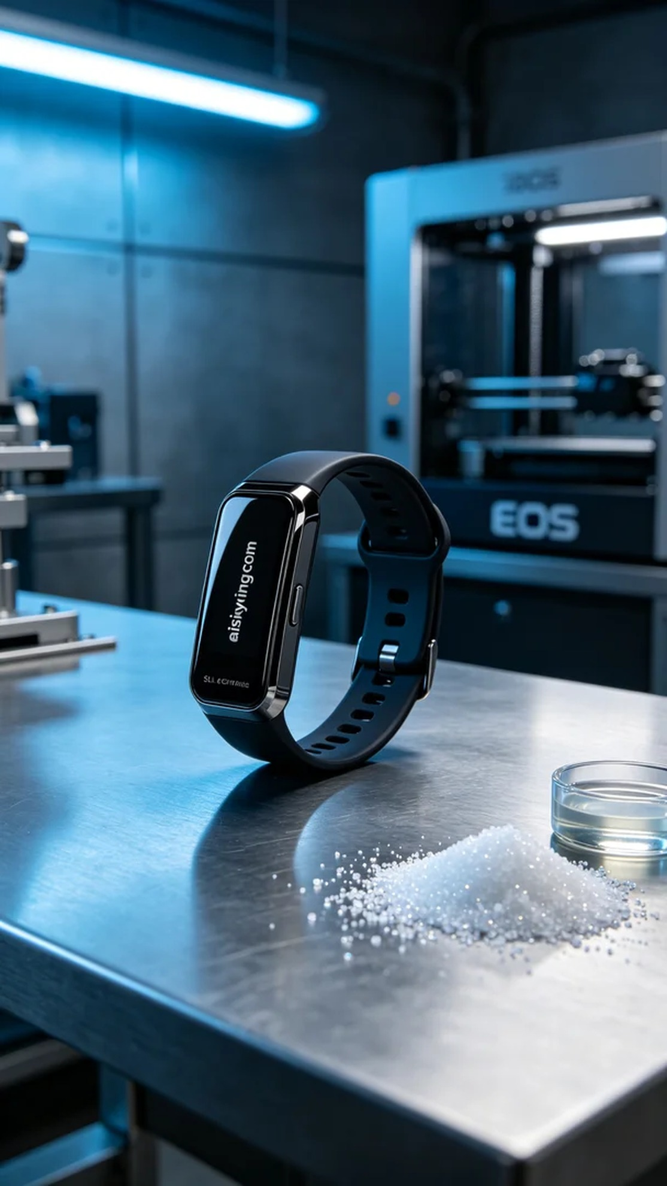
Aiskywing Industrial 3D Printing
Heart Rate Monitor Case


