1055-快门线外壳的3D打印生产记录
Shutter release cable housing
🖨️ SLA光固化
🖥️ 打印机: Stratasys
📦 材料: SLA光固化树脂
生活就像3D打印一样，只有经过耐心的打磨，才能成就完美。最近，有人找我们定制了一个快门线外壳，解决他们的实际问题。
Life is like 3D printing; only through patient refinement can perfection be achieved. Recently, someone approached us to customize a shutter cable housing to solve their practical problem.
________________________________________________________________________________
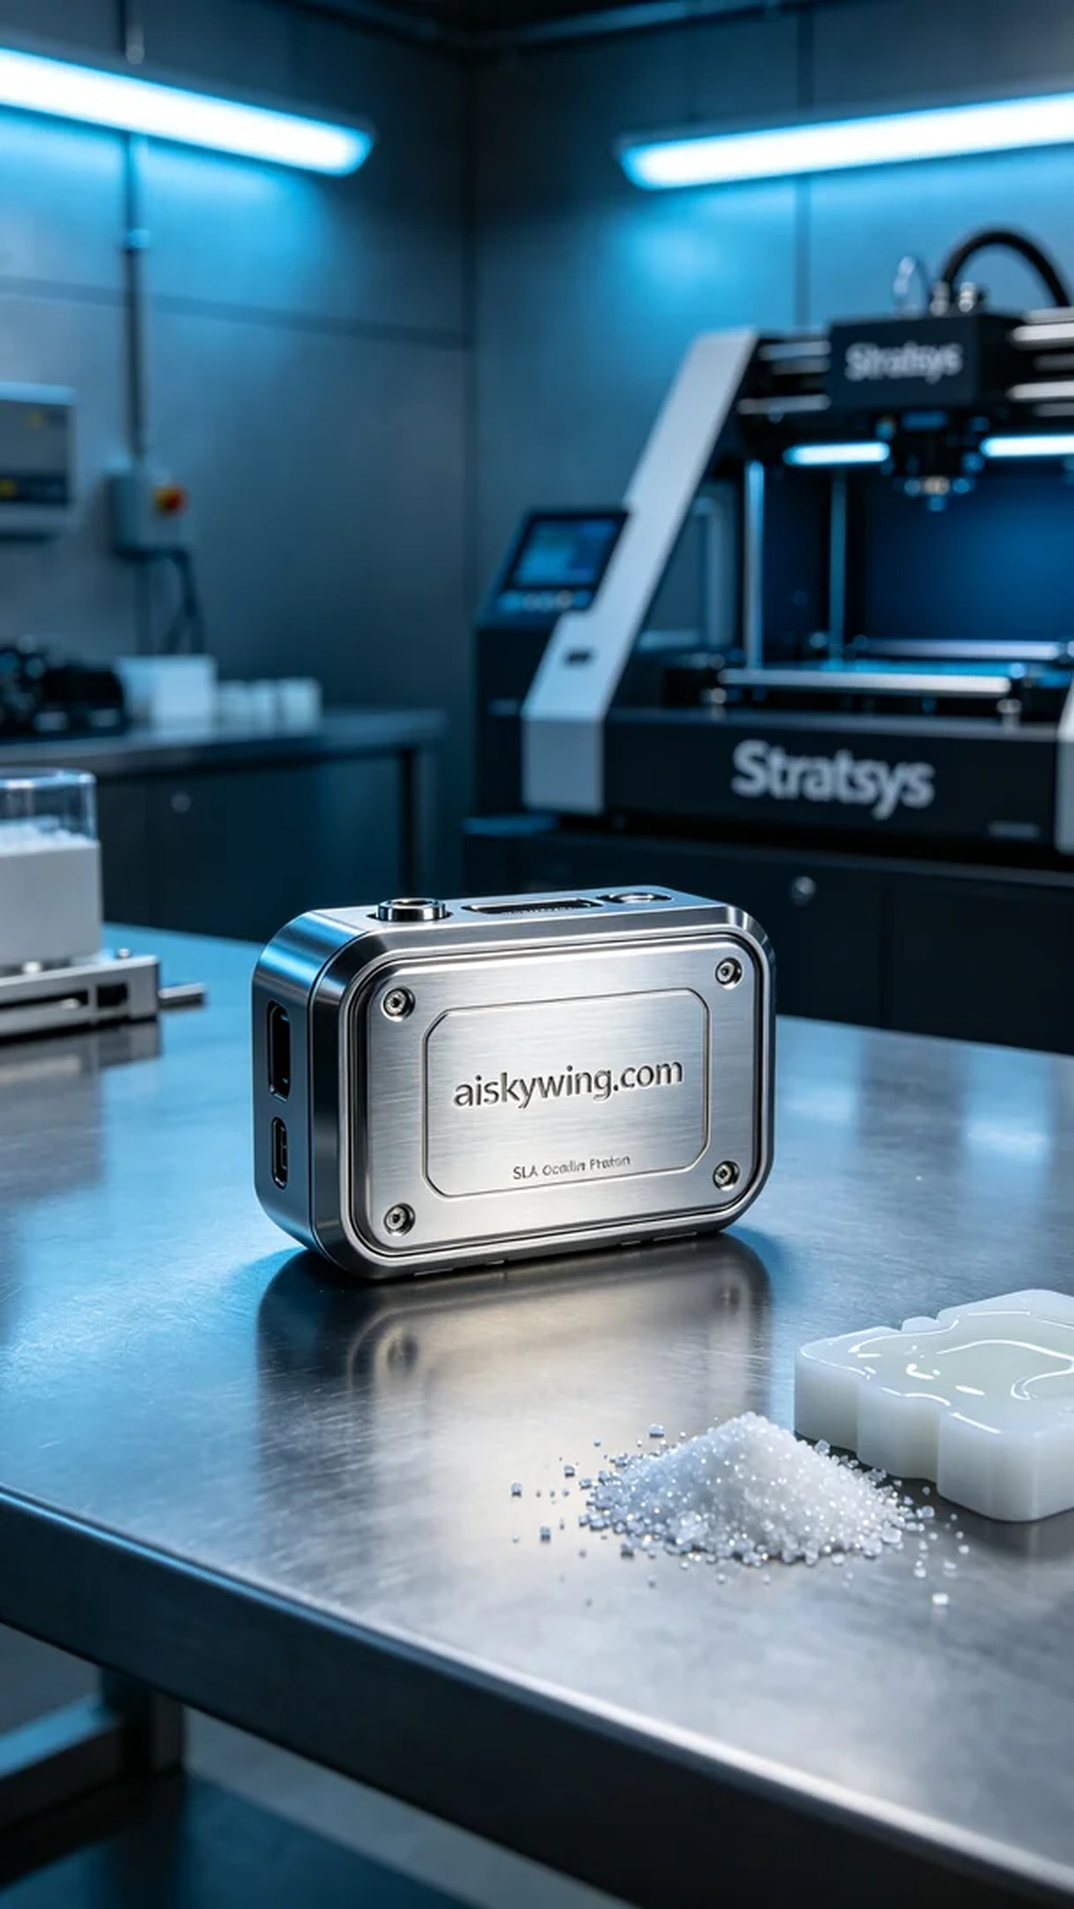
Life is like 3D printing; only through patience and refinement can perfection be achieved. Recently, someone reached out to us on Facebook seeking a new shutter release cable casing to solve their practical issue.
The material we used was SLA (Stereolithography) resin, which offers high transparency and excellent surface gloss, making it ideal for creating protective shells for professional photography equipment. For the printing process, we relied on a Stratasys printer, setting the layer thickness to 0.05mm, maintaining an ambient temperature of 25 degrees Celsius, laser power at 100 milliwatts, and a printing speed of 30mm per second. The estimated print time was about 4 hours.
During the printing process, the Stratasys printer operated smoothly, and we closely monitored the printing quality. Once the printing was completed, the casing boasted clear contours and a smooth surface, with the engraving of "aiskywing.com" vividly visible, showcasing the high resolution and precision of the SLA process.
Post-processing is equally crucial. First, we placed the printed casing in a cleaning machine filled with isopropyl alcohol to remove any uncured resin. Next, we polished the surface to achieve a smoother finish, followed by curing it under UV light to enhance the material's strength and durability. Finally, a thorough inspection was conducted to ensure every detail met our quality standards.
In the end, we successfully produced a flawless shutter release cable casing that met the requirements. Seeing the satisfaction on the person's face brought an unparalleled sense of accomplishment.
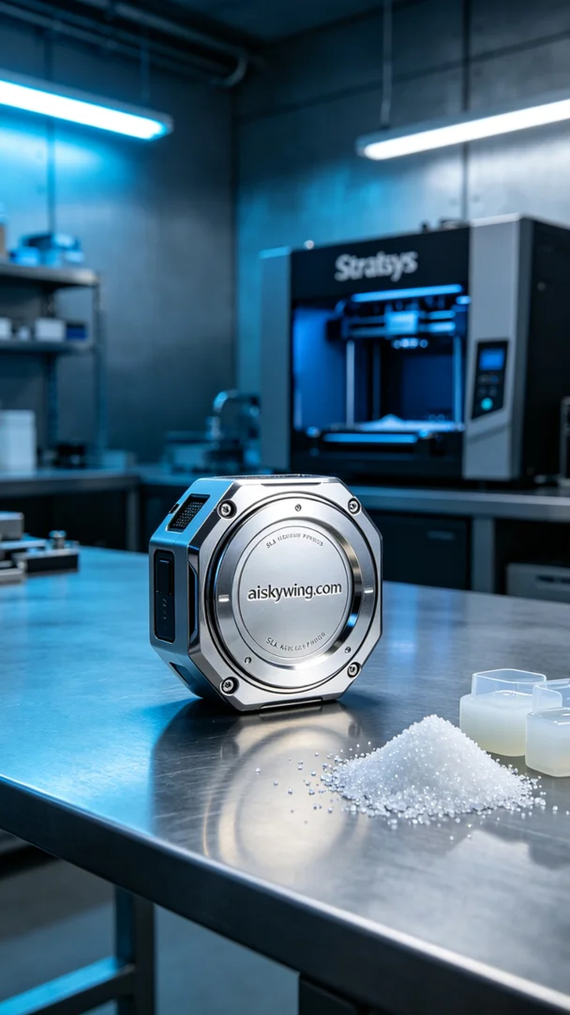
在Facebook上，有人因为快门线的保护壳损坏而联系到我们，希望能够制作一个全新的快门线外壳。这个产品不仅需要耐用，还要具备一定的视觉美感，因此我们决定采用SLA光固化工艺进行打印。
我们使用的原材料是SLA光固化树脂，这种材料具有高度的透明度和优良的表面光泽效果，非常适合制作专业摄影器材的外壳。打印机方面，我们选择了Stratasys品牌的设备。打印设置为层厚0.05毫米，环境温度保持在25摄氏度，激光功率设定为100毫瓦，打印速度为30毫米每秒，预计打印时间为大约4小时。
打印过程中，Stratasys打印机的运行稳定，我们对打印质量进行了实时监控。当打印完成时，外壳的轮廓分明，表面光滑，"aiskywing.com"字样清晰可见，体现了SLA工艺的高分辨率和精细度。
后处理工序同样至关重要。首先，我们将打印好的外壳放入清洗机中，使用异丙醇进行清洗，以去除未固化的树脂。然后，我们对外壳进行了打磨，确保表面更加光滑，最后通过UV固化设备进行固化，以增强材料的强度和耐用性。最后，我们对成品进行了严格检验，确保每一个细节都符合标准。
最终，我们成功制作出了完美的快门线外壳，满足了需求。看到客户满意的笑容，心里的成就感无与伦比。
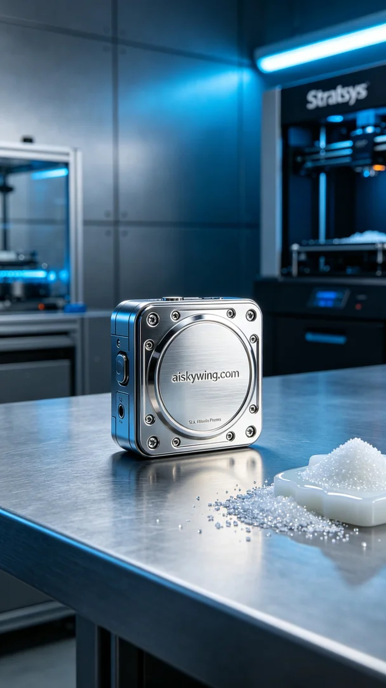
Aiskywing Industrial 3D Printing
Shutter release cable housing


