1056-手机指环扣3D打印生产记录
Phone ring holder
🖨️ SLA光固化
🖥️ 打印机: HP
📦 材料: SLA光固化树脂
生活就像3D打印的过程，精雕细刻才能呈现完美。最近，有人通过TikTok找到我们，希望解决一个关于手机指环扣的问题。
Life is like the process of 3D printing; only through meticulous carving can perfection be achieved. Recently, someone found us through TikTok, hoping to resolve an issue related to phone ring holders.
________________________________________________________________________________
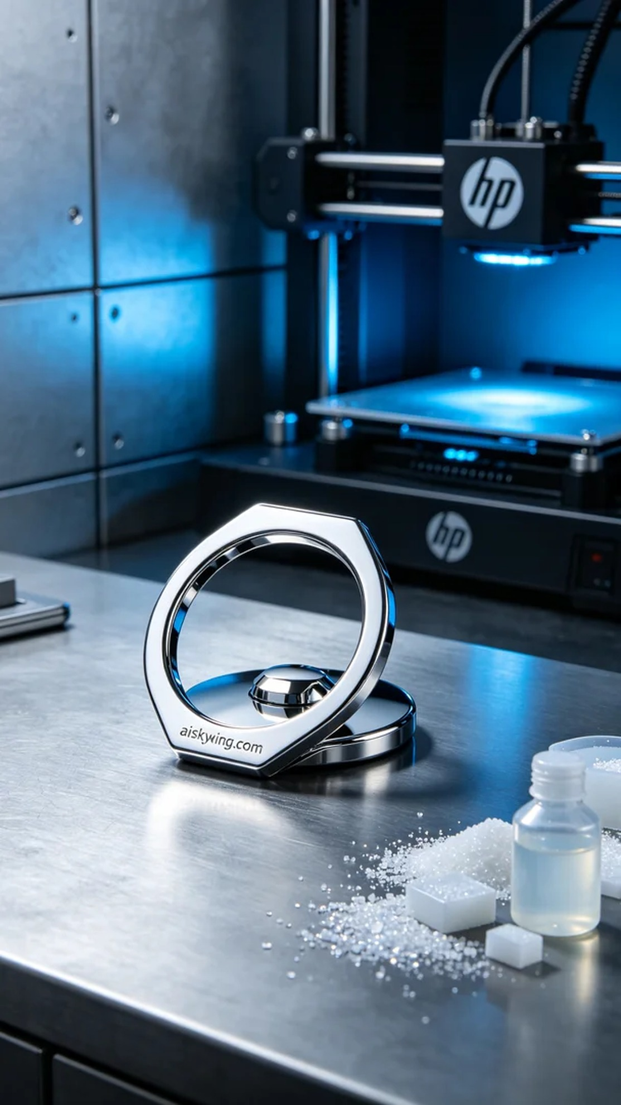
Life is like a 3D printing process; only through careful detailing can we achieve perfection. Recently, someone reached out to us through TikTok with a request to resolve an issue regarding a phone ring holder.
The task was to create a phone ring holder for a friend who saw our work on TikTok and wanted one just like it. This ring holder needed to be both aesthetically pleasing and durable, so we decided to use SLA resin for the printing.
We prepared high-quality SLA resin to ensure excellent detail and gloss in the prints. We used an HP 3D printer for this task, setting the parameters to a layer thickness of 0.05mm, maintaining a temperature of 25 degrees Celsius, with a power setting of 50% and a speed of 30mm per second. We anticipated that the entire printing process would take about 2 hours.
The printing process went smoothly, with the machine operating steadily and the light source properly calibrated to ensure each layer cured effectively. We closely monitored the print quality to ensure that every detail met our expectations. As the print progressed, the phone ring holder's shape gradually emerged, and its mirror finish intensified.
After printing, we proceeded with post-processing. The printed piece was first placed in a cleaning station using isopropyl alcohol to remove any excess resin, followed by further cleaning with an ultrasonic cleaner. Next, we sanded the surface to ensure smoothness before UV curing to enhance durability. Finally, after thorough inspection to confirm all details met the standards, we completed the production of this phone ring holder.
Through this creation, we once again validated the charm and technical intricacies of 3D printing. The completion of the phone ring holder not only fulfilled the requirement but also reinforced our determination to continue progressing on this path.
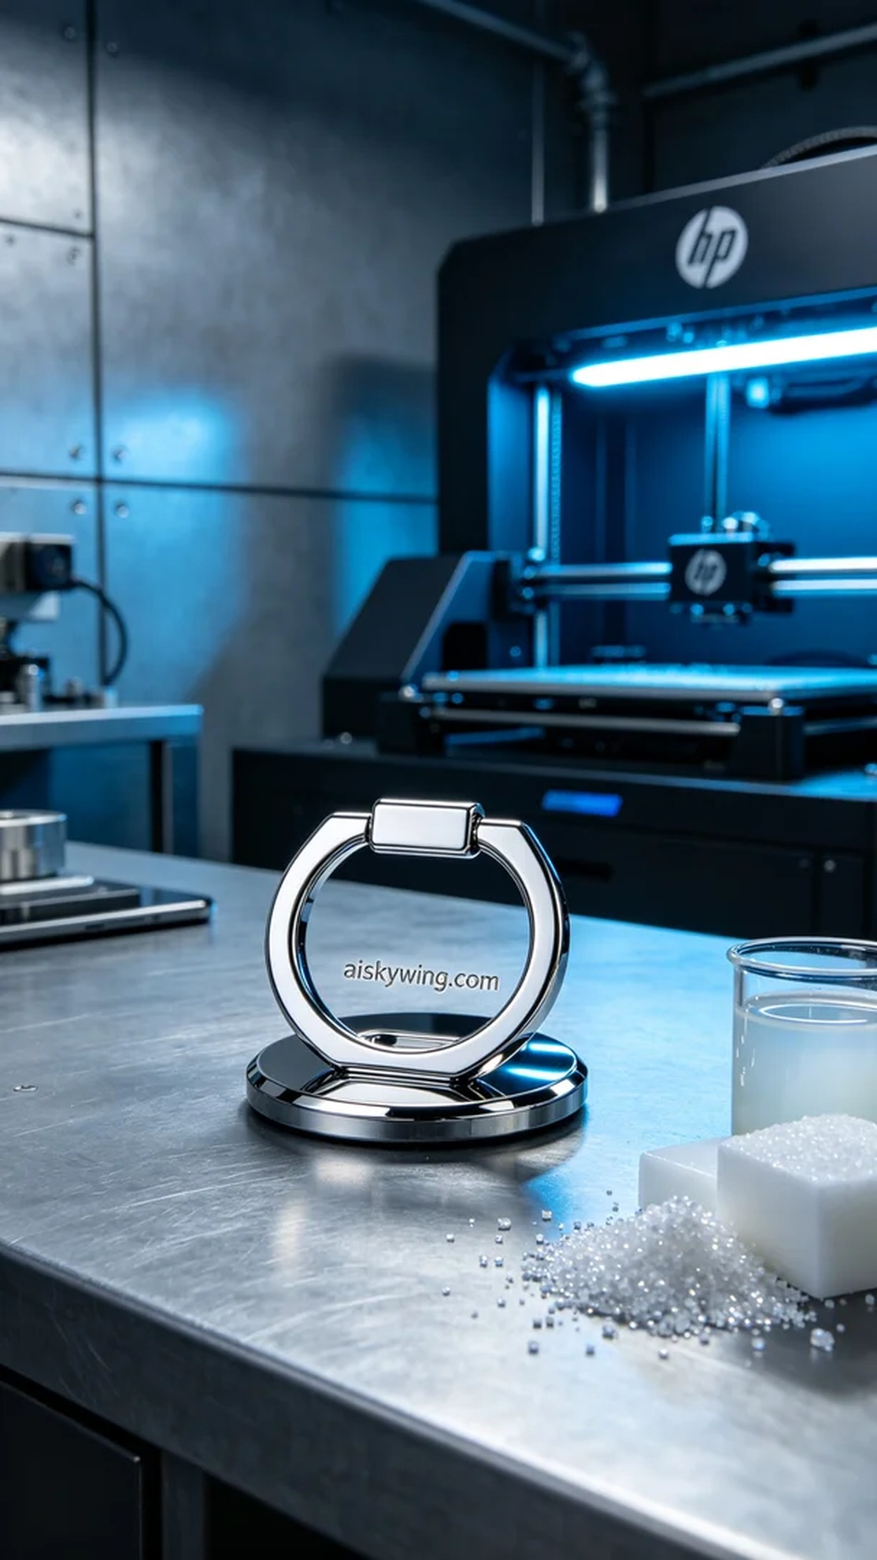
这次的任务是为一个朋友制作手机指环扣，他在TikTok上看到我们制作的作品，想要一个同样的。由于这个指环扣不仅要美观，还需要在材质上达到一定的耐用性，我们决定采用SLA光固化树脂进行打印。
我们准备了高质量的SLA光固化树脂，确保打印出色的细节和光泽。打印中使用的是HP品牌的3D打印机，设置参数为层厚0.05毫米，温度保持在25摄氏度，功率设置为50%，速度为30毫米每秒。我们预计整个打印过程需要约2小时。
打印过程进行得非常顺利，机器的运行平稳，光源也调试得当，确保了每一层的光固化效果。我们在旁仔细监控打印质量，确保细节处都能达到预期效果。随着打印的推进，手机指环扣的形态逐渐显现，表面镜面效果也在不断增强。
打印完成后，我们进行了后处理。首先将打印件放入清洗槽，使用异丙醇清洗去除多余的树脂，然后用超声波清洗机进一步清洁。接下来，我们进行了打磨，确保表面平滑，并进行UV固化处理，以增强其耐用性。最后，经过检验，确认每个细节都符合标准后，终于完成了这款手机指环扣的制作。
通过这次制作，我们再次验证了3D打印的魅力与技术含量。手机指环扣的完成不仅满足了需求，也让我们更加坚定了在这条路上继续前行的决心。
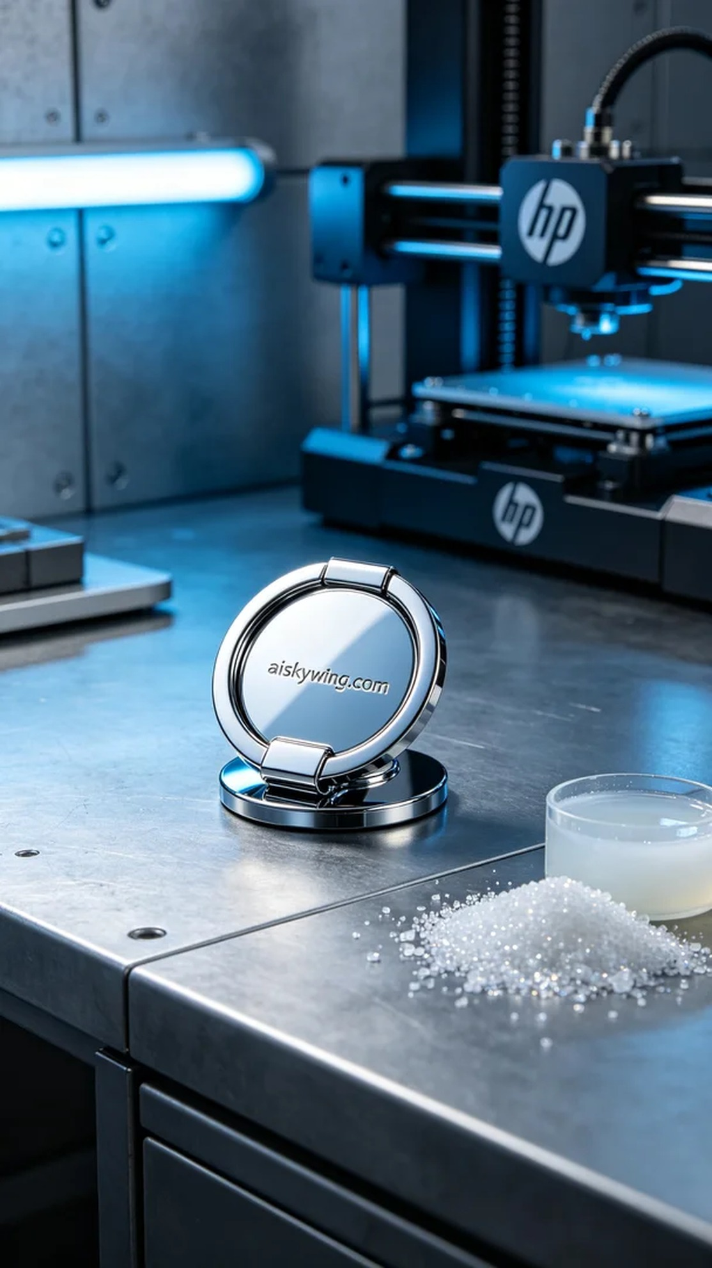
Aiskywing Industrial 3D Printing
Phone ring holder


