1058-手机镜头保护圈的3D打印记录
Mobile phone lens protection ring
🖨️ SLA光固化
🖥️ 打印机: Voxeljet
📦 材料: SLA光固化树脂
在WhatsApp上，有人找我说手机镜头保护圈的需求很迫切，这让我想起了在3D打印中坚持追求完美的重要性。
On WhatsApp, someone reached out to me saying that there is an urgent demand for phone lens protection rings, which reminded me of the importance of striving for perfection in 3D printing.
________________________________________________________________________________
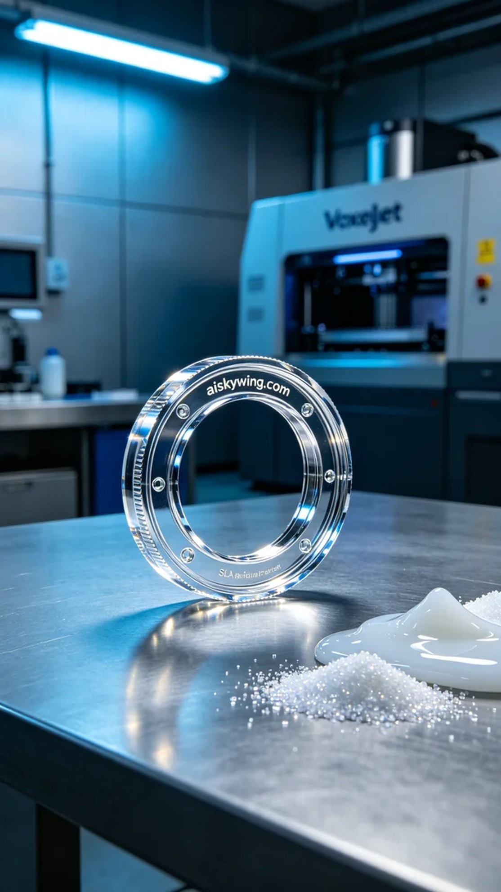
Recently, someone reached out to me on WhatsApp regarding the urgent need for a smartphone lens protector. This task reminded me of the importance of striving for perfection in 3D printing.
For this project, we decided to print a smartphone lens protector using SLA photopolymer resin. This material provides a delicate surface and clear details, perfectly aligning with their requirements for optimal protection during photography.
In the preparation phase, we chose the Voxeljet printer, which is crucial for optimizing the device. We set the layer thickness to 0.05 mm, a print speed of 30 mm per second, and maintained the light source power at 100 mW, ensuring effective resin curing. Additionally, the environment temperature was kept at 25 degrees Celsius to guarantee stability during printing.
As the printing process commenced, I closely monitored the device's operation. With each layer gradually stacking up, the smartphone lens protector began to take shape. The total printing time was around two hours, during which I continuously checked the machine's status and print quality to ensure no defects arose.
After printing, the first step was to carefully remove the product from the vat and wash it with isopropyl alcohol to eliminate any uncured resin on the surface. Next, I polished the product to ensure smooth edges. To enhance durability, we performed a UV curing treatment, followed by a thorough inspection under proper lighting to ensure every detail was spot on.
After a series of meticulous processes, the smartphone lens protector was perfectly formed, meeting the expected quality standards. Every detail was meticulously controlled, ensuring the final product was both elegant and functional.
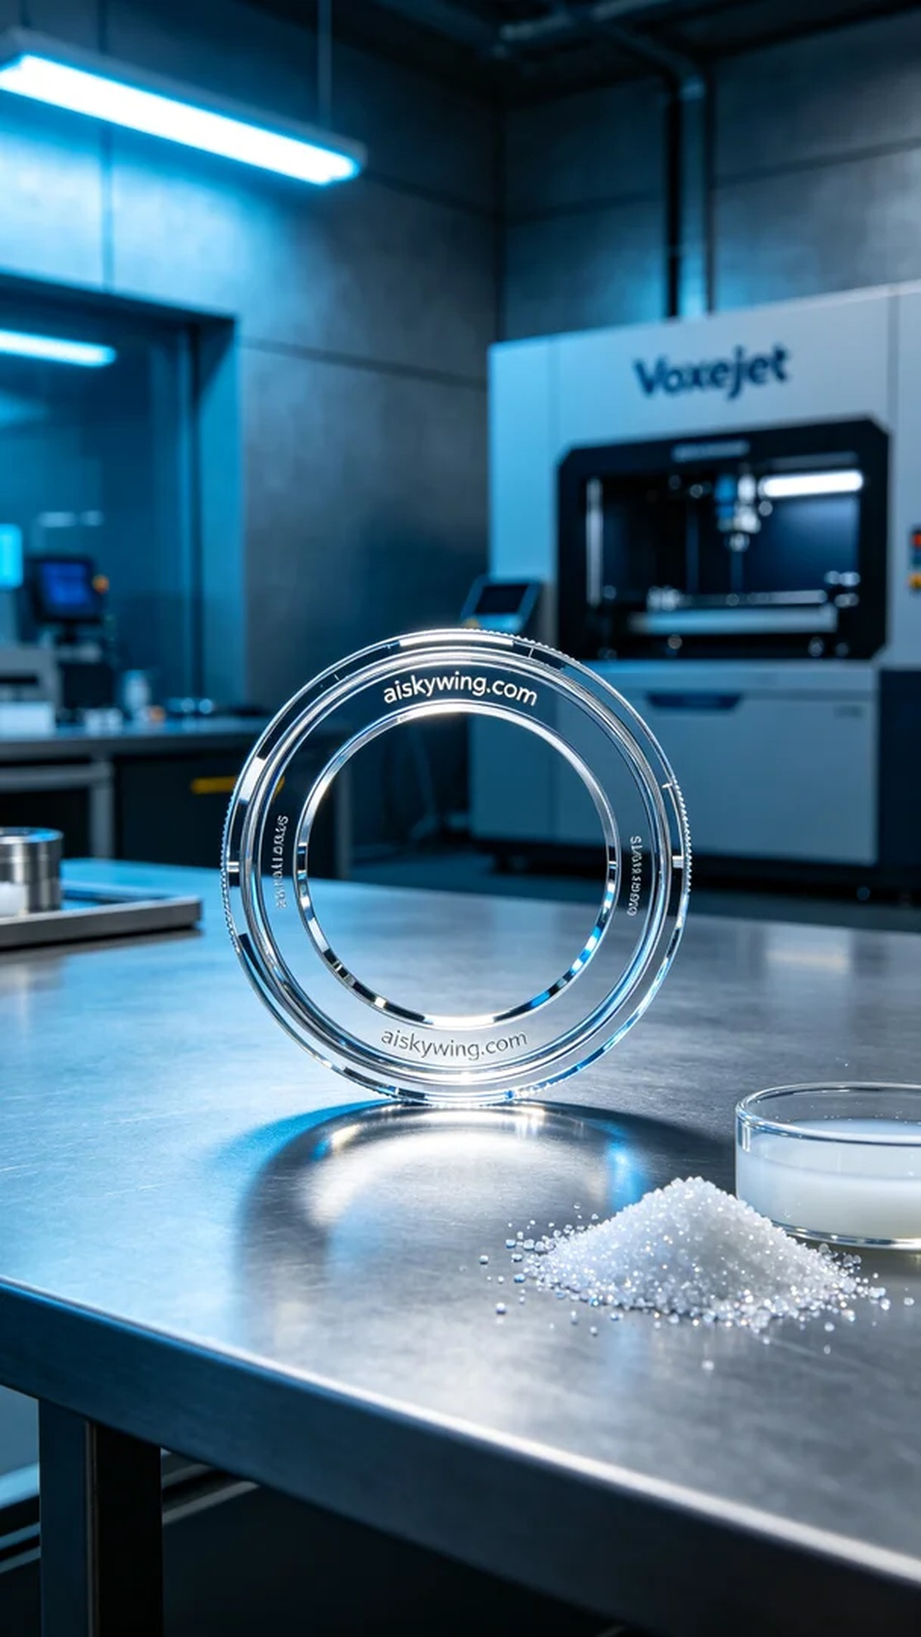
这次的任务是为某人打印一款手机镜头保护圈。他们希望能有一款在摄影时提供更好保护的产品，因此我们决定使用SLA光固化树脂进行打印。这种材料能提供细腻的表面和清晰的细节，正好符合他们的要求。
在准备阶段，我们选择了Voxeljet打印机，这是设备调试的关键步骤。我们设定了层厚0.05毫米，打印速度为30毫米每秒，光源功率保持在100毫瓦，保证了树脂固化的效果。同时，环境温度控制在25摄氏度，以确保打印的稳定性。
打印过程开始后，我密切关注着设备的运行情况。随着每一层的逐步叠加，手机镜头保护圈逐渐成型。打印时间大约为两小时，过程中我随时检查机器的状态和打印质量，确保没有出现任何瑕疵。
完成打印后，第一步是将成品从打印槽中取出，然后进行清洗，使用异丙醇去除表面未固化的树脂。接着，我对产品进行打磨，确保边缘光滑无刺。同时，为了提高耐用性，我们进行了UV固化处理，最后在良好的光线下仔细检验成品的每一个细节。
经过这一系列精细的工序，手机镜头保护圈已经完美成型，质量也达到了预期。每一个细节都经过严格把控，确保了最终产品的优雅与实用。
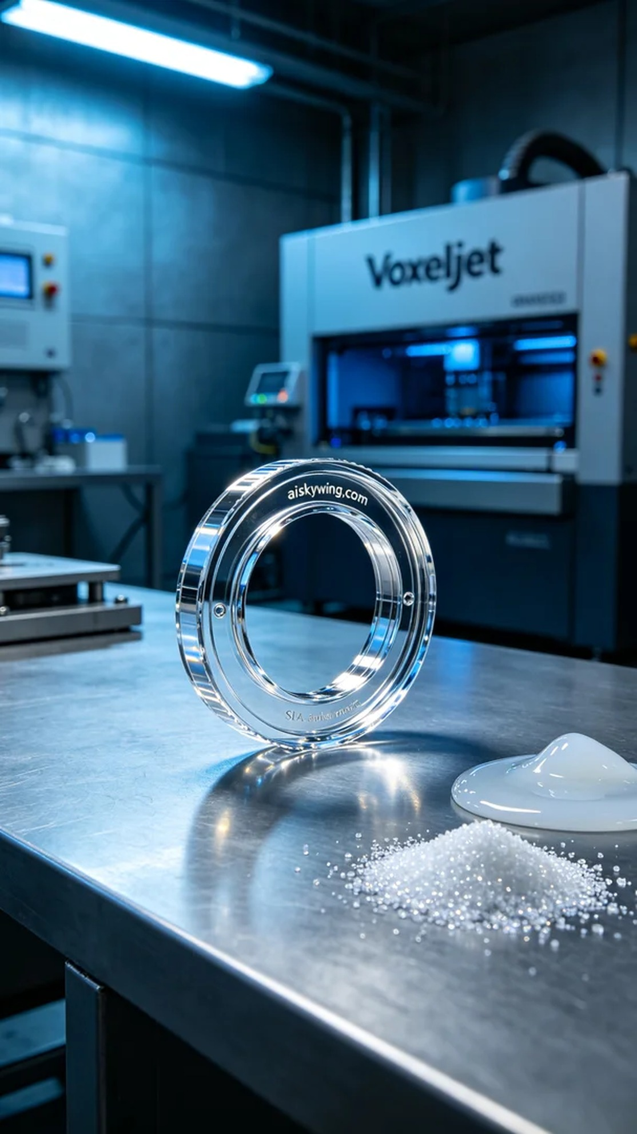
Aiskywing Industrial 3D Printing
Mobile phone lens protection ring


